Exemplary School Library Program Application

Welcome to the opportunity to showcase your school library through the Missouri Department of Elementary and Secondary Education’s Exemplary School Library Program. Please read through the application carefully. If you have any questions, please contact Lisa Scroggs, DESE assistant director of English language arts, at lisa.scroggs@dese.mo.gov.

Table of Contents

- Applicant Information
II. Instruction
Completed
Indicator 1 Differentiated Instruction
Indicator 2 Planning Time
Indicator 3 Types of Literacy
Indicator 4 Assessment
Indicator 5 Academic Learning
III. Leadership
Completed
Indicator 6 Professional Development
Indicator 7 Professional Development Opportunities
Indicator 8 Educational Leader
Indicator 9 Communication and Collaboration
Indicator 10 Stakeholder Relationships
Indicator 11 School Improvement Plan
IV. Library Environment
Completed
Indicator 12 Physical Space
Indicator 13 Program Opportunities
Indicator 14 Current Technologies
V. Library Management
Completed
Indicator 15 Flexible Scheduling
Indicator 16 Program Evaluation
Indicator 17 Budget
Indicator 18 Collection
Indicator 19 Policies and Procedures
VI. Staffing
Completed
Indicator 20 Librarian-to-Student Ratio
Indicator 21 Library Support Staff-to-LMS Ratio
VII. Appendix

Form

Applicant Information
First Name:
Connie King

Last Name:
Katie Fisher

School Contact Email:
Katie.fisher@lps53.org

Position:
Library Media Specialist

School District:
Liberty Public School District

School:
Liberty North High School

School Address:
1000 NE 104th St.

Link to School Librarian’s DESE Library Certification (access your certification account portal at https://apps.dese.mo.gov/weblogin/login.aspx). Please do not provide link to your certificate through your portal as evaluators will not be able to access it without your password. Instead, either save your certificate to an accessible link or provide a screenshot of your certificate below:
Certificate(s) removed prior to publishing application on DESE website.

Return to Table of Contents

Instruction

Indicator #1:
Program regularly delivers differentiated instruction, either directly provided by the librarian or in collaboration with the classroom teacher

(AASL—collaborate, engage, explore, inquire)
Exemplary (2 points): Exhibits research-based instructional practices in the consistent application of differentiated instructional design

Approaching (1 point): Exhibits research-based instructional practices in the application of differentiated instructional design

Required Documentation/Evidence

Lesson plans or anecdotal evidence exhibiting instructional theory or practices including differentiation, i.e. physical needs, learning styles, skill levels, etc. (Examples: Marzano instructional practices, Kagan cooperative strategies, assistive technology in use, multiple intelligences)

Supporting Evidence
Insert Applicable Links Here:
LNHS Library Website and resources:
https://www.lps53.org/domain/1281

Links to differentiated materials (also included with description in narrative):

https://wke.lt/w/s/qcJUCj
Student Notetaking part I(permission from student granted for use)::
Student Notetaking part II (permission from student granted for use):
Google VR Student Tour
Hyperdoc of differentiated literature criticism resources
Training module outline

Insert Documents/Narratives:
The following link leads to the Liberty North Library Website. On our website, we offer students different ways to learn how to use the space, find materials, create, find assistance, branch out to the public library, use databases and learn about themselves as readers. The website was created with the consideration of students who prefer to learn through different means including, but not limited to, videos, written instruction, request for individual assistance, and scaffolded processes for using the library and materials.

LNHS Library Website and resources:
https://www.lps53.org/domain/1281

Differentiated by physical needs:
For students who are differently abled we have made sure that our library space is ADA compliant, including space between book shelves, space between desks, height of shelving, and propped doors. This allows all students to move around the space freely as we assist with checkout, use Kagan strategies for student collaboration during classes and host various events.
When we teach lessons on databases, books, and different checkout formats, we offer instructions on changing the size and font of texts, using speech to text, and using audio books to meet the needs of students with audio and visual impairments. We also offer iPad checkout to assist with learning using assistive technology offered through applications for text-to-speech, speech-to-text, low vision, and other needs that can be met by accessibility features, such as Assistive Touch and Guided Access.

We incorporate hands on activities, audio, video, and written instructions into all lessons. The following links and PDFs show a variety of lessons incorporating these various teaching techniques. All lessons are created with different types of learners in mind, and we often have the opportunity to offer one-to-one instruction based on individual student needs. The examples are from subject area collaborative lessons, as well as from the class offered through the library media center called Digital Media Management.

Collaborative Differentiated Units and Lesson Plans

- Research Lesson AP Research:
- Tomlinson: Differentiation through content, differentiated by learning style
  - This Wakelet supports AP Research
  - offering differing levels of resources as well as various videos to help students with any stumbling blocks that they may run into while researching
  - Links and various resources allow students to access help at the point of need as well as at their level of knowledge.
  - Supporting lesson on finding resources, limiting a search, and searching using advanced options, meets the need of both the beginning researcher as well as a student who needs a quick refresher or only has specific questions throughout the research process.
    - https://wke.lt/w/s/qcJUCj

- French Unit of Study
- Marzano: Cues, questions, and advanced organizers
Marzano: Summarizing and note-taking
    - Organizers to help scaffold student notetaking
    - Gradual release of notetaking to scaffold student work
    - Student Notetaking part I(permission from student granted for use)::
    - Student Notetaking part II (permission from student granted for use):
    - Used summarizing and notetaking to research and synthesize information for a final product Google VR Student Tour
      - Click on icon in left-hand corner to see writing, click on picture icons to see special information, click next to view other scenes, created for VR viewing, can be viewed through Google Expeditions with VR googles
    - Provided feedback through daily formative assessment-see formative assessment examples

- College Composition:
- Tomlinson: Differentiated by skill level and readiness
  - We worked collaboratively with the College Composition instructor to gather differentiated databases and resources for student to use in their literature criticism assignment. Students chose a short story from a list of choices and then researched the different psychological, societal, and economic themes found in their short story of choice. As library media specialists, our job was to meet students’ needs by curating and offering a diverse collection of websites and databases for student to use starting at varying levels of understanding and background research experience. The following guide was created for students to use, along with individual assistance to students in how to find information on the different sites and databases and how to use that information in their research.
  - Click on the link to access the multipage hyper doc:
    - Hyperdoc of differentiated literature criticism resources
- Digital Media Management
  - Our digital Media Management class creates opportunities for students not only to learn in various ways, but also to create using the tools that work best for their learning. The following description includes the stages of the course, how students learn individually with scaffolding created for each individual learners, as well as links and documents showing student examples from the class. Student work is created and then used to help support new students and community users each semester. The example below uses 3d printing as an example. However, students can choose to badge and create modules over any of the technology offered through the fabrication lab, the audio lab, software, digital art, Google Suite, app development, soldering and circuitry, or projects in collaboration with another department that require a student to gain the skills to design, iterate, produce, and present work to an audience. Differentiation in this class is built into each stage of the design, iteration, production, and reflection process.
- Stage one: Train on the technology-hands on learning
Students use video, text, audio, and teacher support to learn the steps and process of creation on their chosen technology. Instructor scaffolds learning for successful independence and success.
  - Marzano: Set objectives, provide feedback, cues, questions, and advance organizer
  - Tomlinson: Differentiated by learning profile and readiness, learning contract, independent study
    - Student selects module and uses an advance organizer coupled with cues and questions to guide student through their learning process (see module guide)
    - Student works with instructor to creates schedule for completion
    - Student and teacher review objectives-these objectives differ if creating a module vs. badging
    - Module for training (also a final student product used from past students. All work is student created. Scaffolding offered by instructors)
    - Training module outline
- Stage two: Research and design your own product-using text and video, design your own product for this particular module
  - Marzano: Students apply new learning by generating an original design and product
  - Tomlinson: Instructional strategies used-tiering, independent studies
    - This phase is also differentiated based on student experience. Beginning students use Tinkercad and more advanced students use design programs such as Sketchup, Blender, SolidWorks, and AutoCad as they create their own design to iterate and 3d print.
- Stage three: Students independently use their new skills to work collaboratively with other programs, administration, and the community.
  - Marzano: Reiterate by researching video and text to improve your product outcome.
- 3d printing-students work with biomedical classes as they design medical devices and print prototypes.
- Sublimation-student works with merchandising student to design t-shirt
- Cricut-student works with merchandising student to design monogram
- Laser printing-student works with child development to design an age-appropriate puzzle
- Digital art/ procreate-student creates canvas print to be hung in the library

- Stage four:
  - Marzano: Students apply new learning by generating an original design and product
  - Levy: differentiation by authentic audience
    - The student modules become the training tools for other students, staff, and community members interested in that area of design and creation.
    - This stage requires students to use their new learning independently to design, problem solve, research, and often add a creative commons license to their final work.
    - Student becomes a customer service expert and takes order for areas in which they have earned a badge throughout the semester, working with students, staff, and the community to iterate and problem solve.
      - Examples of orders: Counselor t-shirts, staff signs, Montessori local preschool t-shirts, sugar containers for FACS, Stickers for Empowered Females Club

Return to Table of Contents

Indicator #2
Librarian has adequate planning time to curate, plan, and develop instruction and instructional resources.

(AASL—collaborate, curate, inquire)
Exemplary (2 points): Is provided a minimum of 50 uninterrupted minutes of plan time per day existing in a flexible format throughout the week

Approaching (1 point): Is provided a minimum of 50 uninterrupted minutes of plan time per day existing in a fixed or hybrid (combination of flexible and fixed) format throughout the week

Required Documentation/Evidence

From a list provided in the application, the librarian will select the appropriate descriptor best reflecting plan time.
- Minimum of 50 uninterrupted minutes per day; flexible schedule
  - Evidence-four-week library schedule, signed letters by administration

Return to Table of Contents

Indicator #3
Program addresses effective and ethical engagement in multiple types of literacy through instruction (examples of types of literacy: digital, media, technology, information, financial, traditional—among others)

(AASL—engage, explore, inquire)
Exemplary (2 points): Exhibits strong evidence of the creation of a critical thinking environment through instruction in five or more types of literacies utilizing state-of-the-art and emerging technologies

Approaching (1 point): Exhibits evidence of literacy instruction in four types of literacies utilizing state-of-the-art and emerging technologies
Required Documentation/Evidence

One piece of evidence exemplifying each type of literacy taught through instruction. Examples may include descriptions of programming, descriptions of lessons, lesson plans, professional development for educators, parent instructional communications (i.e. how to use EBSCOhost from home or safe digital practices), photos of instructional practices, etc.

Supporting Evidence
Links found in this module:
Check out options
Subscription service
Liberty North Library Website: Read
Project Ready
Click here for full slide show and access to all embedded links
Click here for hyper doc shown below.
Helpful Docs & Videos for Getting Reading Material
https://www.lps53.org/domain/2726
List of technology tools available for use through the LNHS LMC
Technology tools and information
Digital Media Management Website
Four Habits and a Move
Helpful Docs & Videos for Getting Reading Material
Research Organizer
Modeled notetaking
Lesson used to teach digital literacy
Google Slide Show notebook with embedded links: Digital Literacy
Optional Narrative:
Literacy Example 1: Traditional
  - Reader’s advisory- We conduct individual and full class checkout options for students. During these checkout times, we work individually with students to meet their needs. This work includes, but is not limited to, discovering what the student enjoys reading, what level of text the student is comfortable with reading, what type of story might stretch the student, and what type of story will keep the student reading in the future. These discoveries are made using the following means:
    - Conversational reading inventory
    - Collaboration with instructors
    - Survey of past reading by the student
    - Observing the students browse for books independently in order to glean interests and make book recommendations.

  - Differentiated collection We have built a collection that ensures all students books that use appropriate language respecting peoples’ cultures and differences. This collection development goal includes, but is not limited to, the following action:
    - In the fall of 2020, we weeded our entire collection to update our offerings. Books that were not being checked out, were no longer accurate, and books that did not reflect our history accurately were taken out of the collection.
    - Following reviews for all purchases to ensure that our new books are up to date, offer a range of topics, genres, and difficulty levels.
    - Student input gathered each year through a fall student survey to help us increase our collection in areas where students were most interested. The survey results are linked below.
  - The LMC website includes links and videos to help students navigate library materials. These links support traditional literature by helping students find materials that are differentiated both by type and by level.
  - Checkout options

- Subscription service We offer students the opportunity to order a subscription bag of books with a personal note, a treat, bookmarks and other goodies along with three books based on their reading interests. This helps us to determine if our collection is meeting student interests as well as to make direct connections with our students in a building with a 2,000 plus population. This interest survey is a Google form to gather information about a reader when they request a book subscription.
  - Click here for the READ page of our library website. This is where students can sign up for a personalized book subscription box with books and treats based on their own reading inventory: Subscription service
  - This link is located on the Liberty North Library Read page for students:
Liberty North Library Website: Read

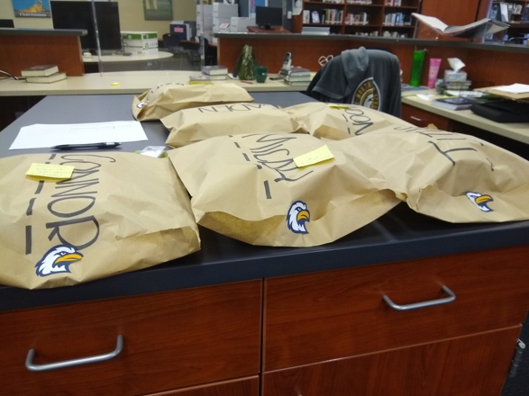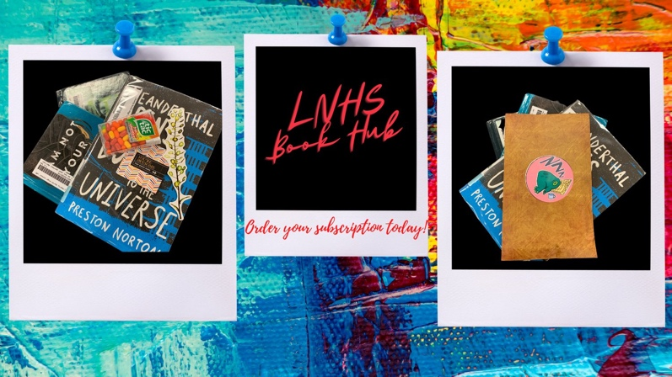

Literacy Example 2: Multicultural Literacy

- Ongoing-Diversity audit performed to analyze collection, weeding and ordering to increase multicultural views and topics in our collection.

- 1/25/2021 Collaboration with ELA to create a Multicultural listening library for the Diversity Festival using publishers currently allowing read aloud recording for limited use during the pandemic. These books are all currently part of the district collection.

- 9/30/2021-currently working with Gay/straight alliance to build collection. We meet every other week in order to gain understanding and build a collection that offers differing perspectives from the LGBTQ+ community through literature.

- 2020-2021 The library media specialists are currently studying the Project Ready curriculum in order to better diversify and understand our collection and how it serves our population. The Project Ready cadres meet monthly as we work through this curriculum: Project Ready

- Author of the month (found on home page of the LNHS Library Website):
On the website we celebrate different authors by highlighting who they are and what they have written to encourage reading a variety of diverse texts and authors, and to offer information about some of the literature we offer to both our students and community through our website (below is a selection from one of our author spotlights). Click here for full slide show and access to all embedded links
Literacy Example 3: Balanced Literacy in reading

- Support for reading aloud, shared reading, and guided reading:

- Collection includes 4,330 eBooks (many titles available with audio)
- Collection includes 454 audio books

- Support for independent reading
- Collection including reading levels from elementary through adult with topics that interest high school students (i.e. Orca, Jake Maddox JV, Hahn, Mark twain award winners through Gateway nominees, Printz Award nominees and award winners)
- We offer a variety of fiction, nonfiction, visual, and audio options at differentiated levels of both reading and informational difficulty.
- Hyper doc. available to teachers, students, parents, and staff with links to Helpful Document and videos for getting reading materials. Helpful Docs & Videos for Getting Reading Material

Literacy Example 4: Balanced Literacy in writing

- Balanced Literacy in Writing: We offer lessons and resources for the writing piece of balanced literacy:
  - Students are introduced to and instructed in all lessons on how to use technology for writing and reading assistance. Students use Grammarly for writing support, MyBIb to format and evaluate research for citations, and NoodleTools for research organizing, notetaking, annotating, and citations. We assist students in using the new technology and resources as they become available, as well as supporting students through large group and individual instruction on using emerging technology to support their research and learning.

- Balanced literacy in collaborative lessons:
- Modeled writing, shared writing, guided writing
- The unit described below, taught in collaboration with French, is one example of the slow release and differentiation allowing students at all levels of research knowledge to practice notetaking at three different levels. This will be more detailed in the assessment piece of this application. The first part of this project was research lead by instruction, the second partially lead with support and the third piece was independent research. Students were able to move at their own pace after modeling to complete the research and writing as well as the project to create a VR tour using Google Tours to view as a class.
  - Research Organizer for history scene
  - Modeled notetaking for history scene

      - Independent scaffolding for notetaking. This part of the lesson is slow release and guided writing.
- Students independently take notes over tour covering restaurants, food, and culture of their chosen French region Students then take their notes and create a tour on Google Tour Creator. The tour is also created using the techniques of balanced literacy in writing. The VR is created and research is written, synthesized, and added to the tour through modeling, writing with instruction, and writing independently.

Literacy Example 5: Technology
- Iteration tools used for creation connected to class content
  - Technology Page on Library Website
  - Digital Media Manager Page
  - List of technology tools available for use through the LNHS LMC
- Tool used based on need
  - Technology tools and information
  - Understanding of commonalities among technology tools
    - In our classes, we emphasize design and iteration over learning how to use a tool. The tools that students use are given as options to solve a problem. For example, if a student wants to invent something, we would look at the invention idea and assess which tool works best-it may be that 3d printing works best, or it might be necessary to combine the use of the 3d printer, the laser printer, and circuitry and programming to create the intended outcome.
    - Our goal is to help students see the commonalities among tools and computer programs so that they are able to use their technology skills across many platforms and future software and technology that may not even yet exist.
- Digital Media Manager class to offer support and iteration training to students and staff
  - Digital Media Management Website
Literacy Example 6: Digital

  - Teaching digital literacy based in the research of Mike Caufield and endorsed by the AASCU.
  - Four Habits and a Move
  - Using S.I.F.T. in the classroom (scroll down, created as a poster)
  - Lesson used to teach digital literacy
  - We have moved to interactive notebooks for resources and lessons. This notebook offers students both resources and how to vet resources that are found online using Four Moves and a Habit. Each of these sections offer links to more information. Along with this notebook we teach classes as they move through the research process:
  - Google Slide Show notebook with embedded links: Digital Literacy

Return to Table of Contents

Indicator #4
Program shows evidence of student growth through assessment

(AASL—collaborate, inquire)
Exemplary (2 points): Regularly assesses the impact of instruction through documented, varied, high-quality formative and summative assessments.

Approaching (1 point): Assesses the impact of instruction through documented formative and summative assessments

Required Documentation/Evidence

Five assessment samples (including formative and/or summative assessments); at least two samples must be connected to the same unit of study and represent varied formats. Samples may be provided in various formats: photos, documents, etc.

Supporting Evidence
Applicable links:
Assessment 1
formative assessment
Assessment 2
Summative assessment of module
Summative Customer Review
Assessment 3
Click here for exit ticket
Assessment 4
Student example of final notes
Student Notetaking part I(permission from student granted for use)
Student Notetaking part II (permission from student granted for use)
Grading rubric used for evaluation
Student Final example of Tour
Assessment 5
Student assessment
Assessment 6
Lesson Wakelet
Genre Survey
Exit Ticket
Assessment Example 1: Identify as formative or summative and include the unit of study

Unit of Study: Digital Media Management Module One
(see lessons for an understanding of how Digital Media Management is set up for independent growth)
Formative Assessment
  - used to assess student time management, problem solving, and iterations
  - click on assessment link below
    - formative assessment (student’s last name removed, permission granted)

Assessment Example 2: Identify as formative or summative and include the unit of study

Unit of Study: Digital Media Management Module One (see lessons for an understanding of how Digital Media Management is set up for independent growth).
Summative Assessment: Informational Module and Customer Review
  - Final assessment of a module is based on feedback that the student has been given throughout their work on the module, and their ability to take that feedback to improve on their final product. Below is a final module example which was assessed for:
  - Clarity and conciseness of writing using technical language
  - Editing for grammar and spelling
  - Final Module Format for publication
  - Students are given the chance to take feedback on the final product and improve on it as part of the learning process.
  - A discussion with the student at the end of each module in order to create a clear understanding of what worked and what did not before the student moves on to their next module. Click on assessment links below:
    - Summative assessment of module
    - Summative Customer Review
  - Link to example of student module
    - Student 3D module

Assessment Example 3: Identify as formative or summative and include the unit of study

Unit of Study: French regions
Formative assessment: notetaking and understanding
- During the notetaking phase of the French research project, several formative assessments were used including:
  - Exit ticket-students filled out an exit ticket with questions and comments at the end of each research phase.
    - Click here for exit ticket
  - Individual conferencing-in collaboration with the French teacher, we conferenced with each student to assess their understanding of the project and how to synthesize their information
  - Assignment checks-students turned in their notetaking at each phase of the project so that we could make sure that they were understanding and we could help them if they were struggling or confused. This was very important formative assessment in terms of a quality final product. Students received feedback and added to their research section before moving on to the next.
  - A dipstick test of thumbs up thumbs down was taken throughout classes as we moved through the phases of research. This allowed us to work with groups of students who were struggling or were ready to move forward more quickly.
  - Scaffolding was created for individual students needs based on these formative assessments throughout the research project.

Assessment Example 4: Identify as formative or summative and include the unit of study

Unit of Study: French regions
Summative Assessment
- Final Notetaking
  - Student example of final notes
    - graded for research, citation, accuracy, completeness (evaluated with formative assessments throughout and summative prior to creating Tour)
  - Student Notetaking part I(permission from student granted for use)
  - Student Notetaking part II (permission from student granted for use)
- Summative assessment of VR presentation created with Google Tours
  - Grading rubric used for evaluation
  - Student Final example of Tour (explained in depth in examples of collaborative teaching)
Assessment Example 5: Identify as formative or summative and include the unit of study

Unit of Study: Biomedical Innovation, design a medical advancement based on your literature review topic.
Formative assessment
- 3d printing in Biomedical innovations:
  - Student assessment to lead to improvements through the design and iteration process

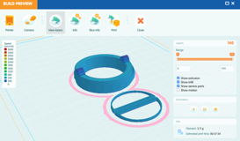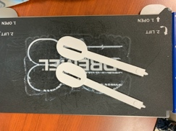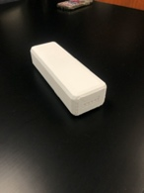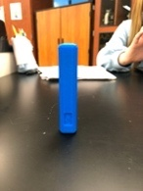

Assessment Example 6: Identify as formative or summative and include the unit of study

- Speech and Theatre Virtual Lesson on locating and selecting texts for performance.
- Formative assessment:
  - Students learn how to find and evaluate materials appropriate for performance.
  - This is a lesson that was delivered virtually and offers students to work independently through the steps of finding material using videos and links for support.
      - Lesson Wakelet
  - Formative assessment-
    - an opening survey in order to allow us to assess the students’ needs very quickly at the beginning of the lesson and tailor the rest of the lesson based on those needs.
      - Genre Survey
    - An exit ticket allowing the teacher librarian to assess the students understanding and gather any remaining questions that students might have individually.
      - Exit Ticket

Return to Table of Contents

Indicator # 5
Program supports student mastery of the essential academic learning requirements and state standards in multiple subject areas

(AASL—collaborate, curate, explore, inquire)
Exemplary (2 points): Establishes collaborative partnerships within and outside of the school community to support multiple subject areas in the mastery of student achievement and the enhancement of life-long learning

Approaching (1 point): Establishes support to multiple subject areas in the mastery of student achievement through the provision of high-quality, relevant resources

Required Documentation/Evidence

Anecdotal evidence expressing the nature of study, collaborative partner, curriculum addressed, and the collaborative nature with which the librarian was involved. An example could be collaborating with the science teacher to provide microscopes and slides of various materials within the library as an exploratory center in an effort to enhance the study of cells. An inclusion of the curricular objective of cell study would be included. Five examples should be submitted, each from a different subject area along with coding of relevant standard(s) from the Missouri Learning Standards.

(Other examples: collecting books for a unit of study; hosting a presenter on a topic; developing lesson plans supporting research goals; planning collaboratively with a public library)

Supporting Evidence-library and subject standards
Links Found in narrative below:
design and CAD support
lesson planning and implementation
curated text, databases, and resources for literary criticism research
Organizer of free financial assistance and information
GSI program

Support Example 1:

Identify subject area: PLTW Science
Course: Principles of Biomedical Engineering

Missouri Learning standards coding:
Science connections (engineering)
9-12.ETS1.A.1 Analyze a major global challenge to specify qualitative and quantitative criteria and constraints for solutions that account for societal needs and wants.
9-12.ETS1.A.2 Design a solution to a complex real-world problem by breaking it down into smaller, more manageable problems that can be solved through engineering.
9-12.ETS1.B.1 Evaluate a solution to a complex real-world problem based on prioritized criteria and trade-offs that account for a range of constraints, including cost, safety, reliability, and aesthetics as well as possible social, cultural, and environmental impacts.

AASL National School Library Standards
I.B.1 Using evidence to investigate questions.
I.B.2 Devising and implementing a plan to fill knowledge gaps.
I.B.3 Generating products that illustrate learning.
I.C.1 Interacting with content presented by others.
I.C.2 Providing constructive feedback.
I.C.3 Acting on feedback to improve.
I.C.4 Sharing products with an authentic audience.
VI.C.1 Sharing information resources in accordance with modification, reuse, and remix policies.
VI.C.2 Disseminating new knowledge through means appropriate for the intended audience

Anecdotal evidence expressing the nature of study:
Students in Principles of Biomedical Engineering work in groups to gather research on a medical topic and design a device to improve on what is currently available. We collaborate with the Biomedical teacher and students to support 3d design and printing through tutorials, small group instruction, and one-on-one support. Our Digital Media Manager students also work collaboratively with the students in this program to support the design and production process.

Collaborative partner:
Barbara Williams
barbara.williams@lps53.org

Curriculum addressed
Competencies (C), Domains (D), Objectives (O), Knowledge and Skills (KS)
O1.1 Design an experiment that investigates a research question.
O2.1 Solve a problem using analytical and critical thinking skills.
KS2.1.1 Devise and execute a plan to solve a problem.
KS2.1.3 Outline how iterative processes inform biomedical science decisions, improve solutions, and
inspire new ideas.
O10.3 Use project management to successfully and efficiently complete tasks as scheduled.

Collaborative nature with which the librarian was involved
-research process
-design and CAD support
-iteration and redesign collaboration with students
-Digital Media Management class coordination for printing and redesign
-Lesson on Copyright and sharing of original product using Creative Commons licensing on Tinkercad and other Cad programs.

Support Example 2: Identify subject area, Missouri Learning Standard(s) coding, and other required documentation.

Subject: Foreign Language-French
Course: French II

Missouri Learning Standard(s) coding:
Foreign Language
4.2b Cultural Comparisons
Compare and contrast tangible and intangible products of the cultures
5.2b Communities
Explore hobbies, activities, and topics of personal interest related to target culture
5.2c Communities
Access information from a variety of authentic sources with high visual support (internet, music, videos, etc.)

AASL National School Library Standards
IV.A.1 Determining the need to gather information
IV.A.2 Identifying possible sources of information
IV.A.3 Making critical choices about information sources to use
IV.B.1 Seeking a variety of sources
IV.B.4 Organizing information by priority, topic, or another systematic scheme
VI.A.1 Responsibly applying information, technology, and media to learning
VI.A.3 Evaluation information for accuracy, validity, social and cultural context, and appropriateness for need
VI.B.2 Acknowledging authorship and demonstrating respect for the intellectual property of others

Anecdotal evidence Expressing the nature of the study:
French II classes studied the history, culture, landmarks, food and people in a French region of their choice. Students studied how the location of each region impacted the history, culture, and food of that region by using real world research on local French sites, translating the food and dishes and studying the pictures and local websites from each region. Students chose a historical landmark that they found interesting, a restaurant that reflected the food of the region, and studied the history of the overall region. Students created a VR tour of their region to teach others about their chosen area’s history, culture, and food and how it was specific to that region.

Collaborative Partner:
Laura Snead
Email: laura.snead@lps53.org

Curriculum addressed
-Students use various sites, both in French and English, to learn about French regions.
-Student are able to translate and understand the monetary exchange rate using real world examples from French websites.
-Students compare and contrast French culture with U.S. culture.
-Students create a product exploring the French regions and the regional implications on the history and culture of the area.

Collaborative nature with which the librarian was involved:
-co-teaching (3-week study)
-resource gathering
-lesson planning and implementation
-lessons on ethical use of information and citing sources
-technology implementation
-VR training
-Assessment

Support Example 3: Identify subject area, Missouri Learning Standard(s) coding, and other required documentation.

Subject: ELA
Course: College Composition 12

Missouri Learning standards coding:
Reading Literary Text
1.A Draw conclusions, infer, and analyze by citing relevant and thorough textual evidence to support analysis of what the text says explicitly as well as inferences drawn from the text, including where the text leaves matters uncertain.
1.D Using appropriate text, determine two or more themes in a text, analyze their development throughout the text, and relate the themes to human nature and the world; provide an objective and concise summary of the text.
3.D Read and comprehend literature, including stories, dramas, and poems, independently and proficiently.

AASL National School Library Standards
I.A.1 Formulate questions about a personal interest or a curricular topic.
I.B. 1. Using evidence to investigate questions.
IV.A.1 Determining the need to gather information
IV.A.2 Identifying possible sources of information
IV.A.3 Making critical choices about information sources to use.
IV.B.1 Seeking a variety of sources.
VI.A. Responsibly applying information, technology, and media to learning

Anecdotal evidence expressing the nature of study:
Students were to read a short story of their choice and research one of the main themes in the story by looking at published literary criticism, topical research on the chosen theme, and the author and story itself. Students were then to write a literary analysis over the short story and theme.

Collaborative partner:
Ronnie Lathrop
ronnie.lathrop@lps53.org

Curriculum addressed
- read texts closely and critically, analyzing the purpose, audience, form, and conventions in varied types of writing.
- focus an essay effectively by constructing an appropriate thesis statement.
- integrate material from a variety of sources thoughtfully and analytically into my writing, citing it appropriately.

Collaborative nature with which the librarian was involved
-curated text, databases, and resources for literary criticism research
-cotaught lesson reviewing citation, database searches, and advanced searching
-Reviewed resources and subject specific databases available through the public library
-created support resources to be posted on teacher’s class page for students to reference as they researched
-worked with students one-on-one to support research and writing.
Support Example 4: Identify subject area, Missouri Learning Standard(s) coding, and other required documentation.

Subject: Family and Consumer Science
Course: Personal Finance

Missouri Learning standards coding:
Personal Finance
I.1.B Apply a rational decision-making process to satisfy wants.
I.2.A. Explain how today’s choices have future consequences
III.1.B Analyze spending habits to recognize current spending and saving trends

AASL National School Library Standards:
IV.A.3 making critical choices about information sources to use.
IV. B.1. Seeking a variety of sources.
VI.D.1 Personalizing their use of information and information technologies.

Anecdotal evidence expressing the nature of study:
In personal finance, students are studying budgeting and taxes. Students were looking at real-world help and resources that can be used once they are out of school to assist with their financial needs and answer financial questions. The teacher also had us curate podcasts for students over budgeting, investing, entrepreneurship, and smart money decisions for the asynchronous learning piece of the class.

Collaborative partner:
Traci Silvey
traci.silvey@lps53.org

Curriculum addressed
-Planning for the future
-Income and careers
-Saving and investing

Collaborative nature with which the librarian was involved
-Curated podcasts and resources covering personal finance
-created organizer of free assistance and information for instructor
Organizer of free financial assistance and information
-Presented free resources available through the public library to students for real world application
Support Example 5: Identify subject area, Missouri Learning Standard(s) coding, and other required documentation.

Identify subject area:
Biology
Course:
AP Biology

Missouri Learning standards coding:
Science Standards (Biology)
9-12.LS2.A. Explain how various biotic and abiotic factors affect the carrying capacity and biodiversity of an ecosystem using mathematical and/or computational representations. [Clarification Statement: Examples of biotic factors could include relationships among individuals (e.g., feeding relationships, symbioses, competition) and disease. Examples of abiotic factors could include climate and weather conditions, natural disasters, and availability of resources. Genetic diversity includes within a population and species within an ecosystem.
9-12.LS2.C.2 D Design, evaluate, and/or refine solutions that positively impact the environment and biodiversity.
AASL National School Library Standards
I.D.3 Enacting new understanding through real-world connections
I.B.3 Generating products that illustrate learning
III.D.2 Recognizing learning as a social responsibility

Anecdotal evidence expressing the nature of study:
This study and use of this GIS program is to give students experience in line with the learner dispositions and the LPS graduate profile. The tool is being used to create maps reflecting urban sprawl, urban deserts, agricultural land and watersheds.

Collaborative partner:
Dr. Brittan Wilson
brittan.wilson@lps53.org

Curriculum addressed:
urban sprawl
urban deserts
agricultural land
watersheds

Collaborative nature with which the librarian was involved
-Research using varied resources
-Ethical use of information
-Coordinating with technology to evaluate and obtain a GSI program for mapping purposes on their final project

Optional Narrative:
The above collaborations only show a snapshot of our work with teachers and the community. We had to choose five, however, we also collaborate regularly with the public library to promote programs and resources that are available to students. This year, it has been especially beneficial to students to use both the resources available at Liberty North, as well as the resources that are available through Mid-Continent and the Kansas City Public Library. We have lead informational events for students and parents about the tutoring and resource options available through the public libraries.

Return to Table of Contents

Leadership

Indicator #6: Librarian provides professional development to teachers, staff, and/or other librarians.

(AASL—engage, explore, inquire)
Exemplary (2 points): Consistently facilitates intentional, purposeful professional development opportunities in a variety of formats

Approaching (1 point): Provides professional development opportunities upon request

Required Documentation/Evidence

List of professional development opportunities facilitated including dates and one-sentence descriptions of topic, purpose, and format. May include session evaluations.

Supporting Evidence
Insert Applicable Links Here:
Ongoing PD
Using public library resources
How to Use Cospaces
Library PD for staff
Microaggressions & Visible Learning
Organizing Your Google Drive
Social Studies PD Ancestry.com
ELA from CRAAP to S.I.F.T. (scroll down for image)
Insert Documents/Narratives:

This year we have offered PD through in person Zoom sessions, asynchronous videos and hyper docs, and regularly through the staff newsletter. We have recently been given permission to have face-to-face professional development opportunities and will be able to offer literacy professional development staring in March. Below are some of the PD events that we have hosted for staff at the district and building levels this year:
District level:

- District level asynchronous PD (all first and second semester PD was remote this year due to Covid)
  - Ongoing PD first offered at the beginning of the 2020-2021 school year
  - How to Use Cospaces (District paid subscription)-offered originally on September 4th. Available to all district staff throughout the year.
  - Using public library resources PD covering Mid-Continent resources available to teachers and students.
- Building level PD
  - Library PD for staff PD Sent during teacher preservice (all preservice was remote this year due to
Covid).
  - Microaggressions & Visible Learning Offered February 12th Building Level Professional Development
  - Organizing Your Google Drive
  - Social Studies PD Ancestry.com
  - ELA from CRAAP to S.I.F.T. (scroll down for image) We are moving from the CRAAP model to S.I.F.T. We have offered PD to ELA teachers on this new model in order to keep our practices up-to-date and relevant.
  - Book Bites-browse books and enjoy a breakfast treat! (approved for 2nd semester, socially distanced in person)
    - This PD is offered once a quarter (2020-2021 school year only 2nd semester 3rd and 4th quarters due to Covid restrictions).
      - Wednesday, March3rd
      - This staff PD is to introduce new literature and tools available from the Liberty North Library Media Center.
      - Spring Break Reads for staff
      - New literature to suggest to students
      - Tools available to staff for use and checkout
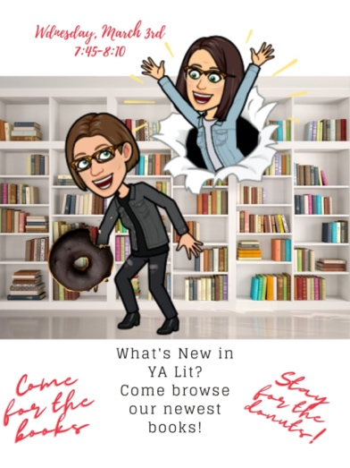
- Wednesday, May 5th (upcoming)
  - This staff PD is to introduce new literature and tools available from the Liberty North Library Media Center.
- New literature to suggest to students
- What to read this summer!
- Tools available to staff for use and checkout
- Mid-Continent visit to talk to staff about summer reading opportunities

Return to Table of Contents

Indicator #7: Librarian attends professional development opportunities for librarians at local, state, and/or national level

(AASL—engage)
Exemplary (2 points): Attends multiple library-specific professional learning events per year, which may include but not be limited to conferences, workshops, webinars, podcasts, graduate courses

Approaching (1 point): Attends a minimum of one library-specific professional learning activity (outside of school-/district-provided professional development) per school year

Required Documentation/Evidence

Brief description of sessions attended (including title, date, sponsoring entity) and impact on library program

Supporting Evidence
Insert Applicable Links Here:

District Level Library Media Retreat PD
Project Ready
GKCASL Fall PD 2020
Connect through a Community Read PD
News Literacy Project: Fall News Literacy Series: Essential concepts for students to be reliably informed

Insert Documents/Narratives:

Title
District Level Library Media Retreat PD
Date
August 13, 2020
Sponsor
Liberty Public Schools (Library Director)
District Level Library Media Retreat PD
Each year we attend a full day library PD retreat with all librarians in the Liberty School District. This PD includes collaboration on the upcoming year, professional connections and discussion on current library topics, collection development planning, reading and discussion. This PD informs our upcoming school year plans and practices.

Title
Project Ready Curriculum
Dates
As a committee we meet monthly to discuss and work on a module of the Project Ready Curriculum. This year’s meetings have taken place on the following dates:
October 1- Module 1-2
November 12-Module 3
December 4- Module 4
January 7-Module 5
February 5-Module 6
Sponsor
Institute of Museum and Library Services (funded by)
Project Ready
The Project Ready Professional Development curriculum has informed and changed the way that we review books, create programming, talk to students and the community, and teach lessons. We have used our learning from this PD to create better programming and displays that are inclusive and celebrate diversity in a culturally respectful way.

Title
GKCSL (local school library organization) Fall Meeting and PD
Date
October 6
GKCASL Fall PD 2020

In this PD we learned about the https://www.rainbowlibrary.org/ and how it can help us diversify our collection at Liberty North. As well as the newest Information related to Covid restrictions and offering access to books 2020-2021

Title
Connect Through a Community Read
Date
September 30, 2020
Sponsor
School Library Journal
Connect through a Community Read PD
This Webinar covered how to set up a community read and how it impacts your program. We would like to incorporate a community read into our programming in the future. This webinar gave us insight into choosing a book that will create discussion for students and community. The webinar also offered ideas on building a culture of reading around a title.

Title
News Literacy Project: Fall News Literacy Series: Essential concepts for students to be reliably informed
Dates
October 20 and 27
Sponsor
News Literacy Project

News Literacy Project: Fall News Literacy Series: Essential concepts for students to be reliably informed

This series covered identifying misinformation, applying fact-checking and digital verification skills, understanding standards of quality journalism and recognizing types and forms of bias. These PD sessions tie directly to our current curriculum and offered new ideas for teaching students how to identify news sources and work through links, pictures, and videos to evaluate the information they are using and decide if that information is reliable and meets their needs.

Date: October 20, 2020
Title: Teaching Digital Verification to Spark News Literacy Learning
Entity: Smart News: Fall News Literacy Series
Impact: In this PD we took looked at the tools and skills needed to verify the authenticity of information and learn to create engaging fact-checking missions for student learning. Topics included exploring deleted or changed web content; developing observation skills to detect false context; and using Google Street view to confirm locations.
We used our learning from this PD to teach lessons on verifying authenticity of information.

Date: October 27, 2020
Title: Understanding bias: A nuanced approach to a vital news literacy topic
Entity: Smart News: Fall News Literacy Series
Impact: The information presented in this PD helped inform our medial literacy lessons and collaborations. The series covered what has changed in digital literacy and how students can learn to check their own biases when reading news and information on the internet. We used this PD to help create lessons on empowering students to evaluate the fainess and impartiality of news coverage.

Upcoming:
Title
MASL Spring Conference April18-20
MASL
Attended each year, will attend virtually for PD this spring.

Return to Table of Contents

Indicator #8: Librarian functions as an educational leader in the school campus and district by serving on committees and/or cohorts

(AASL—collaborate)
Exemplary (2 points): Is consistently included in campus and district leadership planning

Approaching (1 point): Is occasionally included in campus and district leadership planning

Required Documentation/Evidence
Agendas/Minutes
Administrative statement about librarian’s role in planning
Librarian statement of involvement
- Exemplary could be multiple examples from both campus and district
- Approaching could be multiple examples from campus and/or district with a minimum of one example in each area

Supporting Evidence
Insert Documents/Narratives/links:
District level library committees:

Narratives for each committee are written in the linked letters signed by administration:

District Library Technology Committee (Katie Fisher)
Dates and Agendas
Administrative Statement of involvement

District Library Reading engagement (Connie King)
Dates and Agendas
Administrative Statement of involvement

PBIS Leadership District Level (Katie Fisher
PBIS District Level Meeting Agendas
Administrative Statement of involvement

Project Ready 1 Committee (Connie King)
Dates and Agendas
Administrative Statement of involvement

Project Ready 2 Committee (Katie Fisher)
Dates and Agendas
Administrative Statement of involvement

Building level committees:
Department Chair Committee for Building Planning (Connie King)
Department Chair Dates and Agendas
Signed administrative letter

PBIS Leadership Committee building level (Katie Fisher
Dates and Agendas-listed in letter signed by administration
Signed Administrative Letter

Diversity, Equity, and Inclusion Leadership Committee (Connie King)
DEI Dates and Agendas
Signed administrative letter

Return to Table of Contents
Indicator #9: Program regularly communicates and/or collaborates with building- and/or district-level administration concerning library resources, planning, etc.

(AASL—engage, include)
Exemplary (2 points): Communicates quarterly with administration about the state of the library program

Approaching (1 point): Informs building administration about the state of the library program at a minimum of once annually

Required Documentation/Evidence

Copies or summary of information shared with administration that could include meeting notes, presentation, report, etc.

Supporting Evidence
Insert Applicable Links Here:
Liberty North Library CSIP Connections
Safety Protocols Discussed
District level library meetings
District level Monthly SMORE
October: District Level Meeting Agendas
January: District Level Meeting Agendas

Insert Documents/Narratives:

Building Level Communication:

1st Quarter August 27^{th,} 9:30-10:00
Met with building administrators regarding the LNHS Library CSIP connections and plans for the upcoming year
Liberty North Library CSIP Connections
At this meeting we also discussed our plan for checkout and Covid safe practices for the year:
Safety Protocols Discussed

2nd Quarter October 5th 1:45-2:15
Met with building administration to communicate progress with weeding and collection diversity.
Shared the following information:
The collection has been weeded to bring the average fiction copyright date up to 2012, books audited for language, diverse perspectives, collection balance. Shared reports and current purchasing strategies to continue to keep the collection growing and improving.

The nonfiction collection has been weeded in order to portray a balanced and accurate view of history from multiple perspectives, nonfiction titles that were white washed, inaccurate, or dated have been reviewed and removed.

2nd Quarter December 2nd 9:00-9:30
Met with admin to present plan for tutoring center and parent university opportunities. Administration offered compensation to teachers for tutoring, library staff organized, coordinated, and scheduled tutoring sessions both face-to-face and virtual on Wednesdays.

3rd Quarter January 6, 9:30-10
Met with administration to discuss staffing, changes in the library space, and upcoming programming possibilities.

4th Quarter planned meeting June 2nd 9:00 am
Discuss end of the year reports, yearly progress, goals for the upcoming school year, space and staffing

District Level Communication:
The library team meets with our district library coordinator and district library team monthly to discuss library programs, collection development, and collaboration opportunities.
Link with monthly agenda and district level library information:
District level library meetings
District level Monthly SMORE
October: District Level Meeting Agendas
January: District Level Meeting Agendas

Return to Table of Contents

Indicator #10: Program regularly communicates and establishes relationships with stakeholders in the community and beyond

(AASL—collaborate, engage)
Exemplary (2 points):
- Identifies stakeholders
- Communicates the mission, vision, and goals of the school library
- Communicates to all stakeholders regarding participation in library-specific activities
- Models and promotes the use of a professional learning network (PLN)

Approaching (1 point):
- Identifies stakeholders
- Communicates the mission, vision, and goals of the school library
- Models and promotes the use of a professional learning network (PLN)

Required Documentation/Evidence

- Newsletters, flyers, emails
- Descriptions of stakeholders

Supporting Evidence
Insert Applicable Links Here:
Mission and Vision on Website
Parent survey
Library Monthly Newsletter to Community
District Library Website
School Board library review and regular board updates

Insert Documents/Narratives:
Insert Applicable Links Here:

- Identifies stakeholders
  - The Liberty North Library stakeholders include:
    - student body
      - LNHS student body includes students 9th-12
      - We serve both Face-to-Face students and Virtual students within the LNHS boundries
      - Students range from low academic/high need to high academic/college bound
      - We serve 2,100 students all on the LNHS campus
    - staff
      - LNHS staff is comprised of 162 teachers, paraprofessionals, administrators, and custodians. We serve all staff through collaborating, coteaching, and offering support and services.
    - Parents and the community
      - LNHS parents and community are from both Liberty and parts of Kansas City. We serve parents of both face-to-face students and virtual students.
- Communicates the mission, vision, and goals of the school library
  - Each year we use social media, PTA meetings, community events, collaboration, and community outreach to keep our stakeholders informed and involved in our Liberty North Library community. This year has been different due to Covid restrictions; however, we have continued to use social media and virtual collaboration to reach our community.
  - Mission and Vision on Website
  - District Library Website
  - School Board library review and regular board updates
- Communicates to all stakeholders regarding participation in library-specific activities
  - Mission and Vision on Website
  - Parent Survey
  - Library Monthly Newsletter to Community
  - District Library Website
  - School Board library review and regular board updates
- Models and promotes the use of a professional learning network (PLN)
  - Twitter Handle: @LnTheShush twitter also located on library home page click link below and scroll down)
    - Twitter account also found on library home page (scroll down)
    - Follows the following professional organizations and authors as PLN
      - American Library Association
      - Goodreads
      - YA authors
      - Liberty North organizations and groups
  - Facebook Page: LNTheShush
    - Follows the following professional organizations and authors as PLN
      - American Library Association
      - Goodreads
      - YA authors
      - Liberty North organizations and groups
  - Insta Handle: lntheshush
    - Follows the following professional organizations and authors as PLN
      - American Library Association
      - Goodreads
      - YA authors
      - Liberty North organizations and groups

Return to Table of Contents

Indicator #11: Program participates in implementation of the district’s school improvement plan

(AASL—collaborate)
Exemplary (2 points): Provides evidence of supporting the implementation of multiple CSIP objectives

Approaching (1 point): Provides evidence of supporting the implementation of one CSIP objective

Required Documentation/Evidence

Provide a link to district CSIP; identify and explain the support provided to specific CSIP objectives

Supporting Evidence
Insert Applicable Links Here:
District CSIP
Liberty Public School District Library links to CSIP
The Liberty North Library Program CSIP

Insert Documents/Narratives:
Liberty North High School librarians have used the district CSIP (or strategic plan linked above) to guide our program decisions. As a district library team, we worked to align the district library programs to the school improvement plan (District Library CSIP linked above). From the work on the district library plan, we tailored the plan specifically to the Liberty North Library Program. The above links take you to the district CSIP and the district library CSIP. The Liberty North Library Program CSIP which aligns with the district CSIP and district library CSIP: The Liberty North Library Program CSIP

Return to Table of Contents

Library Environment

Indicator #12: Program provides adequate physical space for the library, including flexible space for usage by multiple groups and/or fixed or flexible space for whole-class instruction

(AASL—include)
Exemplary (2 points): Provides furnishing that are mobile, flexible, and functional enough for a variety of instructional and non-instructional uses for a minimum of two (2) classes (based on the average class size in the building)

Approaching (1 point): Provides seating for a minimum of two (2) classes (based on the average class size in the building)
Required Documentation/Evidence

Photos accompanied by brief explanation of how spaces are used

Supporting Evidence
Insert Documents/Narratives:
Even with Covid restrictions, we have continued to offer flexible spaces that can accommodate up to six classes at a time. Class sizes this year are smaller and the small individual desks are mobile and can be reconfigured to allow students to work safely in groups by turning desks while still distanced (all 6’ spaces are marked with tape to make it easy for students to reconfigure the spaces while still offering the option of working in small groups. We also have the attached fabrication lab that is part of our library. This space is set up to offer flexible work spaces for classes and small groups. Along with those spaces we have a writer’s den and an audio studio offering students a quiet space to collaborate on writing and study.

Classroom Space, Café, and Soft Seating (accommodates 4 classes for instruction and 1 class for checkout, the other class space is the fabrication):
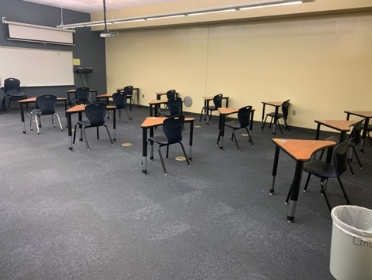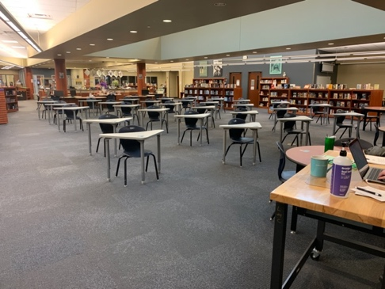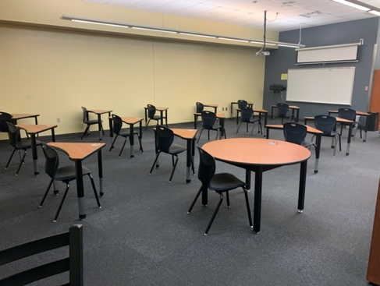

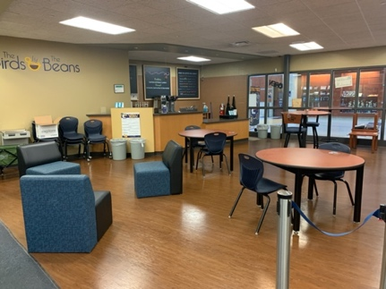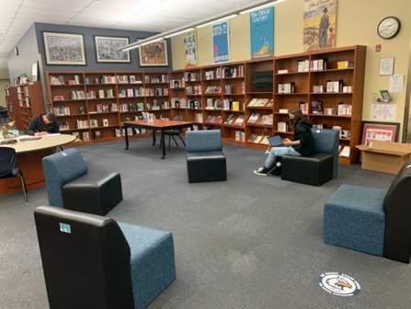

Classroom spaces:
There are five spaces in the library that are used for full class instruction. The two smaller spaces sit 17 students each this year. This is a full class size due to the hybrid schedule. In a regular year these spaces sit 25 students each. The center space accommodates 38 students this year (up to 60 students during a regular year). We also use the café and soft seating area as a teaching space. This year those spaces accommodate 18 students (full class). In a normal year, this space fits 28 students. In total, we can accommodate up to five instructional classes at a time in the library (one being in the fabrication lab), as well as a sixth class for checkout. These spaces all offer flexible space, even with the individual desks this year. We were able to acquire small triangular desks that are easy to turn and still be within the required 6’ spacing for collaboration. The floor has been marked with tape, making it easy for students to move the furniture in the space and stay distanced while working in groups.

Fabrication lab:
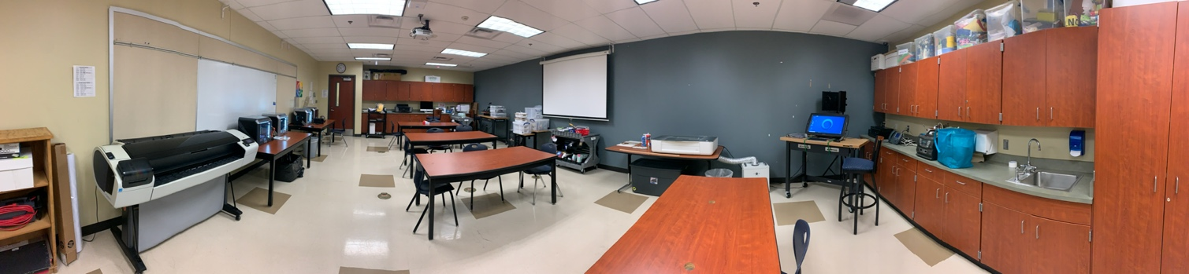

Fabrication Lab: This space is available to students, classes, and staff for design, creation, iteration, and production. Student Digital Media Managers offer training on the machines and online software to classes in collaboration with the library staff, school staff, and the Liberty North Community. In the fabrication lab, we offer 3d printing, laser printing, sublimation, AR, Large format printing, Vinyl printing, Cricut Explore, Cricut Maker, materials for projects, circuitry, soldering, programable circuit boards, robotics, and software for design (Adobe suite, SawGrass Creative Studio, Premium Glowforge software, Premium Cricut software).This space is set up as a flexible work space, with tools and materials on moveable carts that can be used in the fabrication lab, or moved out of the lab to be used in other spaces.
Audio Lab:
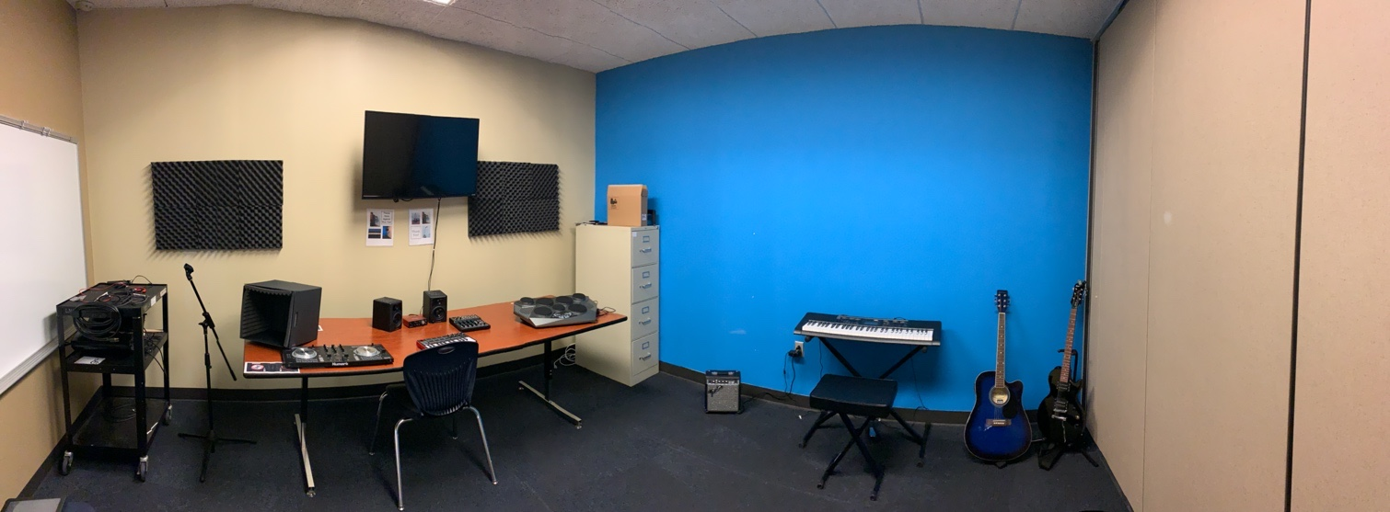

Audio Lab: This space is available to students for creating, recording, and collaborating. This year we are limited to having two students work together in this space. In the past and in the future, it is a space where groups of students can work together on both personal and school-based projects.

We are currently working on expanding the music and recording equipment in the music lab through grants and our library budget, because it has been a space that is inclusive and comforting for students who may struggle in other areas. Last year, students wrote a grant and received money to add an electric guitar, drum set and amplifier to the space. These new additions were available for students at the beginning of the 2020-2021 school year.

Writer’s Den:
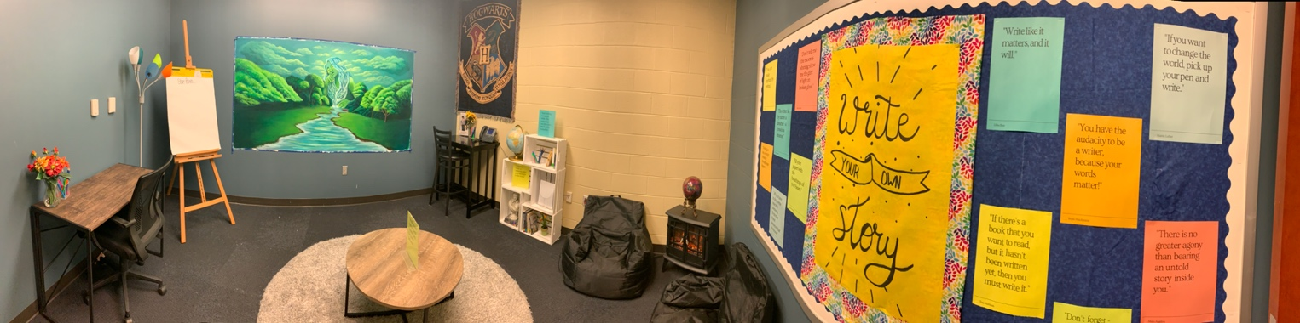

Writer’s Den: This space was designed by Liberty North Students who wrote a grant to furnish the Writer’s Den. The art on the wall is currently in progress. It was designed and painted by a Liberty North student as a passion project for her AP Studio Art class. This space is available for students to checkout for use and includes materials for book binding, space to leave work for other students to read and edit, and books completed by students for other students and staff to read. This is one of our students’ favorite spaces!

Return to Table of Contents

Indicator #13: Program offers a variety of programs and/or opportunities for all members of the library community in a safe and inclusive manner

(AASL—include)
Exemplary (2 points): Offers a minimum of four distinct and cross-curricular programs throughout the year that may
- include family and/or community participation
- take place either during or beyond the school day

Approaching (1 point): Offers a minimum of two distinct and cross-curricular programs that may
- include family and/or community participation
- take place either during or beyond the school day

Required Documentation/Evidence

Calendar of events with enough detail to show the purpose and audience for each event; may include photos and/or evaluation from some events.

Supporting Evidence
Insert Applicable Links Here:
Link to library Calendar of Events (scroll down to calendar, use arrows on calendar image to see months)
Link to the Diversity Festival website
Voting Drive Registration form
Subscription service
Face-to-face appointments for tutoring
Virtual appointments for tutoring
Link to the customer intake form

Insert Documents/Narratives:
This year we have had the opportunity to create resources and lessons for students who are both in the building and virtual. The virtual students, and students who are quarantined, have had the limitation of not being able to be physically in the library space. In order to meet these different needs, we teach virtual lessons, and we organize both face-to-face and virtual one-on-one tutoring with teachers. The library stays open to support students who need support and a space to work due to hardships at home or technical needs. The LNHS LMC provides spaces, resources, and tools to support students’ diverse needs in all content areas as well as to develop their personal interests. The events that are on specific dates are on the library calendar located on the library home page:

Scroll down on library home page, use arrows on right and left of calendar to change months:
Link to library Calendar of Events
Our Digital Media Manager Beyond program is ongoing, as is our book subscription service.

    - Cross-curricular outreach with literacy November 5th-December 14th
      - Little Readers Book Drive: The library book club gathered children’s books for the kindergarten classes at one of our feeder elementary schools. Treats and notes were added to the book bags and each child received three new books and treats to open. This project was to promote literacy and offer these young students new books that were theirs to keep. This project was inspired by research showing that when children own books they are more likely to read and improve literacy skills.
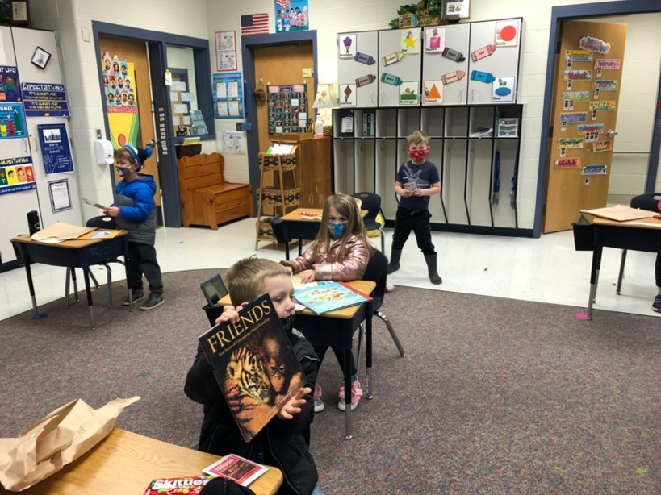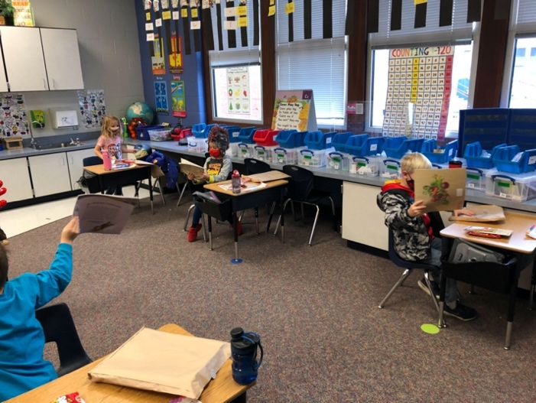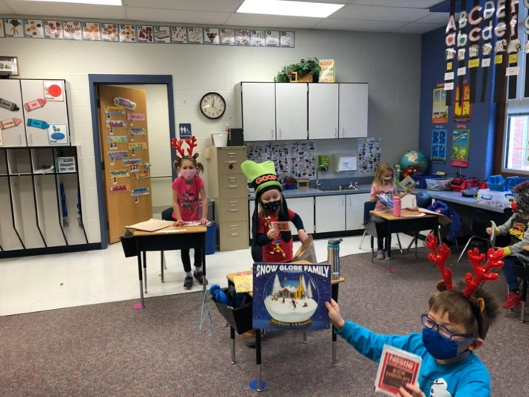

    - Cross-curricular outreach through diversity and inclusion January 25-29
      - Diversity Festival: We collaborated with the Educational Internship Program instructor to assist students in curating and creating a digital library of diverse children’s books that could be used as recorded videos for the district/community. The district hosts a diversity festival each year. In the past we have used this opportunity to showcase our collection and emphasize the importance of diversity in literature. This year, Covid restrictions made this a more difficult task. The high schools collection were highlighted through a curated document of diverse titles. However, in order to overcome the obstacles of Covid restrictions and enhance our involvement, we collaborated with the EIP teacher to help students find books to read that offer diversity, equity, and inclusion. Copyright permissions were considered and the document is only open to the LPS community. Publishers also loosened restrictions during this time, allowing students to share the recorded work legally.
        - Link to the Diversity Festival website (library must use sign in, picture below)
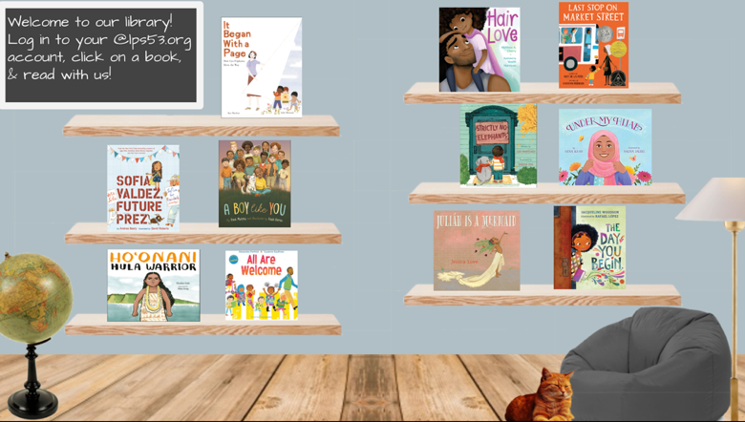

  - Cross-curricular outreach through Voting Drive 2020 September 8-November 3, 2020
    - collaborated on creating form: Registration form
    - collaborated on sending out form, gathering data, and distributing materials to all students eligible to vote in the 2020 election.
    - collaborated on informing students and supporting students in registering and getting to a voting site for the election.

  - Cross-curricular outreach through Book Subscription (LNHS Book Hub)boxes Ongoing
    - Collaborated with ELA to create a program that encourages student literacy
    - Collaboration included introducing ELA teachers promoting Book Hub, LNHS Book Hub introduced in ELA classes during library orientation, and working with reluctant readers to find books they love.
    - Click here for the READ page of our library website. This is where students can sign up for a personalized book subscription box with books and treats based on their own reading inventory: READ Website Page: Subscription service

- Outreach to community-Parent University Sessions November 16, 19, and 21st
    - In the library we have always taken calls to support parents with technology, connecting to their students’ accounts, and understanding the programs available to parents. This year, parents have been especially stressed. In order to support our parent community, we offered sessions on technology tools and resources to help parents support their children. We offered several sessions, both virtual and face-to-face scheduled in the evening and on the weekend to meet the needs of all parents who might be seeking support. Below is the digital flier distributed through the Liberty North Parent News Letter for these sessions: Parent University

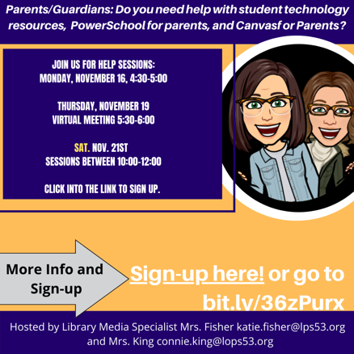

  - Cross-curricular outreach through tutoring center-offered on all virtual Wednesdays
    - In order to help close the digital divide for students who do not have reliable WiFi at home, need extra tutoring or do not have access to other resources that they need to be successful. We have developed a tutoring center open to all student both face-to-face and virtually on Wednesdays. Liberty Public School District’s secondary schools are all virtual on Wednesdays, and the tutoring center offers students the option to learn in person, use school WiFi and other resources, and get individualized help every week.
      - The study center is offered in the library for students and parents on virtual Wednesdays with quiet work space and tutoring in person or virtual tutoring by subject or for general assistance.
      - Links to study center sign up:
        - Face-to-face appointments for tutoring
        - Virtual appointments for tutoring

  - Cross Curricular-Real World Design and Application
      - Digital Media Management Beyond: this business takes orders from the community to produce products from the library fabrication lab. This year our students have worked with administration to design and produce gifts for teachers and t-shirts for Counselor Appreciation Week, they have worked with teachers to design and produce labeled containers for the FACS department, digital media management students worked with GSA Student Club to produce “safe place” vinyl stickers as an outreach to staff (to be placed in spaces letting students know that teachers and staff are allies), and Digital Media Managers Beyond designed and produced t-shirts for a local preschool. Through this program, we also collaborated with the school store to make prototypes for future products.

        - The students in Digital Media Management have taken on jobs from staff, students, administration and community
          - Montessori in the Morning
          - LNHS Administration
          - LNHS Counseling Department
          - LNHS Family and Consumer Science Department
          - Link to the customer intake form used by digital media managers when working with students, teachers, and community members.

Return to Table of Contents

Indicator #14: Program provides a variety of current technologies in the library, including means of remotely accessing library resources at any time

(AASL—curate, explore, include)
Exemplary (2 points): Provides a website with a curated selection of technology resources and openly licensed digital resources, learning management system, and/or social networking to offer 24/7 access to library

Approaching (1 point): Provides links to district-supported resources with 24/7 access

Required Documentation/Evidence
Link to website
Copies of communication sharing technology resource links with library stakeholders

Supporting Evidence
Insert Applicable Links Here:
https://www.lps53.org/domain/1281
Technology Tools LNHS Library
Administration/Staff/support staff PD and newsletter
Community news letter
Parent newsletter about library resources
Beginning of the year orientation 2020-2021
Fabrication lab, audio lab, recording, and presenting
Remote access to databases and other resources
eBooks and Audio Books
Beginning of the year orientation 2020-2021
Insert Documents/Narratives:

Link to library database and resource page of Liberty North Library Website:
Home page: https://www.lps53.org/domain/1281
This page of the website connects students to the many facets of the library.
Click on:
READ
RESEARCH
3d Print arrow (CREATE)
Tutor Center
Author spotlight
All Humans Welcome
Vision and Mission
Technology help
The Liberty North Library website is open 24 hours 7days a week. Students are able to access the digital tools through the site. The library also offers creation tools for student and staff checkout. A list of technology tools that can be checkout or used in the library space can be found here: Technology Tools LNHS Library. Each year we budget in new technology upgrades and equipment in order to continue to offer the newest technology offerings to our students.

- Copies of communication sharing technology resource links with library stakeholders:
  - Administration/Staff/support staff PD and newsletter
  - Community news letter
  - Parent newsletter about library resources
  - All 9th – 12th grade students introduced to new resources each year
Beginning of the year orientation 2020-2021
  - Library site linked on all teacher Canvas Pages for student access

Return to Table of Contents

Library Management

Indicator #15: Program implements flexible scheduling to meet the authentic instructional needs of students

(AASL—collaborate, explore, include)
Exemplary (2 points): The library facility uses a flexible schedule during the length of the school day with all scheduling at the discretion of the professional librarian.

Approaching (1 point): The schedule of the library facility during the length of the school day does not exceed 25 percent fixed scheduling (such as being part of a school’s specials rotation); the remaining 75+ percent of the day’s schedule is flexible and implemented at the discretion of the professional librarian.

Required Documentation/Evidence

Schedule reflective of four consecutive weeks

Supporting Evidence
Insert Applicable Links Here:
Schedule reflective of four consecutive weeks
Insert Documents/Narratives:
The library program at Liberty North uses a flexible schedule during the length of the school day with all scheduling at the discretion of the professional librarians. Each week is different based on the student and teacher needs in the building. This allows the library staff to assist with research, information, technology, and resource needs in a timely manner. If the Library Media Specialists have lessons scheduled every hour of a day, we ensure that each specialist has at least a 50-minute plan time within each day by teaching collaboratively and individually as necessary. This Schedule reflective of four consecutive weeks shows four consecutive weeks from January-February.
During the first three weeks we had a collaborative project with French. The boxes coded yellow are spaces/collaborations where we are teaching. There are some days where parts of our library are used for the EIP program. However, our space can accommodate six classes at a time. There are days where, as co-librarians, we teach together, and days where our teaching collaborations overlap. As there are two full-time librarians, we are able to have the Digital Media Managers scheduled, but also offer a completely flexible schedule that changes at the library media specialists’ discretion.

Return to Table of Contents

Indicator #16: Librarian regularly evaluates the library program

(AASL—This indicator includes addressing all AASL Integrated Frameworks while evaluating the school library program.)
Exemplary (2 points): Regularly designs throughout the school year evaluative tools and acquires evaluative information regarding the school library program from all stakeholders: school librarian, principal, certified teachers and/or support staff, parents, students

Approaching (1 point): Annually designs evaluative tools and acquires evaluative information regarding the school library program from four of the following five stakeholders: school librarian, principal, certified teachers and/or support staff, parents, students.

Required Documentation/Evidence

Evaluative tools(s) utilized with each stakeholder regarding perception of the library program. These may be in the form of surveys, audio discussions, digital photos of physical documents as well as other data collection methods. These evaluations may include the complete library program, book clubs, special celebrations such as Read Across America Week or Banned Book Week, resource collections, resource development, etc.

Supporting Evidence
Insert Applicable Links Here:

Annual Staff Survey
Annual Student Survey
Parent survey
Student Subscription Service Survey
DMM Customer survey
Book Request Form
Orientation Survey
Book Club Evaluation
District level library meetings
District level Monthly SMORE
October: District Level Meeting Agendas
January: District Level Meeting Agendas
Diversity evaluation and audit plan

Insert Documents/Narratives:

LNHS Library Media Specialists regularly design and implement evaluation tools to improve our services. Along with using the data from our annual surveys, we have done an in-depth evaluation through the process of this application. We have been able to plan for next year as we have assessed our collection and programming.

Annual surveys:
Annual Staff Survey
The data gleaned from the 2020-2021 Staff and Student surveys helped us to identify areas where we can improve or enhance our program. Our staff indicated that they would like more information and collaboration around the fabrication lab for personal and student opportunities. We have reached out to staff to offer fabrication lab tours and how-to PD session later this year. Our overall staff feedback was very positive and we will continue to offer the current services while adding communication about new literature and technology as we diversify and grow our collection.

Annual Student Survey
The data from student surveys for 2020-2021 gave positive feedback on our current programs and offerings. Student indicated that they found it easy to use the library and appreciated what we offer in terms of literature, technology, and assistance.

Parent survey
This survey helps us gather information from parents and guardians to evaluate the effectiveness of our programming each year. We add programs as necessary based on the yearly feedback from our parent/guardian surveys.

Student Subscription Service Survey
Students who order a book subscription box are sent the above survey to give us feedback on how we can improve the service. This program has been very popular this year and we have filled 112 subscription orders. The feedback on the survey has lead us to add specialty subscription options during different times of the year and to add subscription options that students felt were missing.

DMM Customer survey
This survey is sent out each time our DMMs complete an order. The feedback is helpful to us and to the Digital Media Managers. We have been able to improve our services based on customer feedback and needs that we had not thought of prior to the customer feedback surveys.

Book Request Form
The book request form allows students to offer suggestions that they think would improve our collection. This form is open at all times and books are ordered within the week of a request if it meets our selection guidelines. If a book does not meet selection guidelines, this form allows us to reach out to the individual student to discuss other books that might fill that need.

Orientation Survey
This survey is given at the beginning of each year (changed specific to year and need) to gather information about our current population and what they are interested in reading. We have been building our adventure section over the last two years based on feedback about our reading community.

Book Club Evaluation
This evaluation gives us data about our book club students interests, what they would like to see book club look like, and if we are meeting the needs of our book club members.

Library media team monthly discussion and evaluation of program: The district library team meets monthly to evaluate our programs at the district level and at the building level. The agendas for some of these meeting can be seen here:
District level library meetings
District level Monthly SMORE
October: District Level Meeting Agendas
January: District Level Meeting Agendas
Our collection evaluation and plan for diversity audit can be found at this link:
Diversity evaluation and audit plan

Return to Table of Contents

Indicator #17: Program has a budget that is adequate to purchase books, materials, supplies, etc., to meet the library’s strategic plan

(AASL—curate, include)
Exemplary (2 points): Collaboratively works to establish an adequate budget with the building and/or district administration by communicating a strategic five-year plan that outlines the vision and progression of the school library program goals in connection with the school and/or district strategic plan

Approaching (1 point): Collaboratively works to establish an adequate budget with the building and/or district administration by communicating a three-year plan that outlines the vision and progression of the school library program strategic plan

Required Documentation/Evidence

Submission of collaborative budgetary plan denoting the library’s strategic plan and its connection to the building or district strategic plan. Submission must include the dollar amount (total and per student) provided by the district to support the library plan. Examples: written reports, spreadsheets.

Supporting Evidence
Insert Applicable Links Here:
5-year budget plan
The above link includes:
Collaboratively works to establish adequate budget with the building and district administration by communicating a strategic five-year plan that outlines the vision and progression of the school library program goals in connection with the school and/or district strategic plan

Insert Documents/Narratives:
The budget process involves ongoing collaboration between library media specialists and the library director. At monthly meetings and in multiple library-specific committees, teams discuss budget needs and make recommendations to influence the library media budget. Each year, the needs of the program and each library are considered and a proposed library media budget is developed by the Library Media Director with guidance from the Assistant Superintendent of Instructional Design and the Chief Financial Officer. This budget is submitted in February. Once approved in May or June, library media specialists may begin using the budget for library acquisitions.

Return to Table of Contents

Indicator #18: Program maintains a current, relevant, and diverse collection of print and/or digital resources that is responsive to the needs of the community and is tied to curriculum

(AASL—curate, explore, include)
Exemplary (2 points):
- Maintains current collection as follows:
  - Nonfiction: At least 70 percent of the resources have copyright dates within the most recent 12 years.
  - Fiction: The average age of a fiction collection is less than 15 years old.
- Supports access on all subjects that meet the needs, interests, and abilities of all persons in the community the library serves
- Supplemental resources extend beyond the school community to connect with the global community

Approaching (1 point):
- Maintains current collection as follows:
  - Nonfiction: At least 70 percent of the resources have copyright dates within the most recent 15 years
  - Fiction: The average age of a fiction collection is less than 17 years old.
- Supports access on all subjects that meet the needs, interests, and abilities of all persons in the community the library serves
Required Documentation/Evidence

Collection analysis reports that clearly show the currency, relevance, and diversity of the library’s collection

Supporting Evidence
Insert Applicable Links Here:

Current, relevant, and diverse collection
Insert Documents/Narratives:
Exemplary (2 points):
The linked document includes reports that show that 70.4 percent of our current Nonfiction collection have copyright dates within the most recent 12 years. The average age of the Liberty North fiction collection is less than 9 years old.
Links within the document will show access on all subjects that meet the needs, interests, and abilities of all persons in the community the library serves. This is evident in the breakdown of the collection through reports showing the diversity of our titles to meet student, staff, and community needs and interests. The supplemental resources extend beyond the LNHS school community to connect with the global community can be found in the document under the link to our library research page.

Click on the following link for documentation, reports, and narrative about the LNHS collection:
Current, relevant, and diverse collection

Return to Table of Contents

Indicator #19: Program maintains policies, procedures, and practices as set by the local school board

(AASL—curate, engage)
Exemplary (2 points): Has an up-to-date policy (within the last five years) including all of the following:
- Fines/Damaged materials
- Challenged books
- Collection development
- Volunteers
- Donations
- Borrowing policy
- Inventory
- Acceptable use
- Confidentiality
- Intellectual freedom
- Weeding

Approaching (1 point): Has an up-to-date policy (within the last five years) including nine of the following:
- Fines/Damaged materials
- Challenged books
- Collection development
- Volunteers
- Donations
- Borrowing policy
- Inventory
- Acceptable use
- Confidentiality
- Intellectual freedom
- Weeding

Required Documentation/Evidence

Link(s) to policies
- Fines/Damaged materials
- Challenged books
- Collection development
- Volunteers
- Donations
- Borrowing policy
- Inventory
- Acceptable use
- Confidentiality
- Intellectual freedom
- Weeding

Supporting Evidence
Insert Applicable Links Here:
Click Here for District Policies for all of the following Liberty Public School Library policies

Insert Documents/Narratives:
Library policies and procedures are reviewed yearly. These policies and procedures guide our processes in the LNHS library. We update all policies and procedure as necessary based on the needs and changes of our population.
Click Here for District Policies for all of the following Liberty Public School Library policies
The spreadsheet in the above link gives access to all LPS Library up-to-date policy (within the last five years) including all of the following:
- Fines/Damaged materials
- Challenged books
- Collection development
- Volunteers
- Donations
- Borrowing policy
- Inventory
- Acceptable use
- Confidentiality
- Intellectual freedom
- Weeding

Return to Table of Contents

Staffing

Indicator #20: Program maintains an appropriate librarian-to-student ratio

(AASL—include, inquire)
Exemplary (2 points): Exhibits the following:
- 1.0 full-time librarian assigned full time to a library in a school* with a student population of 1-750
- 1.5 full-time librarians assigned full time to a library in a school* with a student population of 751-1,500
- 2.0 full-time librarians assigned full time to a library in a school* with a student population exceeding 1,500

Approaching (1 point): Exhibits ratio of one full-time librarian assigned full time to a library in a single school*

*Because of the variety of library/school configurations among Missouri schools (one library for two campuses, two libraries on a single campus, etc.), applicant must include a description of the configuration in his/her school and explain how all stakeholders are sufficiently served within this configuration. Library staffing must be such that the library is open to students at any time during the regular school day.

Required Documentation/Evidence

Written verification from school or district administration regarding student access to library at any time during the regular school day in addition to librarian’s required description of configuration (see above)

Supporting Evidence
Insert Applicable Links Here:
Official document signed by administration about staffing and library accessibility hours

Insert Documents/Narratives:
Students at Liberty North High School have access to the library at also have access to the digital library tools at all times. All students both virtual and face-to-face may request to check out print materials. The LNHS library serves all students and staff of the school and is the only library on the LNHS campus.
Official document signed by administration about staffing and library accessibility hours

Return to Table of Contents

Indicator #21: Program maintains an appropriate library support staff-to-librarian ratio

(AASL—include, inquire)
Exemplary (2 points): Has one full-time paraprofessional library support staff per librarian without additional outside duties during instructional day to ensure the library is open to students and staff through the entire school day

Approaching (1 point): Has equivalent of one paraprofessional library support staff per librarian performing library-related duties in the library a minimum of 75% of the instructional day to ensure the library is open to students and staff through the entire school day

Required Documentation/Evidence
Written verification from school or district administration verifying paraprofessional hours and library accessibility hours

Supporting Evidence
Insert Applicable Links Here:
Official document signed by administration stating paraprofessional staffing and hours

Insert Documents/Narratives:
The Liberty North Library has two library paraprofessionals. One of these paraprofessionals is full-time and has no duties outside of the library. The other paraprofessional is 75% time and spends one day a week at the District Office. This paraprofessional does not have other duties while at Liberty North during her 75% paraprofessional library assignment. Our total paraprofessional staffing is 1.75 library paraprofessionals. The paraprofessionals are in the library for 15 minutes prior to the start of the school day and 15 minutes after the final bell.
Official document signed by administration stating paraprofessional staffing and hours

Return to Table of Contents

Appendix

Return to Table of Contents

‌

