Library Environment

Indicator #12: Program provides adequate physical space for the library, including flexible space for usage by multiple groups and/or fixed or flexible space for whole-class instruction

(AASL—include)
Exemplary (2 points): Provides furnishing that are mobile, flexible, and functional enough for a variety of instructional and non-instructional uses for a minimum of two (2) classes (based on the average class size in the building)

Approaching (1 point): Provides seating for a minimum of two (2) classes (based on the average class size in the building)
Required Documentation/Evidence

Photos accompanied by brief explanation of how spaces are used

Supporting Evidence
Insert Applicable Links Here:

Insert Documents/Narratives:

The Rockwood Summit High School library meets the expectations for a score of EXEMPLARY in indicator 12 because the library provides furnishings that are mobile, flexible, and functional enough for a variety of instructional and non-instructional uses for a minimum of two (2) classes (based on the average class size in the building). For this indicator, Rockwood Summit librarians have selected the following pieces of evidence: photographs and a brief explanation of how spaces are used.

Rockwood Summit Library - Main Area
Evidence: photographs of main area and furnishings

The Rockwood Summit library’s main area is used for both walk-in students and classes and can seat up to 90 students. In a traditional (non-pandemic) year, a variety of flexible, mobile, and functional furniture provides seating options for students looking to read, study, or work. Much of this furniture has been removed to encourage social distancing and to avoid the spread of COVID-19.
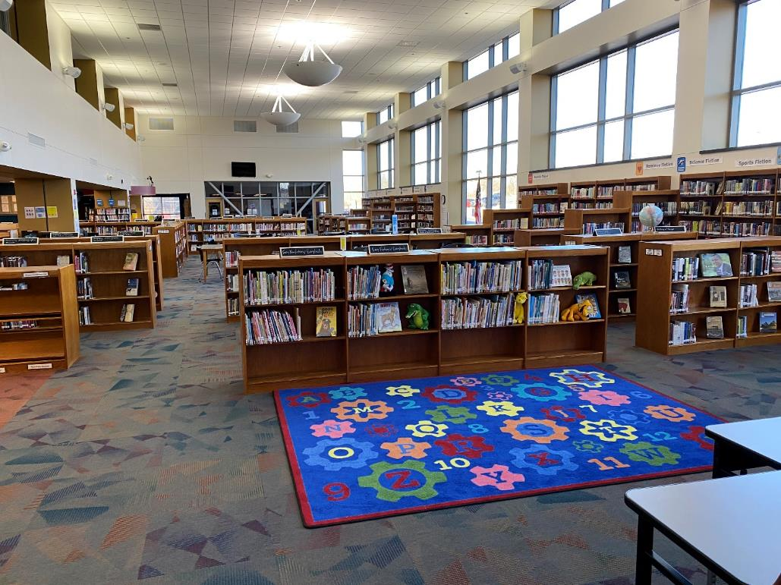
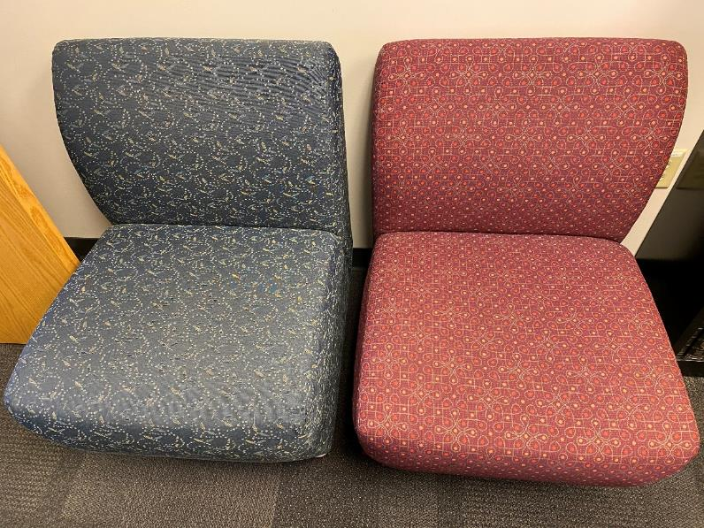
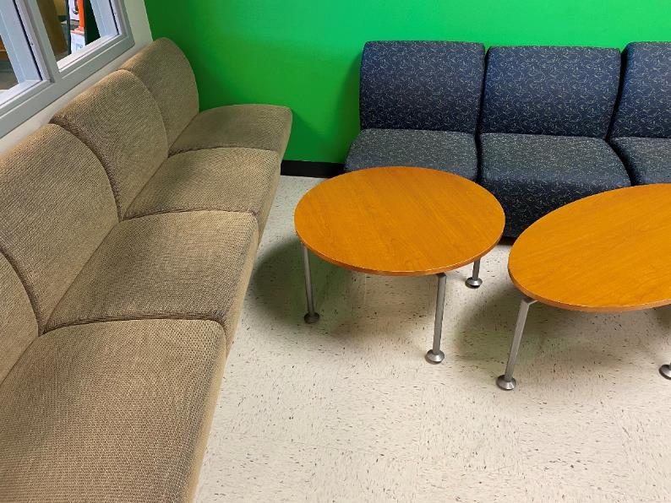

Rockwood Summit Library - Open Classroom
Evidence: photograph of open classroom

The open classroom provides seating for up to 32 students. It contains speakers and a projector and a smartboard as well as a traditional whiteboard, and it can be used to meet the needs of whole classes or smaller instructional groups.

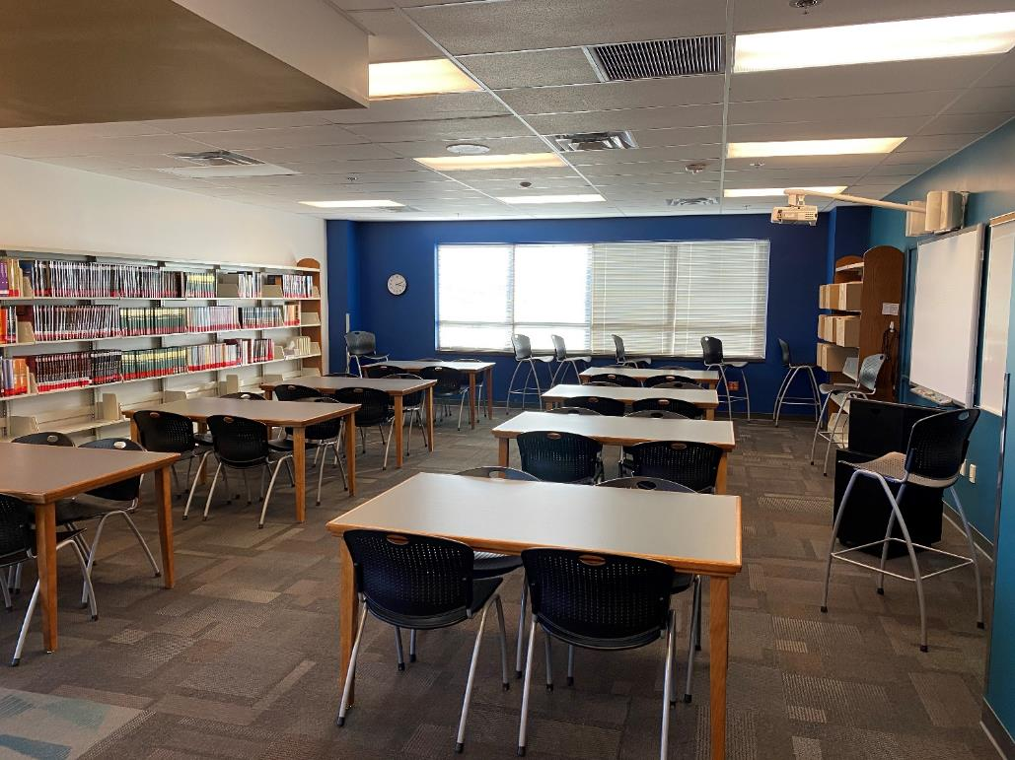

Rockwood Summit Library - Closed Classroom
Evidence: photograph of closed classroom

The closed classroom provides seating for up to 32 students (note: in an attempt to encourage social distancing, some seats have been removed during the pandemic). It contains speakers and a projector and a smartboard as well as a traditional whiteboard, and it can be used to meet the needs of whole classes or smaller instructional groups.

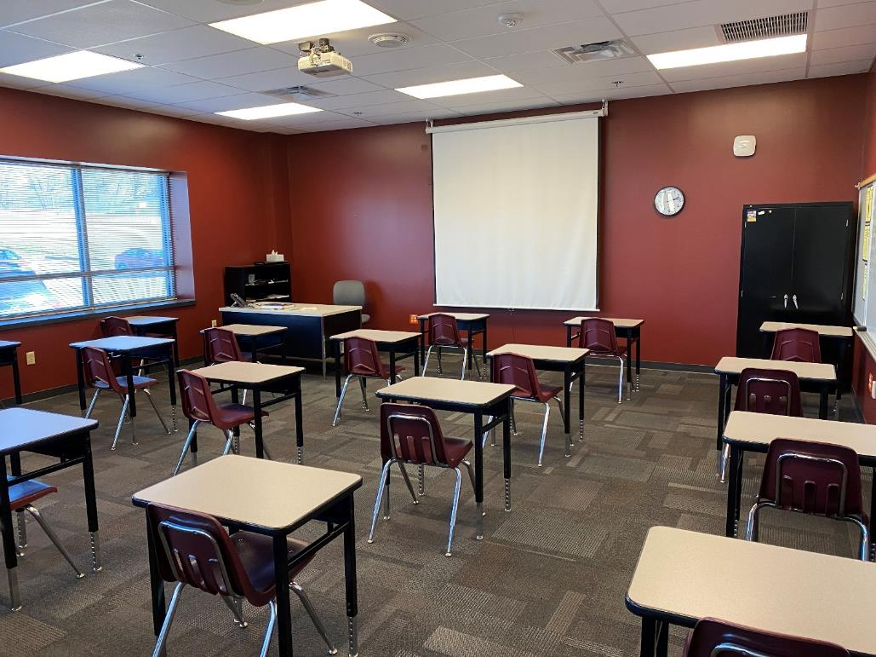

Rockwood Summit Library - Open Computer Lab
Evidence: photograph of open lab

The open lab provides seating and desktop computers for up to 32 students (note: some computers have their monitors turned down to encourage social distancing during the pandemic). In addition to the desktop computers, this space contains speakers and a projector and a smartboard as well as a traditional whiteboard, and it can be used to meet the needs of whole classes or smaller instructional groups.

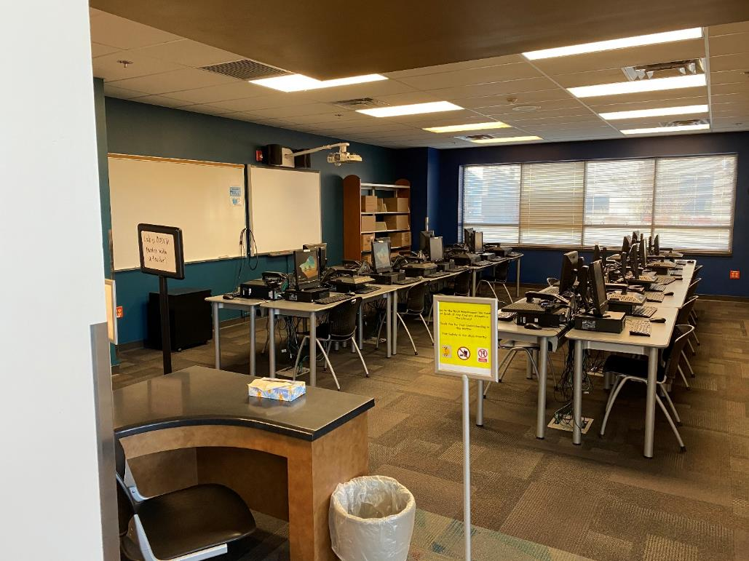

Rockwood Summit Library - Closed Computer Lab
Evidence: photograph of closed lab

The closed lab provides seating and desktop computers for up to 30 students (note: some computers have their monitors turned down to encourage social distancing during the pandemic). In addition to the desktop computers, this space contains speakers and a projector and a smartboard as well as a traditional whiteboard, and it can be used to meet the needs of whole classes or smaller instructional groups.

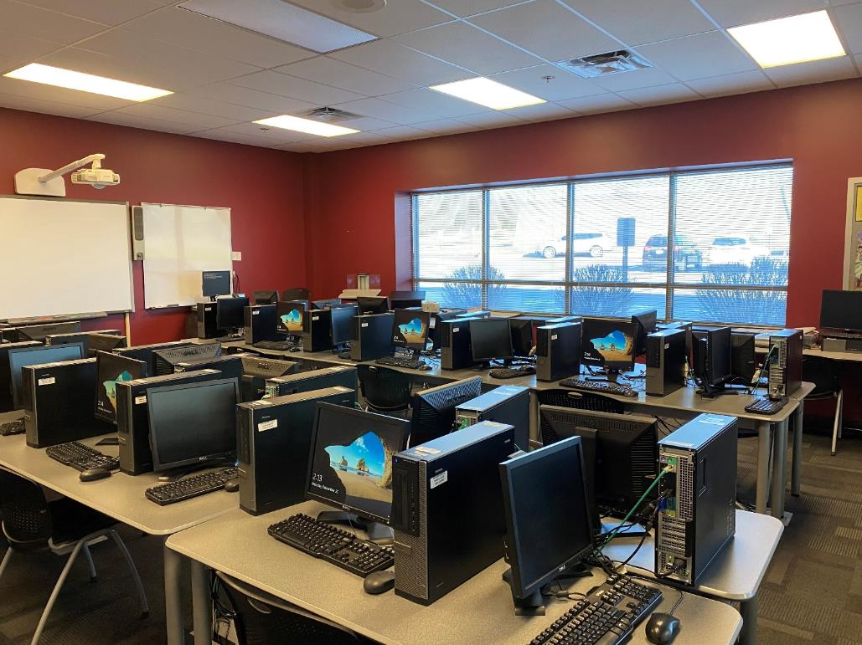

Rockwood Summit Library - Media Production Room
Evidence: photograph of media production room

The media production room provides three desktop computers as well as specialized media equipment (video transfer equipment, sound recording equipment, etc.). Although not capable of hosting a full class, the room is an excellent addition for students looking to produce multimedia projects using library equipment.

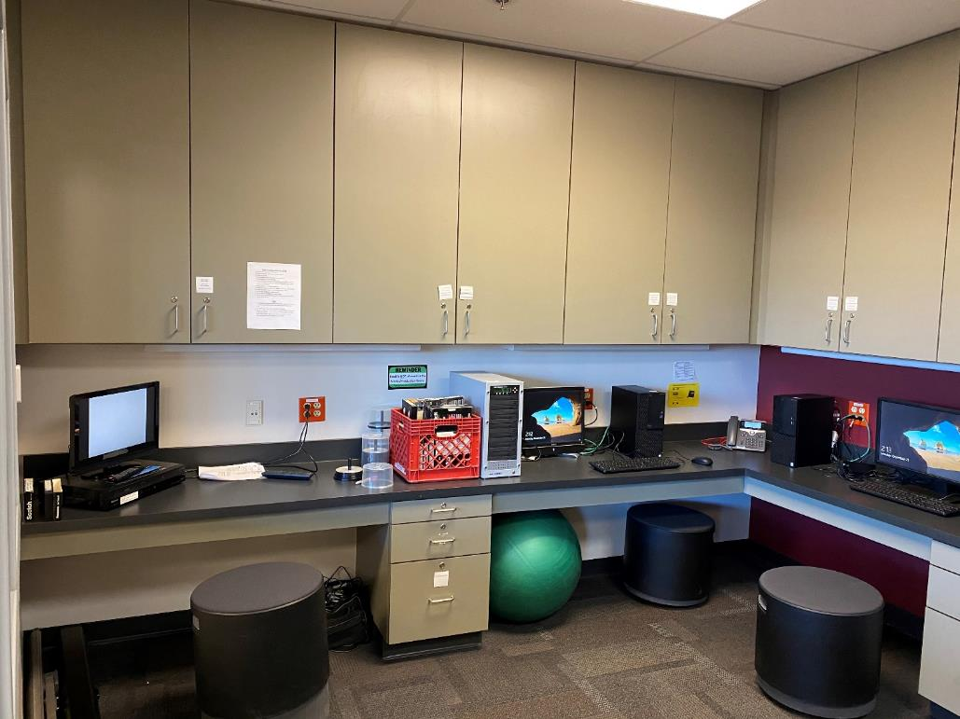

Return to Table of Contents

Indicator #13: Program offers a variety of programs and/or opportunities for all members of the library community in a safe and inclusive manner

(AASL—include)
Exemplary (2 points): Offers a minimum of four distinct and cross-curricular programs throughout the year that may
- include family and/or community participation
- take place either during or beyond the school day

Approaching (1 point): Offers a minimum of two distinct and cross-curricular programs that may
- include family and/or community participation
- take place either during or beyond the school day

Required Documentation/Evidence

Calendar of events with enough detail to show the purpose and audience for each event; may include photos and/or evaluation from some events.

Supporting Evidence
Insert Applicable Links Here:

Insert Documents/Narratives:

The Rockwood Summit High School library meets the expectations for a score of EXEMPLARY in indicator 13 because the library offers a variety of programs and opportunities for all members of the library community in a safe and inclusive manner. The programs include Banned Books Week, Hispanic Heritage Month, Teen Tech Week, Veterans Day / Thank a Veteran, author visits, Read to the Summit, Gateway Book Club, and the Gateway Readers’ Award program.

- Banned Books Week. Rockwood Summit librarians conducted programming for the 2021 Banned Books Week. This programming coincided with the ALA’s annual Banned Books Week and with 9LA classes’ reading of Fahrenheit 451. Rockwood Summit librarians taught lesson on censorship, book challenges, and the importance of intellectual freedom. Students participated in activities asking them to review lists of frequently challenged books, assess books against challenges, and write to banned authors as part of the #DearBannedAuthor campaign. The library displayed frequently challenged books for students visiting the library to browse.

- Hispanic Heritage Month. To celebrate Hispanic Heritage Month, Greg and Margaret did several different items of programming. First, they taught a lesson to several Spanish classes. In this lesson, Greg and Margaret asked students to think initially about what aspects of Latinx culture they were most familiar with. Then Greg and Margaret presented recent titles by popular Latinx YA authors. Students were then given the opportunity to check out these titles and to find more information by accessing TeachingBooks.net to read summaries, listen to author interviews, watch book trailers, and more. This activity helped students explore the world and become familiar with diverse authors. Throughout the month, the library featured Latinx authors, titles, and significant people from history, so that students visiting the library could learn more about Hispanic heritage.

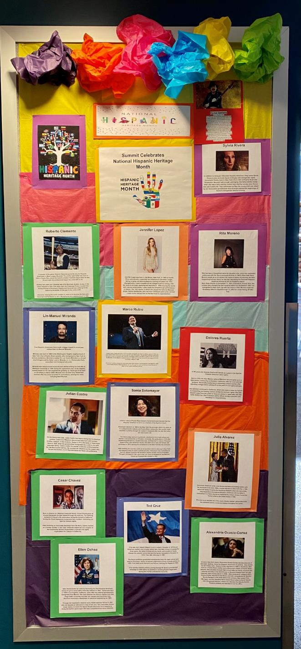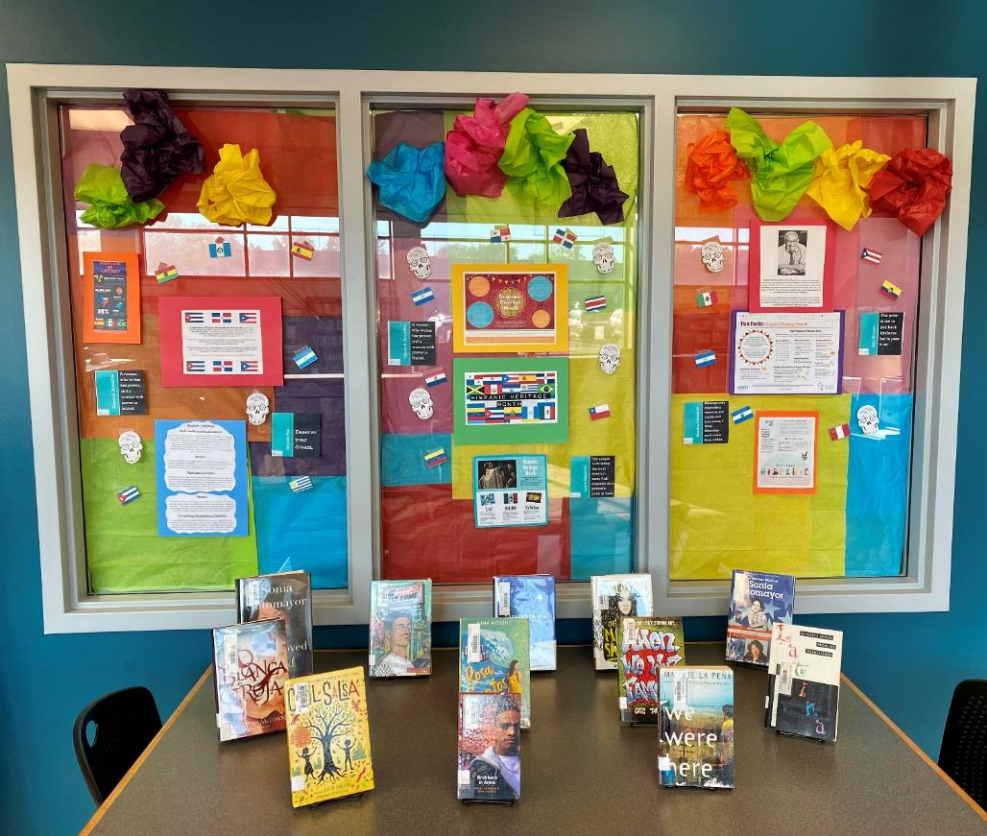

- Teen Tech Week. Although officially Teen Tech Week has been combined into TeenTober, Rockwood Summit librarians still chose to conduct a week of programming encouraging teens to come into the library to explore various technology-related activities and improve their tech literacies. Throughout the week, teens had the opportunity to participate in a scavenger hunt that helped them become familiar with tech-related equipment, software, and spaces in the library. This scavenger hunt was hosted on Google Forms. Teens also had opportunities to explore ebook and audiobook apps in the library’s collection, complete an hour of code, watch a TED talk, and learn how to clean up their digital footprint.

- Veterans Day / Thank a Veteran. To celebrate Veterans Day, Rockwood Summit librarians met with classes from Language Arts, Social Studies, SSD, Freshman Seminar, and more to learn about the origins and meaning of Veterans Day. Librarians taught students how to write (by hand) a thank-you note for a veteran. Then students created thank-you cards for veterans. Some of these cards were distributed at Rockwood Summit’s annual Veterans Day parade, while others were shared with a local Honor Flights organization. Card-making materials and a Veterans Day book display were available as part of library programming for walk-in patrons.

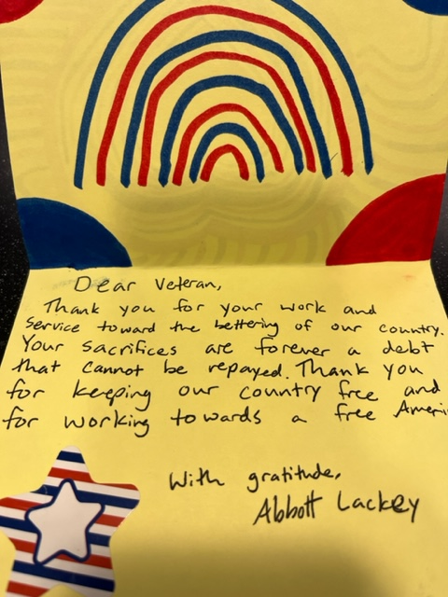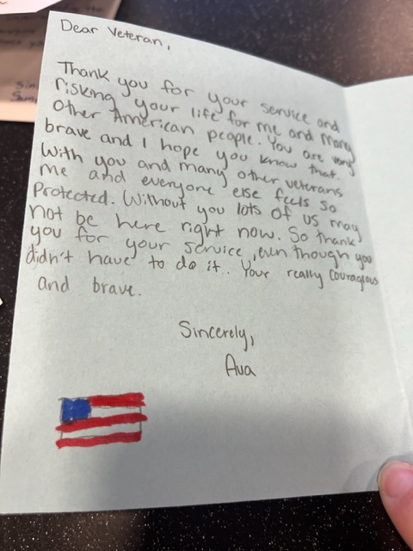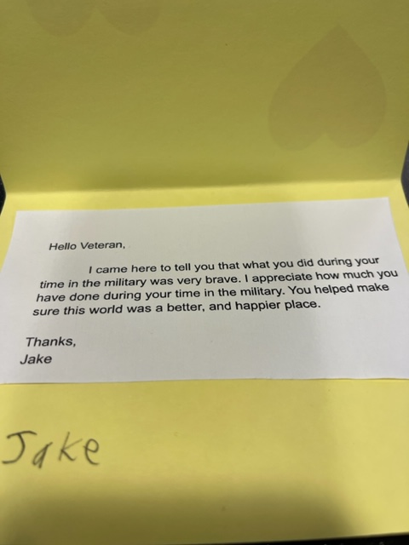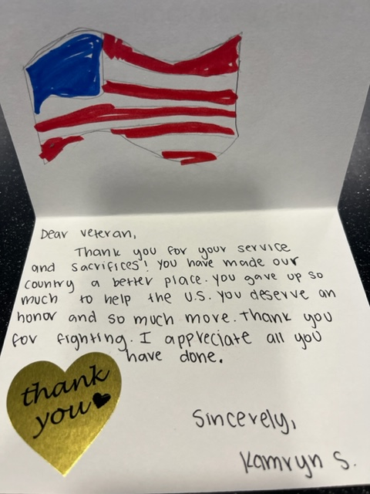

- Author Visits. Rockwood Summit librarians included multiple author visits as part of their programming. With the support of the Missouri State Library, Rockwood Summit librarians coordinated an author visit from Mindy McGinnis to all four Rockwood School District. McGinnis discussed the opioid epidemic in the context of her recent book, Heroine. McGinnis spoke about the importance of making good choices and early on taking personal responsibility for learning how to handle trauma and stress without recourse to substance abuse. She also spoke about the pathway to recovery for people already grappling with addiction. In collaboration with other district officials, Margaret spearheaded author Mitali Perkins’s Zoom visit to all four high schools. Libraries purchased copies of Perkins’s works, and then, in her presentation, Perkins talked about her own cross-cultural experience growing up and the transformative power of crossing boundaries. In her visit to the high schools, Perkins encouraged students to learn to respectfully and thoughtfully communicate with people who might seem different from them; she emphasized the need for thoughtful engagement as we all, in various ways, seek to cross cultural barriers.

- Read to the Summit Reading Marathon. In order to encourage recreational reading, the RSHS Library sponsored a reading marathon that ran from November 15 - January 7. All members of the school community (students, staff, administrators, and parents/guardians) were encouraged to participate by setting one of four reading goals for themselves. (See flyer for details.) Participants submitted their logs at the end of the marathon and those who completed their goal received a medal and were entered into a raffle for additional prizes.
- Gateway Book Club. The Gateway Book Club is an extracurricular activity that Margaret started in 2005. Margaret and Greg have co-sponsored the activity since 2016. The club meets monthly to discuss a common read, and all Summit students are welcome to join. Because Greg and Margaret do not want the cost of books to deter anyone from joining, they provide a copy of each monthly book selection for every club member, using either library activity money or a Donors Choose project to purchase the titles. Monthly meetings are usually held in-person, but the club has met via Zoom since April due to the pandemic. This year, membership has grown dramatically, with over twenty students regularly attending (compared to six students in 2020-2021). Additionally, this year the Gateway Book Club expanded its reach to involve community members by holding a Community Read in January. Members of the book club were invited to have a friend or family member read the book that month (Daughter of Sparta) and join us for a discussion after school. The Gateway Book Club continues to provide a much-needed opportunity for avid readers to be part of a community that shares their passion for books.
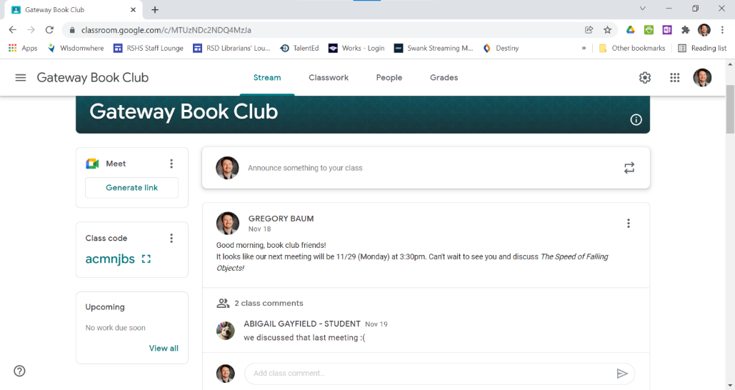

- Gateway Readers Award Program. As we do every year, we have actively promoted MASL’s Gateway Readers Award during the 2021-22 school year. All of our copies of the 15 nominated titles have been prominently displayed in the library since the beginning of the school year. We have distributed Gateway bookmarks to students and Gateway posters to ELA teachers to hang in their classrooms. These titles are included in book selection lessons and highlighted in First Chapter Friday reading throughout the year. Students who read two or more titles are eligible to cast a vote for the winning title in early March.

Return to Table of Contents

Indicator #14: Program provides a variety of current technologies in the library, including means of remotely accessing library resources at any time

(AASL—curate, explore, include)
Exemplary (2 points): Provides a website with a curated selection of technology resources and openly licensed digital resources, learning management system, and/or social networking to offer 24/7 access to library

Approaching (1 point): Provides links to district-supported resources with 24/7 access

Required Documentation/Evidence

Link to website
Copies of communication sharing technology resource links with library stakeholders

Supporting Evidence
Insert Applicable Links Here:

Insert Documents/Narratives:

The Rockwood Summit High School library meets the expectations for a score of EXEMPLARY in indicator 14 because the library provides a website with a curated selection of technology resources and openly licensed digital resources, a learning management system, and social networking to offer 24/7 access to the library. For this indicator, Rockwood Summit librarians have selected the following pieces of evidence: the Rockwood Summit library website; Rockwood Summit library’s “Services for Online Learning” flyer; the Rockwood Summit library’s virtual makerspace; the Rockwood Summit databases page; the Rockwood Summit library’s ebook and audiobook access information page; the Rockwood Summit’s Canvas course; the Rockwood Summit library’s Twitter account; Rockwood Summit parent instructional communication / welcome video; the Rockwood Summit subscription to the New York Times.

Rockwood Summit Library Website
Evidence: link

The Rockwood Summit library’s website can be accessed here:
https://www.rsdmo.org/domain/1948

The Rockwood Summit library’s website provides access to a curated selection of technology and digital resources. Through the library’s website, students can access our Destiny catalogue, where they can search for and request technology resources: cameras, headphones, Chromebooks, Nook e-readers, iPods, audio recorders, Playaway audiobooks, and more. They also have access to ebook and audiobook resources, both of which are available through the Destiny catalogue in conjunction with Follett and MackinVia.

Rockwood Summit Library’s “Services for Online Learning” Flyer
Evidence: flyer

Another piece of evidence that shows that the Rockwood Summit librarians provide a variety of current technologies that are remotely accessible is the “Services for Online Learning” flyer. Margaret and Greg developed and digitally distributed this flyer in response to the school district’s decision to continue in the 2021-2022 school year to continue to provide a limited version of remote learning for the small number of students who are still enrolled virtually. The flyer highlights how Summit librarians can help remote and in-person teachers with teaching (lessons on database use, media literacy, book selection, technology, etc.), collaborating (designing lessons and projects, conferring with students), resources (online access to Swank, databases, physical books, etc.), technology (headsets, cameras, microphones, programs like WeVideo), and librarian-made lessons and resources already available on the library Canvas page.

Rockwood Summit Library’s Virtual Makerspace:
Evidence: makerspace bingo card

Another piece of evidence that the Rockwood Summit library provides 24/7 access to a curated selection of technology resources is the virtual makerspace. The Rockwood Summit library’s virtual makerspace emerged in response to the COVID-19 pandemic; traditional makerspace opportunities (puzzles, crafts, Legos, the 3D printer, the green screen, etc.) had to be removed from the library to encourage social distancing. In order to still provide patrons with stimulating, engaging, creative opportunities, the Rockwood Summit librarians developed a makerspace that featured free, online, curated resources for coding, animation, creative writing, puzzles, engineering, and more. Unlike traditional makerspace materials and projects, these resources are available 24/7. As part of the bingo project, students could win a prize by completing a variety of makerspace activities.

Rockwood Summit Library’s Databases
Evidence: link to database webpage, library brochure, teacher email and resources

The Rockwood Summit library’s database page may be accessed here:
https://www.rsdmo.org/Page/4231

The library’s database page is another piece of evidence that the Rockwood Summit library provides 24/7 access to curated library resources. In this case, Rockwood Summit library databases, as well as Rockwood School District databases, are available continuously to students. Students accessing these databases from home are required to log in; the library’s database page includes a secured link to the campus and district passwords, which enables students to access these databases without requiring them to memorize a list of additional passwords. The Rockwood Summit library’s database page also includes links to St. Louis County Library resources, as part of our partnership with the county library system. Rockwood Summit librarians provide students with a brochure at the beginning of each school year; this brochure contains a list of databases students can access 24/7, along with instructions on how to access databases from home.

Rockwood Summit Library’s Ebook and Audiobook Information Page
Evidence: PDF of page

The Rockwood Summit library’s ebook and audiobook information page is evidence that the library provides 24/7 access to a curated selection of licensed digital resources. This document lists the available sources for ebooks and audiobooks: the library’s Destiny catalogue; the St. Louis County Library’s Overdrive (which students have access to through our partnership with the county library); MackinVia; Audible (free school page); and the Junior Library Guild ebook collection. In addition to links to each collection, this document also provides links to instructions on how to access and use each site.

Rockwood Summit Library’s Canvas Course
Evidence: images of page and modules

The Rockwood Summit library’s Canvas course is another piece of evidence that the library provides 24/7 access to current technologies and resources. The Canvas course is organized into modules that cover the following topics: an overview of library policies, services, and resources; an introduction to the databases; an introduction to ebooks; an overview of resources available through the district’s partnership with the St. Louis County Library system; a series of lessons on the research process; advanced lessons on choosing recreational reading material; and a selection of teacher-specific resources like Learning Ally and Learning Express.
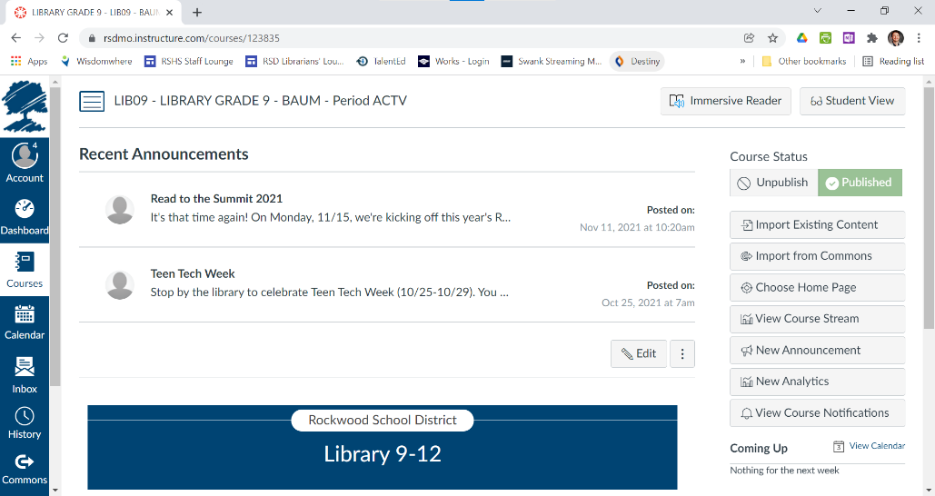
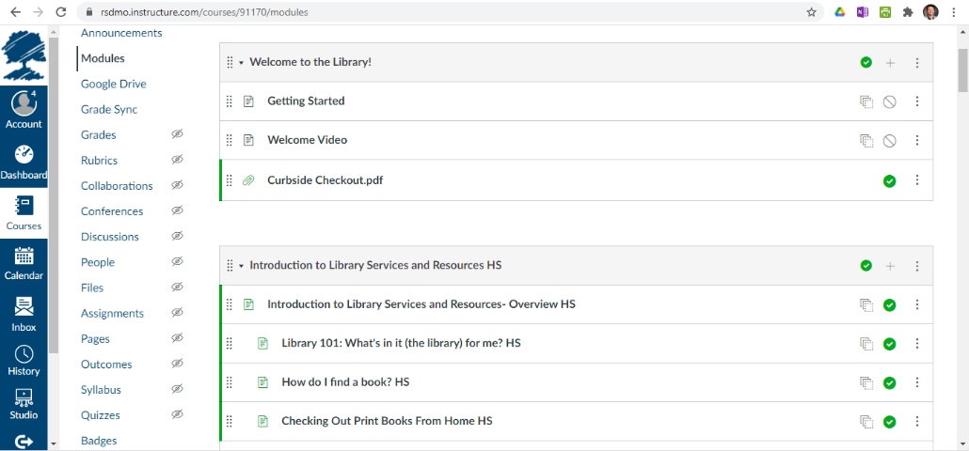

Rockwood Summit Library’s Twitter Account
Evidence: selected tweets

One piece of evidence of the Rockwood Summit library providing access to curated resources through social networking is the Rockwood Summit Library Twitter account. As the selected tweets show, the library Twitter account is regularly updated and used to communicate with stakeholders about new items in the collection, makerspace opportunities, and reminders about online access opportunities through the library website.

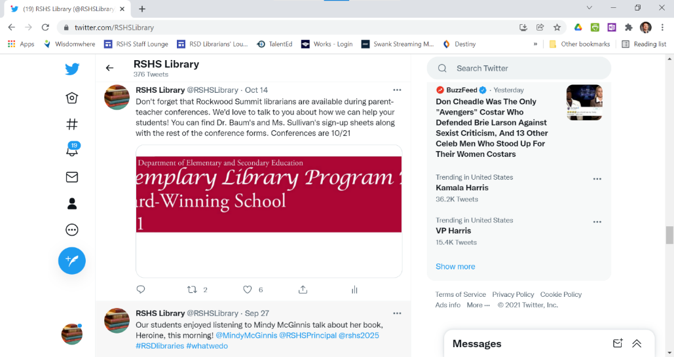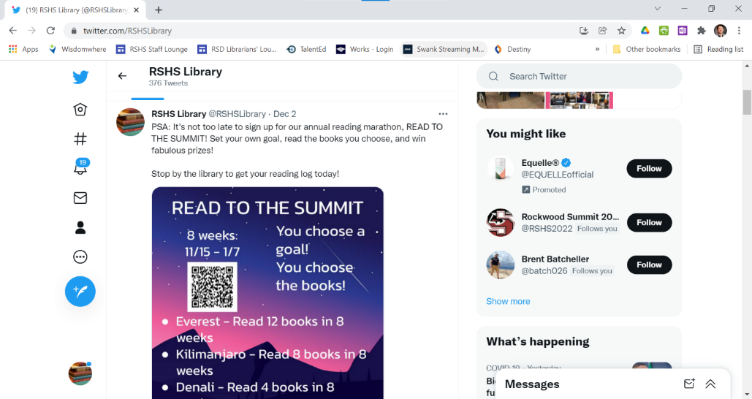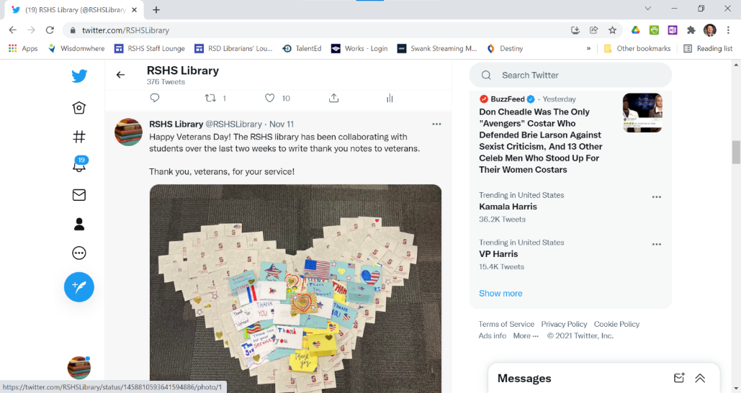

Rockwood Summit Parent Instructional Communication
Evidence: welcome video

Another piece of evidence that the Rockwood Summit library provides access to curated resources and 24/7 access to the library’s digital resources is the welcome video for parents of incoming students. In the video, librarians introduce parents to digital library resources, including ebooks, audiobooks, databases, movies, newspapers, magazines, and more. They also help parents learn how their Rockwood students could access these materials through a partnership with the St. Louis County library, with which the Rockwood School District has partnered to ensure that every student has a library card.

Rockwood Summit Subscription to the New York Times
Evidence: handout on NYT subscription access; handouts on NYT resource for LA, SS, and STEM
An additional piece of evidence that the Rockwood Summit library provides access to a curated selection of technology resources is the school-wide New York Times subscription. Rockwood Summit librarians purchased individual subscriptions for each staff member and student in the school. Then Rockwood Summit librarians conducted professional development to help teachers implement this resource into their classrooms. This is a curated resource; Rockwood Summit librarians considered digital subscriptions to the Washington Post, the Wall Street Journal, and the St. Louis Post-Dispatch before deciding to subscribe to the Times. Staff and students have 24/7 access to this resource.

Return to Table of Contents

Library Management

Indicator #15: Program implements flexible scheduling to meet the authentic instructional needs of students

(AASL—collaborate, explore, include)
Exemplary (2 points): The library facility uses a flexible schedule during the length of the school day with all scheduling at the discretion of the professional librarian.

Approaching (1 point): The schedule of the library facility during the length of the school day does not exceed 25 percent fixed scheduling (such as being part of a school’s specials rotation); the remaining 75+ percent of the day’s schedule is flexible and implemented at the discretion of the professional librarian.

Required Documentation/Evidence

Schedule reflective of four consecutive weeks

Supporting Evidence
Insert Applicable Links Here:

Insert Documents/Narratives:

The Rockwood Summit High School library meets the expectations for a score of EXEMPLARY in indicator 15 because the library facility uses a flexible schedule during the length of the school day with all scheduling at the discretion of the professional librarian. For this indicator, Rockwood Summit librarians have selected the following pieces of evidence: a schedule reflective of four consecutive weeks.

Rockwood Summit Library Calendar
Evidence: PDF of four weeks

The Rockwood Summit library’s calendar displays flexible scheduling that meets the authentic instructional needs of students. Scheduling is at the discretion of the school’s two professional librarians.

Return to Table of Contents

Indicator #16: Librarian regularly evaluates the library program

(AASL—This indicator includes addressing all AASL Integrated Frameworks while evaluating the school library program.)
Exemplary (2 points): Regularly designs throughout the school year evaluative tools and acquires evaluative information regarding the school library program from all stakeholders: school librarian, principal, certified teachers and/or support staff, parents, students

Approaching (1 point): Annually designs evaluative tools and acquires evaluative information regarding the school library program from four of the following five stakeholders: school librarian, principal, certified teachers and/or support staff, parents, students.

Required Documentation/Evidence

Evaluative tools(s) utilized with each stakeholder regarding perception of the library program. These may be in the form of surveys, audio discussions, digital photos of physical documents as well as other data collection methods. These evaluations may include the complete library program, book clubs, special celebrations such as Read Across America Week or Banned Book Week, resource collections, resource development, etc.

Supporting Evidence
Insert Applicable Links Here:

Insert Documents/Narratives:

The Rockwood Summit High School library meets the expectations for a score of EXEMPLARY in indicator 16 because the librarians regularly design evaluative tools and acquire evaluative information regarding the school library program from all stakeholders: school librarian, principal, certified teachers and/or support staff, parents, students. For this indicator, Rockwood Summit librarians have selected the following pieces of evidence: student surveys and survey responses; audio recording of student panel; staff surveys and survey responses; parent/community surveys and survey responses; “State of the Library” annual report and minutes.

Student Feedback
Evidence: Freshman Seminar lesson survey responses; US History lesson survey responses; library survey responses; audio recording of student panel
- Students surveys are one piece of evidence that Rockwood Summit librarians regularly design evaluative tools and acquire evaluative information regarding the school library program from all stakeholders.
- One example of this comes from surveys of Freshman Seminar classes. Freshman Seminar is a semester-long class for 9th-grade students. It is designed to help students transition successfully from middle school to high school. Rockwood Summit librarians collaborate with freshman seminar teachers to implement library resources and support into the Freshman Seminar curriculum. At the end of the fall semester, librarians surveyed students to see which lessons were most helpful and to receive feedback on how to improve the library-related content of the course. One piece of feedback that librarians received in Fall 2020 was that many students already knew how to write an email appropriately. In order to make the email etiquette lesson more effective and meaningful, this year librarians expanded the portion of the lesson that had to do with informal vs. formal registers and the importance of email etiquette, rather than simply focusing on the structure of a correctly formatted email. Unfortunately, the lesson still received the lowest rating in Fall 2021 (of the lessons librarians taught), and so Rockwood Summit librarians will need to consider whether to continue including this lesson with revision.
- Another example comes from two U.S. History classes, both taught by Mr. Miller, who collaborated with us on nine lessons during the first semester of the 2021-22 school year. At the end of the semester, we surveyed the students in those classes to find out which lessons they learned from and which ones they liked. Approximately half of the students responded, reporting that they felt they had learned something from each lesson. Interestingly, students were more likely to say they learned something from the lesson than to say they liked the lesson, a sign they focused on learning. We also asked which lesson was their favorite and which was their least favorite. We are already using this data to inform future instruction. For instance, the favorite lesson was creating a podcast, we plan to incorporate another podcast assignment at the end of the second semester.
- Rockwood Summit librarians also surveyed the full student body about the library program. 66 students responded. Of those students, over half (59.1%) said they had checked out a book from the library this school year. 83.3% of students rated library staff as friendly and helpful. 89.4% of students said the library had a good selection of fiction books. Student feedback encouraged librarians to continue broadening their selection of books, to work with teachers to find more time for students to come to the library, and to provide easy-to-read maps throughout the library.
- Rockwood Summit librarians also conducted a discussion evaluating the library program with a panel of students. A recording of this panel discussion provides additional evidence that Rockwood Summit librarians regularly design evaluative tools and acquire evaluative information about the library program. In this panel discussion, students praised the atmosphere of the school library in general and said that they enjoyed using the library. Their main suggestion for feedback was that sometimes the assistant at the circulation desk was not welcoming to students. In response to that information, Rockwood Summit librarians have worked with library assistants to create a more welcoming atmosphere.

Staff Surveys
Evidence: survey responses

- Staff surveys are another piece of evidence that Rockwood Summit librarians regularly design evaluative tools and acquire evaluative information regarding the school library program from all stakeholders.
- For the most part, staff responded with praise and support of the library program. However, Rockwood Summit librarians also received valuable feedback and constructive criticism from teachers. For example, one piece of feedback that affected Margaret and Greg’s collection development plan came from World Language teachers (Spanish and French). Teachers requested short, low-level readers that their students could check out from the library. After considering the curricular need and the cost of the book sets, Rockwood Summit librarians decided to add these to the collection.
- Special Education teachers also asked for more opportunities to visit the library and participate in makerspace activities. This teacher works specifically with students in intervention programs. Although last year, the library reduced makerspace activities in response to COVID-19, this year, Margaret and Greg have developed monthly makerspace activities that act as extensions for the skills and topics that Special Education students are studying.
- In the January survey, staff feedback showed high levels of satisfaction with the librarians, the library space, and the library collection. Staff did request more high-low titles for IEP classes and an expanded range of audiobooks, which will be factored into Rockwood Summit librarians’ collection development plan.

Parent/Community Surveys
Evidence: survey responses

- The parent and community survey is another piece of evidence that Rockwood Summit librarians regularly design evaluative tools and acquire evaluative information regarding the school library program from all stakeholders.
- 34 parent and community members responded to the survey.
- Of those respondents, 70.6% agreed or strongly agreed that the Rockwood Summit Library Media Center is an important part of the school community. 50% agreed or strongly agreed that the library staff is friendly and helpful. These numbers have prompted Rockwood Summit librarians to reconsider how they promote the library and how to improve patron satisfaction.
- As a follow-up to last year’s survey, where parents and guardians indicated a lack of familiarity with library services, Rockwood Summit librarians sent out a welcome video providing an overview of library services. This area will continue to be a focus for Rockwood Summit librarians since the survey indicates that only 20.6% feel familiar with library services and resources.
- In the feedback section, several parents and community members expressed concerns about content of titles in the library collection. Other parents and community members applauded the library for titles representing diverse characters and asked librarians to continue to increase representation in the library collection. Rockwood Summit librarians will continue to follow collection development best practices in terms of both age-appropriate content and diversity.

“State of the Library” Annual Report
Evidence: report and minutes

- The “State of the Library” annual report and meeting minutes are another piece of evidence that Rockwood Summit librarians regularly design evaluative tools and acquire evaluative information regarding the school library program from all stakeholders.
- In the report, Rockwood Summit librarians provide an overview of the current state of the library: collaborative instruction, including changes made to continue accommodating remote learning; library programming during the 2021-22 school year; updates to the Rockwood Summit Library Media Center’s collection and collection development policy; budget request for 2022-23; and staffing.
- In the annual meeting, Rockwood Summit librarians were able to follow up on these items, including a conversation with the building principal about damaged library equipment and converting one library assistant to a “resource assistant,’ using the example of another high school in the district. Summit librarians also had an opportunity to discuss how the library’s five-year plan and budgetary plan align with and support the building’s strategic plan and the district’s strategic plan. At the end of the meeting, plans were made to meet the following year with new action items.

Return to Table of Contents

Indicator #17: Program has a budget that is adequate to purchase books, materials, supplies, etc., to meet the library’s strategic plan

(AASL—curate, include)
Exemplary (2 points): Collaboratively works to establish an adequate budget with the building and/or district administration by communicating a strategic five-year plan that outlines the vision and progression of the school library program goals in connection with the school and/or district strategic plan

Approaching (1 point): Collaboratively works to establish an adequate budget with the building and/or district administration by communicating a three-year plan that outlines the vision and progression of the school library program strategic plan

Required Documentation/Evidence

Submission of collaborative budgetary plan denoting the library’s strategic plan and its connection to the building or district strategic plan. Submission must include the dollar amount (total and per student) provided by the district to support the library plan. Examples: written reports, spreadsheets.

Supporting Evidence
Insert Applicable Links Here:

Insert Documents/Narratives:

The Rockwood Summit High School library meets the expectations for a score of EXEMPLARY in indicator 17 because the librarians collaboratively work to establish an adequate budget with the building and/or district administration by communicating a strategic five-year plan that outlines the vision and progression of the school library program goals in connection with the school and/or district strategic plan. For this indicator, Rockwood Summit librarians have selected the following pieces of evidence: library strategic plan, including budgetary plan, the district strategic plan; and the State of the Library annual report with meeting minutes.

Rockwood Summit Library Five-Year Plan
Evidence: five-year plan, with separate budgetary plan spreadsheet

The library’s budgetary plan, in conjunction with the library’s five-year plan, provides evidence that the Rockwood Summit library is adequately funded in order to achieve goals that are aligned with building and district plans.

The library’s budget is adequate to support the library’s goals as outlined in the library’s five-year plan (which in turn reflects building and district CSIP) in the following ways:
- The library’s first goal in its five-year plan is to support multiple literacies and help all students to become lifelong readers. In support of this goal, the library budget allocates $5,000 to technology-related supplies, $23,500 to collection development, and $2,500 to resource materials. By maintaining a current, diverse, and relevant library collection, the librarians are better able to help all readers find books of interest. The resource budget allows librarians to invest in subscriptions like the New York Times and other periodicals, which offers opportunities for students to learn media literacy and visual literacy. The technology budget allows for the purchase of subscriptions to databases, to help students master information literacy, and equipment, to support technological literacy.
- The library’s second goal in its five-year plan is to foster lifelong learning by collaborating with staff across curricula. The library’s budget reflects that goal by allocating $5,000 to technology-related resources, $23,500 to collection development, and $2,500 to resource materials. Money for technology-related resources allows the library to support multiple curricula through database subscriptions and equipment purchases. Money for collection development, especially the priority investment in current and relevant nonfiction, allows the library to support multiple curricula. Money for resource materials allows for subscriptions to the New York Times and other periodicals that support multiple curricula. For example, in school year 2021-2022, the Rockwood Summit library renewed its purchase of individual subscriptions to the New York Times for all staff and students. In collaboration with the science department, the library also added National Geographic to its online and print periodical collection and Consumer Reports to its print periodical collection.
- The library’s third goal is to act as the heart of the Rockwood Summit community. The library budget reflects this goal by allocating $2,000 to library supplies, $5,000 to technology-related supplies, $23,500 to collection development, and $2,500 to resource materials. The $2,000 to library supplies allows the library to invest in supplies to keep the library clean, attractive, and welcoming, including investments in furnishings that are comfortable, functional, and mobile. This money also goes toward makerspace materials such as (in non-pandemic years) the 3D printer, puzzles, STEAM competitions, the Cricut (for making shirts), button-making, etc. The $5,000 to technology-related supplies includes equipment in the media production room, which clubs, organizations, and teams use--for example, this year, several sports teams have used the library space more than usual because they are in the process of digitizing game footage and team pictures. Teams and clubs also regularly make use of the library’s cameras, tripods, and green screen, all of which must be regularly updated and replaced. The $23,500 to collection development represents a desire to keep a current, diverse, and relevant collection that all patrons will find engaging and useful. This also includes staff, which is reflected in the library’s commitment to investing in professional development materials. The $2,500 to resource materials also supports this goal as the library invests in periodicals that support clubs, organizations, student and staff hobbies and pastimes, and general use of the library as a space for people to come together as a community.
- The library’s fourth goal in its five-year plan is to provide a flexible, adaptable, and accessible space that supports learning. The library’s budget reflects that in allocating $2,000 to library supplies and $2,000 to repairs and maintenance. The $2,000 to library supplies allows the library to invest in supplies to keep the library clean, attractive, and welcoming, including investments in furnishings that are comfortable, functional, and mobile. The $2,000 to repairs and maintenance covers a service contract with Bibliotheca, which allows the library to keep the security gates and book sensitization equipment in top working condition.
- The library’s fifth goal in its five-year plan is to enhance existing collections and services. This goal is reflected in the allocation of $5,000 to technology-related supplies, $23,500 to collection development, and $2,500 to resource materials. The $5,000 to technology-related supplies allows the library to invest in database subscriptions and online services, as well as equipment such as cameras, tripods, microphones, webcams, document cameras, and external DVD drives, all of which are in high demand. The $23,500 to collection development allows the library to continue building a current, diverse, and relevant collection that all patrons will find engaging and useful. This also includes staff, which is reflected in the library’s commitment to investing in professional development materials. The $2,500 to resource materials allows for subscriptions to the New York Times and other periodicals that support multiple curricula as well as periodicals that support clubs, organizations, student and staff hobbies and pastimes.
- The library’s sixth goal in its five-year plan is to improve outreach and communication to patrons and stakeholders. The library’s budget is adequate to support this goal, and this goal is reflected in the allocation of $2,000 to library supplies and $5,000 to technology-related supplies. The $2,000 to library supplies allows the library to use circulation materials to effectively communicate with patrons about borrowed items. The $5,000 in technology-related supplies allows the library to maintain a current website and social media presence.
- The library’s seventh goal in its five-year plan is to provide the highest quality of service to all patrons. The library’s budget is adequate to support this goal, and this goal is reflected in the $2,000 allocated to repairs and maintenance, in the $23,500 allocated to collection development, and in the $2,500 allocated to resource materials. The $2,000 to repairs and maintenance covers a service contract with Bibliotheca, which allows the library to keep the security gates and book sensitization equipment in top working condition. The $23,500 in collection development allows the library to obtain titles of interest for the librarians’ professional development—this year, for example, this included copies of books by Jennifer Lagarde and Tom Bober. The $2,500 in resource materials allows the library to subscribe to professional journals such as School Library Journal, Booklist, and more. Although library support staff are not directly paid for out of the library budget, and although the librarians advocate for the DESE exemplary standard of one full-time paraprofessional per librarian, the library currently receives adequate support to meet this goal.
- The library’s eighth goal in its five-year plan is to adapt services as new technologies become available. The library’s funding is adequate to support this goal, and this goal is reflected in allocating $23,500 to collection development, $5,000 to technology-related supplies, and $2,500 to resource materials. Money in collection development has allowed the librarians to flexibly adapt to changing needs and technologies; for example, during the two years of the pandemic, the librarians shifted collection development to ebooks, which has allowed students learning at home to access titles more easily. Money in technology-related supplies allows librarians to continue to invest in new and evolving technology to support teachers and curriculum. In years past, the library has invested in Google Cardboard 3D viewers, for example, as well as video cameras, document cameras, microphones, and more. This year, the library has continued to invest in HDMI-VGA adapters, Lightning-auxiliary adapters, breakout box materials, headphones, XLR microphones and cables, camera tripods, and additional technology to support remote and in-person teaching.

State of the Library Annual Report
Evidence: report, meeting minutes, Rockwood Summit building strategic plan, Rockwood School District strategic plan

In an annual meeting with the building principal, Rockwood Summit librarians reviewed library expenditures, the five-year plan and budgetary plan, and building and district goals to ensure that the library budget supports library, building, and district goals as well as to advocate for an adequate budget to support those goals. During this year’s annual meeting, Rockwood Summit librarians followed up on items from the last year’s meeting, particularly on damaged equipment. Then Rockwood Summit librarians discussed how the library’s goals aligned with school and district plans. In this conversation, Rockwood Summit librarians identified the following:
- The library’s goals 1, 2, 4, 5, 7, and 8 (as outlined in the five-year plan) directly support the building strategic plan’s objective that “All students will demonstrate academic growth and be well prepared for their future.”
- The library’s goals 3, 4, 6, and 7 (as outlined in the five-year plan) directly support the building strategic plan’s objective “Create a safe and caring learning environment that includes a positive school culture and positive collaboration and communication throughout the school and community.”
- The library’s goals 1, 2, 4, and 5 (as outlined in the five-year plan) directly support the district strategic plan’s objectives “Student Academic Learning,” “Universal Equity, Opportunity, Access,” “Efficiency and Effectiveness,” and “Staff, Teachers, and Learners.”
- The library’s goals 3, 4, 6, 7 (as outlined in the five-year plan) directly support the district strategic plan’s objectives “Character and Well-Being,” “Community Networks,” and “Strong Leadership.”

Return to Table of Contents

Indicator #18: Program maintains a current, relevant, and diverse collection of print and/or digital resources that is responsive to the needs of the community and is tied to curriculum

(AASL—curate, explore, include)
Exemplary (2 points):
- Maintains current collection as follows:
  - Nonfiction: At least 70 percent of the resources have copyright dates within the most recent 12 years.
  - Fiction: The average age of a fiction collection is less than 15 years old.
- Supports access on all subjects that meet the needs, interests, and abilities of all persons in the community the library serves
- Supplemental resources extend beyond the school community to connect with the global community

Approaching (1 point):
- Maintains current collection as follows:
  - Nonfiction: At least 70 percent of the resources have copyright dates within the most recent 15 years
  - Fiction: The average age of a fiction collection is less than 17 years old.
- Supports access on all subjects that meet the needs, interests, and abilities of all persons in the community the library serves
Required Documentation/Evidence

Collection analysis reports that clearly show the currency, relevance, and diversity of the library’s collection

Supporting Evidence
Insert Applicable Links Here:

Insert Documents/Narratives:

The Rockwood Summit High School library meets the expectations for a score of EXEMPLARY in indicator 18 because the librarians maintain a current collection as follows:
- Nonfiction: At least 70 percent of the resources have copyright dates within the most recent 12 years.
- Fiction: The average age of a fiction collection is less than 15 years old.
- Supports access on all subjects that meet the needs, interests, and abilities of all persons in the community the library serves.
- Supplemental resources extend beyond the school community to connect with the global community.
For this indicator, Rockwood Summit librarians have selected the following pieces of evidence: library collection analysis; diversity resource lists.

Rockwood Summit Collection Analysis
Evidence: Excel spreadsheets, email from Gale rep about database updates

The Rockwood Summit Collection Analysis report provides evidence that the library’s fiction collection has an average age of less than 15 years old. Currently, the average age of the library’s fiction collection is 9 years old. A more detailed accounting of the fiction titles and their publication dates can be found in the accompanying spreadsheet.

The Rockwood Summit nonfiction collection analysis report shows that 70 percent of the nonfiction collection have copyright dates within the most recent 12 years. The library’s current total number of nonfiction titles is 5552. Of those titles, 4279 have a copyright date within the most recent 12 years. That is equivalent to 77.1% of the nonfiction collection. A more detailed accounting of these titles and their publication dates can be found in the accompanying spreadsheet.

The RSHS Library also provides access to nonfiction materials through subscriptions to high-quality databases, including Gale In Context Biography, Gale in Context Science, Gale in Context Global Issues, Gale LitFinder for Schools, ABC-Clio Social Studies Databases, and SIRS Knowledge Source. Students can easily access these resources through the library’s website. These databases contain information on a wide variety of topics and are updated frequently, giving students access to the most current information available.

Rockwood Summit Diversity Resources
Evidence: lists; Mackin collection analysis; TeachingBooks collection analysis

Diversity resource lists, compiled by the Rockwood Summit library staff and by Mackin and TeachingBooks, are non-comprehensive lists representative of the collection’s diversity; these lists provide evidence that the Rockwood Summit library supports access on all subjects, interests, and abilities of all people in the community the library serves.
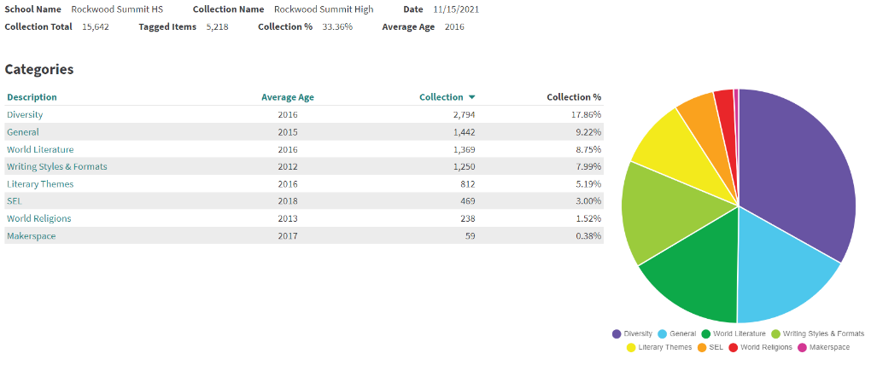
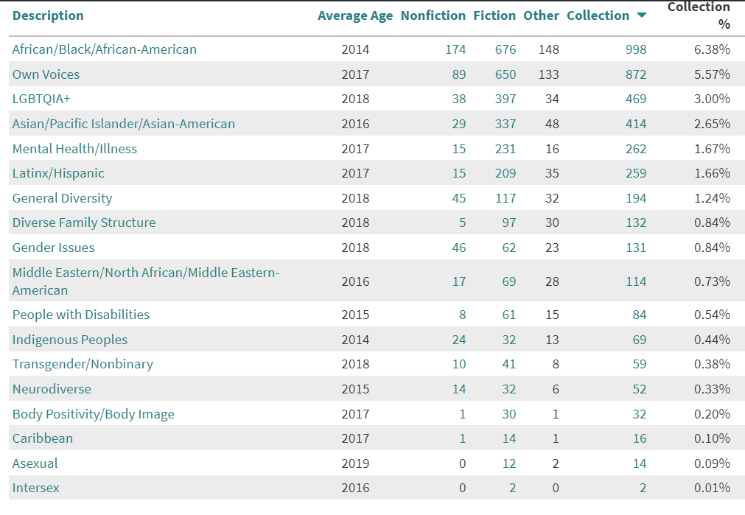
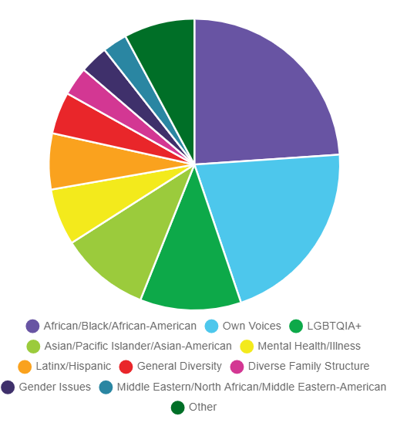
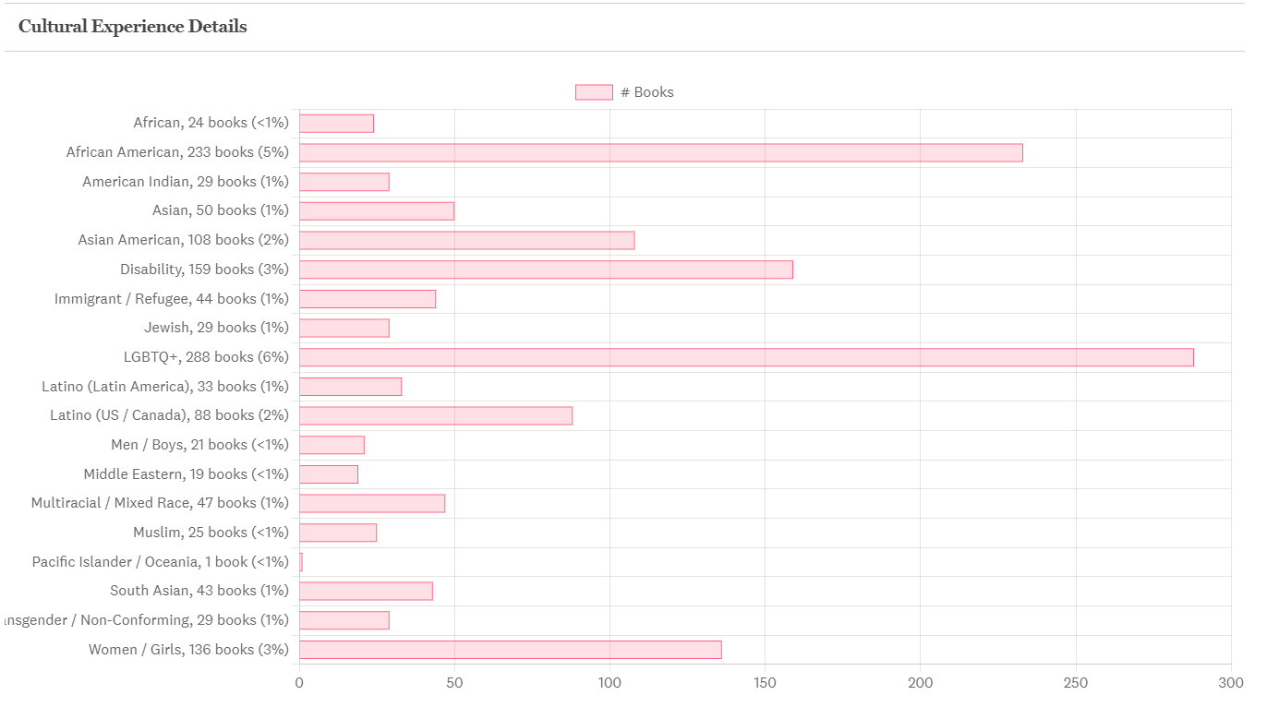

Rockwood Summit - St. Louis County Library Partnership
Evidence: student library card instructions, emails

The Rockwood Summit library provides access to supplemental resources that extend beyond the school community and help students connect with the global community. The St. Louis County Library is a key partner in providing these resources. Rockwood School District provides each student with a county library card that can be used to borrow digital materials (such as ebooks and audiobooks) and access digital content (including subscription databases). In partnership with St. Louis County librarians, the Rockwood Summit librarians have hosted classes for students to help them learn what resources are available through the county library. The Rockwood Summit library has also hosted youth outreach representatives from the County Library to support their reading programs and to curate reading lists for students.

Return to Table of Contents

Indicator #19: Program maintains policies, procedures, and practices as set by the local school board

(AASL—curate, engage)
Exemplary (2 points): Has an up-to-date policy (within the last five years) including all of the following:
- Fines/Damaged materials
- Challenged books
- Collection development
- Volunteers
- Donations
- Borrowing policy
- Inventory
- Acceptable use
- Confidentiality
- Intellectual freedom
- Weeding

Approaching (1 point): Has an up-to-date policy (within the last five years) including nine of the following:
- Fines/Damaged materials
- Challenged books
- Collection development
- Volunteers
- Donations
- Borrowing policy
- Inventory
- Acceptable use
- Confidentiality
- Intellectual freedom
- Weeding

Required Documentation/Evidence

Link(s) to policies

Supporting Evidence
Insert Applicable Links Here:

Insert Documents/Narratives:

The Rockwood Summit High School library meets the expectations for a score of EXEMPLARY in indicator 19 because the library program has an up-to-date policy (within the last five years) including all of the following: Fines/Damaged materials, Challenged books, Collection development, Volunteers, Donations, Borrowing policy, Inventory, Acceptable use, Confidentiality, Intellectual freedom, Weeding. For this indicator, Rockwood Summit librarians have selected the following pieces of evidence: Rockwood School District library handbook.

Rockwood School District Library Handbook
Evidence: link to handbook

The Rockwood School District’s library handbook provides evidence that the Rockwood Summit library program maintains policies, procedures, and practices set by the local school board.

This handbook can be found here:

RSHS Library webpage (link to handbook at the bottom of this page):
https://www.rsdmo.org/Page/4230

(direct link to handbook):
https://drive.google.com/file/d/1TxEbuPrL9-tcUdt5TX_2iBqFy9u9_oRJ/view?usp=sharing

Return to Table of Contents

Staffing

Indicator #20: Program maintains an appropriate librarian-to-student ratio

(AASL—include, inquire)
Exemplary (2 points): Exhibits the following:
- 1.0 full-time librarian assigned full time to a library in a school* with a student population of 1-750
- 1.5 full-time librarians assigned full time to a library in a school* with a student population of 751-1,500
- 2.0 full-time librarians assigned full time to a library in a school* with a student population exceeding 1,500

Approaching (1 point): Exhibits ratio of one full-time librarian assigned full time to a library in a single school*

*Because of the variety of library/school configurations among Missouri schools (one library for two campuses, two libraries on a single campus, etc.), applicant must include a description of the configuration in his/her school and explain how all stakeholders are sufficiently served within this configuration. Library staffing must be such that the library is open to students at any time during the regular school day.

Required Documentation/Evidence

Written verification from school or district administration regarding student access to library at any time during the regular school day in addition to librarian’s required description of configuration (see above)

Supporting Evidence
Insert Applicable Links Here:

Insert Documents/Narratives:

The Rockwood Summit High School library meets the expectations for a score of EXEMPLARY in indicator 20 because the library program exceeds the following expectations:
- 1.0 full-time librarian assigned full time to a library in a school* with a student population of 1-750
- 1.5 full-time librarians assigned full time to a library in a school* with a student population of 751-1,500
- 2.0 full-time librarians assigned full time to a library in a school* with a student population exceeding 1,500
For this indicator, Rockwood Summit librarians have selected the following pieces of evidence: a description of the Rockwood Summit library; written verification from school or district administration regarding student access to the library at any time during the regular school day in addition to the librarians' required description of configuration.

Rockwood Summit Library Description
Evidence: n/a

Rockwood Summit High School serves 1,303 students in grades 9‐12. The library media center is open daily from 7:30am to 4:15pm (M-Th) and 7:30am-3:30pm (F) and is staffed by two full-time certified library media specialists and two part-time library assistants. The high school library operates on a flexible schedule and teachers may book time in the two computer labs, two classrooms, main area, and media production room. Students are welcome to visit the library media center before and after school, during the day with a pass from their teacher, or during their lunch block. The LMC has four SmartBoards used for instruction and more than seventy desktop computers available for student use, providing access to the internet, library catalog, and various subscription databases. The students also have access to Destiny resource lists, which allow the librarians to curate focused collections of print and digital resources. In addition, the library staff provide support for the school’s 1:1 Chromebook program. The library media specialists regularly collaborate with teachers on research and technology projects, including 3D printing and media production. The library media specialists encourage literacy by providing and promoting well-reviewed and high interest materials, offering reading incentive programs, and facilitating the school’s summer reading program.

Rockwood Summit Building Principal Written Verification
Evidence: PDF of statement of verification

The included PDF of a written statement of verification from Dr. Emily McCown, principal of Rockwood Summit High School, is evidence that the Rockwood Summit library program exceeds the standard set for EXEMPLARY in this indicator.

Return to Table of Contents

Indicator #21: Program maintains an appropriate library support staff-to-librarian ratio

(AASL—include, inquire)
Exemplary (2 points): Has one full-time paraprofessional library support staff per librarian without additional outside duties during instructional day to ensure the library is open to students and staff through the entire school day

Approaching (1 point): Has equivalent of one paraprofessional library support staff per librarian performing library-related duties in the library a minimum of 75% of the instructional day to ensure the library is open to students and staff through the entire school day

Required Documentation/Evidence
Written verification from school or district administration verifying paraprofessional hours and library accessibility hours

Supporting Evidence
Insert Applicable Links Here:

Insert Documents/Narratives:

The Rockwood Summit High School library meets the expectations for a score of EXEMPLARY in indicator 21 because the library program has one full-time paraprofessional library support staff per librarian without additional outside duties during instructional day to ensure the library is open to students and staff through the entire school day. For this indicator, Rockwood Summit librarians have selected the following pieces of evidence: a description of the Rockwood Summit library’s support staff; written verification from school or district administration verifying paraprofessional hours and library accessibility hours.

Rockwood Summit Library Support Staff Description
Evidence: job descriptions

Rockwood Summit High School serves 1,303 students in grades 9‐12. The library media center is open daily from 7:30am to 4:15pm (M-Th) and 7:30am-3:30pm (F) and is staffed by two full-time certified library media specialists and two part-time library assistants. Additional support is provided by an instructional technology resource teacher and a technical support specialist. Combined, these four support staff surpass the standard set for exemplary (one full-time library support staff per librarian) in this indicator:
- Lead Library Assistant: 30 hours a week, 7:30am-3:30pm, 4 days a week, with a half hour for lunch. The Lead Library Assistant can work an additional 20 hours per year on days students are not present. She usually works these hours just prior to the first day of student attendance and the day after students are dismissed for the summer.
- Library Assistant: 14 hours a week, 8:00am-3:30pm, 2 days a week, with a half hour for lunch.
- Instructional Technology Support Specialist: full time, flexible scheduling split between Rockwood Summit and another high school
- Technical Support Specialist: full time at Rockwood Summit

This level of staffing allows the library to offer a flexible schedule and flexible access. The full-time technical support specialist takes care of student Chromebook repairs and many other tech support responsibilities that librarians in other districts are responsible for. The Instructional Technology Support Specialist is available to meet with teachers by appointment. He also has “office hours” in our library once or twice a week; teachers can drop by for help then, too. Having a library assistant before school and during the school day five days per week allows the librarians to collaborate with teachers. Moreover, teachers may sign up to bring their classes to use one of the two computer labs or one of the two classroom areas in the library. Teachers may also send small groups of students to the library to check out books or work on a media project such as WeVideo. Students may visit the library before school, after school, and at lunch without a pass. They may visit the library during class time with a pass from their teacher.

Rockwood Summit Building Principal Written Verification
Evidence: PDF of statement of verification

The included PDF of a written statement of verification from Dr. Emily McCown, principal of Rockwood Summit High School, is evidence that the Rockwood Summit library program exceeds the standard set for EXEMPLARY in this indicator.

Return to Table of Contents

Appendix

Return to Table of Contents

