Exemplary School Library Program Application

Welcome to the opportunity to showcase your school library through the Missouri Department of Elementary and Secondary Education’s Exemplary School Library Program. Please read through the application carefully. If you have any questions, please contact Lisa Scroggs, DESE assistant director of English language arts, at lisa.scroggs@dese.mo.gov.

Table of Contents

- Applicant Information
II. Instruction
Completed
Indicator 1 Differentiated Instruction
Indicator 2 Planning Time
Indicator 3 Types of Literacy
Indicator 4 Assessment
Indicator 5 Academic Learning
III. Leadership
Completed
Indicator 6 Professional Development
Indicator 7 Professional Development Opportunities
Indicator 8 Educational Leader
Indicator 9 Communication and Collaboration
Indicator 10 Stakeholder Relationships
Indicator 11 School Improvement Plan
IV. Library Environment
Completed
Indicator 12 Physical Space
Indicator 13 Program Opportunities
Indicator 14 Current Technologies
V. Library Management
Completed
Indicator 15 Flexible Scheduling
Indicator 16 Program Evaluation
Indicator 17 Budget
Indicator 18 Collection
Indicator 19 Policies and Procedures
VI. Staffing
Completed
Indicator 20 Librarian-to-Student Ratio
Indicator 21 Library Support Staff-to-LMS Ratio
VII. Appendix

Form

Applicant Information
Librarian First and Last Names:
Joy Corwin

Co-Librarian First and Last Names:
Jill Lemons

School Contact Email for Librarian:
jchslibrary@jcschools.us

School Contact Email for Co-Librarian:
Jill.lemons@jcschools.us

School District:
Jefferson City School District

School:
Jefferson City High School

School Address:
609 Union Street
Jefferson City, MO 65101

Link to School Librarian’s DESE Library Certification (access your certification account portal at https://apps.dese.mo.gov/weblogin/login.aspx). Please do not provide link to your certificate through your portal as evaluators will not be able to access it without your password. Instead, either save your certificate to an accessible link or provide a screenshot of your certificate below:
Certificates removed prior to publication of this application on DESE website.

Return to Table of Contents

Instruction

Indicator #1:
Program regularly delivers differentiated instruction, either directly provided by the librarian or in collaboration with the classroom teacher

(AASL—collaborate, engage, explore, inquire)
Exemplary (2 points): Exhibits research-based instructional practices in the consistent application of differentiated instructional design

Approaching (1 point): Exhibits research-based instructional practices in the application of differentiated instructional design

Required Documentation/Evidence

Lesson plans or anecdotal evidence exhibiting instructional theory or practices including differentiation, i.e. physical needs, learning styles, skill levels, etc. (Examples: Marzano instructional practices, Kagan cooperative strategies, assistive technology in use, multiple intelligences)

Supporting Evidence
Insert Applicable Links Here:
JCHS Main Library Page: https://www.jcschools.us/domain/713
Tutorials: https://www.jcschools.us/domain/2875

Insert Documents/Narratives:

The JCHS Library regularly and consistently differentiates instruction for our varied student body.
Tutorials on our website aide in helping students who may need information delivered differently based on their learning styles. Specifically, tutorials on how to use our library management system and our e-book system aide students with digital support. These tutorials meet the needs of multiple learning styles using the VARK model. These websites are used by students 9-12 based on individual student needs. When delivering similar instruction to classes who visit the library, we offer information in order to accommodate different modalities of learning. Our Jay Time 9th graders, for example, all visit during the month of September for orientation to the library, and these students will receive the information in ways that represent all four of the learning styles: visual, auditory, reading/writing, and kinesthetic. We prepared a library scavenger hunt that allowed students of all learning styles to work together to attain mastery of the skills needed to navigate their new library.

On our website, we have assignments on facets of Digital Citizenship like Geotagging, Cookies, etc. that teachers are encouraged to use or to invite us to lead or partner with them in teaching to their students. Teachers may request that we also come to co-teach any of these lessons or lead the lesson for a class. These assignments also serve the needs of various learning styles and require the students to use many of the Marzano strategies such as comparison, contrast; homework and practice; cooperative learning, and non-linguistic representations. We are including a PDF of one of the lessons here as representative of the ones available. All of the assignments are linked on our tutorial page, and any teacher in our domain may access the documents with all of the links.

Thorough our library management software Destiny Discover by Follett, we create collections to allow for differentiation in various ways. For example, we have a collection entitled “Quick Reads” which teachers and librarians may utilize when helping students search for titles with a lower Lexile or because an assignment requires a shorter text. In addition, we have collections for college bound students and Advanced Placement students. This also allows for differentiation. Some teachers, for example, will request students to check out a "quick read," knowing that a particular student needs a book with a certain Lexile level. All of our English I, English II, and English III classes have students select a book for free choice, independent reading, and this is one of the ways we differentiate for classes and within classes. The senior elective courses, dual credit courses, and AP English Literature and Language courses utilize the collections for the college bound, and we teach them how to use the system to find the titles they need for their assignments.

We have several forms of assistive technology through our database selections. For example, Gale Student Resources allows students to enlarge the text, translate documents into another language for ELL learners, have the text read to them. Another important feature for special education teachers and students is the advanced search option that allows searching by Lexile score. Through our eBook platform, Sora, we offer many of the same titles in audio and print for students who need to receive the information in multiple ways. Also, Sora has a font for dyslexic students to assist them in reading text.

Our technology center offers differentiation in the devices and applications required. For special education students in our self-contained classes, iPads better meet the needs of those differently abled. For other mainstreamed students, iPads are available for teacher and student checkout.

For a further representation of the lessons we offer to students in our building, refer to the menu of options in the PDF below. Since at the secondary level we have a completely flexible schedule, teachers may request these lessons at any time or collaborate with a library media specialist to create a lesson tailored to the curricular needs of the students in their classrooms.

To demonstrate how we differentiate using one of the lessons from the menu of options:
For our "Importance of Reading" lesson listed in the menu of option above, students who are more tactile and logical benefit from the use of data and numbers written on laminated cards which propel our discussion of the physical and emotional health benefits of reading. (See copy of lesson plan) This lesson has been used with particular success with our ELL students.

To give you some idea of how often we offer lessons that require differentiation such as in the examples above, to date this school year, we have had 199 teachers either visit the library for lessons or request a librarian to assist them in their classrooms. 777

Return to Table of Contents

Indicator #2
Librarian has adequate planning time to curate, plan, and develop instruction and instructional resources.

(AASL—collaborate, curate, inquire)
Exemplary (2 points): Is provided a minimum of 50 uninterrupted minutes of plan time per day existing in a flexible format throughout the week

Approaching (1 point): Is provided a minimum of 50 uninterrupted minutes of plan time per day existing in a fixed or hybrid (combination of flexible and fixed) format throughout the week

Required Documentation/Evidence

From a list provided in the application, the librarian will select the appropriate descriptor best reflecting plan time.
- Minimum of 50 uninterrupted minutes per day; flexible schedule
- Minimum of 50 minutes per day; flexible schedule
- Minimum of 50 uninterrupted minutes per day; fixed or hybrid (combination of flexible and fixed) schedule
- Minimum of 50 minutes per day; fixed or hybrid (combination of flexible and fixed) schedule
- Less than 50 minutes per day

- Minimum of 50 uninterrupted minutes per day; flexible schedule
- Minimum of 50 minutes per day; flexible schedule
- Minimum of 50 uninterrupted minutes per day; fixed or hybrid (combination of flexible and fixed) schedule
- Minimum of 50 minutes per day; fixed or hybrid (combination of flexible and fixed) schedule
- Less than 50 minutes per day

Return to Table of Contents

Indicator #3
Program addresses effective and ethical engagement in multiple types of literacy through instruction (examples of types of literacy: digital, media, technology, information, financial, traditional—among others)

(AASL—engage, explore, inquire)
Exemplary (2 points): Exhibits strong evidence of the creation of a critical thinking environment through instruction in five or more types of literacies utilizing state-of-the-art and emerging technologies

Approaching (1 point): Exhibits evidence of literacy instruction in four types of literacies utilizing state-of-the-art and emerging technologies
Required Documentation/Evidence

One piece of evidence exemplifying each type of literacy taught through instruction. Examples may include descriptions of programming, descriptions of lessons, lesson plans, professional development for educators, parent instructional communications (i.e. how to use EBSCOhost from home or safe digital practices), photos of instructional practices, etc.

Supporting Evidence
Literacy Example 1: Type of Literacy: Digital

Digital Literacy has three major components: finding and viewing digital content, creating digital content, and communicating the content with others.

To ensure that our students are digitally literate, we find many ways to create learners who are able to do all three of the major components of digital literacy. One example of how we educate students on finding and viewing digital content is when classes come in to learning about our eBook, digital magazine, and audiobook platform Sora. Each student follows us on their own Chromebooks to ensure all know how to find and view the content as well as alter reading settings to allow for personal needs and preferences.

An example of how students create digital content is when our Sociology teacher teamed with a librarian on a project on the influences of socialization in adolescents today. Students had to first find and view digital content over one of the following five socialization influences: economy, religion, school, media, family, and government. Then, using both Canva and Google Slides, students created content for both a presentation of 8-12 minutes and an infographic that required them to analyze, classify, and categorize the information.

The sociology example also above also meets the component of communicating the content with others. Another example that meets this criterion is the American History photo project. In this activity, students do a reverse image search on a famous American photograph, research the time period surrounding the photo as well as the photographer, and then record a presentation of the information to share with others via Google Classroom. Students also create an annotated bibliography for this assignment where they evaluate the sources they have found, including the digital resources, using the lesson the librarians share with them about how to create an annotated bibliography.

Literacy Example 2: Type of Literacy: Informational

We regularly teach students in our AP Biology, Astronomy, and Geology classrooms how to find peer-reviewed sources for both weekly current event projects and analysis of published scientific studies. For the current event projects, students learn how to use our access and utlize our digital subscriptions to magazines as well as analyze a website for validity for scientific findings. For the academic journal analysis, Students create advanced searches in Ebsco Explora and Gale Student Resources to narrow their findings and critique the articles using criteria created by the teacher and the librarian to meet the assignment’s needs. Students have to complete close reading assignments of peer-reviewed articles that they find, also learning about the steps of the scientific process.

Hyperdoc shared with students to direct research for AP Biology:

Literacy Example 3: Type of Literacy: Media

Understanding the underlying messages of various medium is an important life skill for all, and JCHS Library meets this criterion in many ways.

Our library exhibits exemplary status of this indicator through regular instruction in the library and classrooms of our school. An example is when our English I departmental team requested librarians to design and teach a lesson on bias before the students began their persuasive essay. Using a Nearpod lesson, students were able to interact with information presented in a state-of-the-art technology to learn how to detect bias when researching for their upcoming papers. Then, when students arrive to the library to research for their individual project, we showed them how to use our technology to access various databases that we offer to the students for research such as Gale Opposing Viewpoints and Facts on File Issues and Controversies. Once students access the databases, they use their previous knowledge for the Nearpod lesson to evaluate their findings.

Using the Nearpod lesson (see link below), each student was able to interact using a Chromebook with the interactive lesson concerning media messages and media bias. Students were then able to apply their new critical thinking skills to the research process.

Literacy Example 4: Type of Literacy: Multicultural

Multicultural Literacy is the ability to find similarities and differences between one’s own culture and those of another culture. These parallels may be in in beliefs, customs, or values.

JCHS Library supports the education of multicultural literacy throughout the school year. One of the ways we were asked to assist in the classroom in an instructional capacity this year was when a Spanish instructor asked us to help her students use technology to find current events in Hispanic countries for weekly assignments. The students came to the library to find out how to use their Chromebooks and our online resources to find current events that would allow them to better understand the culture of those living in countries around the world. Students were encouraged to use World Geography and Culture Online to find photos and current events. Two other resources students were encouraged to use were Gale Student Resources and Ebsco Explora; using these databases for this assignment required students to know how to do advanced searches to get the most current events and the reliability and accuracy of these articles was compared to those we found on Google doing an advanced search. Students were able to determine what sources were most helpful and reliable through this process using critical thinking.

In addition to instructional support of multicultural literacy, our program supports diversity throughout the year through analyzing our collection using diversity audits. These audits direct our curation of resources. Part of our current Professional Growth Plan reads: “curates materials from diverse perspectives in order to reflect our student population and actively eliminate bias in our collection.” This school year, we have made goals including the following:

1. Based on the diversity audit, JCHS Library will purchase titles during the school year for the library collection where our audit shows low percentages of representation. At the end of the year, the diversity audit will show a growth of 1-3% in each of the subgroups that fall below the diversity audit of our school.
2. In addition, in our Online Card Catalog Destiny Discover, JCHS Library will create or add to collections that celebrate diverse groups and experiences under-represented groups: including Asian and Pacific Islanders, Hispanics, intellectually disabled persons, those who suffer from mental illnesses, and more.
We will create at least four new digital collections and add to the already created collections of LGBTQ and African-American Spotlight. We will promote these collections through classroom visits, virtual displays, and library displays.

Diversity Audit from TitleWise:

We also choose professional development opportunities such as the Perma-Bound author series linked here to keep abreast of discussions, literature, and authors in the field of multicultural literacy. For our book clubs throughout the year, we choose diverse books by authors from various backgrounds and ethnicities to ensure students read a wide array of books. Through the discussions with students, we are able to have meaningful discussions about the books, authors, society as a whole, and how we all contribute to a tolerant society.

Literacy Example 5: Type of Literacy: Traditional Literacy

Traditional literacy encompasses reading, writing and understanding text.

One of the most frequent ways that JCHS library supports traditional literacy is through our book tastings. Many classes come to the library for book tastings, a way students choose materials for recreational reading or independent reading in the classroom. Students arrive to find books from various genres on our tables. Students then rotate throughout the tables based on a timer and are encouraged to metaphorically “taste” the books: reading the front, back, first paragraph, etc. to determine if the books meet their needs for reading. Both before and after the book tastings, librarians show students how to use the library technological resources to find their preferred genre using our online card catalog and its various features. We also do book talks and encourage students to recommend favorite authors and titles to their classmates. During these book tastings, students learn how to use the more advanced features of the technology available in our online card catalog.

Students are also encouraged to write book reviews, fulfilling another component of traditional literacy, and we show them how to add online reviews of the books they choose. At the culmination of each book club we host throughout the school year, all members of the book club write a book review to share on Destiny Discover.

Sample entries of book reviews:
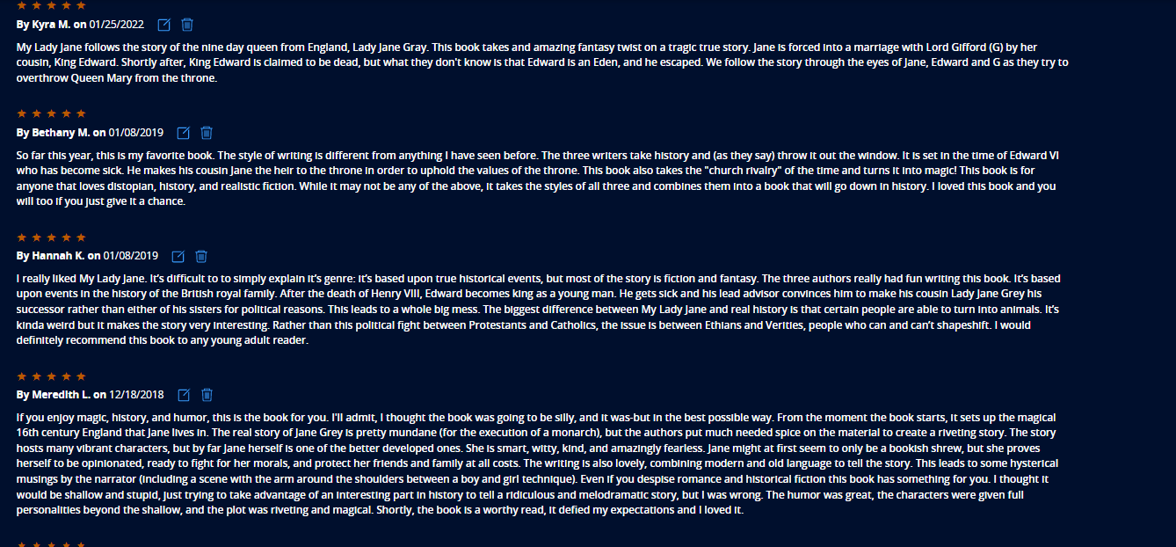

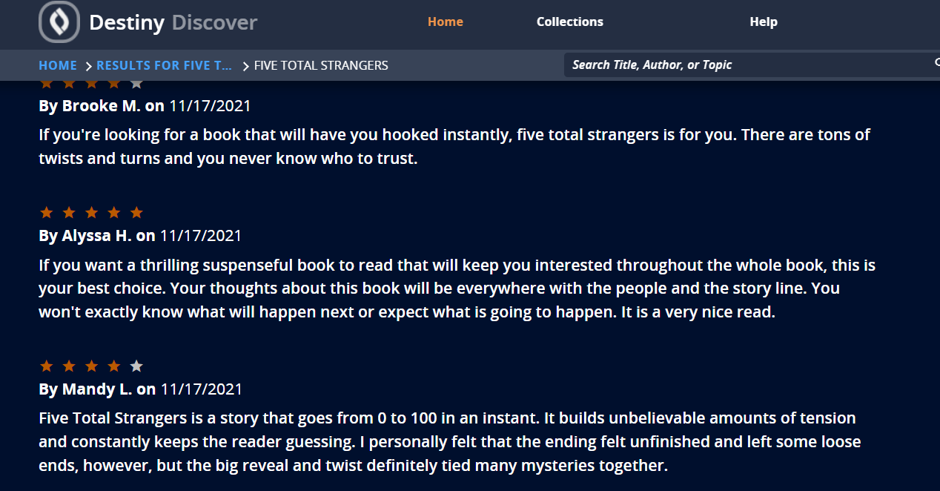

Literacy Example 6: Type of Literacy: Technology

Technology literacy is the ability to effectively use technology in a digital environment to create or communicate.

Our school is a one-to-one with Chromebooks, and our technology center supports our students on a daily basis with individual one-on-one help, constantly helping students and staff who visit with questions and concerns. Two of the four people in our Library Media Center are assigned to the technology center with the purpose of supporting the digital education of our students and staff. Students come to them for help with all of the apps and platforms that our district supports. In addition, the technology center offers students instruction in digital citizenship, recording practices, and support for all apps in the Google Suite.
Technology Center Website Link

In addition to the valuable one-on-one help, parents, staff, and students have full access to our district resource links: https://www.jcschools.us/domain/43
The resources available here help students and parents in the practical use and troubleshooting of their devices including help for when schools have a closure: https://www.jcschools.us/Page/17593

Our Technology Center is always looking for ways to educate students on technology matters whether that be how to use a Chromebook, the significance of social media, or digital citizenship. See attached picture of a display that has led to individual conversations and lessons with students who visit the Tech Center.
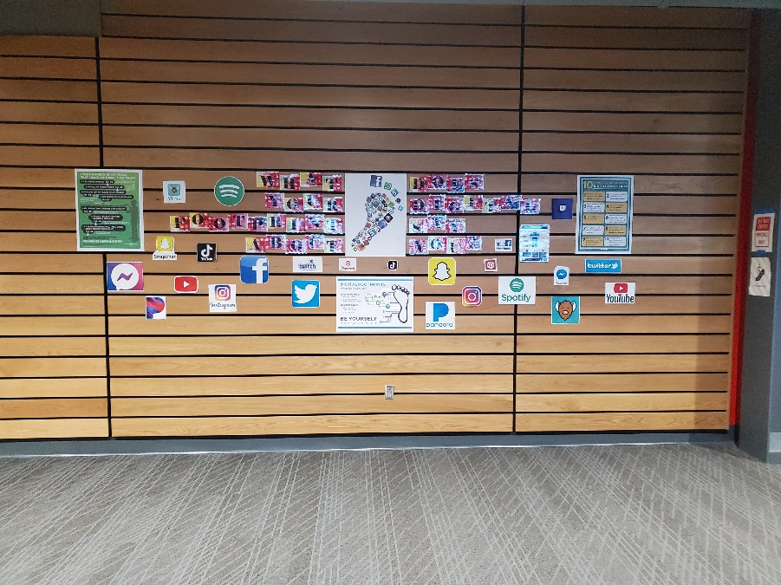

Optional Narrative:

Return to Table of Contents

Indicator #4
Program shows evidence of student growth through assessment

(AASL—collaborate, inquire)
Exemplary (2 points): Regularly assesses the impact of instruction through documented, varied, high-quality formative and summative assessments.

Approaching (1 point): Assesses the impact of instruction through documented formative and summative assessments

Required Documentation/Evidence

Five assessment samples (including formative and/or summative assessments); at least two samples must be connected to the same unit of study and represent varied formats. Samples may be provided in various formats: photos, documents, etc.

Supporting Evidence
Assessment Example 1: Formative: For Sociology, librarians collaborated with the teacher to introduce research skills on finding information on significant early innovators to the establishment of Sociology as a study. Students were surveyed to see their prior knowledge of resources available to them in the library. Librarians presented print and digital resources, including databases, available from the library. We discussed the types of resources, how to access them, and why they were superior to other resources found on the internet. Formative assessments were taken based on questioning students on their understanding of material presented and observation of student choice of resources in both print and electronic form. Librarians were then able to guide student choice to reputable and verified resources using databases instead of a general google search. A Works Cited slide was required in their summative project as well. Students were tasked to create a presentation (6 minutes) that addressed the critical questions including images, graphics, and citations from the resources accessed in the library. They were to develop 2 philosophical questions for discussion during their presentation to further enhance audience participation and consideration of new information. The final piece of the project was to find a modern day news article that dealt with a topic the sociology innovator would be interested in. Students were to explain the inferred opinion of their innovator in the presentation.

Assessment Example 2: Identify as formative or summative and include the unit of study

Summative: (9th & 10th grade) Spanish 1 Students were tasked to find out what is happening in the world. They were to link their current event in relevance from local, national, to global level in a Hispanic country. The library media specialists instructed the class on locating current events using our digital and print subscriptions to local and national newspapers as well as databases for access to global newspapers. Librarians conferred with individual students during their research time over two weeks and offered support throughout the project. Students completed a presentation along with a Works Cited slide detailing the sources used as their summative assessment.

Spanish 1 video
Assessment Example 3: Identify as formative or summative and include the unit of study

American History: Students use deductive reasoning to find circumstances surrounding a famous photograph from U.S. History. They conduct a reverse image search using clues from the picture their teacher presents to them when they arrive to the library. Then, students conduct research of the photographer and the historical context of the photograph. Formative assessments were conducted throughout the exploratory class period where students had to find clues in the photograph to determine its provenance. They created an annotated bibliography of the sources used while analyzing the information and validity of sources for the famous photograph as a summative project for American History.
Sample famous historical photograph used for project:
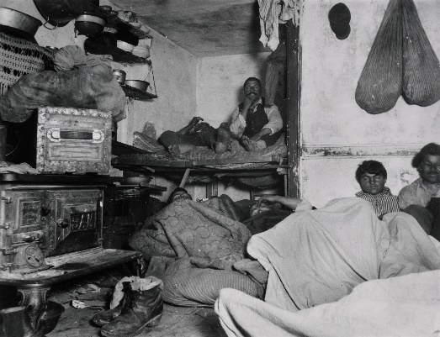

Student example:

Assessment Example 4: Identify as formative or summative and include the unit of study

For English I and II classes, librarians introduce, model, and assess student management of library resources. Students learn how to search for resources, how to cite resources, and judge sources for credibility and relevance to topic. Librarians surveyed students with a google form to see what information they knew and used the data to drive our instruction for the research unit.
We introduced students to our website and its many links and resources including Destiny Discover. They learn how to use Destiny for collections created for class projects. They also learn how to get citation information for the books the library has that they use for projects. Students learn how to use various database resources such as Gale Student Resources, Ebsco Explora, Facts on File Issues and Controversies, etc. Librarians model and demonstrate how to find information, use the highlighting and note-taking features as well as assist students in logging in using their Gmail accounts so that articles and images may be sent directly to their Google Drives. Formative assessments are conducted throughout the research projects to determine student mastery of creating a Works Cited page, conducting varied research on a chosen topic, and collecting and saving the appropriate research information. Summative assessment of the project is the student’s individual research essays.

Assessment Example 5: Identify as formative or summative and include the unit of study

Formative & Summative: 9th through 12th grade write reviews for Book Club on Destiny Discover.
Students involved in a book club for three or more weeks are required to publish a book review on Destiny Discover to receive credit. The initial student reviews from students were used as a formative assessment. Their work left much to be desired and first draft examples are included below. This prompted our lesson on what a review should include or provide to the reader. Students brainstormed ideas and then looked for reviews on Goodreads that they felt were exceptional. Students then reviewed their initial work and drafted a second review for peer edit before editing and submitting their review to Destiny Discover. The review is used as a summative assessment piece at the conclusion of the book. Participants are working toward the Jay Readers Award. For this distinction, students must complete at least two book clubs along with other requirements to receive the Jay Readers Award at the end of the school year.

Jay Readers Award Requirements

Optional Narrative:
Both Example 4 & 5 utilized the Library Unit of Study regarding the use of our OPAC Destiny Discover and serve as at least two samples that must be connected to the same unit of study and represent varied formats.

Return to Table of Contents

Indicator # 5
Program supports student mastery of the essential academic learning requirements and state standards in multiple subject areas

(AASL—collaborate, curate, explore, inquire)
Exemplary (2 points): Establishes collaborative partnerships within and outside of the school community to support multiple subject areas in the mastery of student achievement and the enhancement of life-long learning

Approaching (1 point): Establishes support to multiple subject areas in the mastery of student achievement through the provision of high-quality, relevant resources

Required Documentation/Evidence

Anecdotal evidence expressing the nature of study, collaborative partner, curriculum addressed, and the collaborative nature with which the librarian was involved. An example could be collaborating with the science teacher to provide microscopes and slides of various materials within the library as an exploratory center in an effort to enhance the study of cells. An inclusion of the curricular objective of cell study would be included. Five examples should be submitted, each from a different subject area along with coding of relevant standard(s) from the Missouri Learning Standards.

(Other examples: collecting books for a unit of study; hosting a presenter on a topic; developing lesson plans supporting research goals; planning collaboratively with a public library)

Supporting Evidence
Support Example 1: Identify subject area, Missouri Learning Standard(s) coding, and other required documentation.

The Jefferson City School District began a new partnership in the fall of 2021 with Missouri River Regional Library to more than double our eBook and periodical offerings through Sora, our Overdrive eBook and audiobook provider. Students who sign on to Sora through their Jefferson City account now are able to check out eBooks, audiobooks, and periodicals from the public library as well. We continue discussions with Missouri River Regional Library to offer interlibrary loan of print materials as well. We hope to have this in place by the end of the 2021-2022 school year. This partnership supports the goal of creating lifelong learners and readers in our school and community.
This collaboration supports the curriculum of all courses as students may search for resources for any course; however, the partnerships especially supports these Missouri Learning Standards:
ELA.RL. 1-3
Reading Literary Text
    - Comprehend and Interpret Texts (Approaching Texts as a Reader)
    - Analyze Craft and Structure (Approaching Texts as a Writer)
    - Synthesize Ideas from Multiple Texts (Approaching Texts as a Researcher)

ELA.RI.1-3
Reading Informational Text
- Comprehend and Interpret Texts (Approaching Texts as a Reader)
- Analyze Craft and Structure (Approaching Texts as a Writer)
- Synthesize Ideas from Multiple Texts (Approaching Texts as a Researcher)

Support Example 2: Identify subject area, Missouri Learning Standard(s) coding, and other required documentation.

The art department uses the library space as an exhibit for their sculptures, paintings, and projects throughout the year. This collaboration has been beneficial for the students and the instructors as having a common area as an exhibit for their work. It also has resulted in student interest in the library space as well as exposure for other exhibits and displays that we have. The JCHS Library hosted an art show during the month of February where classes were able to come in throughout the school day to view the artwork of their peers. During parent/teacher conference night on February 17, parents and community members were also invited to the library to see the art show. Events such as this with parent, building, and community support meet the indicator objective of enhancing lifelong learning.

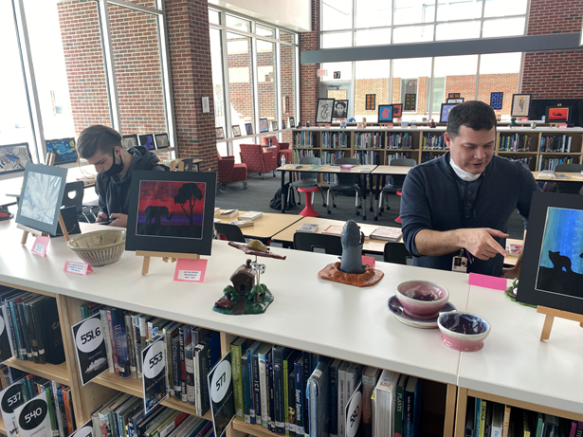

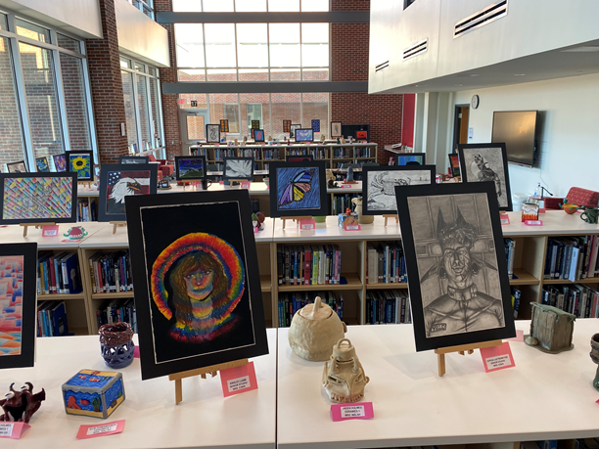

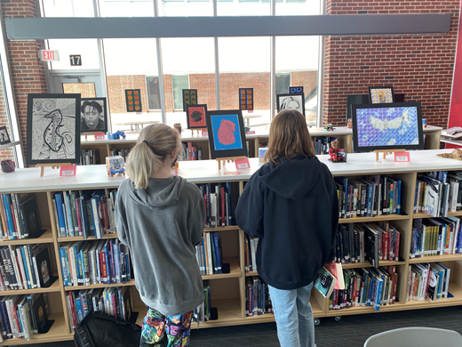

Visual Arts: Pr4.1.III
Critique, justify, and present choices in the process of analyzing, selecting, curating, and presenting artwork for a specific exhibit or event
Support Example 3: Identify subject area, Missouri Learning Standard(s) coding, and other required documentation.

The health teachers asked for a partnership with the librarians when students began their units on alcohol abuse and drug abuse. The instructors asked the library media specialists to create a lesson helping students find credible and reliable resources, to pull resources for student use both in the library and in the classroom, and to help students create Works Cited entries for their projects. As the lesson progressed, one of the health teachers was concerned about negative aspects of the topic on students, so we brainstormed to find ways to focus student research on organizations and groups that help people addicted to drugs and alcohol, and we made that one of the research aspects of the project.

National Health Education Standards – The NHES are written expectations for what students should know and be able to do by grades 2, 5, 8, and 12 to promote personal, family, and community health.

Standard 1: Students will comprehend concepts related to health promotion and disease prevention to enhance health.
Standard 2: Students will analyze the influence of family, peers, culture, media, technology, and other factors on health behaviors.
Standard 3: Students will demonstrate the ability to access valid information, products, and services to enhance health.
Health Education GLE’s: Substance Education C. Substance Use vs. Non-Use
Evaluate the short and long term effects of alcohol, tobacco, and other substances on the body (e.g., changes in mood, thought processes, mental ability, coordination, reaction time) and draw conclusions on the impact of these substances on personal, social, and economic threats to society
Review healthy alternatives to substance use and investigate effective strategies to promote individual, family, and community health
Assess the risk of chemical dependency and locate available help if alcohol, tobacco, and other substance use becomes a problem
Evaluate personal risks for chemical dependency based upon personal, family, and environmental factors

Support Example 4: Identify subject area, Missouri Learning Standard(s) coding, and other required documentation.

A social studies teacher partnered with the librarians on his historical photograph unit where students are given a famous historical photograph and have to find the historical context, the photographer’s biography, and present the photograph and the information to the class. The librarian gives students a lesson and demonstration on how to make visual inferences with a historical photograph, how to use key search terms to find the image, and then demonstrates a reverse image search. Students then use the library resources to complete the information on the biography on the photographer and the historical context of the photograph as well as an annotated bibliography of the sources which includes upper levels of thinking in analysis and evaluation.

Missouri Learning Standards: SS.9-12.AH.4
Social Studies 9-12, American History:
Apply the economic concepts of innovation, supply and demand, barriers to trade, labor, business cycle, credit, and wage gap to explain the causes of the Great Depression.
Describe the possible consequences, both intended and unintended, of government policies to improve economic conditions and increase productivity.
Describe the consequences, both intended and unintended, of government policies to improve individual and societal conditions.
Apply the economic concepts of innovation, supply and demand, international trade, labor, business cycle, and credit to evaluate global interdependence along with economic and security challenges.
Analyze patterns of immigration to determine their effects on economic, cultural, and political developments.

Support Example 5: Identify subject area, Missouri Learning Standard(s) coding, and other required documentation.

Librarians created HyperDocs with links for research using the library resources for multiple science courses: Astronomy, Geoscience and AP Biology. We collaborated with the teachers to determine which classes needed peer-reviewed academic journal articles, reference articles, or current events in the field. Librarians reviewed science units in Schoolnet, where our district houses all of our curriculum documents, in order to tailor the HyperDocs to each of the classes.

The documents and studies that the students found helped them meet the following learning standards depending on the classes listed above.

PS4.B.1
Communicate technical information about how electromagnetic radiation interacts with matter.
LS2.A.1
Explain how various biotic and abiotic factors affect the carrying capacity and biodiversity of an ecosystem using mathematical and/or computational representations.
LS2.B.1
Construct and revise an explanation based on evidence that the processes of photosynthesis, chemosynthesis, and aerobic and anaerobic respiration are responsible for the cycling of matter and flow of energy through ecosystems and that environmental conditions restrict which reactions can occur.
ESS1.A.2
Construct an explanation of the Big Bang theory based on astronomical evidence of light spectra, motion of distant galaxies, and composition of matter in the universe.
ESS1.A.3
Communicate scientific ideas about the way stars, over their life cycle, produce elements.
ESS2.A.2
Analyze geoscientific data to make the claim that one change to Earth's surface can create changes to other Earth systems.
ESS3.A.1
Construct an explanation based on evidence for how the availability of natural resources, occurrence of natural hazards, and changes in climate have influenced human activity.

Support Example 6: Identify subject area, Missouri Learning Standard(s) coding, and other required documentation.

Every year the library department of Jefferson City School District collaborates with the Missouri River Regional Library to host storytellers in all of our schools. Professional storytellers are recruited to perform at our schools to various groups of students. At Jefferson City High School, we have hosted storytellers every year that we have been able to do so. This year, our storyteller will visit in March. Students and classes may sign up to attend in the library. In the past, we have also had storytellers do a storytelling workshop with a group of students who are interested in the art of storytelling. This activity supports multiple Missouri Learning Standards:
ELA.RL.3.A

Compare and contrast the experience of reading a story, drama, or poem to listening to or viewing an audio, video, or live version of the same text, noting how a performance impacts personal interpretation.

ELA.SL.1.C
Review the key ideas expressed and demonstrate understanding of multiple perspectives through reflection and paraphrasing.

Interpret information presented in diverse media and formats (e.g., visually, quantitatively, orally) and explain how it contributes to a topic, text, or issue under study.

Fine Arts Theater Standards, Perform 4.A., Respond 7.A, Respond 9.A

Link to public library’s website information on storytelling: https://www.mrrl.org/event/storytelling-festival-program
In addition to performing at the schools, the storytellers perform at the public library.

Newspaper article about storytelling festival from a previous year with mention of Jefferson City High School. We are including this article since the festival for this year is in March which is after the submission deadline for this application.
News Tribune article

Optional Narrative:

Return to Table of Contents

Leadership

Indicator #6: Librarian provides professional development to teachers, staff, and/or other librarians.

(AASL—engage, explore, inquire)
Exemplary (2 points): Consistently facilitates intentional, purposeful professional development opportunities in a variety of formats

Approaching (1 point): Provides professional development opportunities upon request

Required Documentation/Evidence

List of professional development opportunities facilitated including dates and one-sentence descriptions of topic, purpose, and format. May include session evaluations.

Supporting Evidence
Insert Applicable Links Here:

Wakelet Page for JCHS Library

Insert Documents/Narratives:

The librarians of JCHS consistently facilitate intentional, purposeful professional development for our staff.

One of the librarians attended the recorded MLA webinar in January of 2022 providing information and clarity on the differences between the MLA 8th edition and the MLA 9th edition.
We then provided professional development to the English Department during their Department meeting on February 23, 2022.

The English I team asked for help in creating tutorials for students and teachers on how to use Prezi’s new feature for presentations and video-making. The librarians created and shared the videos with teachers for their use and for their students.
Using Prezi to Make Videos
Using Prezi to Make Presentations

Librarians send out a Google Form in the spring to prepare for our 6th annual Staff Summer Book Clubs. Librarians choose 4-5 contemporary titles for staff to choose from. Based on their survey responses, we will choose two books to offer for staff to read over the summer. We typically meet once in June and once in July to discuss the novels. This form of professional development is helpful in building staff and librarian relationships as well as giving teachers a time to read contemporary literature over the summer that they can use in their classrooms.

On September 19, 2021, a teacher in our world languages department requested help on recording options for her lesson. The request grew to a professional development opportunity for our world language department on how to use Screencastify for recording lessons. This type of professional development has been useful for our teachers during the COVID shutdowns, and they continue to request help with taping lessons even when we are in session so that they can practice a flipped classroom and help the many students who are on medical leave for COVID.

In addition to this professional development with Screencastify, in September of 2021 one of our instructional coaches requested that we offer assistance to a teacher who wanted to change a traditional paper project into a technology-based assessment. We helped the teacher in the transition for this assessment both on an individual basis and in the classroom as support on September 27, 2021.

We utilize Book Connections to help us with our personal professional development goals for 2021/ 2022 in our Professional Growth Plans. This service helps analyze collections, identify and bring to life diverse texts, and encourage reflection on cultural representation. This along with the Titlewise analysis is helping us grow our collection to better represent our student population. Along with this topic, we have provided and highlighted several book discussions to promote cultural awareness in our building with students and staff discussing topics such as anti-racism, white fragility, and other culturally sensitive topics. This has helped to promote dialog and community within our school.
We have tried to follow the same diverse book titles as used in the MASL book clubs.

We provide tech tool suggestions each month in our library newsletter Check It Out and then offer professional development opportunities for staff before and after school to learn and put the tools from the Teacher Corner into practice. Examples and dates are listed below along with the monthly newsletters detailing each month’s professional development topic.
For example, in October we presented information on Mote. This bit was featured in the newsletter to entice staff to come learn about Mote. Giving good quality feedback is one of the most important things you do for our students at JCHS! Because it’s so time-consuming, most teachers don’t give nearly enough. A tool like Mote makes it easier to give feedback faster. It’s a Google Chrome extension that lets you add voice comments in the comment field of any Google Doc, Slide presentation, spreadsheet, or inside the Google Classroom environment.
Teachers then came to sessions before or after school which provided opportunity to install the extension with support as well as have time to navigate and utilize Mote with their current classes. This also provided an open dialog between colleagues in best practice of use.
Most recently, we featured our professional development sessions on using Pear Deck. Imagine if you could engage every student in your class, every day. What if you could instantly see who’s confused and who’s ready for more? That’s the power of Pear Deck. And now, with the Pear Deck for Google Slides Add-on, you can add the magic of formative assessments and interactive questions to your presentations right from Google Slides.
Each month is a new professional development opportunity for staff.

During the planned early release professional development in March, the librarians will offer a breakout session for a Staff Book Tasting where staff will be able to peruse many of our titles that may pertain to professional development, curricular objectives, course offerings, and reading for enrichment. We will also offer book talks recommending several titles for personal and professional use.

Our technology center director presented to staff on the usage of the Clear Touch Panels installed in all classrooms for educational technology use. August 20, 2021

Our technology center director presented GoGuardian screen monitoring software for basic and advanced users. September 16, 2021

Our technology center director facilitated professional development about Google Meet in October of 2021. This has been a crucial training for staff since we have had so many absences due to COVID. This allows teachers ways to communicate with students who are quarantined to keep the up-to-date on the formative and summative assessments.

In November of 2021, the tech center director offered training on Diigo, a Chrome extension used to annotate text. Close reading annotation has been a focus of our building instructional strategies for the last couple of years. Helping teachers find tools to make annotation digital is essential for our school.

One of the librarians presented to K-12 library media specialists on the topic of "Book Clubs: Lighting a Fire for Reading they Can't Put Out" on August 19, 2021. Below are screenshots of a few slides from the Google Slides presentation.
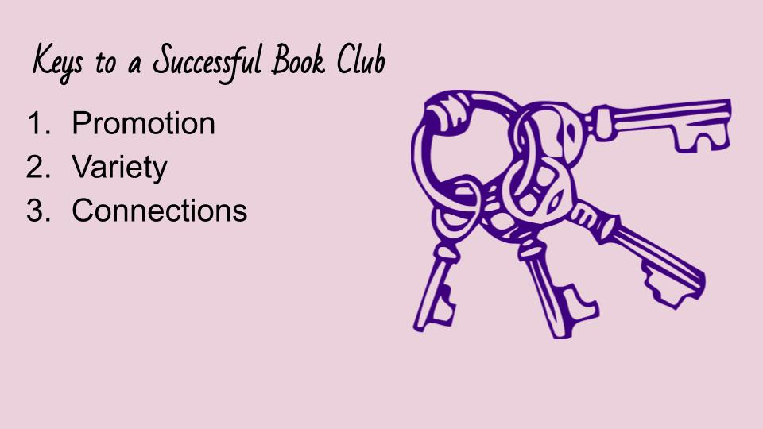
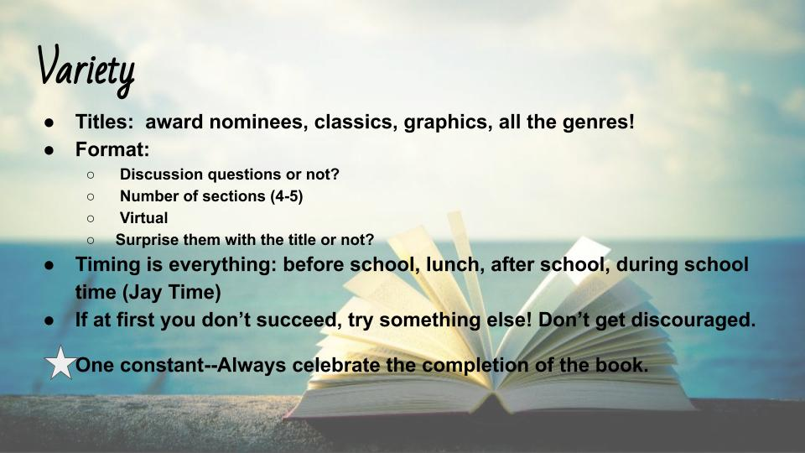
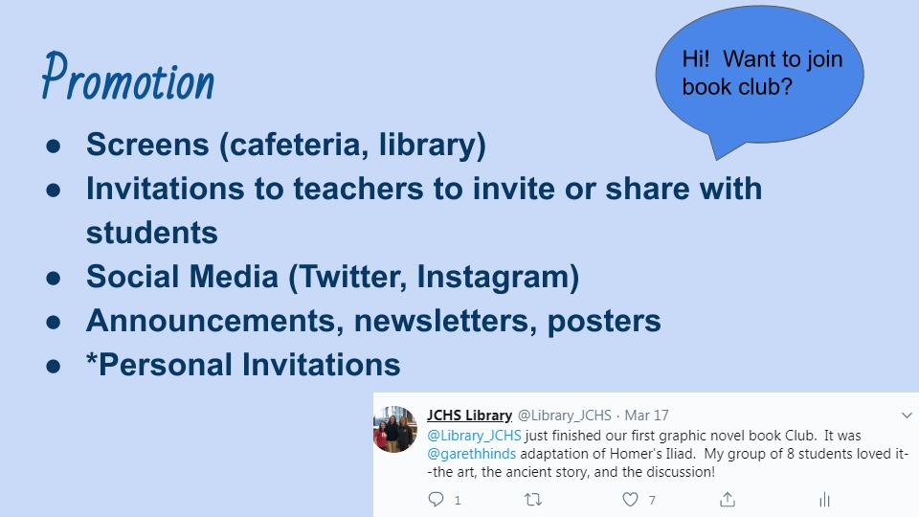

Return to Table of Contents

Indicator #7: Librarian attends professional development opportunities for librarians at local, state, and/or national level

(AASL—engage)
Exemplary (2 points): Attends multiple library-specific professional learning events per year, which may include but not be limited to conferences, workshops, webinars, podcasts, graduate courses

Approaching (1 point): Attends a minimum of one library-specific professional learning activity (outside of school-/district-provided professional development) per school year

Required Documentation/Evidence

Brief description of sessions attended (including title, date, sponsoring entity) and impact on library program

Supporting Evidence
Insert Applicable Links Here:

Both JCHS librarians will be attending the MASL state conference on April 10-12, 2022:
https://maslonline.org/2022-masl-spring-conference/

One of the JCHS Librarians attended School Library Journal’s Day of Dialogue on October 7:
https://www.slj.com/?event=school-library-journal-day-of-dialog-2021-fall

Webinar offered by Modern Language Assocation on February 1:
https://webinars.mla.org/webinar/whats-new-in-the-ninth-edition-of-the-mla-handbook/

Insert Documents/Narratives:

Both of the JCHS Librarians attend multiple library-specific professional learning activities throughout the school year offered nationally, state-wide, and locally.

The MASL conference (see link above) which we will attend April 10-12, 2022, will offer keynote speakers and breakout sessions on the most current trends in library science and library programming. From previous years, we know to expect to network with other librarians to revitalize our current programs and gain new information and techniques that will aide us in helping students achieve. Specifically, this year’s theme is “Amplify Voices,” so we look forward to finding ways to give students voice in their library.

One of the librarians (Jill) attended the School Library Journal’s Day of Dialogue virtually on October 7 (see link above). Many sessions focused on diversity and diverse authors which is also a facet of our Professional Growth Plan this school year, so these sessions in particular gave us ideas, vocabulary, and advice on incorporating more diverse titles as well as ways to present these diverse titles to our students in the most effective ways.

One of the JCHS librarians (Joy) attended two webinars offered by Overdrive with their Tuesdays with Sora series: Curation Master Class: Personalizing your Sora Explore Page on September 14 and Managing Your Digital Collection Throughout the Year on October 5. These webinars were helpful in giving us the tools to create new collections in Sora by using curated collections created by Overdrive as well as teaching us how to curate our own throughout the year to target specific student interests and needs. The facilitators gave practical advice and tips on how best to manage your collection to boost checkouts and meet the needs of many subgroups of students.

One of the librarians (joy) attended a webinar offered by the Modern Language Association on the changes in the MLA 9th Edition Handbook (see link above). This information informs us of the most up-to-date information on items pertinent to student composition and research including inclusive language, parenthetical documentation, manuscript formatting, changes in grammar and usage, etc. This information will assist us in helping staff and students working on research projects and essays in all subject areas.

At the district level, our Library Director has planned monthly professional development meetings for all librarians K-12 where each month we are given current articles over a topic in library science to read before we meet. Then, at the meeting, we discuss the topics and how they impact our district, our students, and our schools. Some of the monthly topics we have read articles about and discussed include: weeding, eliminating fines and fees, and incorporating diverse books and authors. Also at each meeting, three or four librarians present a positive facet of their library to the group: this might be a technique used for close reading, a way to get students engaged in reading over the breaks, or a way to more efficiently weed titles, just to name a few. See the PDF below for a sample agenda from on of these collaborative professional development meetings.

Return to Table of Contents

Indicator #8: Librarian functions as an educational leader in the school campus and district by serving on committees and/or cohorts

(AASL—collaborate)
Exemplary (2 points): Is consistently included in campus and district leadership planning

Approaching (1 point): Is occasionally included in campus and district leadership planning

Required Documentation/Evidence

Agendas/Minutes
Administrative statement about librarian’s role in planning
Librarian statement of involvement
- Exemplary could be multiple examples from both campus and district
- Approaching could be multiple examples from campus and/or district with a minimum of one example in each area

Supporting Evidence
Insert Applicable Links Here:

Insert Documents/Narratives:
Joy is a member of the Policy and Procedure committee for the district along with being a Lead Teacher in our building. Both of these roles are essential to the leadership in our district as well as our building. She meets monthly for both positions. Her participation allows us crucial knowledge to building and district information as well as input to influence topics and outcomes.

Jill is a member of the social committee, both in building and the library department, as well as the chair of the JC Reads Committee. Both of these positions are district level and help to facilitate relationships within our building as well as the community. The social committee for Jefferson City High School works to support and celebrate staff while also sharing building activities and achievements. The Library social committee works to celebrate and support our district library staff. The JC Reads committee works to promote reading and literacy throughout the year within the Jefferson City School District and then throughout the community during JC Reads Week (the second week in March). We partner with Scholastic and Downtown Book and Toy (local bookstore) to promote a poetry and bookmark contest within the community. The committee interviews and features local celebrities about their reading life and favorite titles. Celebrities also submit a video of themselves reading their favorite picture book to share with students in the district. This helps to bridge reading in a world view and make it more than something we only do at school or work, but for enjoyment!

Associate Principal’s Letter
District Library Coordinator’s Letter

Sample Agendas/Minutes from Lead Teacher and Policy and Procedure Committee Meetings:

Sample Social Committee and JC Reads Documents:

In addition, the Library/Tech Center Department meets monthly with the assistant principal assigned to oversee the library and technology center, Tylisha Dade. We discuss any needs, evaluate policies and procedures, and plan for the future.

Return to Table of Contents
Indicator #9: Program regularly communicates and/or collaborates with building- and/or district-level administration concerning library resources, planning, etc.

(AASL—engage, include)
Exemplary (2 points): Communicates quarterly with administration about the state of the library program

Approaching (1 point): Informs building administration about the state of the library program at a minimum of once annually

Required Documentation/Evidence

Copies or summary of information shared with administration that could include meeting notes, presentation, report, etc.

Supporting Evidence
Insert Applicable Links Here:

Insert Documents/Narratives:
We create quarterly reports and meet with our administrator to discuss the state of the library, our statistical data, any potentials needs or obstacles, and plans for moving forward. The attached PDF includes the quarterly reports for the 2021-2022 school year thus far. With each quarterly report, we discuss library usage statistics including eBook, audiobook, and print circulation. We also discuss topics such as database usage statistics, budget expenditures and requests, Epsilon Beta club news and activities, ordering and weeding updates.

Return to Table of Contents

Indicator #10: Program regularly communicates and establishes relationships with stakeholders in the community and beyond

(AASL—collaborate, engage)
Exemplary (2 points):
- Identifies stakeholders
- Communicates the mission, vision, and goals of the school library
- Communicates to all stakeholders regarding participation in library-specific activities
- Models and promotes the use of a professional learning network (PLN)

Approaching (1 point):
- Identifies stakeholders
- Communicates the mission, vision, and goals of the school library
- Models and promotes the use of a professional learning network (PLN)

Required Documentation/Evidence

- Newsletters, flyers, emails
- Descriptions of stakeholders

Supporting Evidence
Insert Applicable Links Here:

JCHS Library Newsletter
https://twitter.com/library_jchs
https://www.facebook.com/JCHSLIBRARY/
https://www.instagram.com/library_jchs/

#jaysread
jchsepsilonbeta

Catalogued Newsletters
Insert Documents/Narratives:

Our stakeholders are students, staff (teachers, administrators, counselors, etc.), and parents/community members. We communicate regularly with all stakeholders through our monthly newsletters, social media, and website. We also regularly communicate our activities and promotions happening in the library through the daily Jaynouncements. These are informational slides that project in the cafeteria daily with student announcements. They are also available on our website for access when a student is absent or parents want to be in the know. This is how we display and advertise what is currently happening in the library for students, staff and parents/community members. We also communicate through several social media platforms which are open to everyone (see links above).

We use all of the above professional learning networks to promote and advertise all library activities, new books, fun news about the library and more. We have many followers including administrators, students, teachers, parents, other libraries as well as authors. Throughout our PLN, we have connected with authors, other librarians from districts across the state, and educational technology trainers. We share what we have learned with our staff often. For example, Eric Curts and his educational technology instruction has helped us and our staff with many Google apps, extenstion, tips and tricks, etc. to make teaching in a one-to-one Google school more effective and efficient. We love to build relationships with authors using social media. We have planned an author visit for Fall of 2022 after reaching out to Mindy McGinnis after our book club finished her book Heroine. To offset the cost of such a visit, we are in the process of networking with Columbia Public School libraries, our public library, and local book stores.

We create and distribute monthly newsletters to all stakeholders. We encourage teachers to hang them in their rooms. The newsletters are posted at every water fountain for students to read at the water bottle stations. They also are catalogued on our website for perusal by parents and other community members. These newsletters feature monthly events, showcase new resources, and contain a "Teacher's Corner" to convey messages to teachers about how the library can help them meet their curricular goals.
Link to Newsletters

We share information about library-specific news and events to community stakeholders and parents through the S'More newsletter (see this link for an example: S'More) that the administrators send out to parents and guardians. We email the information to the assistant principal in charge of parent communications to include in the monthly communication. We also share with staff and administration throughout the district through the "Wednesday Wire" that goes to all staff in the entire district.

The daily Jaynouncements (staff and student announcements for our whole campus) are created and distributed by one of the JCHS librarians. Through this, we are able to include many promotions of library events and library news.

Return to Table of Contents

Indicator #11: Program participates in implementation of the district’s school improvement plan

(AASL—collaborate)
Exemplary (2 points): Provides evidence of supporting the implementation of multiple CSIP objectives

Approaching (1 point): Provides evidence of supporting the implementation of one CSIP objective

Required Documentation/Evidence

Provide a link to district CSIP; identify and explain the support provided to specific CSIP objectives

Supporting Evidence
Insert Applicable Links Here:

Insert Documents/Narratives:

Under the goal of increasing student achievement in the Jefferson City School District’s Strategic Plan, one of the building action steps for Jefferson City High School reads: “Utilize Jaytimes to monitor student academic success and support learning through a focused learning time.” Jaytimes are the blocks during each school day where students have time for focused learning, time for RTI instruction, time to talk about their progress with a staff member, and other important education and instruction. Each freshman and sophomore has a Jaytime during a prescribed block of the day. To support this action step, the JCHS Library has offered several educational opportunities for our students. One of them is a freshman orientation in the form of a library scavenger hunt. This scavenger hunt for new freshmen was a way to acclimate new students in the building to the resources available in the JCHS Library and on our digital platforms. We prepared this activity for the beginning of the year because the students utilize the library for their focused learning time.

Another way we have supported this building action step is offering book clubs to students during Jaytimes. Students sign up for a book club lasting anywhere from 3-5 weeks over a novel. Students read the novel and discuss important points about the novel during their Jaytime in the library. This important part of our library program supports increasing student achievement in reading and comprehension. Students from our book clubs report becoming better readers through the activities, reading, and discussion throughout their session. The reading discussion and activities also directly supports many ELA reading objectives which directly supports this building objective in our SIP: “The MPI scores on the English II, Biology, Algebra I, and Government EOC’s will increase by 4 points annually.”
In April-May of every school year, we promote our summer reading challenge during Jay Times. Students sign up individually or teachers can bring their whole Jay Time to attend a session in the library where students learn about the challenge and have the opportunity to check out up to five print books for summer reading. Students may also check out eBooks and audiobooks via Sora as well. The challenge asks students to read five books over the summer. We have a Bingo chart that challenges students to read different types of books. In this way, students read diverse titles from different genres. This activity supports the above goal of supporting learning through the Jay Time focused learning time.
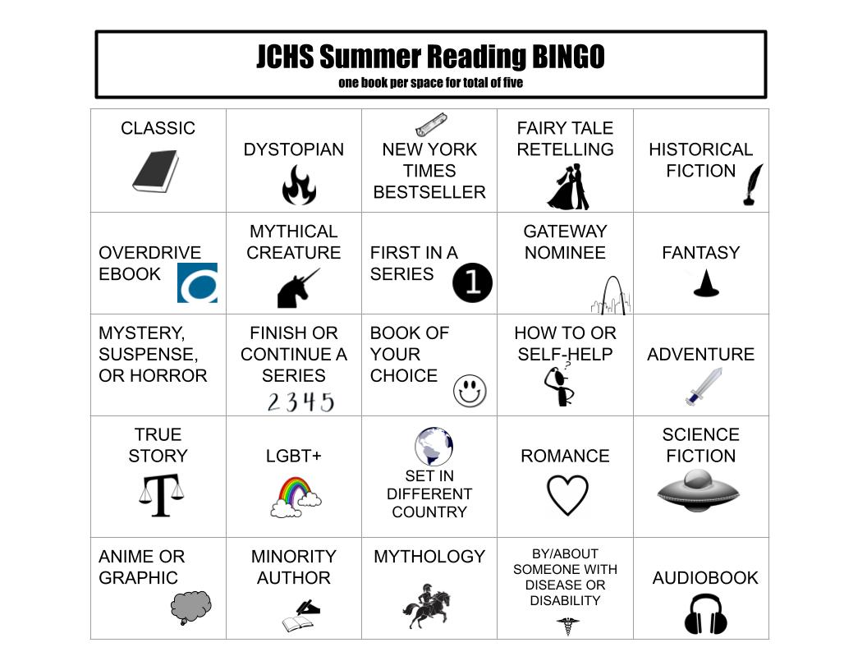

Another district level goal of Jefferson City School District is to achieve college, career, and life readiness. One of the building action steps reads: “Incorporate ACT College and Career Readiness Standards in lesson planning to develop ACT/EOC style questions once per instructional unit.” The JCHS Library supports this action step by providing resources for students and staff members in ACT preparation and preparation for other tests such as the ASVAB, SAT among others. Students may create an account with Learning Express Library via our library website. See this link for our online resources including Learning Express Library and the ACT Academy: https://www.jcschools.us/domain/2745
The Learning Express Library has a plethora of information, tutorials, and sample exams to help students with everything from college test admissions to resume and cover letter skills.

Another way that we support this district goal is by curating resources in our collection to help students as they are choosing their life path. We offer many digital and print resources on careers. Students exploring career paths often check out multiple books to help them determine their future goals. In addition, we offer digital and print resources on choosing the right college, writing essays for college admission, and adjusting to college life.

Jefferson City High School’s Building Strategic Plan

Return to Table of Contents

Library Environment

Indicator #12: Program provides adequate physical space for the library, including flexible space for usage by multiple groups and/or fixed or flexible space for whole-class instruction

(AASL—include)
Exemplary (2 points): Provides furnishing that are mobile, flexible, and functional enough for a variety of instructional and non-instructional uses for a minimum of two (2) classes (based on the average class size in the building)

Approaching (1 point): Provides seating for a minimum of two (2) classes (based on the average class size in the building)
Required Documentation/Evidence

Photos accompanied by brief explanation of how spaces are used

Supporting Evidence
Insert Applicable Links Here:

Insert Documents/Narratives:

In the center classroom space on the 3rd floor, up to 30 students may meet for whole group instruction. The chairs are on rollers, so it is easy to rearrange the space as needed. We have an outdoor classroom with seating for another 28-30 students. We have a quiet study Reference Room with seating for 7-8 students, multiple soft seating chairs on rollers situated throughout the library with side tables, and a meeting room up front facing the hallway with seating for an additional 6 students. The average class size at JCHS is 20-25 students.

In addition, all of our lower bookcases are on rollers for flexibility. Our print collection is housed in the 3rd floor area.

On the fourth floor, the Tech Center area functions as a central hub for all technology and media at our school as well as providing another classroom space. There is a partition wall that separates the area into two spaces that may be used for group work or other classroom activities. There is also an area off to the side where students and staff may work in a study area.

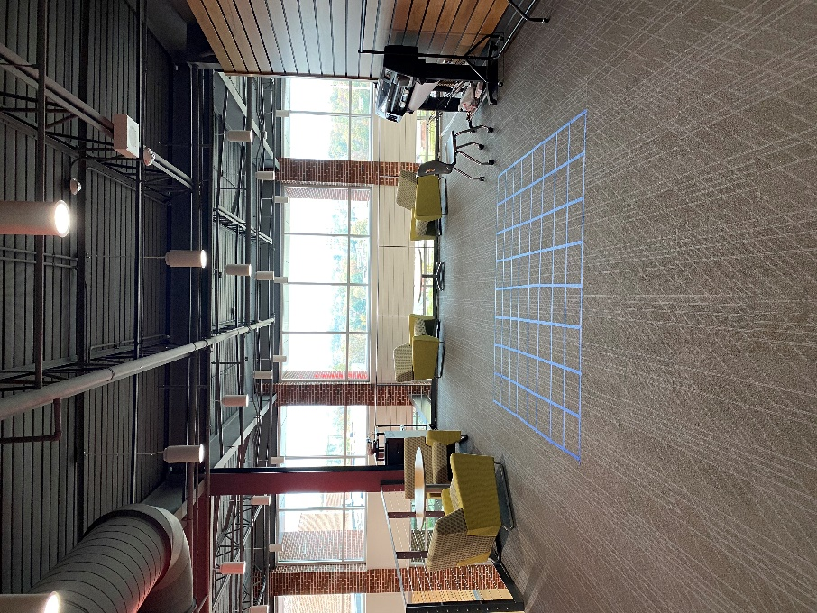
Classroom Space #1 4th floor
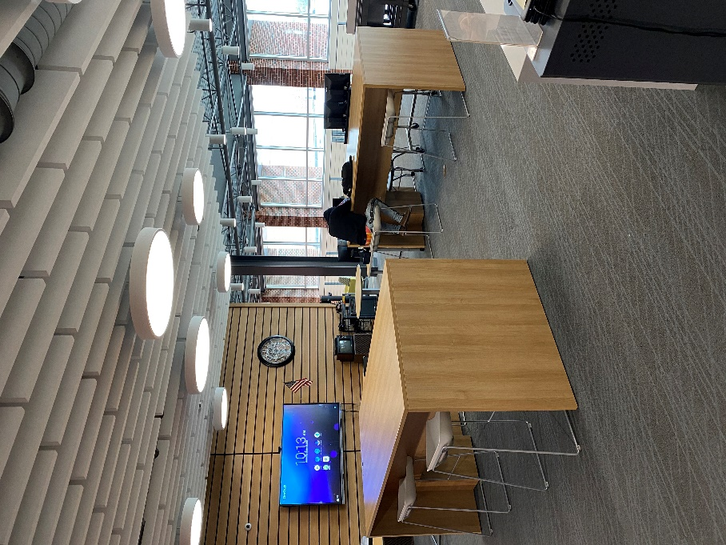
Classroom Space in Tech Center
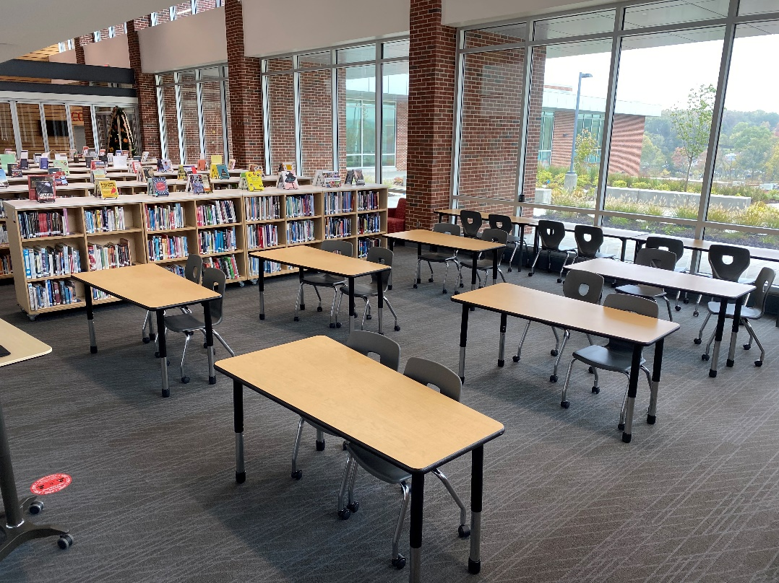
Classroom Space with mobile desks on 3rd floor
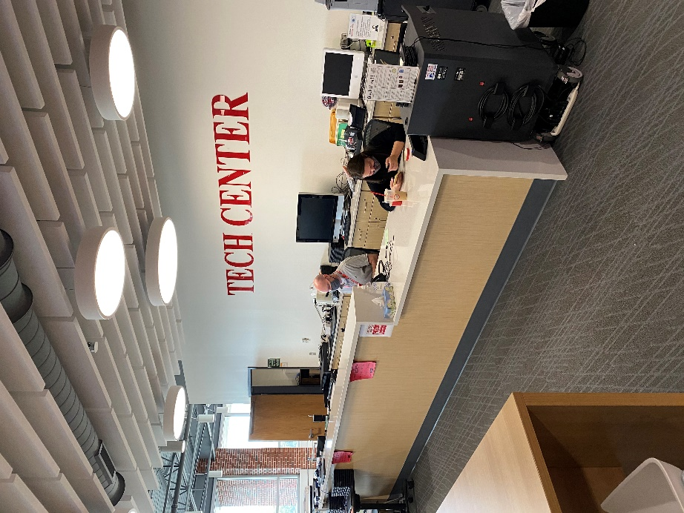
Technology Center Help Desk 4th floor
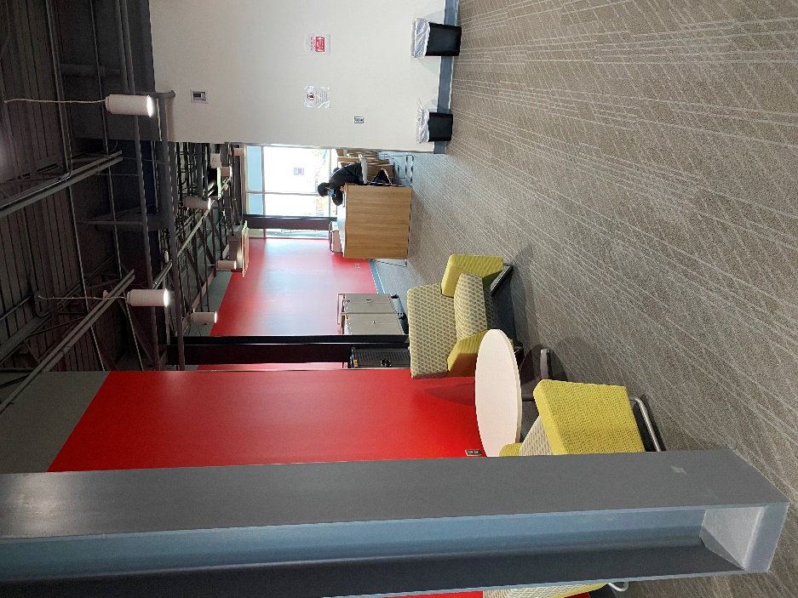
Collaboration Space 4th floor
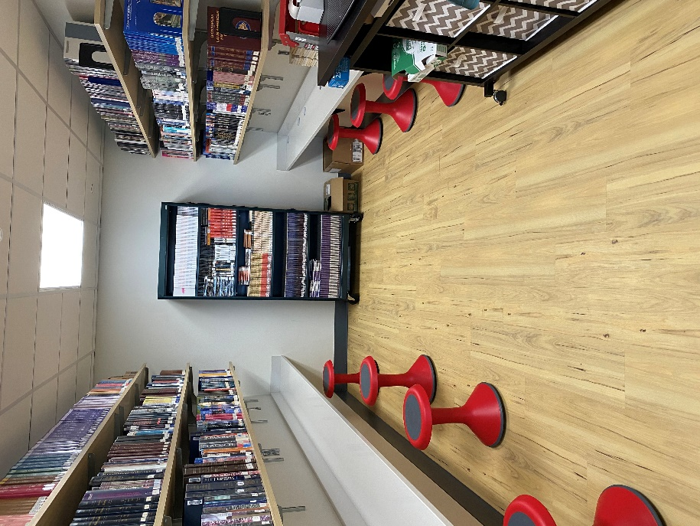
Reference Room Study Area 3rd floor
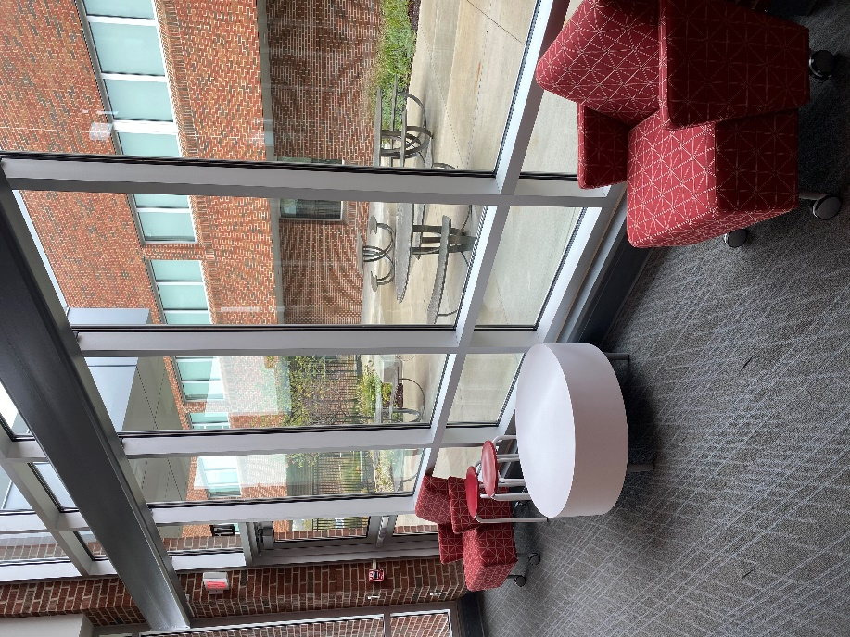
View of outdoor classroom from inside 3rd floor library space
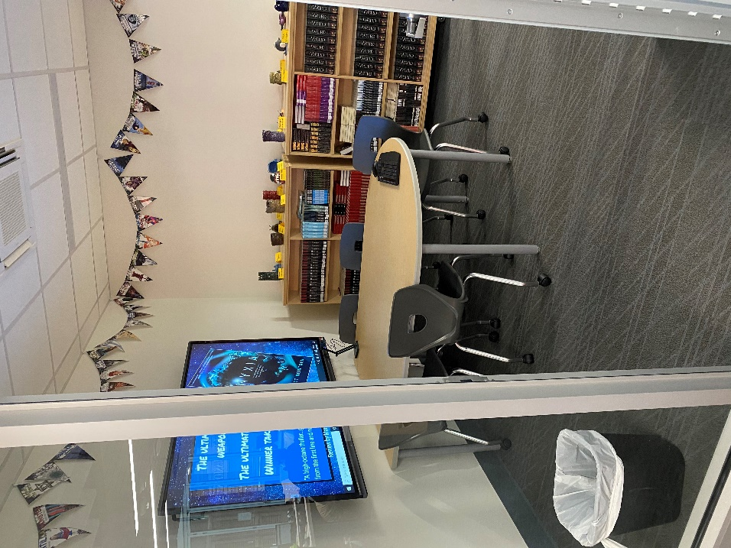
Collaboration/Meeting Space 3rd floor

Return to Table of Contents

Indicator #13: Program offers a variety of programs and/or opportunities for all members of the library community in a safe and inclusive manner

(AASL—include)
Exemplary (2 points): Offers a minimum of four distinct and cross-curricular programs throughout the year that may
- include family and/or community participation
- take place either during or beyond the school day

Approaching (1 point): Offers a minimum of two distinct and cross-curricular programs that may
- include family and/or community participation
- take place either during or beyond the school day

Required Documentation/Evidence

Calendar of events with enough detail to show the purpose and audience for each event; may include photos and/or evaluation from some events.

Supporting Evidence
Insert Applicable Links Here:

Insert Documents/Narratives:

The Thanks "Giving" Tree at the JCHS Library has evolved over the years from originally a mitten tree to now a way for our community of staff, students, and parents to donate items for local charities. This past year from October to December, we hosted a fundraising drive at our school which collected and donated mittens, hats, gloves, books, and toys to the Samaritan Center, a local charitable organization that helps local families in need of assistance. During the 2021-2022 season, the JCHS Library collected and donated over 75 items.

Epsilon Beta, our JCHS Library club, participated in Jack O' Lantern Jam which is an outreach to Jefferson City elementary age students. This year, our club members promoted literacy by hosting elementary school students in two activities: the young members of our community along with their parents read autumn-themed books with Epsilon Beta members and made bookmarks to take with them after the readings.

During the first two weeks of November, JCHS Library promoted the Big Library Read that Overdrive promotes through Sora, our eBook provider. This year’s Big Library Read title was Five Total Strangers by Natalie Richards. We promoted this on our PLN, our newsletter, the Smore that goes out to parents, and through staff communication. We encouraged parents to join the digital eBook club by using our public library.
Promotional Graphic used on social media, emailed to teachers and parents, advertised on our Clear Touch computer screens in the library.
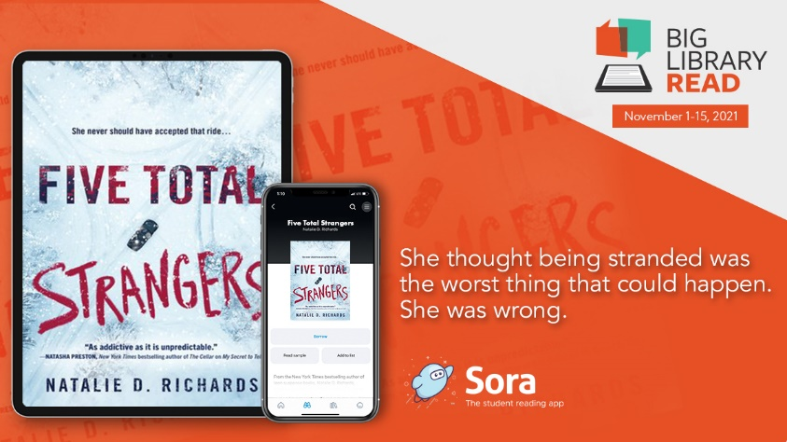

Our library offers a place for Art I, II, and III and Ceramics I and II students to display their creations. This partnership gives the wider school community and staff a chance to learn about the mediums the students use to create artwork. Viewing is available throughout the school day and any time the library is open after hours (i.e. for conferences and games). During a parent/teacher conference night on February 17, parents and other family members were able to visit the JCHS Library for an art show that showcased student and staff art.

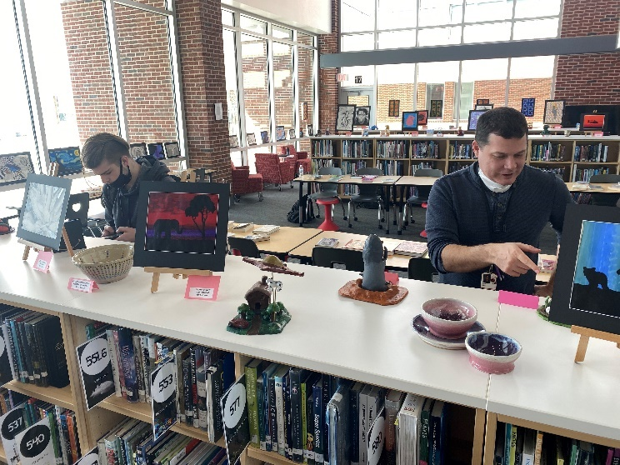

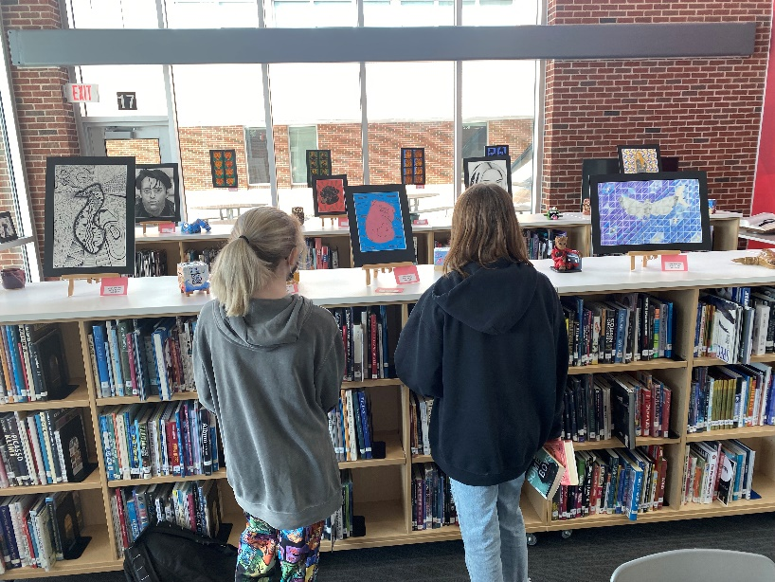

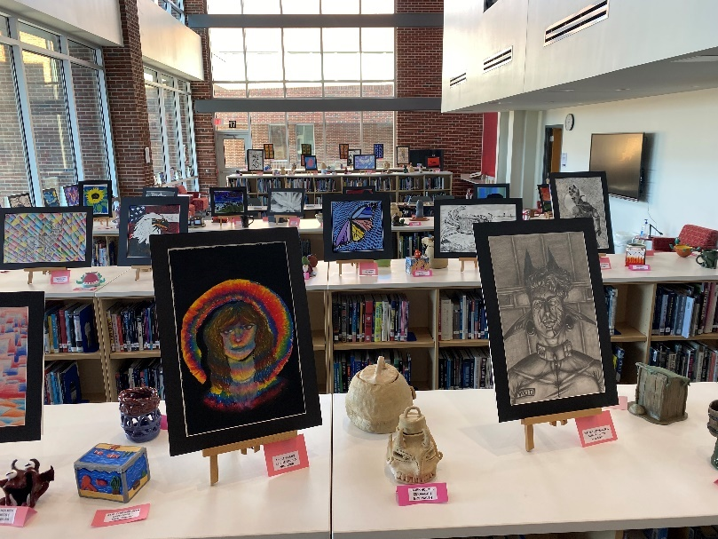

The librarians used books we purchased from First Book Marketplace to promote a Winter Break Reading Challenge with our students. We had three winter-themed books students and staff could choose from to read over the two-week break. We also had a list of 10 winter-themed activities for students to do focused on reading and fun for students to complete: read the instructions to a board game and play it, read your book to someone older than you, read your book to someone younger than you, etc. After winter break, we hosted a breakfast in the library for those who completed the challenge. It was a huge success. We had 51 students and staff members participate, and we plan to do another challenge this year over Spring Break.
Following is a promotional graphic used on our Clear Touch computer screens, emailed to students and staff, and promoted on social media:
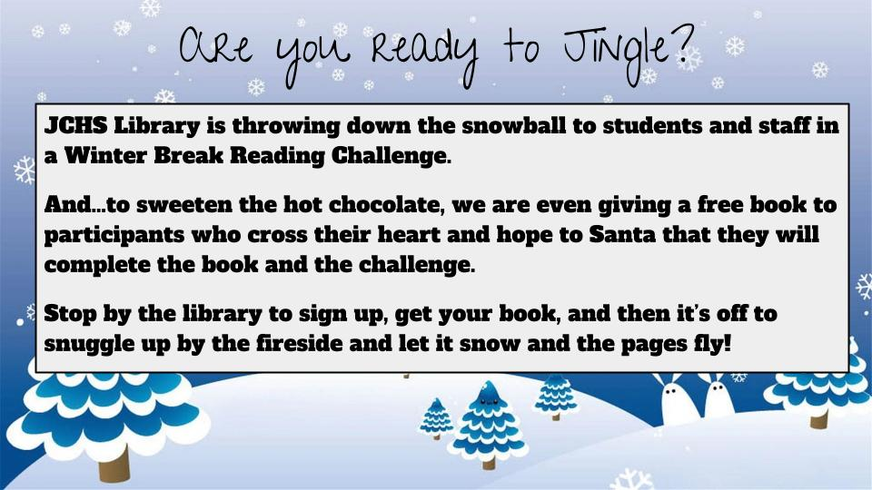

The JCHS Library offers a Seal of Excellence in Reading to seniors who meet criteria explained here:
https://www.jcschools.us/domain/4076
In addition, to students in grades 9-11, students may earn the Jay Reader’s Award explained here:
https://www.jcschools.us/domain/4075

The Seals of Excellence in all departments, the Jay Reader’s Award, and many other honors are presented at Jay Pride Night in May. The parents, staff, and community members are invited to attend. The awards the library gives to students offer both an incentive to read for all of our students and a recognition of excellence for those who choose to grow as readers and citizens. The Seal of Excellence has the added requirement of a community service project. We have had students choose to serve the community in rewarding ways. For example, this year a senior who works at a nursing home is reading to elderly patients. Another senior who plans to join the military after graduation is presenting to her Military Leadership class on the importance of reading for soldiers and other military personnel.

On March 16, 2022, our students will have an opportunity to join a virtual author visit with Adib Khorram along with Capital City High School students in our district. We have promoted this visit with our Epsilon Beta Library Club as well as our Gay Straight Alliance club since his books feature LBGTQ characters. This will give our students an opportunity to learn about a writer’s process, inspiration, and career as well as converse about his books which we have available for checkout in the library.

On April 22-23, 2022, Jefferson City High School Library will be hosting the state Epsilon Beta conference. Epsilon Beta is an organization for students interested in the library and library science. Both librarians at JCHS have sponsored this club for six years. We are thrilled to be hosting the first conference to be held in three years as they last two were cancelled because of COVID-19. During this conference, we and our students will network with other students and librarians throughout the state. Students will participate in competitions, and have the opportunity to run for state leadership offices.
Epsilon Beta Website

Return to Table of Contents

Indicator #14: Program provides a variety of current technologies in the library, including means of remotely accessing library resources at any time

(AASL—curate, explore, include)
Exemplary (2 points): Provides a website with a curated selection of technology resources and openly licensed digital resources, learning management system, and/or social networking to offer 24/7 access to library

Approaching (1 point): Provides links to district-supported resources with 24/7 access

Required Documentation/Evidence

Link to website
Copies of communication sharing technology resource links with library stakeholders

Supporting Evidence
Insert Applicable Links Here:

JCHS Library Webpage
JCHS Library Online Resources
JCHS Library Tutorials

Insert Documents/Narratives:

Access at school does not require a sign on if on the district network with a district device. Students using a district device on a non-district network can still access the Learning Management System (Google Classroom) and subscription resources with a user i.d. and password. Students are provided their user i.d. and passwords at the beginning of the year from the Counseling Dept.
Our website and connections are regularly tested to maintain constant access to over 20 subscription resources for students and staff. We have crafted individual class direction sheets to show staff and students how to access the available resources at any time. Plus, we are only an email away to answer any questions or requests at any time. Students and staff regularly contact us through our website as well.
The students may access all resources on and off campus. We have a list of passwords that they may access when signed in to their school Gmail accounts. Students also may log in to Destiny Discover and Sora for eBooks from any device including their phones.

We have Twitter and Instagram accounts with the handle Library_JCHS for social networking.

Our students and staff utilize email to contact us directly to request books, services (like editing assistance, printing services, and book recommendations), and assistance with lessons and finding resources. We appreciate their ability and comfort in our working relationship that they consider us an essential part of their educational team.

Return to Table of Contents

Library Management

Indicator #15: Program implements flexible scheduling to meet the authentic instructional needs of students

(AASL—collaborate, explore, include)
Exemplary (2 points): The library facility uses a flexible schedule during the length of the school day with all scheduling at the discretion of the professional librarian.

Approaching (1 point): The schedule of the library facility during the length of the school day does not exceed 25 percent fixed scheduling (such as being part of a school’s specials rotation); the remaining 75+ percent of the day’s schedule is flexible and implemented at the discretion of the professional librarian.

Required Documentation/Evidence

Schedule reflective of four consecutive weeks

Supporting Evidence
Insert Applicable Links Here:

Insert Documents/Narratives:
Screenshots of four consecutive weeks are below. The librarians create the calendar and the schedule. The numbers and last names indicate the block and the teacher who is coming to the library for lessons and instruction. Some blocks indicate book clubs offered by the librarians and (AS) and (BS) stand for after school and before school activities planned in the library. Our schedule is 100% flexible.

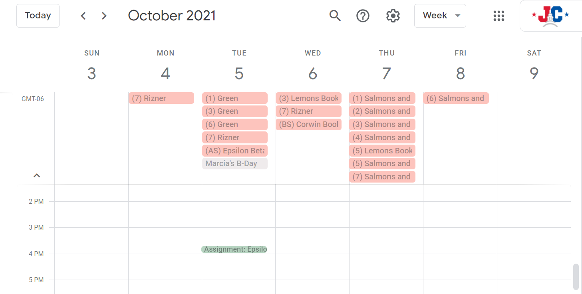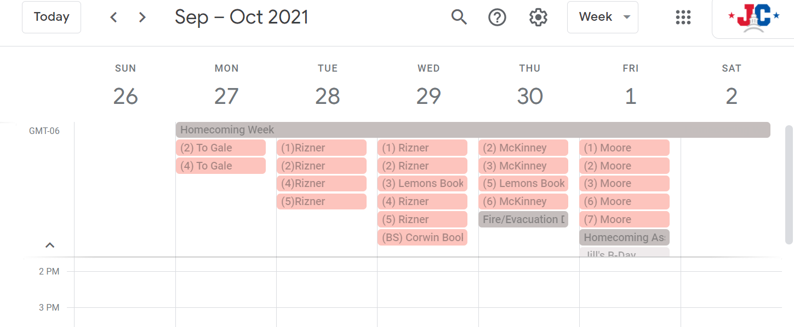

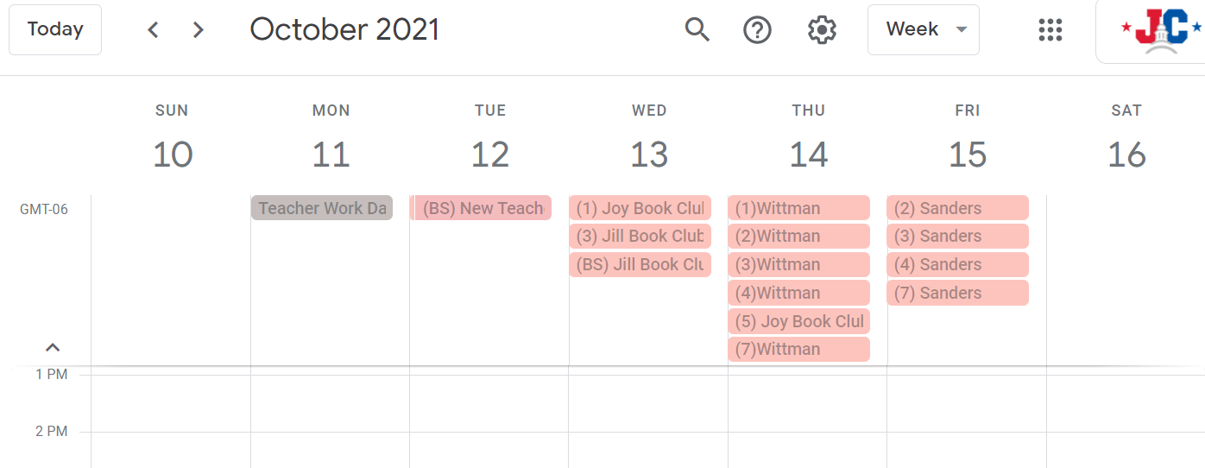

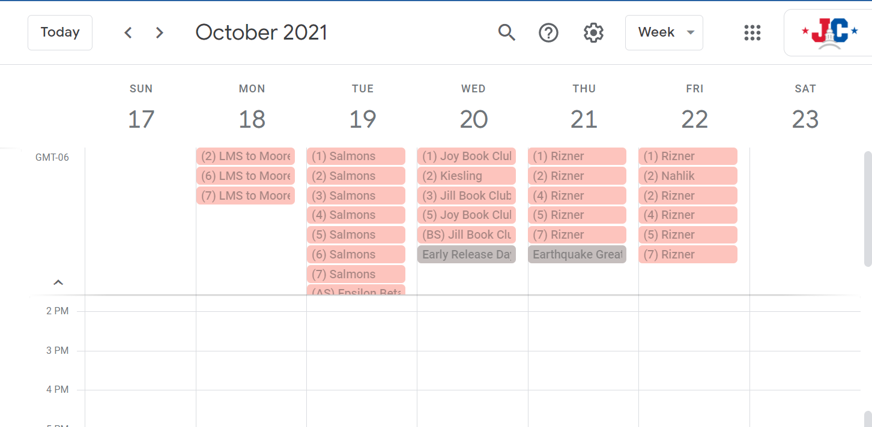

Return to Table of Contents

Indicator #16: Librarian regularly evaluates the library program

(AASL—This indicator includes addressing all AASL Integrated Frameworks while evaluating the school library program.)
Exemplary (2 points): Regularly designs throughout the school year evaluative tools and acquires evaluative information regarding the school library program from all stakeholders: school librarian, principal, certified teachers and/or support staff, parents, students

Approaching (1 point): Annually designs evaluative tools and acquires evaluative information regarding the school library program from four of the following five stakeholders: school librarian, principal, certified teachers and/or support staff, parents, students.

Required Documentation/Evidence

Evaluative tools(s) utilized with each stakeholder regarding perception of the library program. These may be in the form of surveys, audio discussions, digital photos of physical documents as well as other data collection methods. These evaluations may include the complete library program, book clubs, special celebrations such as Read Across America Week or Banned Book Week, resource collections, resource development, etc.

Supporting Evidence
Insert Applicable Links Here:

Comment/Suggestion Box

Insert Documents/Narratives:

The JCHS Library designs multiple evaluative tools and garners information from all stakeholders about our library program.

The Librarians meet quarterly with the administrative team for our building. We present our quarterly report with highlights of programming during this meeting with all principals. We have an open relationship with our principals and request feedback regularly through several modes of communication, but email and text messages are the preferred methods. Our administration also provides regular feedback during our monthly staff meetings as well as our quarterly Library/Admin meetings. For example, we are preparing to celebrate JC Reads Week with much fanfare for an entire week. We were discussing dress up days and getting permission/approval for other celebrations happening during the week. Our admin provided funding to our idea of having a giveaway for each grade level and one for staff. We are going to provide Kindle paperwhites as our giveaway prize.

We regularly ask for feedback from all stake holders (parents/community members) through the use of our comment/suggestion box. Anyone may contact us through this avenue of communication to provide anonymous feedback or suggestions to our program. See the link above. We also open our doors to parents and community members on open house night and various parent/teacher conference nights throughout the year. These sessions give us a chance to talk with parents, community members, and students about what the library offers, get feedback from parents via an exit survey or individual conversations.

We also request feedback from teachers and students after a lesson or project in the library to better prepare for next time. We appreciate the feedback given by everyone. This is usually how we garner the most suggestions and improvements are made to the program. Students have the best ideas and suggestions.

From one student survey, students requested to have a maker/craft time during their JayTime/study hall classes. So, we created a series of planned crafts that students could sign up for to come to the library and make a gift to take with them. All ideas were student created and the library provided supplies and assistance with instruction. This will most likely become a regular part of our programming because of the popularity and positive comments.

Librarian feedback is provided by our district library coordinator. She comes to the library quarterly to observe a lesson and our library environment. She then makes suggestions for improvement or highlights programming we could implement. We have also been using the DESE application to evaluate our program as well. We have found this to be a good tool to gauge our level of excellence in programming. We as school librarians annually evaluate our program, our collection, and our professional growth through tools that our director has provided for us.

All of our freshmen complete Library Orientation, we sent them a survey via Google Forms afterward, in which they evaluated the efficacy of the orientation. Through their feedback, we have a better understanding of what facets of the orientation went well and where we could improve. This year we changed the format to a scavenger hunt based on the suggestions from students last year. It was better received and students know more about the library after changing the format.

After our staff Summer Book Clubs, we sent evaluations through a Google Forms to the participants on several issues: their perception of the book choice, what they did and did not like about the scheduling and format, and thoughts and suggestions of how to get more involvement. The responses were very helpful in planning our book clubs for next summer. After each book club offered to students, we send out surveys to the students for feedback on the book choice, their experience, and their likelihood of joining book club again.

We send a review of our Jays Read Book Clubs to students at the conclusion of each session. This helps us see what students have enjoyed and what suggestions they have for future book clubs.

At the end of each school year, we send staff a survey in Google Form format to assess what they have found helpful, what suggestions they have, and which of our resources they have used. This allows us to plan for the following year. We also use this time to assess which of our databases have been utilized the most since we pair the form responses with usage statistics from the databases the library has purchased.

Return to Table of Contents

Indicator #17: Program has a budget that is adequate to purchase books, materials, supplies, etc., to meet the library’s strategic plan

(AASL—curate, include)
Exemplary (2 points): Collaboratively works to establish an adequate budget with the building and/or district administration by communicating a strategic five-year plan that outlines the vision and progression of the school library program goals in connection with the school and/or district strategic plan

Approaching (1 point): Collaboratively works to establish an adequate budget with the building and/or district administration by communicating a three-year plan that outlines the vision and progression of the school library program strategic plan

Required Documentation/Evidence

Submission of collaborative budgetary plan denoting the library’s strategic plan and its connection to the building or district strategic plan. Submission must include the dollar amount (total and per student) provided by the district to support the library plan. Examples: written reports, spreadsheets.

Supporting Evidence
Insert Applicable Links Here:

Insert Documents/Narratives:

The five-year strategic plan of the library is in the attached PDF. The collaborators of this plan include the library program coordinator, the JCHS Library Media Center staff, and the administrator supervising the JCHS Library.

The strategic plan of JCHS Library connects to the overall district strategic plan in the following ways:
One of the goals of our strategic plan reads as follows:
Local Assessment (High School) - Improve student performance on unit assessments by accomplishing the following
objectives:
● Average percentage earned by students will increase 2-3% each year on unit assessments
● Average percent of points earned on unit assessments will be 80% or higher
● 80% of students will achieve proficiency (need benchmark percentage for proficiency) on unit assessments

The library’s strategic plan supports this because one of our goals reads:
The Jefferson City High School Library Media Center will build a print and digital collection
that supports student mastery of curriculum in all subject areas.

Building a collection that supports student mastery of curriculum connects with improving student performance on unit assessments. With our attention to curricular needs, our collection will aide students in growth.

The second overall goal of the district’s strategic plan reads:

ACHIEVE COLLEGE, CAREER, AND LIFE READINESS : District Goals a) The percentage of students scoring at or above the State standard on college and career ready assessments will increase by 5% annually b) On an annual basis, the graduation rate will increase by 3% until we are at or above the state average.

The JCHS Library’s strategic plan also supports and connects with this goal. One of our goals is to “offer a welcoming and comfortable space to learn and create.” Students who feel welcomed and comfortable in a place of learning—what our plan calls “educational and creative center of the
school campus”—will be more apt to stay in school. Part of creating a culture of learning that supports growth to graduation is having places where students of all backgrounds and ability levels feel welcome and important. In addition, our strategic plan also reads that JCHS Library “will offer learning opportunities for multiple learning styles,” another component of learning that will enable students to have success and achieve college, career, and life readiness.

To address the budgetary plan of JCHS Library, the funds allocated to the JCHS Library Media Program come from three accounts, two of which are constant and allocated per year. The third account, an activity account, fluctuates in amount, and the funds carry over from one year to the next. This allows us to save funds for larger expenditures such as author visits or field trips.
The attached spreadsheet explains these funds in more detail.

The number of students attending JCHS in grades 9-12 is 1, 114, making the library expenditure per student $28.73.

Return to Table of Contents

Indicator #18: Program maintains a current, relevant, and diverse collection of print and/or digital resources that is responsive to the needs of the community and is tied to curriculum

(AASL—curate, explore, include)
Exemplary (2 points):
- Maintains current collection as follows:
  - Nonfiction: At least 70 percent of the resources have copyright dates within the most recent 12 years.
  - Fiction: The average age of a fiction collection is less than 15 years old.
- Supports access on all subjects that meet the needs, interests, and abilities of all persons in the community the library serves
- Supplemental resources extend beyond the school community to connect with the global community

Approaching (1 point):
- Maintains current collection as follows:
  - Nonfiction: At least 70 percent of the resources have copyright dates within the most recent 15 years
  - Fiction: The average age of a fiction collection is less than 17 years old.
- Supports access on all subjects that meet the needs, interests, and abilities of all persons in the community the library serves
Required Documentation/Evidence

Collection analysis reports that clearly show the currency, relevance, and diversity of the library’s collection

Supporting Evidence
Insert Applicable Links Here:

Demographic information for Jefferson City, MO from US Census can be found at https://www.census.gov/quickfacts/jeffersoncitycitymissouri

Insert Documents/Narratives:

Our school has 1,399 students in grades 9-12; 531 students qualify for free or reduced lunch.

The TitleWise analysis of our collection from Follett in the PDFs below reflect an average age for fiction of 8 years (2013) and the average age for fiction is 13 years (2008):

Explanation of how databases help meet this indicator: In addition to our print collection, JCHS Library offers students many resources through databases. Listed on our website (jcschools.us/domain/2745), all of the databases we offer are listed: Gale Student Resources, Gale Opposing Viewpoints, American History Online, Facts on File Issues and Controversies, World Geography and Culture Online, Bloom's Literature, Ebsco Explora, and more. These databases continually update and add new material to keep the resources up to date for student and staff research and use. In addition, on our Online Resources Page, we have digital access to the Washington Post, The St. Louis Post Dispatch, and the local paper The Jefferson City News Tribune. These databases help meet the curricular needs of our school as well as allow students the opportunity to delve into what interests them. Students who need resources at a lower reading level may conduct searches using differing lexile levels, have text read to them, or have text translated into another language using some of these databases. With our local public library collaboration, students now have access to many digital magazines as well: National Geographic and The Economist are two that students use to explore the global community in addition to databases where they can learn about other parts of our nation and our world. They are not limited to just academic titles though. They have access to many different genres and interests with this partnership.

Return to Table of Contents

Indicator #19: Program maintains policies, procedures, and practices as set by the local school board

(AASL—curate, engage)
Exemplary (2 points): Has an up-to-date policy (within the last five years) including all of the following:
- Fines/Damaged materials
- Challenged books
- Collection development
- Volunteers
- Donations
- Borrowing policy
- Inventory
- Acceptable use
- Confidentiality
- Intellectual freedom
- Weeding

Approaching (1 point): Has an up-to-date policy (within the last five years) including nine of the following:
- Fines/Damaged materials
- Challenged books
- Collection development
- Volunteers
- Donations
- Borrowing policy
- Inventory
- Acceptable use
- Confidentiality
- Intellectual freedom
- Weeding

Required Documentation/Evidence

Link(s) to policies

Supporting Evidence
Insert Documents/Narratives:
The Library Program Handbook (last updated in 10/2020) has all of the policies listed above. Refer specifically to page 4 for links to School Board policies.

Return to Table of Contents

Staffing

Indicator #20: Program maintains an appropriate librarian-to-student ratio

(AASL—include, inquire)
Exemplary (2 points): Exhibits the following:
- 1.0 full-time librarian assigned full time to a library in a school* with a student population of 1-750
- 1.5 full-time librarians assigned full time to a library in a school* with a student population of 751-1,500
- 2.0 full-time librarians assigned full time to a library in a school* with a student population exceeding 1,500

Approaching (1 point): Exhibits ratio of one full-time librarian assigned full time to a library in a single school*

*Because of the variety of library/school configurations among Missouri schools (one library for two campuses, two libraries on a single campus, etc.), applicant must include a description of the configuration in his/her school and explain how all stakeholders are sufficiently served within this configuration. Library staffing must be such that the library is open to students at any time during the regular school day.

Required Documentation/Evidence

Written verification from school or district administration regarding student access to library at any time during the regular school day in addition to librarian’s required description of configuration (see above)

Supporting Evidence
Insert Applicable Links Here:

JCHS Library Staff from left Jon Thornhill, Lisa Davis, Jill Lemons, and Joy Corwin

Insert Documents/Narratives:

PDF of letter from Assistant Principal Tylisha Dade-Johnson with verification:

Return to Table of Contents

Indicator #21: Program maintains an appropriate library support staff-to-librarian ratio

(AASL—include, inquire)
Exemplary (2 points): Has one full-time paraprofessional library support staff per librarian without additional outside duties during instructional day to ensure the library is open to students and staff through the entire school day

Approaching (1 point): Has equivalent of one paraprofessional library support staff per librarian performing library-related duties in the library a minimum of 75% of the instructional day to ensure the library is open to students and staff through the entire school day

Required Documentation/Evidence
Written verification from school or district administration verifying paraprofessional hours and library accessibility hours

Supporting Evidence
Insert Documents/Narratives:

Written verification from Assistant Principal Tylisha Dade verifying library accessibility and staffing of the Library Media Center which includes two full-time librarians, a full-time clerk, and a full-time technology leader.

Copy of Google Slide presentation with job duties of library and technology center staff:

Return to Table of Contents

Appendix

Return to Table of Contents

