MISSOURI DEPARTMENT OF ELEMENTARY AND SECONDARY EDUCATION
Missouri Schools for the Severely Disabled

Administrative Service Area Map

20
32

9
AREA I 56
Lois Freeman, Director 6 71
E.W. Thompson School
1520 Thompson Blvd. ⁷⁵
Sedalia, MO 65301 45 21
660-530-5588
66

36

14

8

7

3 40
C.O.

55

24

23

AREA III
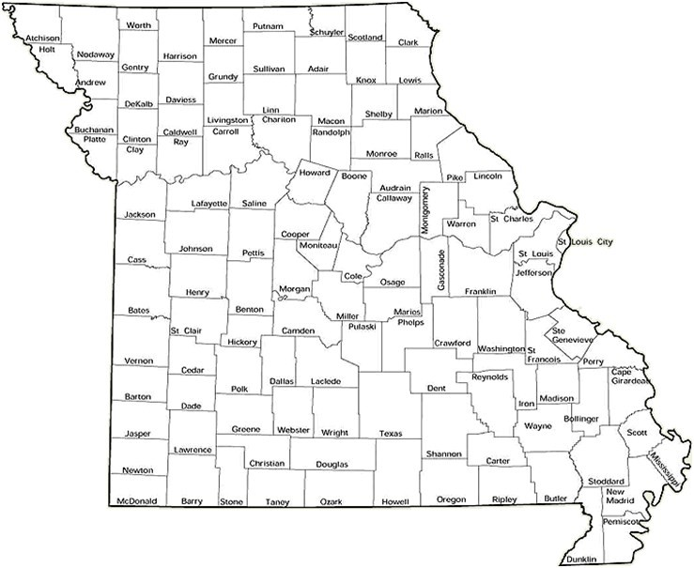Cheryl Paige, Director Gateway/ Hubert Wheeler School 3815 Magnolia Avanue
St. Louis, MO 63110 314-633-3968

70

2

15

61

11
1 30
49
48
27

34 18
60 4

AREA II
Sheryl Youngblood, Director
Director Green Valley School
1601 E. Pythian Street
Springfield, MO 65802-2141
417-895-6850
10

School contains area administrative offices MSSD Central Office
C.O.
P.O. Box 480
Jefferson City, MO 65102-0480 573-751-4427

MSSD Schools and Locations

1 – Greene Valley School, Springfield | 15 – Special Acres School, Park Hills | 45 – Briarwood School, Harrisonville
2 – Mapaville School, Mapaville | 18 – Ozark Horizon School, West Plains | 48 – College View School, Joplin
3 – H. Kenneth Kirchner School, Jefferson City | 20 – Verelle Peniston School, Chillicothe | 49 – New Dawn School, Sikeston
4 – Shady Grove School, Poplar Bluff | 21 – E.W. Thompson School, Sedalia | 55 – Dogwood Hills School, Eldon
6 – Lakeview Woods School, Lee’s Summit | 23 – B.W. Robinson School, Rolla | 56 – Prairie View School, Marshall
7 – Boonslick School, St. Peters | 24 – Citadel School, Potosi | 60 – Current River School, Doniphan
8 – Delmar A. Cobble School, Columbia | 27 – Crowley Ridge School, Dexter | 61 – Ozark Hills School, Salem
9 – Maple Valley School, Kansas City | 30 – Skyview School, Mountain Grove | 66 – Cedar Ridge School, Nevada
10 – Bootheel School, Clarkton | 32 – Helen M. Davis School, St. Joseph | 70 – Gateway/Hubert Wheeler School, St. Louis
11 – Parkview School, Cape Girardeau | 34 – Oakview School, Monett | 71 – Rolling Meadows School, Higginsville
14 – Lillian Schaper School, Bowling Green | 36 – Mississippi Valley School, Hannibal | 75 – Dale M. Thompson/Trails West School, Kansas City
 | 40 – Autumn Hill School, Union

2021

