Professional Development Workshops 2021-2022
Sponsored by DESE Division of Skilled Technical Science
Call or email your Missouri Instructional Coach to secure a training date
Kelli Engelbrecht | kelli.engel625@gmail.com | 573-694-9127

#1 - Defining the Mission...
Framework Integration
(4-5 hours - Any classroom instructor)
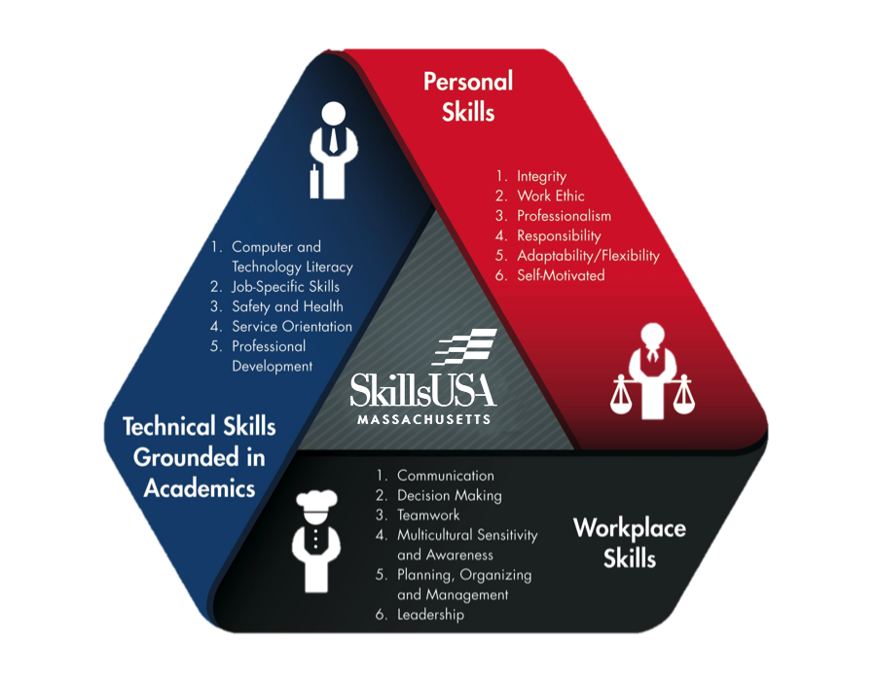
Engaging lesson plan integration of personal skills, workplace skills and technical skills into your curriculum. Workplace skills include values, personality traits and personal characteristics for success in life and the workplace.

Objectives:
-Explain the SkillsUSA Framework and Essential Elements.
--Workplace Skills, Personal Skills, and Technical Skills Grounded in Academics
-Describe the connection between the SkillsUSA Framework and industry-identified workplace needs.
-Demonstrate integrating SkillsUSA resources and opportunities into the individual classroom.
-Develop an Essential Element integration plan into a current lesson using more than two resources.

#2 - Delivering the Mission...
Program of WorkThat Works
(2 hours - SkillsUSA classroom teachers and chapter advisors)
Create organized and effective opportunities for students
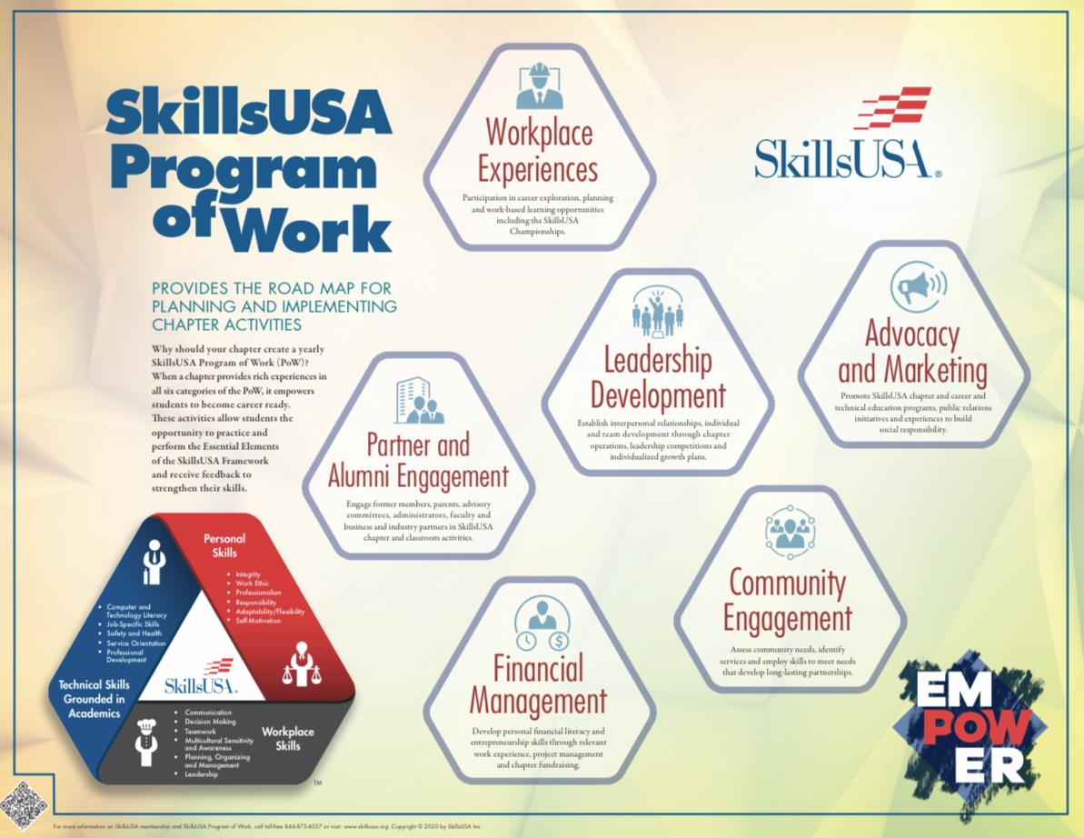
Objectives:
-Introduce the new Program of Work: Advocacy and Marketing, Community Engagement, Financial Management, Leadership Development, Partner and Alumni Engagement, and Workplace Experiences
-Enable instructors to manipulate the six launch guides.
-Learn to use templates, budget sheets, calendars, etc.
-Make easy information upload from PoW to CEP

#3 - Delivering the Mission...
Career Essentials: Foundations Curriculum
(3-4 hours - SkillsUSA classroom teachers and chapter advisors)
Prepare students to be ready to excel in the workplace and to be leaders of their communities by teaching career readiness skills.
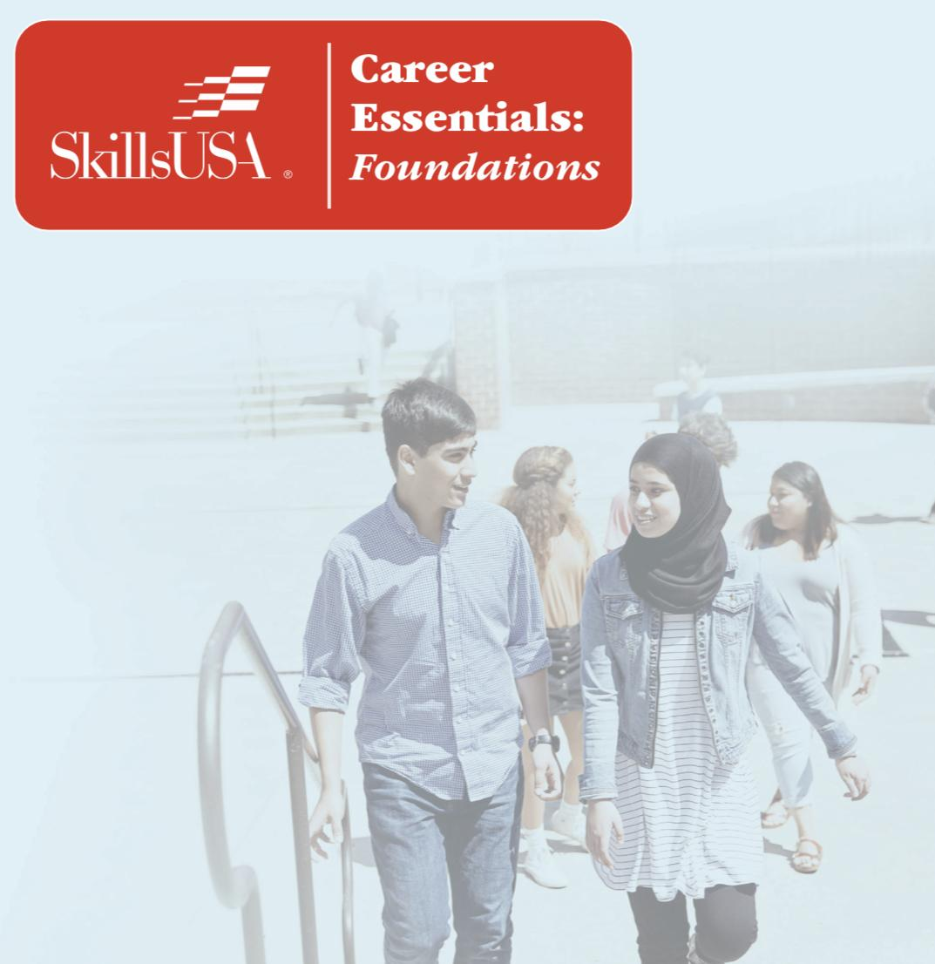
Objectives:
-Intentionally incorporate the SkillsUSA Framework Essential Elements into your curriculum calendar.
--Workplace Skills, Personal Skills, and Technical Skills Grounded in Academics
-Become familiar with the free (for paid advisor members) user-friendly lessons incorporating employability skills, engaging activities and proven teaching methods for effective learning.

#4 - Delivering the Mission...
Conflict Management
(1 hour - All teachers/advisors)
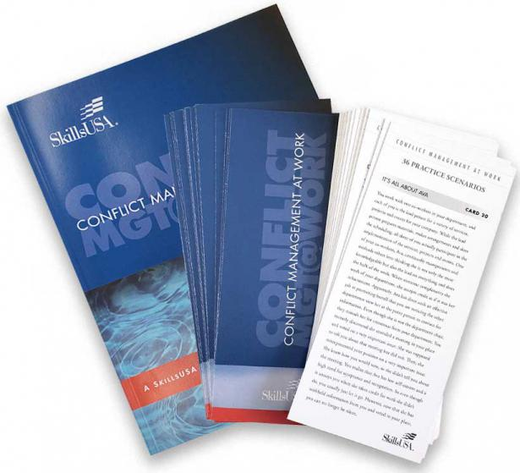
Help students effectively manage conflict at work and within their personal life

Objectives:
-Understand the difference between ‘managing conflict’ and ‘reacting to conflict’.
-Learn to use the new resource set which comes ready with lessons and practice scenarios.

#5 - Delivering the Mission...
E-Resources
(2 hour - SkillsUSA Teachers/advisors)
Use the amazing professional development professional member resources
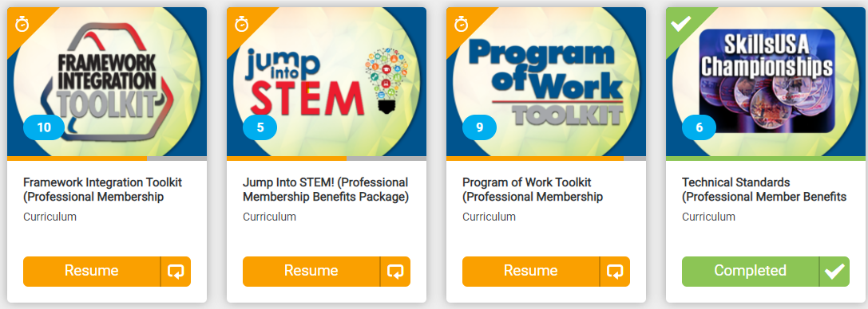
Objectives:
-Be able to locate the online professional benefit resources within the Absorb system.
-Learn to use the new resources to make your job as an advisor and instructor much easier and more effective.
-Investigate the resources to learn about their useful contents for running a chapter and integrating workplace readiness skills.

#6 - Delivering the Mission...
Jumpstart 2.0 & Impact
(1.5 hours - All teachers/advisors)
Energize your audience with planned activities and launch productive teams.
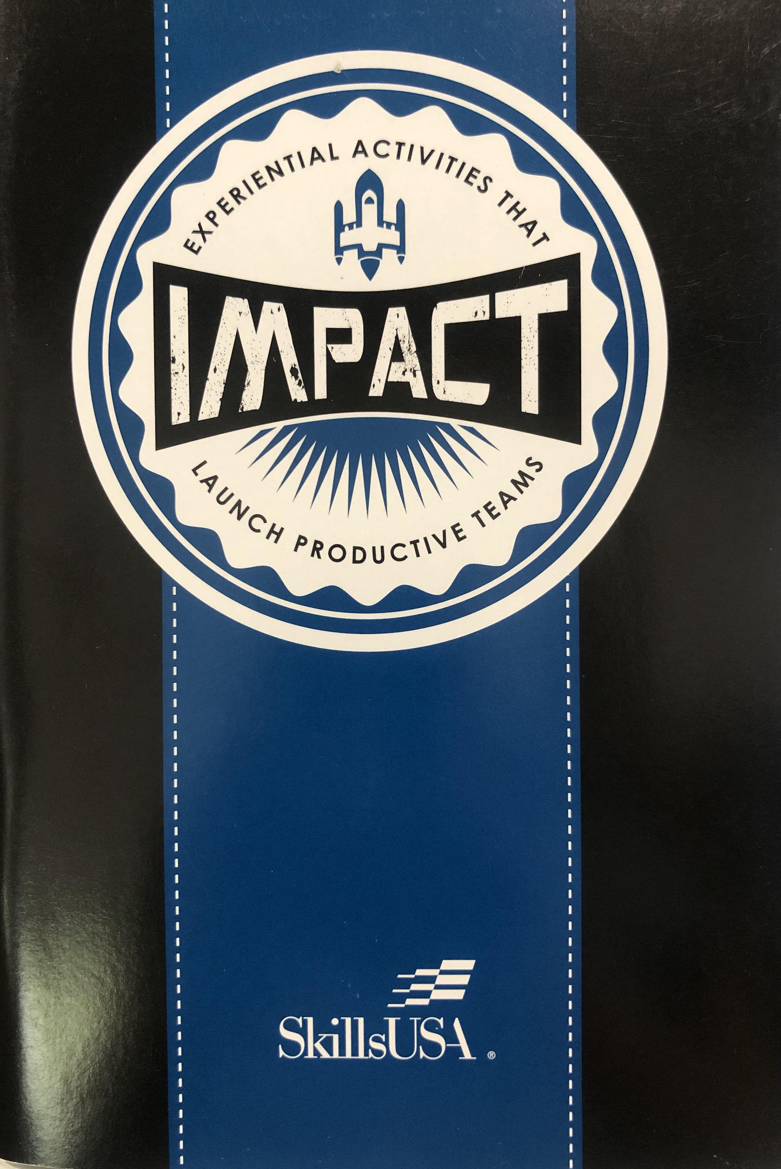
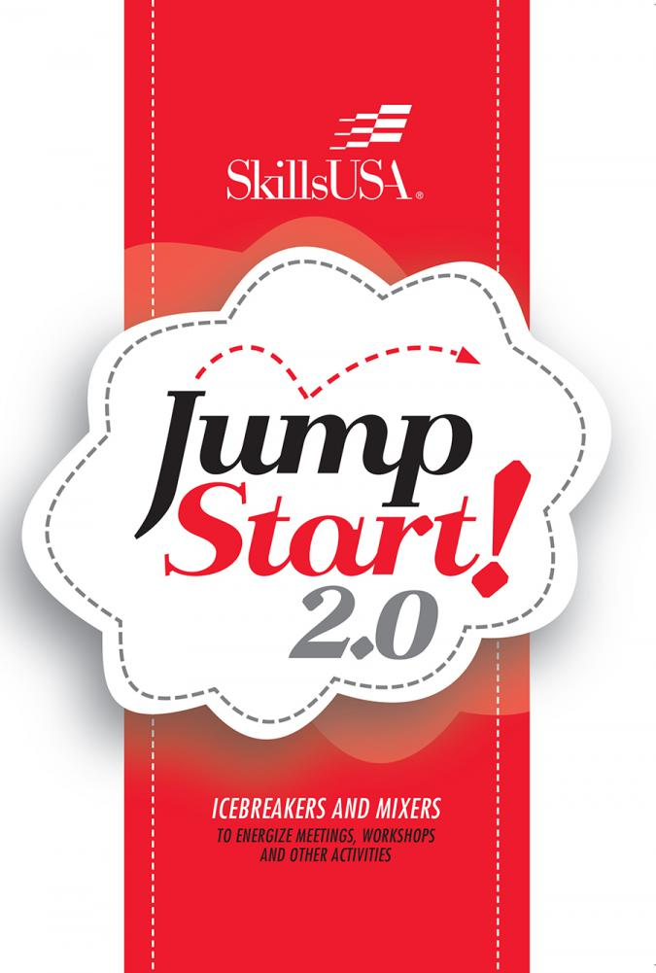
Objectives:
-Identify the usefulness of the new Jumpstart 2.0 resource booklet which comes with 33 mixers and icebreakers immediately ready to use.
-Use icebreakers and energizers in your classroom, meetings and workshops by adding some fun and a little joy to the agenda.
-Incorporate Jumpstart 2.0 activities into face to face and online learning.
-Become familiar with activities within the Impact resource booklet which details 36 activities that will help launch productive teams.
-Learn how both resources can help you instill workplace readiness skills outlined in the SkillsUSA Framework.
-Experience hands-on how to integrate an activity into your classroom instruction.

#7 - Measurement of the Chapter...
Chapter Excellence Program (CEP)
(4-5 hours - SkillsUSA teachers/advisors)
Impact the lives of students by building a successful SkillsUSA chapter!
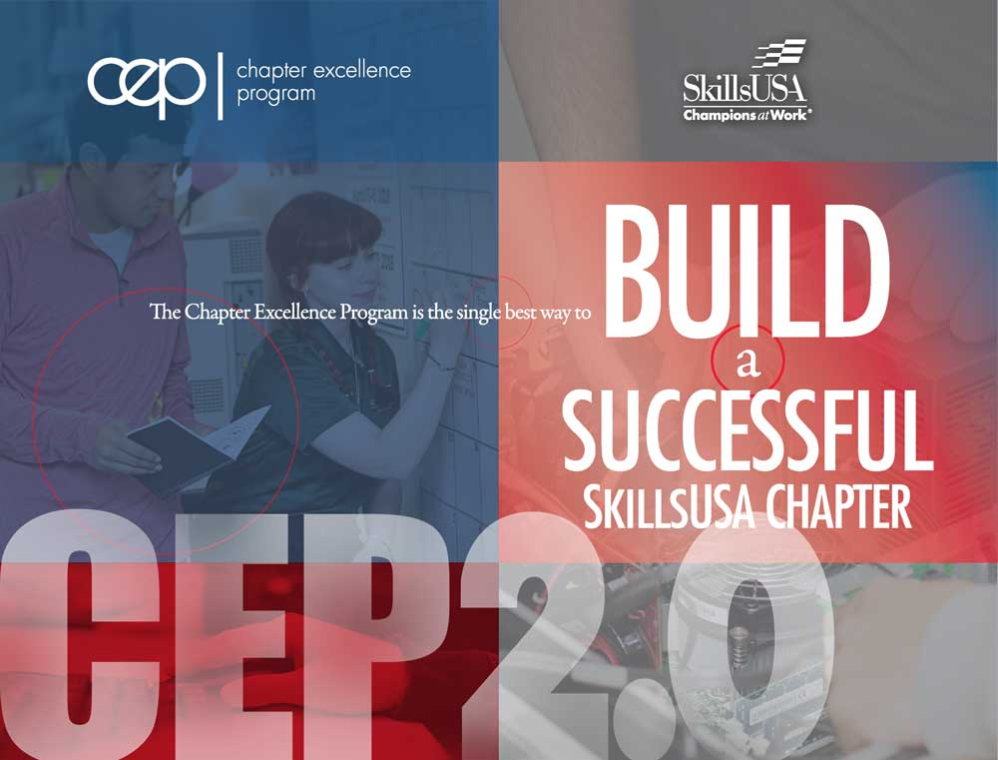
Objectives:
-Explain the SkillsUSA Framework, it’s connection to business & industry and the SkillsUSA Framework Essential Elements.
--Workplace Skills, Personal Skills, and Technical Skills Grounded in Academics
-Explain the 10 Phases of CEP and articulate how you will implement them within your classroom structure to build a quality SkillsUSA Chapter.
-Engage students to create activities that have SkillsUSA Framework Essential Element skill building embedded.
-Articulate the alignment between the workplace learning taking place within the 10 Phases of CEP and how the learning meets DESE Common Criteria and Quality Indicators (CCQI).

#8 - Measurement of the individual and chapter...
SMART Goals
(1.5 hours - All teachers/advisors)
Help students personal goals and Program of Work Goals
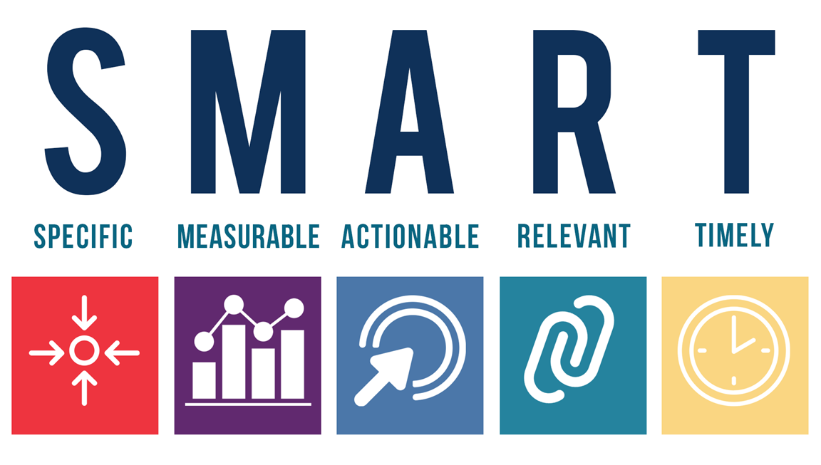
Objectives:
-Understand the five components of writing a clear and measurable goal.
- Write personal goals and goals for activities and workplace skills to be learned within the Program of Work.

#9 - Measurement of the individual and program...
Importance of Industry Recognized Credentials (IRC)
(.5 hours - All CTE teachers/advisors)
Overview to explain how/why credentials are attained and reported
Technical Skill
Attainment &
Industry
Recognized
Credentials
Objectives:-IRC will be defined.
-Learn how to get a specific IRC approved.
-Guidance given for selecting appropriate IRC or TSA.
-Become familiar with stackable credentials.
-Learn steps to reporting scores to DESE.

#10 - Measurement of the Individual...
Career Essentials Overview
(1 hour - All instructors)
Basic review of the four courses in the Career Essentials Suite.
Facilitator led virtual, real-time demonstration of the online learning management system. The Career Essentials Overview is also a great opportunity to ask questions in real-time and view how Career Essentials can be smoothly implemented in a variety of learning environments.

#11 - Measurement of the Individual...
Career Essentials Certified Teacher Training
(4 hours, 1-4 sessions - All instructors)
An online course to help students strengthen workplace readiness competencies and mindsets they can apply in a world of work context.
Objectives:
-List and describe course components and types of learning events within the learning management system.
-Implement the Project Based Learning Works (PBLWorks) seven teaching practices.
-Illustrate how the PBLWorks seven project-based teaching practices exist within the Career Essentials Experience courses.
-Explain the key steps to getting started as a teacher in the learning management system including making purchases, reviewing support, and accessing instructor versions of courses.

