Indicator #10: Program regularly communicates and establishes relationships with stakeholders in the community and beyond

(AASL—collaborate, engage)
Exemplary (2 points):
- Identifies stakeholders
- Communicates the mission, vision, and goals of the school library
- Communicates to all stakeholders regarding participation in library-specific activities
- Models and promotes the use of a professional learning network (PLN)

Approaching (1 point):
- Identifies stakeholders
- Communicates the mission, vision, and goals of the school library
- Models and promotes the use of a professional learning network (PLN)

Required Documentation/Evidence

- Newsletters, flyers, emails
- Descriptions of stakeholders

Supporting Evidence
Insert Applicable Links Here:

Insert Documents/Narratives:

The Lafayette High School librarians have identified the following stakeholders: students, teachers/staff, and parents:

- Students. We currently serve 1,740 students in grades 9-12. Almost 91% of our students reside in Wildwood, Chesterfield, Ballwin and Ellisville, predominantly white, middle-class suburbs of St. Louis in which LHS is located. Approximately 9% of our students live in the City of St. Louis and attend LHS as part of the Voluntary Interdistrict Choice Corporation (VICC) program. Due to COVID this year, students may choose to learn at school or from home. At this time, 59% of students are learning in person at LHS, while 41% of students are learning virtually from home.

Student demographics include:
- 74% of students are white
- 10% of students are Black
- 9% are Asian-American
- 4% of students are Hispanic
- 3% of students are multiethnic
- 15 students are English Language Learners (ELL)
- 229 students have Individualized Education Plans
- 272 students are identified as Gifted
- 166 students qualify for free or reduced meals

- Teachers/Staff. The LHS Library serves 147 certified staff (teachers, administrators, counselors) and 68 support staff (administrative assistants, classroom assistants, nurses, cafeteria and custodial staff).

- Parents. Although the LHS Library does not directly serve parents, we consider them a stakeholder group because they are an important part of our school community. We want them to be aware of the materials and services we offer so that they can encourage their children to use the library.

The mission of the LHS Library is prominently displayed on our library webpage, our school bulletin boards, and our library entrance. The goals are communicated to our school administrators via the library 5 year plan.

LHS Library Webpage

The LHS library media specialists establish relationships and communicate with all levels of stakeholders keeping patrons informed in a variety of formats.

Communication with students:
Evidence: sample emails, Canvas inbox message, First Chapter Friday class schedule, Book Club poster, pictures of bulletin boards, picture of TV monitor announcements
The LHS library keeps students informed of resources and services available to them. Messages are sent directly to students via email and Canvas inbox messages to promote library events like the RSD One Read, the Winter Reading Marathon, and the Bookmark Contest. As we began the school year remotely, the library media specialists sent an email to all freshmen and students new to LHS to introduce the library staff and all services available. Communication to students is often relayed from the library through Language Arts teachers since students in all grade levels have a Language Arts class. The LHS library media specialists also join 36 language arts classes each week to read aloud the first chapter of a book; during this time with students, news of new resources and library events is also shared. Additionally, the library staff maintains several bulletin boards which display current library information including Gateway nominees, Book Club selections, library events and other library services. Posters hung around the school campus advertise monthly programming and events. TV monitor displays throughout the building also feature scrolling announcements which include library materials and promotions. The LHS Library webpage is also a form of communication with students, and it is frequently updated to reflect current resources and programming.

Communication with teachers/staff:
Evidence: sample emails, “LHS at Home Learning Services”, “3 Things You Should Know”, Making Connections newsletter link
Due to Covid restrictions this year, our communication directed specifically to teachers, administrators and staff is limited to email or Zoom format. At the beginning of the year, the librarians sent an all staff email communicating the library services that were available since we began the school year learning from home. The LHS library media specialists joined department level PLCs via Zoom meetings to share information regarding print and web resources to support curricular use. Library resources and events for staff continue to be advertised via email. Regular communication between LHS librarians and building teachers, administrators, and staff also includes the monthly infographic “3 Things You Should Know”. Each month, the LHS librarians create this informational piece highlighting the library and its services: a web resource or digital technology that is cross curricular; a library event for students and staff participation/promotion; a list of new or popular titles available. Regular communication between Lafayette librarians and district administrators and staff is the monthly library newsletter Making Connections. In this newsletter, Lafayette librarians contribute monthly updates about their work. Finally, in a typical school year, the LHS library hosts a “Breakfast and Books” event two times a year allowing school staff to preview new titles which may be checked out for curricular or personal needs.

Making Connections Newsletter

Communication with parents
Evidence: sample paragraphs from Administrative newsletter, sample emails to Lancer Parent Organization President, sample email from Lancer Parent Organization President to parents
LHS librarians contribute to the weekly Administrative newsletter which is sent to parents via email. In this newsletter, all grade level principals communicate important news and events about the school, and the library program is also featured. Throughout this school year, the following topics have been included: curbside checkout information (especially important for parents and students who chose remote/concurrent learning); information about the LHS library’s partnership with the St. Louis County Library; and information about LHS Winter Reading Marathon. The LHS librarians also communicate with the Lancer Parent Organization president who shares information at monthly parent meetings. Topics the president has relayed to parents include the RSD One Read, Curbside Checkout Information, the partnership between the LHS Library and the St. Louis County Library, and the “3 Things You Should Know” monthly infographic.

Professional Learning Networks:

MASL Membership
Evidence: narrative below
Lafayette High School librarians model and promote the use of a professional learning network through their membership in the Missouri Association of School Librarians. Both LHS librarians belong to MASL, and both librarians have attended online workshops during the 2020-2021 school year. Nichole is also a part of the statewide Gateway Committee. As a part of this PLN, she works closely with librarians from various regions in the state collaborating on book selection, award guidelines, and program promotion.

Professional Learning Community - High School Cohort
Evidence: narrative below
Another piece of evidence that LHS librarians model and promote the use of a professional learning network is their participation in the Rockwood cohort of high school librarians. Both are actively involved in this cohort. During the 2020-2021 school year, the cohort has focused on supporting teachers in a concurrent learning environment, promoting programs for in person and at home learners, and the application for the DESE Exemplary Library program. Frequent emails sharing resources have helped the PLC work together with lessons and technology. The librarians have also met regularly over Zoom to discuss the exemplary library application including evidence, narratives, best practices, and to provide encouragement and support during the application process.

Lafayette High School Library’s Twitter Account
Evidence: PDF of selected tweets
One piece of evidence for the LHS library’s modeling and promotion of a professional learning network and regular communication with students, teachers, administrators, parents, and community leaders is the LHS Library Twitter account. As the selected tweets show, the library Twitter account is regularly updated and used to communicate the mission, goals, and vision of the library and to demonstrate the library’s daily involvement with classes and students. It is also used to communicate to stakeholders how to participate in library-specific activities such as the reading marathon, the Gateway book club, etc.

Future Ready Librarians Facebook Group
Evidence: narrative below
The LHS Librarians read and participate in postings on a closed Facebook group for Future Ready Librarians. This group provides rich discussion and content sharing for librarians of all grade levels. The librarians use this forum to seek input and share experiences with other future ready oriented librarians.

Return to Table of Contents

Indicator #11: Program participates in implementation of the district’s school improvement plan

(AASL—collaborate)
Exemplary (2 points): Provides evidence of supporting the implementation of multiple CSIP objectives

Approaching (1 point): Provides evidence of supporting the implementation of one CSIP objective

Required Documentation/Evidence

Provide a link to district CSIP; identify and explain the support provided to specific CSIP objectives

Supporting Evidence
Insert Applicable Links Here:

Insert Documents/Narratives:

Rockwood School District Comprehensive School Improvement Plan
Evidence: links

The Rockwood School District comprehensive school improvement plan may be found at the following web address: www.rsdmo.org/forward

In addition, Lafayette High School librarians are including a link to the goal areas of the comprehensive school improvement plan which includes the objectives that our Library program supports: https://forward.rsdmo.org/plan/goals/Pages/default.aspx

The LHS librarians support the goal of Student Academic Learning:

Objective: Engage all students to take OWNERSHIP OF THEIR LEARNING.
The LHS librarians promote student voice and choice in research assignments and book selection. For example, in Advanced Language Arts and Research Presentation classes, librarians help students choose a research topic centered around a theme. Students brainstorm possible topics and meet with librarians to conference about the resources available and how to create an argumentative thesis statement that supports their personal assertion. For students in English Language Arts classes, librarians promote independent reading which supports individual interests; librarians teach students various lessons to help them locate books that meet reading preferences. By giving students voice and choice, they will be better equipped to be researchers and readers in adulthood.
Objective: Equip all students with the FLEXIBILITY AND ADAPTABILITY needed to be successful in an ever-changing world.
The LHS librarians ensure students possess the digital communication, digital literacy and digital citizenship skills necessary to engage effectively with others. For examples, LHS librarians teach Freshmen Seminar students the mechanics of email as well as the appropriate etiquette for composing emails in a professional manner. After this lesson, students crafted an email to an educator or coach practicing a skill that they will use during high school and beyond. Freshmen seminar students also learned troubleshooting techniques to maintain their school issued Chromebook.

The LHS librarians also teach students how to disseminate information and analyze information to determine bias. For example, LHS librarians worked with an English as a Second Language class to teach them how to identify fake news and to determine how to fact check news found on social media. This skill is essential for students in navigating the social media encountered on a daily basis.

The LHS librarians support the goal of Universal Equity, Opportunity and Access:

As stated in the RSD Library Media Handbook, “The role of the school library media centers in the Rockwood School District is to provide an inclusive, collaborative, dynamic learning environment which bridges the gap between access and opportunity for all learners. Our goal as RSD library media specialists is to empower learners with diverse skills and to promote innovative practices. Each library media program is infused in the culture of the school, and the library media specialist focuses on providing opportunities for students to think critically and creatively, to engage thoughtfully and respectfully, and to explore our world ... We ensure quality resources are available through both physical and virtual means, allowing for the library media center to be a 24/7 hub of learning. The mission of the RSD school library media center is to foster an environment in which all students have the tools and skills necessary to prepare for an ever-changing future.”

Objective: Provide a CULTURALLY RESPONSIVE ENVIRONMENT for all students.
The LHS librarians affirm our beliefs that all students have the right to free access to all expression of ideas. The library offers opportunities for all students to learn. The library offers a diverse collection to meet the variety of needs of all learners.

The LHS librarians support the goal of Character and Well-being:
Objective: Provide WARM, WELCOMING AND SAFE school environments.
The LHS library staff have created a space that is warm and welcoming for students as the hub of our school. The library provides a place of opportunity for students to work together or work alone for academic, personal or recreational purposes. Every student is created upon entering the library and library staff remains visible and available to support patrons. The library services include resource access, academic support, Chromebook troubleshooting, and opportunities to de-stress. The library creates inviting displays and engaging programs and events for our community.

The LHS librarians support the goal of Community Networks:
Objective: SUSTAIN AND EXPAND PARTNERSHIPS that meet the needs of students, staff and families.
SLCL eCard Services Event: LHS library media specialists collaborated with a youth librarian at St. Louis County Library to create a virtual presentation for parents demonstrating the materials available to students through their Rockwood School District/St. Louis County Library eCard. This presentation demonstrated how students could use their eCard to access ebooks, audiobooks, and databases offered through St. Louis County Library as well as online test preparation materials and online tutoring available through the St. Louis County Library website.

Community One Read: The District Lead Librarian, in collaboration with the Social Studies curriculum coordinator, spearheaded the district’s One Read of Stamped. Administrators, staff, students, and community members read Stamped over the course of several months, culminating in a panel discussion of the text and its ideas on race and culture. In addition to promoting the One Read to our school community, the LHS library media specialists purchased additional copies and offered a personal growth/development opportunity in our community. Over the course of 9 weeks, teachers, students, and parents who chose to participate added thoughts and ideas and reactions to online, collaborative platforms including Padlet, Answer Garden, and Google Jamboard. This allowed our school participants to connect their thinking to others at Lafayette High School. A panel discussion was held on February 8, 2021, where participants could join a virtual panel discussion where community and school leaders discussed next steps in this learning journey of diversity and culture.

The LHS librarians support goal of Efficiency and Effectiveness:
Objective: Maintain fiscal responsibility by supporting a BALANCED BUDGET.
The LHS librarians are fiscally responsible. The district has provided a sizable budget with which the library supports research and recreational needs of patrons. The librarians follow a 5 year plan that outlines goals in collection/resource development. The library maintains accurate records with spreadsheets for each account. In addition, librarians meet annually with administration to review budget and program goals. The library prepares monthly expense reports which justify each purchase and are submitted to building and district administration. This transparency of financial data supports fiscal responsibility.

Return to Table of Contents

Library Environment

Indicator #12: Program provides adequate physical space for the library, including flexible space for usage by multiple groups and/or fixed or flexible space for whole-class instruction

(AASL—include)
Exemplary (2 points): Provides furnishing that are mobile, flexible, and functional enough for a variety of instructional and non-instructional uses for a minimum of two (2) classes (based on the average class size in the building)

Approaching (1 point): Provides seating for a minimum of two (2) classes (based on the average class size in the building)
Required Documentation/Evidence

Photos accompanied by brief explanation of how spaces are used

Supporting Evidence
Insert Applicable Links Here:
Insert Documents/Narratives:

The Lafayette High School Library provides furnishings that are mobile, flexible, and functional enough for a variety of instructional and non-instructional uses for a minimum of two (2) classes (based on the average class size in the building).

Lafayette High School Library - Main Area
Evidence: photographs of main area and furnishings
The LHS library’s main area is used for both walk-in students and classes and can seat up to 90 students. In a traditional (non-pandemic) year, a variety of flexible, mobile, and functional furniture provides seating options for students looking to read, study, or work. Much of this furniture has been removed to encourage social distancing and to avoid the spread of COVID-19.
Lafayette High School Library – Two Open Classrooms
Evidence: photograph of open classrooms

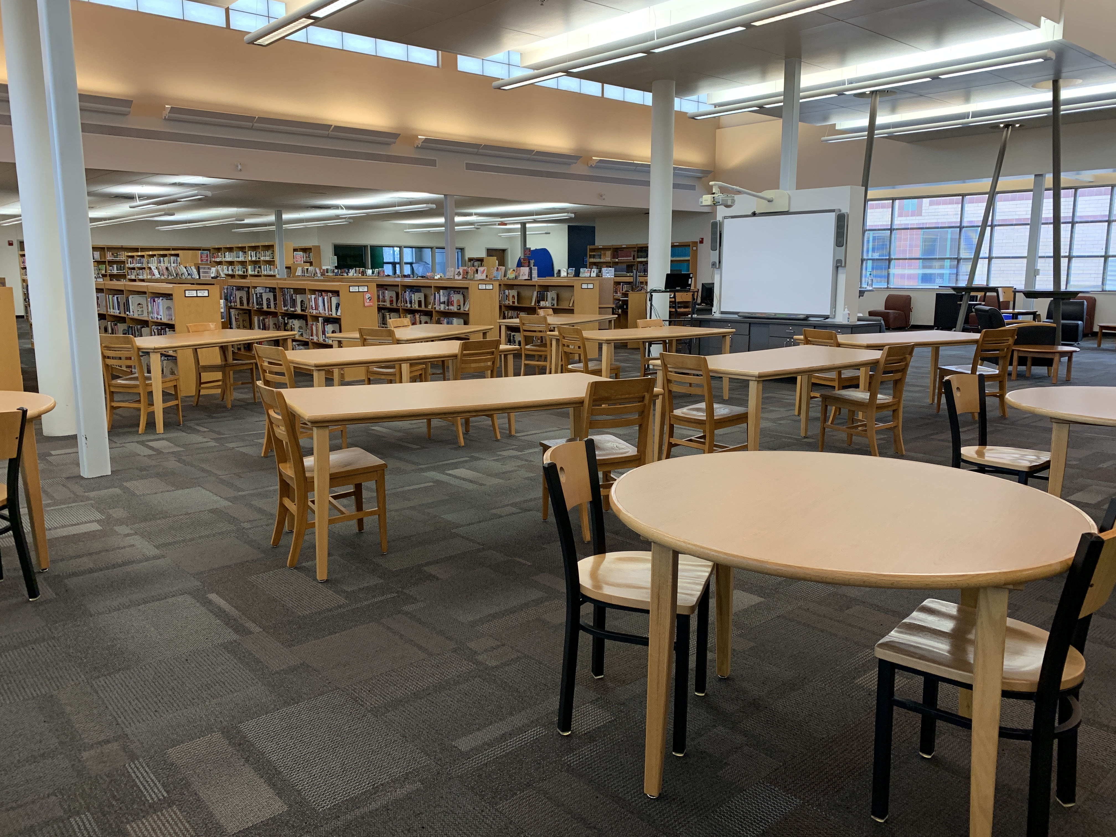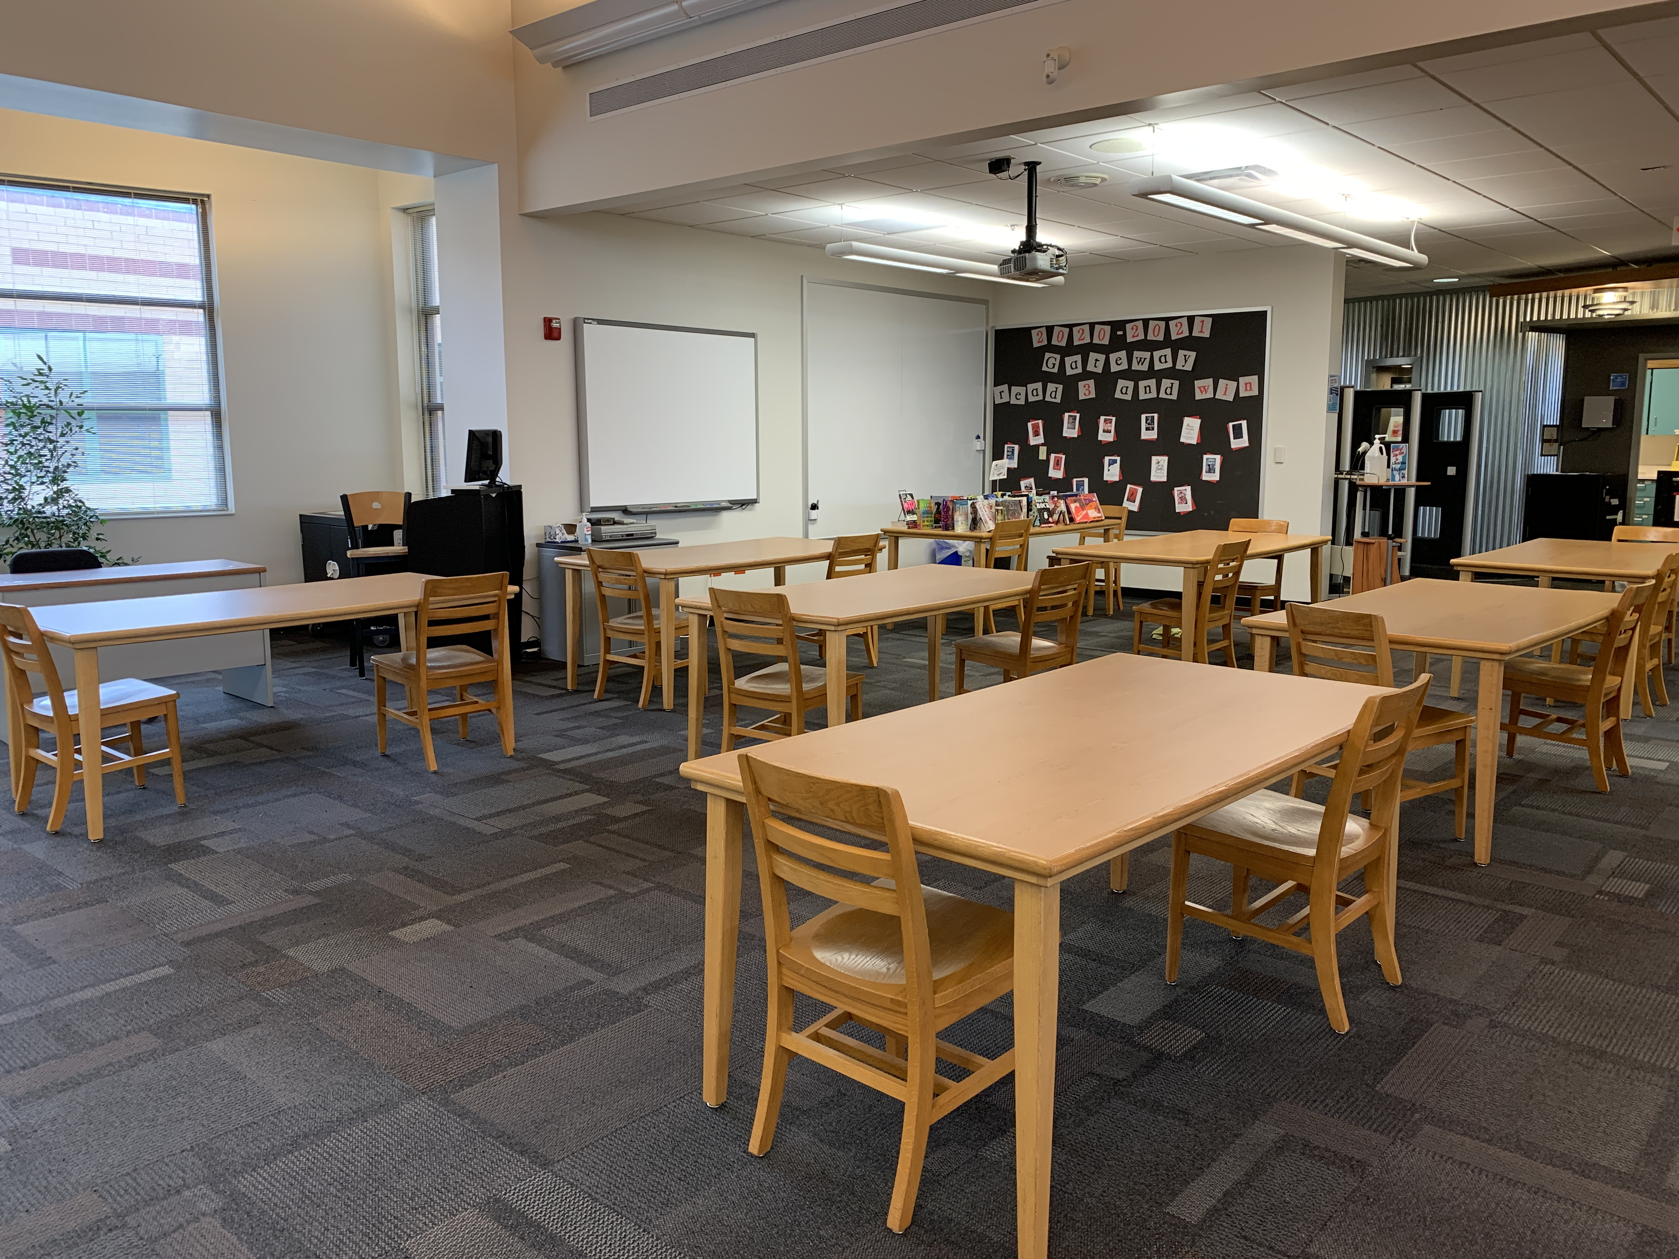

Each open classroom provides seating for up to 32 students. It contains speakers and a projector and a smartboard, and it can be used to meet the needs of whole classes or smaller instructional groups (note: in an attempt to encourage social distancing, some seats have been removed during the current school year).

Lafayette High School Library - Video Conference Classroom
Evidence: photograph of video conference classroom
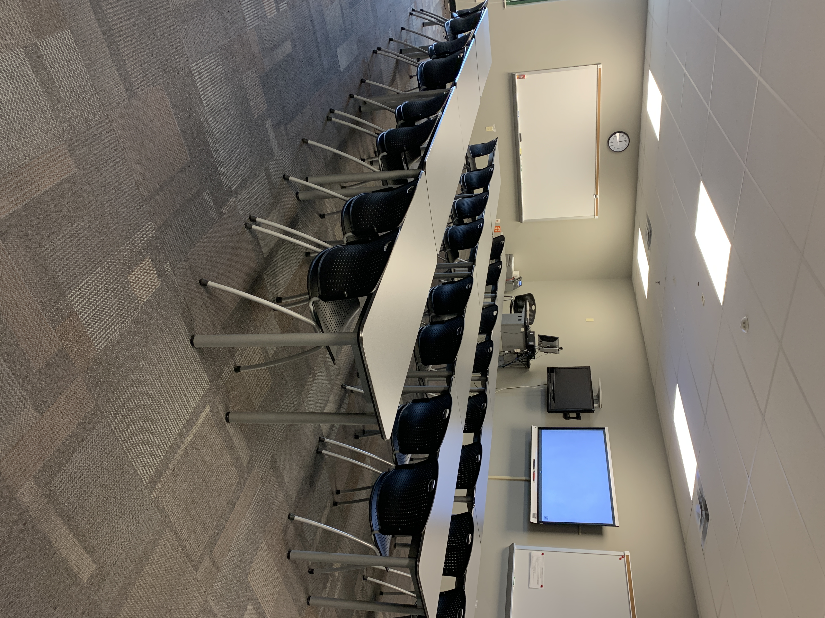
The closed classroom provides seating for up to 32 students (note: in an attempt to encourage social distancing, some seats have been removed during the current school year). It contains speakers and a projector and a smartboard as well as a traditional whiteboard, and it can be used to meet the needs of whole classes or smaller instructional groups.

Lafayette High School Library - Open Computer Lab
Evidence: photograph of open lab

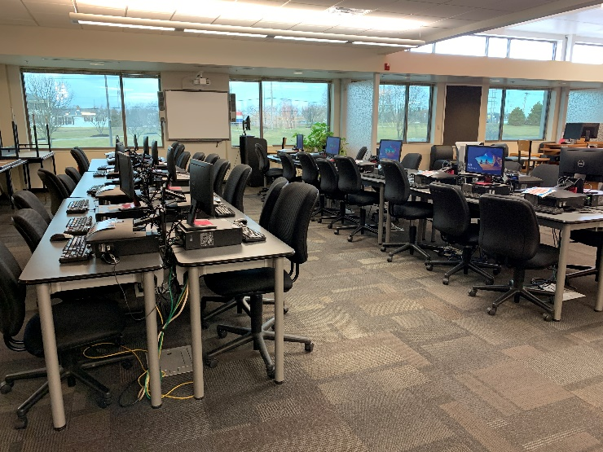
The open lab provides seating and desktop computers for up to 32 students (note: some computers have their monitors turned down to encourage social distancing during the pandemic). In addition to the desktop computers, this space contains speakers and a projector and a smartboard, and it can be used to meet the needs of whole classes or smaller instructional groups.

Lafayette High School Library - Media Work Room
Evidence: photograph of media production room
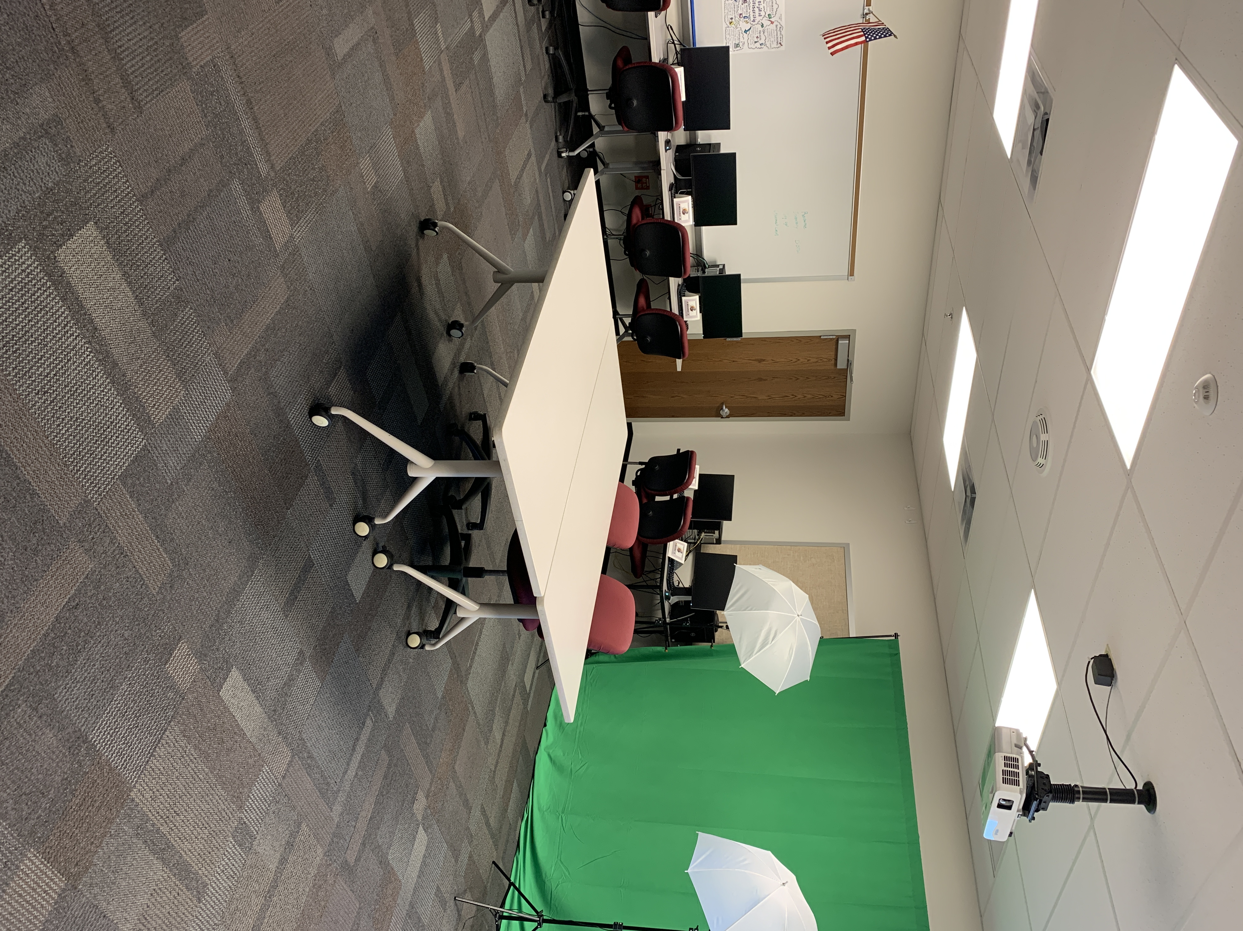

The media production room provides one desktop computer as well as specialized media equipment (poster printer, video transfer equipment, sound recording equipment, green screen and lighting, etc.). This space also hosts our eSports lab, including 10 high speed computers, high level graphic displays and gaming mice and keyboards. Although not capable of holding a full class, the room is an excellent addition for students looking to produce collaborative multimedia projects using library equipment as well as for our students who will be a part of a competitive new sport.

Lafayette High School Library - Conference Room
Evidence: photograph of conference room

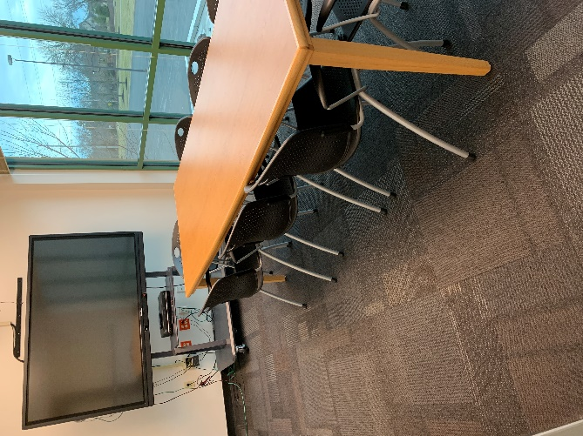
The library conference room provides seating for eight individuals (note: some computers have their monitors turned down to encourage social distancing during the pandemic). A desktop computer and Promethean board are available, as well as a DVD player. This room is available for small presentations or meetings.

Lafayette High School - Early Childhood Area
Evidence: photograph of early childhood area
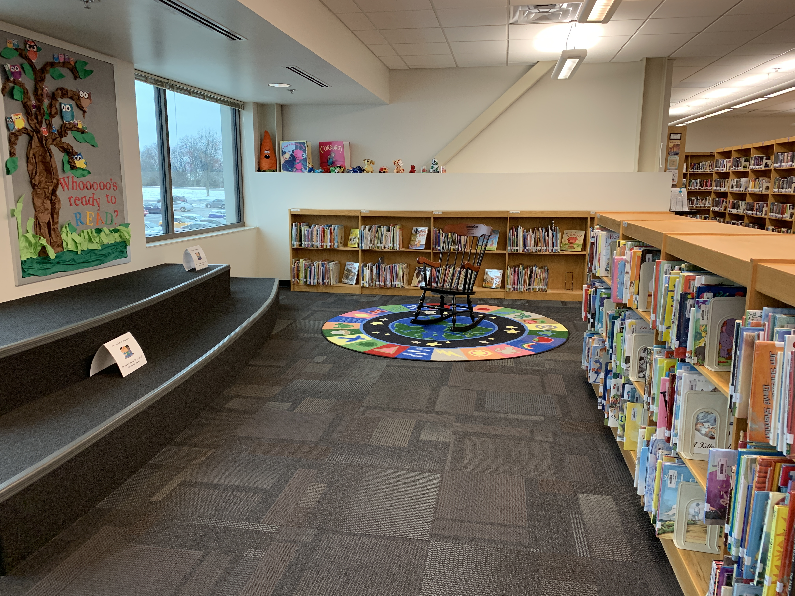
The Early Childhood Area provides a stair step seating space for our preschool students. This space is used during weekly story time (during the Pandemic, story time has been virtual). 1,725 books purchased specifically for our preschool population are housed on shelves accessible to our youngest students.

Return to Table of Contents

Indicator #13: Program offers a variety of programs and/or opportunities for all members of the library community in a safe and inclusive manner

(AASL—include)
Exemplary (2 points): Offers a minimum of four distinct and cross-curricular programs throughout the year that may
- include family and/or community participation
- take place either during or beyond the school day

Approaching (1 point): Offers a minimum of two distinct and cross-curricular programs that may
- include family and/or community participation
- take place either during or beyond the school day

Required Documentation/Evidence

Calendar of events with enough detail to show the purpose and audience for each event; may include photos and/or evaluation from some events.

Supporting Evidence
Insert Applicable Links Here:

Insert Documents/Narratives:

Evidence: Flyers for each event as described below:

LHS Book Club. (September 21, October 12 and 26, November 9 and 30, December 14, January 11 and 25, February 8 and 22)
The LHS Book Club is an extracurricular activity offered to any interested student. The club meets twice a month: once to discuss a common read and another time to discuss good books currently being read by members. Meetings are usually held in-person, but the club has met via Zoom since April due to the pandemic. The LHS Book Club continues to provide a much needed opportunity for avid readers to be part of a community that shares their passion for books.

Launch Party with Nic Stone. (September 29)
In September, the Rockwood Library Media Program collaborated with the Rockwood Department of Educational Equity and Diversity to offer a special author event: a launch party with bestselling author Nic Stone to celebrate the release of her book Dear Justyce. The launch party, which was held via Zoom due to the pandemic, was open to all members of the Rockwood secondary schools’ community (students, teachers, and staff). The LHS Library purchased multiple copies of Dear Justyce for the library collection so that students would have easy access to the title. The launch party promoted reading while highlighting important issues of social justice in American society.

LHS Winter Reading Marathon. (December 1st through January 15th)
LHS staff and students were invited to participate in the LHS Winter Reading Marathon. Promoted through English Language Arts classes, school emails, Canvas inbox messages, social media, and grade level newsletters, the school community was encouraged to register for a specific race distance: marathon=26 hours, half marathon=13 hours, 10K=6 hours, 5K=3 hours. The race ran from December 1-January 15. Participants created a reading log to document their “distance” read. A mid-race check-in in the format of a Google Form encouraged progress toward the chosen goal, asked for minutes read so far, included a spot for a reading selfie, and allowed for support with reading suggestions. 29 individuals asked for book recommendations in this check-in. LHS librarians made individual recommendations based on reading history and preference and sent possible titles via email. At the conclusion of the race, 81 participants read a total of 1590 hours. Finishers received a certificate, Starbursts, and a free book of choice to celebrate their accomplishment.

Gateway Readers Award Program. (August 24th through March 16th)
The LHS library promotes the 15 Missouri Gateway Nominee books. Books are featured in a prominent display in the entry to the library and a bulletin board both in the library space and in remote areas in the building. These titles are book talked to English Language Arts classes and are often used as a First Chapter Friday read alouds shared with English Language Classes. Students are encouraged to read at least 3 titles by March in order to cast a vote for the best book of the year in Missouri. To provide a variety of access points for all types of readers, the LHS library has purchased multiple copies of all 15 Gateway books; copies of eBooks and available eAudiobooks have been purchased as well. Librarians also encourage avid readers to rate the Gateway preliminary Reader-Selector titles, a list of 25 books that will eventually become the next Gateway list.

Community One Read. (Promotion began December 4th; Panel Discussion February 10th)
In December, January and February, the Lafayette Library promoted the district’s inaugural one read of the book Stamped: Racism, Antiracism, and You by Jason Reynolds and Ibram X. Kendi. Administrators, staff, students, and community members read Stamped over the course of several months, culminating in a panel discussion of the text and its ideas on race and culture. In addition to promoting the One Read to our school community, the LHS library media specialists purchased additional copies and offered personal growth/development opportunities specific to our school community. Over the course of 9 weeks, teachers, students, and parents who chose to participate added thoughts and ideas and reactions to the book on online, collaborative platforms including Padlet, Poll Everywhere, and Google Jamboard. This allowed our school participants to connect their thinking to others at Lafayette High School, family members, and other community members as a whole.
Library Bookmark Contest. (February 1st through March 31st)
Rockwood students were invited to create an original bookmark to celebrate National Library Week; designs were to promote school libraries. The LHS librarians created a flyer for the event, and it was shared with students through English Language Arts and Art teachers and via Canvas inbox messages along with being posted in the school’s scrolling announcements in the Commons area. This is the second annual contest; last year’s contest was interrupted with Covid restrictions, though several students had turned in their entries. This contest gives all students an opportunity to participate and often brings students to the library who may not be avid readers; it allows the LHS librarians to make connections with a variety of students.

Curbside Checkout. (Yearlong service)
The LHS Library started offering curbside checkout at the beginning of the school year when all students were learning from home. We provided students and teachers with instructions on requesting books through Destiny. We also gave students the option of requesting titles by emailing the library staff. Students could pick up their requests during school hours. We worked with our school’s social worker and the administrative team to make arrangements for students who could not arrange transportation to LHS to pick up library materials. A number of students used curbside service while others opted for ebooks, books from the public library, or books they purchased on their own. Regardless of where students got their books, the LHS library resources were available to them. We continue to offer this service to students who have chosen to continue learning virtually.

SLCL eCard Services Event. (January 26th)
LHS library media specialists collaborated with a youth librarian at St. Louis County Library to create a virtual presentation for parents demonstrating the materials available to students through their Rockwood School District/St. Louis County Library eCard. This presentation demonstrated how students could use their eCard to access ebooks, audiobooks, and databases offered through St. Louis County Library as well as online test preparation materials and online tutoring available through the St. Louis County Library website.

Return to Table of Contents

Indicator #14: Program provides a variety of current technologies in the library, including means of remotely accessing library resources at any time

(AASL—curate, explore, include)
Exemplary (2 points): Provides a website with a curated selection of technology resources and openly licensed digital resources, learning management system, and/or social networking to offer 24/7 access to library

Approaching (1 point): Provides links to district-supported resources with 24/7 access

Required Documentation/Evidence

Link to website
Copies of communication sharing technology resource links with library stakeholders

Supporting Evidence
Insert Applicable Links Here:
Insert Documents/Narratives:
Lafayette Library Website
Evidence: link

The Lafayette High School library’s website can be accessed here:
https://www.rsdmo.org/lafayette/library/Pages/default.aspx

The Lafayette library’s website provides access to a curated selection of technology and digital resources. Through the library’s website, students can access our Destiny catalogue, where they can search for and request technology resources: cameras, headphones, Chromebooks, Nook e-readers, audio recorders, and more. They also have access to ebook and audiobook resources, both of which are available through the Destiny catalogue in conjunction with Follett and MackinVia.

Lafayette Library’s Database Page
Evidence: link

The Lafayette library’s database page may be accessed here:
https://www.rsdmo.org/lafayette/library/Pages/Databases.aspx

The library’s database page is another piece of evidence that the Lafayette library provides 24/7 access to curated library resources. In this case, Lafayette library databases, as well as Rockwood School District databases, are available continuously to students. Students accessing these databases from home are required to log in; the library’s database page includes a secured link to the campus and district passwords, which enables students to access these databases without requiring them to memorize a list of additional passwords. The Lafayette library’s database page also includes links to St. Louis County Library resources, as part of our partnership with the county library system.

Lafayette Library’s Ebook and Audiobook Information Page
Evidence: PDF of Resources for Book Access for RSD Students and Staff

The Lafayette library’s ebook and audiobook information page is evidence that the library provides 24/7 access to a curated selection of licensed digital resources. This document lists the available sources for ebooks and audiobooks: the library’s Destiny catalogue; the St. Louis County Library’s Overdrive (which students have access to through our partnership with the county library); MackinVia; Audible (free school page); and the Junior Library Guild ebook collection. In addition to links to each collection, this document also provides links to instructions and individual video tutorials on how to access and use each site.

Lafayette Library’s Canvas Course
Evidence: image of Canvas course page and modules

The Lafayette library’s Canvas course is another piece of evidence that the library provides 24/7 access to current technologies and resources. The Canvas course is organized into modules that cover the following topics: an overview of library policies, services, and resources; an introduction to the databases; an introduction to ebooks; an overview of resources available through the district’s partnership with the St. Louis County Library system; a series of lessons on the research process; advanced lessons on choosing recreational reading material; and a selection of teacher-specific resources like Swank Streaming Video, Learning Ally, and Learning Express.

Rockwood School District Canvas Resources
Evidence: image of Canvas Student Virtual Locker

The Rockwood School District Canvas Student Virtual Locker is another piece of evidence that the library provides 24/7 access to current technologies and resources. The Canvas Virtual Locker is on each Canvas course in which our students are enrolled. Students use the Canvas courses daily for access to their course materials. On the front page of each course is a “Student Resources” link that takes students (and their parents or guardians) to a “Virtual Locker.” The virtual locker houses direct links to library resources, available 24/7. Links include the St. Louis County Library (for eCard access), Rockwood School District databases, Destiny (our library management system), and the library webpage. Teachers direct students to use these resources for research and easy access.

Lafayette Library’s “LHS Library at Home Services” Flyer
Evidence: flyer

Another piece of evidence that shows that the Lafayette librarians provide a variety of current technologies that are remotely accessible is the “LHS Library at Home Services” flyer. The LHS Librarians developed and digitally distributed this flyer in response to the school district’s decision in August to temporarily shift to remote learning. The flyer highlights how LHS librarians can help with teaching (lessons on database use, media literacy, book selection, technology, etc.), collaborating (designing lessons and projects, conferring with students), resources (online access to Swank, databases, physical books, etc.), technology (headsets, cameras, microphones, programs like WeVideo), and librarian-made lessons and resources already available on the library Canvas page.

Lafayette High School--technology available to teachers to support online/remote learning
Evidence: pictures of new technologies

With students learning both at home and in person, librarians have provided a broad array of technologies to support this learning. The library researched and acquired audio and video equipment, connecting cables and USB hubs. In terms of sound devices, some teachers required bluetooth headsets to move around the classroom while others needed voice amplification devices, lavalier microphones or classroom snowball microphones to capture conversations within a space. In addition to sound devices, the library also provides document cameras and webcams for teachers to show events in class or video cameras for them to record, for example, labs or lectures in advance to post online. In short, the library quickly identified teacher needs for supporting online learning, provided equipment, and then arranged support and instruction for setup and use. By providing necessary equipment, the library ensured appropriate remote access to instruction for students.
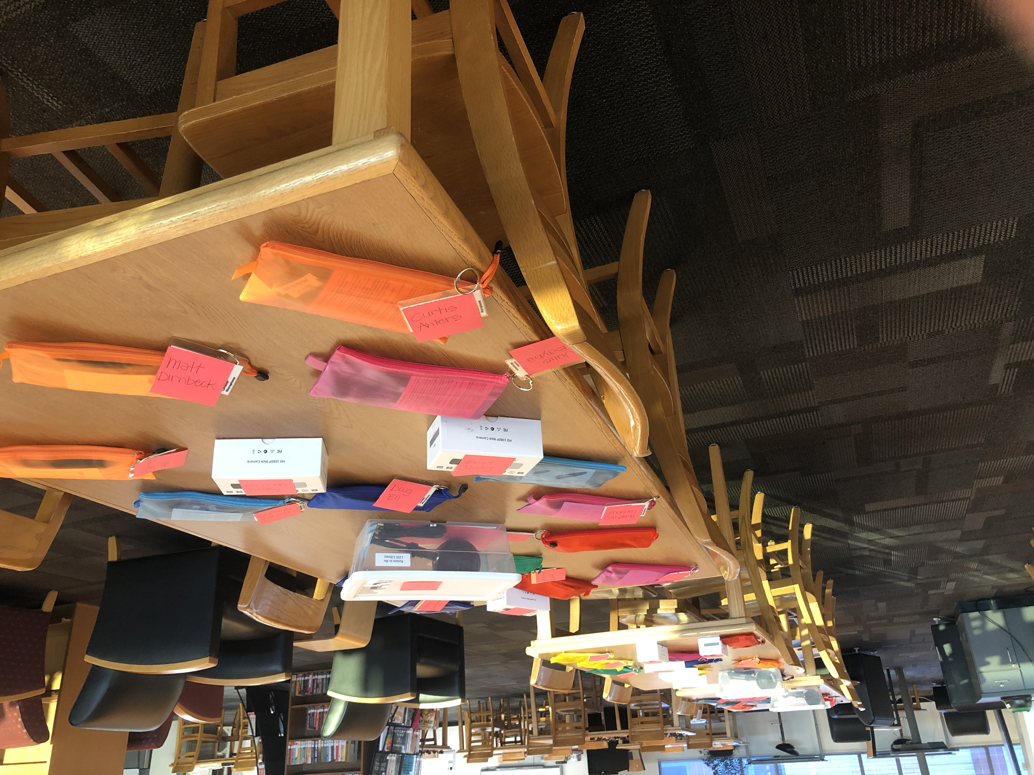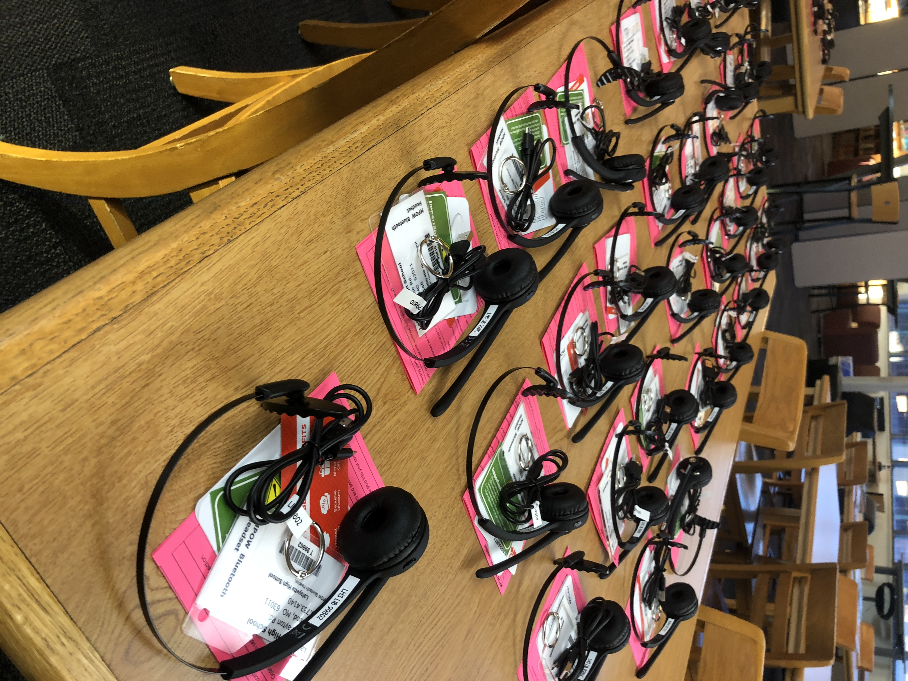

Lafayette Library’s Swank Streaming Subscription
Evidence: teacher-oriented Swank handout

Another piece of evidence that the Lafayette library provides 24/7 access to library resources is the Swank Streaming subscription. Swank Streaming is a movie distribution and licensing service as well as a streaming service; the subscription offers educators the ability to select and share movies from the catalogue, which students can then stream and watch on their personal devices. If the catalogue does not contain the film that a teacher wants to show, teachers can request additional movies. Because the films can all be accessed on personal devices, the service provides 24/7 access to instructional materials chosen by educators.

Lafayette Library’s Twitter Account
Evidence: PDF of selected tweets

One piece of evidence of the Lafayette library providing access to curated resources through social networking is the Lafayette Library Twitter account. As the selected tweets show, the library Twitter account is regularly updated and used to communicate with stakeholders about new items in the collection, library events, and reminders about online access opportunities through the library website.

Lafayette Parent Instructional Communication
Evidence: flyer

Another piece of evidence that the Lafayette library provides access to curated resources and 24/7 access to the library’s digital resources is the parental instructional communication on which Lafayette and Rockwood Summits librarians collaborated with the St. Louis County Library. Over a Zoom meeting, librarians introduced parents to digital library resources, including ebooks, audiobooks, databases, test preparation materials, movies, newspapers, magazines, and more. They also helped parents learn how their Rockwood students could access these materials through a partnership with the St. Louis County library, with which the Rockwood School District has partnered to ensure that every student has a library card.

Return to Table of Contents

Library Management

Indicator #15: Program implements flexible scheduling to meet the authentic instructional needs of students

(AASL—collaborate, explore, include)
Exemplary (2 points): The library facility uses a flexible schedule during the length of the school day with all scheduling at the discretion of the professional librarian.

Approaching (1 point): The schedule of the library facility during the length of the school day does not exceed 25 percent fixed scheduling (such as being part of a school’s specials rotation); the remaining 75+ percent of the day’s schedule is flexible and implemented at the discretion of the professional librarian.

Required Documentation/Evidence
Schedule reflective of four consecutive weeks

Supporting Evidence
Insert Applicable Links Here:
Insert Documents/Narratives:
The Lafayette High School library meets the expectations for a score of EXEMPLARY in indicator 15 because the library facility uses a flexible schedule during the length of the school day with all scheduling at the discretion of the professional librarian. For this indicator, Lafayette librarians have selected the following pieces of evidence: a schedule reflective of four consecutive weeks.

Lafayette High School Library Calendar
Evidence: PDF of four weeks
The Lafayette High School library’s calendar displays flexible scheduling that meets the authentic instructional needs of students. Scheduling is completely at the discretion of the school’s two professional librarians. Librarians schedule classes as requested by teachers based on availability to collaborate and availability of space.

Return to Table of Contents

Indicator #16: Librarian regularly evaluates the library program

(AASL—This indicator includes addressing all AASL Integrated Frameworks while evaluating the school library program.)
Exemplary (2 points): Regularly designs throughout the school year evaluative tools and acquires evaluative information regarding the school library program from all stakeholders: school librarian, principal, certified teachers and/or support staff, parents, students

Approaching (1 point): Annually designs evaluative tools and acquires evaluative information regarding the school library program from four of the following five stakeholders: school librarian, principal, certified teachers and/or support staff, parents, students.

Required Documentation/Evidence

Evaluative tools(s) utilized with each stakeholder regarding perception of the library program. These may be in the form of surveys, audio discussions, digital photos of physical documents as well as other data collection methods. These evaluations may include the complete library program, book clubs, special celebrations such as Read Across America Week or Banned Book Week, resource collections, resource development, etc.

Supporting Evidence
Insert Applicable Links Here:

Insert Documents/Narratives:
The Lafayette High School library meets the expectations for a score of EXEMPLARY in indicator 16 because the librarians regularly design evaluative tools and acquire evaluative information regarding the school library program from all stakeholders: school librarian, principal, certified teachers and/or support staff, parents, students. For this indicator, Lafayette librarians have selected the following pieces of evidence: student surveys and survey responses; staff surveys and survey responses; parent/community surveys and survey responses; “State of the Library” annual report.

Student Surveys
Evidence: library survey responses, lesson survey responses

Students surveys are one piece of evidence that Lafayette librarians regularly design as evaluative tools to acquire evaluative information regarding the school library program from all stakeholders.
One example of this comes from surveys of students after lessons are taught. For example, we surveyed classes who participated in First Chapter Friday readings and found that mystery and suspense were rated the highest, and thus plan to incorporate more titles in those genres for this semester. Lafayette librarians also surveyed the full student body about the library program. This survey provided library staff with invaluable information about topics important to students. For example, one student who was an at-home learner mentioned that she would love to be able to browse shelves at a time that other students were not present. After seeking permission from administration, we will launch after school hours to meet these needs.

Staff Surveys
Evidence: survey responses

Staff surveys are another piece of evidence that Lafayette librarians regularly design as evaluative tools to acquire evaluative information regarding the school library program from all stakeholders.

Parent/Community Surveys
Evidence: survey responses
The parent and community survey is another piece of evidence that Lafayette librarians regularly design evaluative tools and acquire evaluative information regarding the school library program from all stakeholders.

“State of the Library” Annual Report
Evidence: report and agenda
The “State of the Library” annual report and meeting agenda are another piece of evidence that Lafayette librarians regularly design evaluative tools and acquire evaluative information regarding the school library program from all stakeholders.

Return to Table of Contents

Indicator #17: Program has a budget that is adequate to purchase books, materials, supplies, etc., to meet the library’s strategic plan

(AASL—curate, include)
Exemplary (2 points): Collaboratively works to establish an adequate budget with the building and/or district administration by communicating a strategic five-year plan that outlines the vision and progression of the school library program goals in connection with the school and/or district strategic plan

Approaching (1 point): Collaboratively works to establish an adequate budget with the building and/or district administration by communicating a three-year plan that outlines the vision and progression of the school library program strategic plan

Required Documentation/Evidence

Submission of collaborative budgetary plan denoting the library’s strategic plan and its connection to the building or district strategic plan. Submission must include the dollar amount (total and per student) provided by the district to support the library plan. Examples: written reports, spreadsheets.

Supporting Evidence
Insert Applicable Links Here:

Insert Documents/Narratives:
The Lafayette High School library meets the expectations for a score of EXEMPLARY in indicator 17 because the librarians collaboratively work to establish an adequate budget with the building and/or district administration by communicating a strategic five-year plan that outlines the vision and progression of the school library program goals in connection with the school and/or district strategic plan. For this indicator, Lafayette librarians have selected the following pieces of evidence: library strategic plan, including budgetary plan and the district strategic plan, and the State of the Library annual report with meeting minutes.

Lafayette Library Five-Year Plan
Evidence: PDF of plan which contains budgetary plan spreadsheet

The library’s budgetary plan, in conjunction with the library’s five-year plan, provides evidence that the Lafayette HS library is adequately funded in order to achieve goals that are aligned with building and district plans.

The library’s budget is adequate to support the library’s goals as outlined in the library’s five-year plan (which in turn reflects building and district CSIP) in the following ways:
- The library’s first goal in its five-year plan is to support multiple literacies and help all students to become lifelong readers. In support of this goal, the library budget allocates $24,556 to collection development, and $1,800 to processing materials. By maintaining a current, diverse, and relevant library collection, the librarians are better able to reach all readers. This budget also supports subscriptions to periodicals, which offers opportunities for students to learn media literacy and visual literacy. Our district budget supports the purchase of subscriptions to databases, to help students master information literacy, and a $2,000 media budget supports the purchase and maintenance of equipment, to support technological literacy.
- The library’s second goal in its five-year plan is to foster lifelong learning by collaborating with staff across curricula. The library’s budget reflects that goal by allocating $1,000 to video conferencing, $24,556 to collection development, and $2,000 to media materials. Money for technology-related resources from the building and district budgets allows the library to support multiple curricula through database subscriptions and equipment purchases. Money for collection development allows the library to support multiple curricula, from nonfiction purchases for science courses to fiction purchases to support a newly created Black Literature course. The library regularly canvases staff for purchase requests and buys films and books to meet curriculum needs. In addition, the library purchases media that meet the needs of our staff and students in the online environment. For example, we have purchased and provide support for a film streaming platform called Swank, allowing teachers to show video content to students at home and in person. The video conferencing budget provides direct opportunities for teachers and students to interact with experts in the field, giving us a budget for procuring virtual author visits for courses like Creative Writing.
- The library’s third goal is to act as the heart of the Lafayette community. The library budget reflects this goal by allocating $2,600 to library supplies, $2,000 to technology-related supplies, $1000 to videoconferencing, and $24,556 to collection development. The $2,600 to library supplies allows the library to invest in supplies to keep the library clean and organized. This money also goes toward student destress materials such as (in non-pandemic years) puzzles, coloring materials, board games and group art. The $2,000 to technology-related supplies includes equipment in the media work room, which is utilized by students for curricular purposes and clubs and groups for media production. For example, we maintain a green screen and video equipment that is, in turn, used by sports teams for creating intro videos. The $24,556 to collection development represents our commitment to keeping a current, diverse, and relevant collection that our patrons--both student and staff-- will find engaging and representative for their recreational needs. Part of the $1000 videoconferencing budget allows the library to create virtual opportunities for our school community to come together for author visits. The library seeks to remain the heart of our school community.
- The library’s fourth goal in its five-year plan is to provide a flexible, adaptable, and accessible space that supports learning. The library’s budget reflects that in allocating $2,600 to library supplies. The $2,600 to library supplies allows the library to invest in supplies to keep the library clean, attractive, and welcoming, including investments in furnishings that are comfortable, functional, and mobile. This budget is also used to purchase display items that invite patrons to enjoy library contests and highlight materials.
- The library’s fifth goal in its five-year plan is to enhance existing collections and services. This goal is reflected in the allocation of $2,000 to technology-related supplies, and $24,556 to collection development. The $2,000 to technology-related supplies allows the library to maintain equipment such as cameras, tripods, microphones, and external DVD drives, all of which are required by teachers and students in creation of media each year. The $24,556 to collection development allows the library to continue building a current, diverse, and relevant collection that all patrons will find engaging and useful. By utilizing student and staff surveys and input, library materials purchased will reflect learning interests, curricular needs, and student and staff interests.
- The library’s sixth goal in its five-year plan is to improve outreach and communication to patrons and stakeholders. The library’s budget is adequate to support this goal, and this goal is reflected in the allocation of $2,600 to library supplies and $2,000 to technology-related supplies. The $2,600 to library supplies allows the library effectively communicate about circulated materials with our patrons. The $2,000 in technology-related supplies allows the library to continue its social media footprint and create quality media for outreach to our community.
- The library’s seventh goal in its five-year plan is to provide the highest quality of service to all patrons. The library’s budget is adequate to support this goal, and this goal is reflected in the $24,556 allocated to collection development. The $24,556 in collection development allows the library to obtain titles of interest for the librarians’ professional development as well as subscribe to professional journals such as School Library Journal and Booklist. Although the library budget does not directly support memberships to professional organizations, other building funds are utilized in attending PD opportunities, when possible.
- The library’s eighth goal in its five-year plan is to adapt services as new technologies become available. The library’s funding is adequate to support this goal, and this goal is reflected in allocating $24,556 to collection development, $2,000 to technology-related supplies. Money in collection development has allowed the librarians to flexibly adapt to changing needs of patrons; for example, during this time, at-home learners require the necessity of purchasing eBooks, which has allowed students learning at home to access titles more easily. Money in technology-related supplies allows librarians to support new and emerging technologies. This year, for example, the library has invested in bluetooth microphones and headsets, voice amplifiers, classroom microphones and webcams--all in support of remote and concurrent teaching.

State of the Library Annual Report
Evidence: report

In an annual meeting with the building principal, Lafayette librarians reviewed library expenditures, the five-year plan and budgetary plan, and building and district goals to ensure that the library budget supports library, building, and district goals as well as to advocate for an adequate budget to support those goals.

Return to Table of Contents

Indicator #18: Program maintains a current, relevant, and diverse collection of print and/or digital resources that is responsive to the needs of the community and is tied to curriculum

(AASL—curate, explore, include)
Exemplary (2 points):
- Maintains current collection as follows:
  - Nonfiction: At least 70 percent of the resources have copyright dates within the most recent 12 years.
  - Fiction: The average age of a fiction collection is less than 15 years old.
- Supports access on all subjects that meet the needs, interests, and abilities of all persons in the community the library serves
- Supplemental resources extend beyond the school community to connect with the global community

Approaching (1 point):
- Maintains current collection as follows:
  - Nonfiction: At least 70 percent of the resources have copyright dates within the most recent 15 years
  - Fiction: The average age of a fiction collection is less than 17 years old.
- Supports access on all subjects that meet the needs, interests, and abilities of all persons in the community the library serves
Required Documentation/Evidence

Collection analysis reports that clearly show the currency, relevance, and diversity of the library’s collection

Supporting Evidence
Insert Applicable Links Here:

Insert Documents/Narratives:

The Lafayette High School library meets the expectations for a score of EXEMPLARY in indicator 18 because the librarians maintain a current collection as follows:
- Nonfiction: At least 70 percent of the resources have copyright dates within the most recent 12 years.
- Fiction: The average age of a fiction collection is less than 15 years old.
- Supports access on all subjects that meet the needs, interests, and abilities of all persons in the community the library serves.
- Supplemental resources extend beyond the school community to connect with the global community.
For this indicator, Lafayette librarians have selected the following pieces of evidence: library collection analysis; diversity resource lists.

Lafayette Collection Analysis
Evidence: Data from Titlewise and Mackin collection analysis, Excel spreadsheet

The Lafayette Collection Analysis report provides evidence that the library’s fiction collection has an average age of less than 15 years old. Currently, the average age of the library’s fiction collection is 2012, or 9 years old. A statistical analysis of the fiction titles and their publication dates can be found in the graphs from the current Titlewise analysis data as well as a section of the complete collection analysis from Mackin. Of additional consideration, our students have access to a St. Louis County eCard, providing complete access to 1000s of current fiction titles via the Overdrive system.

The Lafayette nonfiction collection analysis report shows that72.2 percent of the nonfiction collection have copyright dates within the most recent 12 years. The library’s current total number of nonfiction titles is 9178. Of those titles, 6624 have a copyright date within the most recent 12 years (2008). That is equivalent to 72.2 percent of the nonfiction collection. In addition, the library’s nonfiction collection is supplemented by eBooks and articles as found in EBSCO (provided by MORENet), SIRS and Gale (provided by district subscriptions). Our students also have access to a rich collection of nonfiction eBooks via their St. Louis County Library eCard. A more detailed accounting of these titles and their publication dates can be found in the accompanying graphs from a current Titlewise analysis of the collection, a chart of the nonfiction titles, and an excel spreadsheet listing of the nonfiction titles in the collection.

Lafayette Diversity Resource Lists
Evidence: lists

Diversity resource lists, compiled by the Lafayette library staff, are non-comprehensive lists representative of the collection’s diversity; these lists provide evidence that the Lafayette library supports access for all subjects, interests, and abilities of all people in the community the library serves.

Lafayette High School- St. Louis County Library Partnership
Evidence: informational flyers, student handouts

The Lafayette HS library provides access to supplemental resources that extend beyond the school community and help students connect with the global community. The St. Louis County Library is a key partner in providing these resources. Rockwood School District provides each student with a county library card that can be used to borrow digital materials (such as eBooks and eAudiobooks) and access digital content (including subscription databases). In partnership with Rockwood Summit High School librarians, the Lafayette librarians have also hosted an information meeting for parents and guardians to help them learn what resources are available to their students through the county library. Students and teachers have access to tutorial videos with step by step instructions on how to access these sources, and librarians regularly present access lessons to classes to meet their personal recreational reading and research needs with these resources in mind. Annually, the Lafayette Library also partners with the St. Louis County Library to promote summer reading. While all promotions will most likely be digital in this school year, the library plans to continue to promote the program.

Return to Table of Contents

Indicator #19: Program maintains policies, procedures, and practices as set by the local school board

(AASL—curate, engage)
Exemplary (2 points): Has an up-to-date policy (within the last five years) including all of the following:
- Fines/Damaged materials
- Challenged books
- Collection development
- Volunteers
- Donations
- Borrowing policy
- Inventory
- Acceptable use
- Confidentiality
- Intellectual freedom
- Weeding

Approaching (1 point): Has an up-to-date policy (within the last five years) including nine of the following:
- Fines/Damaged materials
- Challenged books
- Collection development
- Volunteers
- Donations
- Borrowing policy
- Inventory
- Acceptable use
- Confidentiality
- Intellectual freedom
- Weeding

Required Documentation/Evidence

Link(s) to policies

Supporting Evidence
Insert Applicable Links Here:

Insert Documents/Narratives:
The Lafayette High School library meets the expectations for a score of EXEMPLARY in indicator 19 because the library program has an up-to-date policy (within the last five years) including all of the following: Fines/Damaged materials, Challenged books, Collection development, Volunteers, Donations, Borrowing policy, Inventory, Acceptable use, Confidentiality, Intellectual freedom, Weeding. For this indicator, Lafayette librarians have selected the following pieces of evidence: Rockwood School District library handbook.

Rockwood School District Library Handbook
Evidence: PDF of handbook

The Rockwood School District’s library handbook provides evidence that the Lafayette library program maintains policies, procedures, and practices set by the local school board.

Return to Table of Contents

Staffing

Indicator #20: Program maintains an appropriate librarian-to-student ratio

(AASL—include, inquire)
Exemplary (2 points): Exhibits the following:
- 1.0 full-time librarian assigned full time to a library in a school* with a student population of 1-750
- 1.5 full-time librarians assigned full time to a library in a school* with a student population of 751-1,500
- 2.0 full-time librarians assigned full time to a library in a school* with a student population exceeding 1,500

Approaching (1 point): Exhibits ratio of one full-time librarian assigned full time to a library in a single school*

*Because of the variety of library/school configurations among Missouri schools (one library for two campuses, two libraries on a single campus, etc.), applicant must include a description of the configuration in his/her school and explain how all stakeholders are sufficiently served within this configuration. Library staffing must be such that the library is open to students at any time during the regular school day.

Required Documentation/Evidence

Written verification from school or district administration regarding student access to library at any time during the regular school day in addition to librarian’s required description of configuration (see above)

Supporting Evidence
Insert Applicable Links Here:

Insert Documents/Narratives:
The Lafayette High School library meets the expectations for a score of EXEMPLARY in indicator 20 because the library program exceeds the following expectations:
- 1.0 full-time librarian assigned full time to a library in a school* with a student population of 1-750
- 1.5 full-time librarians assigned full time to a library in a school* with a student population of 751-1,500
- 2.0 full-time librarians assigned full time to a library in a school* with a student population exceeding 1,500
For this indicator, Lafayette librarians have selected the following pieces of evidence: a description of the Lafayette Library; written verification from school or district administration regarding student access to the library at any time during the regular school day in addition to the librarians' required description of configuration.

Lafayette Library Description
Lafayette High School serves 1740 students in grades 9‐12 as well as 147 full time certified staff and 68 support staff, including administrative assistants, classroom assistants, nurses and cafeteria and custodial staff. The library media center is open daily from 8:00 am to 4:10pm (M-Th) and 8:00 am-3:30pm (F) and is staffed by two full-time certified library media specialists and one full-time library assistant. The high school library operates on a flexible schedule and teachers *may book time in the computer lab space, two open classrooms, video conference room and media workroom. Students are welcome to visit the library media center before and after school, during the day with a pass from their teacher, or *during their lunch block. The LMC has four SmartBoards used for instruction and more than thirty-six desktop computers available for student use, providing access to the internet, library catalog, and various subscription databases. The students also have access to Destiny resource lists, which allow the librarians to curate focused collections of print and digital resources. In addition, the library staff provide support for the school’s 1:1 Chromebook program. The library media specialists regularly collaborate with teachers on research and technology projects. The library media specialists encourage literacy by providing and promoting well-reviewed and high interest materials, offering reading incentive programs, and facilitating the school’s summer reading program.
*During this pandemic, the library has adjusted the number of students and classes who may meet in the library to meet the social distancing requirements as set by the school district and county health officials.

LHS Assistant Principal Colleen Fields Written Verification
Evidence: PDF of statement of verification

The included PDF of a written statement of verification from Colleen Fields, Assistant Principal of Lafayette High School, is evidence that the Lafayette library program exceeds the standard set for EXEMPLARY in this indicator.

Return to Table of Contents

Indicator #21: Program maintains an appropriate library support staff-to-librarian ratio

(AASL—include, inquire)
Exemplary (2 points): Has one full-time paraprofessional library support staff per librarian without additional outside duties during instructional day to ensure the library is open to students and staff through the entire school day

Approaching (1 point): Has equivalent of one paraprofessional library support staff per librarian performing library-related duties in the library a minimum of 75% of the instructional day to ensure the library is open to students and staff through the entire school day

Required Documentation/Evidence
Written verification from school or district administration verifying paraprofessional hours and library accessibility hours

Supporting Evidence
Insert Applicable Links Here:

Insert Documents/Narratives:
The Lafayette High School library meets the expectations for a score of EXEMPLARY in indicator 21 because the library program has one full-time paraprofessional library support staff without additional outside duties during instructional day to ensure the library is open to students and staff through the entire school day. For this indicator, Lafayette librarians have selected the following pieces of evidence: a description of the Lafayette High School support staff; written verification from school or district administration verifying paraprofessional hours and library accessibility hours.

Lafayette High School Library Support Staff Description
Evidence: narrative below

Lafayette High School serves 1740 students in grades 9‐12. The library media center is open daily from 8am to 4:10pm (M-Th) and 8am-3:30pm (F) and is staffed by two full-time certified library media specialists and one full-time library assistant. Additional support is provided by a teacher instructional technologist and a building technical support specialist. Combined, these three support staff surpass the standard set for exemplary (one full-time library support staff per librarian) in this indicator:
- Library (Resource) Assistant: 35 hours a week, 7:50am-3:20pm, 5 days a week, with a half hour for lunch and 20 additional hours for days when students are not present.
- Teacher Instructional Technologist: full time, flexible scheduling split between Lafayette and another high school
- Technical Support Specialist: full time at Lafayette

Lafayette Building Principal Written Verification
Evidence: PDF of statement of verification, PDF of job descriptions for 3 positions listed

The included PDF of a written statement of verification from Colleen Fields, Assistant Principal of Lafayette High School, is evidence that the Lafayette library program exceeds the standard set for EXEMPLARY in this indicator.

Return to Table of Contents

Appendix

Return to Table of Contents

