BEGINNER LACES USER MANUAL- Missouri
This User Manual is intended as a resource to walk you through the basic data entry procedures for entering student, class, and staff data into the LACES NexGen database. This is not intended as a replacement for your state’s MIS policies, or federal implementation guidelines to meet NRS standards.
Questions related to the LACES NexGen database can be directed to our technical support staff using the technical support link provided in LACES, or at http://info.literacypro.com/solutions/laces/crmlng.htm, or by emailing technical support at helpdesk@literacypro.com or by calling them at 1-888-714-9464. Technical support is answered in the following order: form, emails, calls, with urgent issues addressed based on priority. Questions related to state or federal policy should be directed to whomever the state directs such questions, or by accessing the NRS Implementation Guidelines at http://nrsweb.org/foundations/implementation_guidelines.aspx.
You can access the training database at the same site as your actual database: https://laces.literacypro.com/laces Use the username motraining1 and the password motraining1 to access the training site instead of your actual site.
This manual does not replace the Help documentation available throughout the LACES NexGen database. Help can be accessed by clicking the Help link provided on each page of the database, or by using the provided Help link: https://laces.literacypro.com/Help/LACESNexGen/NetHelp/
State and federal policies are subject to change, and information provided in this manual is current as of October 2016. Please check the NRS website at nrsweb.org, your state’s MIS and adult education policies on the state website, and the Release Notes provided with each software update made in LACES NexGen for updates to policies and data entry, collection, and reporting methods.

General LACES information: Pages 2-13
Searches: Pages 14-18
Students: Pages 19-59
Classes: Pages 60-72
Staff: Pages 73-78
Dashboard/Printing/Scheduled Services: Pages 79-86

Introduction to LACES NexGen

LACES NexGen is compatible with most common internet browsers, including Chrome (recommended), Mozilla Firefox, Internet Explorer 9+, Microsoft Edge, and Safari (not recommended). LACES is accessed at the following URL: https://laces.literacypro.com/laces

Data Entry

When data must meet certain standards for reporting purposes, consistency becomes critical. In order to achieve this consistency, certain measures must be taken prior to doing the initial data entry. This is especially important if participants are continuing from prior years, and more importantly, from prior reporting periods/periods of participation. It cannot be stressed enough how important it is to enter your data chronologically, in a timely fashion, and according to the rules and guidelines based on your reporting system and state guidelines.

Common Mistakes/Issues and Glossary

Obviously, learning any new software application can take some time. Our best recommendation is to use and explore the database often to become familiar with the most common features. Additionally, use the training notes, help files, FAQ’s, and all provided documentation. Contact LiteracyPro Systems, Inc. Technical Support when you have questions.

Listed below are some common mistakes/issues that you should try to avoid.

Ignoring Warnings or Recommendations

Take heed of the recommendations the software gives you, and read the warnings, error messages, and informational windows. If they do not make sense, contact Technical Support if you need more information.

Single-clicking vs. double-clicking

Most functions you will perform in LACES require only a single mouse click. One common exception is opening a file from a list, which requires double clicking. A good tip is to single click if you are unsure: if nothing happens, go ahead and double click. Additionally, when using a toolbar with sub-menu items, wait to click until you have moved the mouse pointer to the sub-menu item. Clicking on the main menu line will only refresh the page, costing you time.

Hitting Enter on your Keyboard versus the Save button in the Database

We recommend using the Tab button or mouse to move around in the database, and not to use the Enter button on your keyboard. Hitting Enter can cause the database to save what has been entered up to that point in time and return you to the main screen, but may result in fields not being completed and saved past the point at which you hit Enter. Use Tab to go from field to field, or your mouse, and click Save when you have completely entered the data for that page.

Deleting Files

It is never recommended that you delete files other than accidental duplications or mistakes. LACES is designed so that you will not have to delete any files. Many times, historical data may be needed, or students may return after a period of being absent. Records should be left in the database, provided the record is correctly updated to prevent it from incorrectly being included in current fiscal year searches if they have no current FY activity. Records that have had a fiscal year summary created for a prior fiscal year cannot be deleted without technical support assistance, in order to provide consistency of numbers in prior FY reports.

Definitions

The following is a short list of some common terms used not only within this guide, but within the software itself.

Student: A person receiving instruction within your organization
Staff Member: A paid employee or unpaid volunteer working for your organization who can be assigned as an instructor for class settings
Tutor: A trained volunteer for your organization who can be assigned as an instructor for group and pair settings and one-on-one student instruction
Volunteer: A volunteer who does not provide instruction to students but engages in other organizational activities

Student Status Definitions
Prospective: Student has made contact with your organization but has not yet completed the entire intake process or been assigned to instruction. Every new student entered into LACES comes in as Prospective.
Waiting: Student is waiting to be enrolled in a class or matched with a tutor in a pair or small group. Prospective students can be manually updated to Waiting, or will be automatically marked as Waiting if they are enrolled in an instructional setting that is at or past the Max Enrollment
Never attended/never started: Student never received instruction. Prospective students can be manually updated to Never Attended if they do not enroll within 90 days of completing an intake form
Enrolled: Student is currently enrolled in at least one instructional setting; pair, class, or group. Automatic status for a student enrolled in one or more instructional settings
On Hold: Student was previously enrolled, but is not currently assigned to an instructional setting, for temporary reasons.
Left: Student is no longer enrolled, and has exited the program either by leaving or completion. Automatic status for a student exited from all instructional settings.
Completed Program: Student is no longer enrolled, and has exited the program and completed requirements set forth by your agency to indicate completion of the program. This status can be set manually from the automatic Left status the database generates upon exit.

LACES Help Center and Technical Support

Your LACES contract includes basic technical support. This means that you can receive unlimited technical support at no additional charge. Technical support issues should be communicated to LACES via the online technical support form. To access the tech support link, click the ? icon in the upper right hand corner, beside the person profile icon.

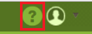

This will take you to the LACES Help section, which includes links for FAQ’s, Release Notes, the User Guide, and the Technical Support request form. Click More to access the section in which you are interested. The technical support form link can also be accessed separately from NexGen. You can access the link at http://info.literacypro.com/solutions/laces/crmlng.htm and also save it as a Favorite or Bookmark.

You can also contact technical support via telephone: 1-888-714-9464, or email at HelpDesk@literacypro.com. However, priority support is given to tickets generated using the Online Help Desk form. You may also request a telephone appointment at a specific time and day, based on technical support staff availability.

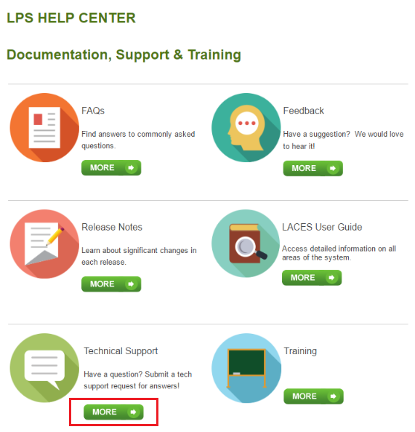

LACES NexGen will continue to grow in features, functionality, and ease of use. Builds/updates occur on a regular basis, and documentation is provided with each build to highlight new features and changes. Build information is posted on the User News for your convenience. NexGen is currently in a Beta stage and will continue to receive regular updates.

State Specific Customizations
Most menus in LACES contain federal and state standard fields. In some cases, the menus or field options have been customized to fit Missouri-specific needs. Many fields can be modified with state approval. If menus do not contain options you feel are necessary to provide the functionality your program needs, please contact DESE with requests for menu or field modification and they can decide if they wish to pursue having it changed.

Navigation
When you first log in to LACES, you are usually taken to the Student grid. You can customize your Start Page from the Student grid to other starting pages using your Person Profile menu.

The Person Profile section contains information specific to your username, as well as agency information and links to database information.

To access the person profile, click the drop-down menu to the right of the profile icon (the circle with the head in it.)

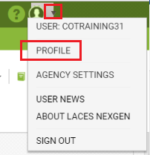

The Person Profile contains the following items:
- Profile
- Agency Settings
- User News
- About LACES NexGen
- Sign Out

The Profile section contains the Settings and Security tabs. Settings allows you to choose your Start Page from the available options. The default is Student, but you may change it if desired. Someone who works primarily doing data analysis may want to have the Dashboard as their start page, or a teacher with a full access role may want their start page to be the Class page. Display Rows allows you to choose how many records will display per page in each grid. We recommend setting this number to 200, as that will load relatively quickly and will also allow you to use page sub-setting to create FY summaries for selections over 200. Make your selections from the drop-down menu and click the Save button.

The Security tab contains your username and password information and allows you to update your email address, if needed.

Agency Settings contains four tabs: Agency Data, Choice Lists, Signin Summary and Delete Log.

The Agency Data is simply address and contact information for your agency.

The Choice List tab allows System Administrators the ability to modify some drop-down menus in LACES NexGen in order to customize those fields for your own agency. Looking at the forms you use compared to the screens and fields available in LACES NexGen, decide what menu items you need on your choice list. Fields should typically not be modified without approval from DESE as they may need to remain as they are for reporting purposes. Keywords are optional fields that can be used however you wish, but you may also need to modify the choice list for Building and Room, class Days and Times, Referral Sources, Goals, Comment Types, Tutor Locations, Donation Types, and Social Services, just to name a few options.
Modifying Choice Lists is one of the most powerful ways that you can customize your database. These menus can be customized by adding new choices, hiding choices, editing existing choices, or changing the order in which choices are displayed. To modify your choice list, go to the Agency Settings option in the Person Profile menu in the upper right-hand corner of the database.

From the available tabs, click Choice Lists and wait while the available options load. You will know the list has loaded when the top window has filled in with an item, such as Abuse or Accommodation. Click the dropdown menu to the right of the item and search the available options for the field you wish to modify. Click to select.

If there is no modifier to the word, it will usually refer to the Student, such as Keyword. Other population Keywords would be listed as TutorKeyword, ClassKeyword, etc. To add an item to the choice list, click Add New Item and complete the applicable fields in the Display Order, Short Description, Long Description, and Visible Box, then click Save. The “Display Order” field lets you choose the numerical order in which you want the new choice list item to display. Smaller numbers will display first. We recommend that if you are choosing numbers for the display order, choose items with a wide range such as 10, 20, 30, or 100, 200, 300, etc., rather than 1, 2, 3, so that if you ever need to add additional items, you won’t have to re-order your whole list. Although you cannot delete choice list items, you can make them not visible by deselecting the “Visible” box. Hiding a choice list item will not remove that item if it has already been added to a record; however, it will prevent the item from displaying in the drop-down menu in the future. Editing an existing item acts retroactively, and will change that item if it has already been added to a record.

It is extremely important to remember that modifying the items in your Choice lists can impact whether data populates to your reports correctly. Certain fields are directly data-mapped to reports and modifying those items or using another choice list item similar to a default item can impact your reports. We recommend that only one person in your agency modifies choice lists, so that there is a consistent record of changes made. Also, changes made to the Choice List affect everyone in the agency, not just the user who makes the change.

The Sign-in Summary displays log-in information for everyone who has accessed your agency, including number of signins, last sign in date, and the IP address for the last signin.

The Delete Log will indicate if an entire person record has been deleted, and by whom, as well as the data of deletion and whether it occurred in legacy LACES or LACES NexGen. The Delete Log only displays entire person record deletion; for individual record deletion such as assessments or hours, use the Audit Log contained in the person record.

The User News page contains information for freeze and rollover dates, links to release notes, the tech support form, and the legacy software documentation. Documentation for the new software can and should be accessed from the Help links on each page of LACES NexGen.

About LACES NexGen displays the most current build and copyright information.

The Sign Out link should be used to exit LACES NexGen. Although many users simply close the system without signing out, this can lead to issues with accounts being locked if the system thinks you are still logged in, or with other users not being able to log in because all licenses appear to be in use. We recommend signing out prior to closing out the whole database.

Toolbars

The green left-hand toolbar at the top of the page displays the various populations in the database. The most commonly used are displayed individually, and less commonly used are grouped under the “More” menu.

The primary populations are:

- Dashboard: Contains graphic representations of common used data analysis tools that can be added and drilled-down into.
- Student: Contains all students entered into the system. Defaults to Current FY students, but can display all students and different selections of students based on search and filter results.
- Class: Contains all classes entered into the system. Defaults to Active classes, but can display all classes and different selections of classes based on search and filter results. Classes can only have Staff assigned as instructors, but otherwise function similarly to Groups. Classes can only have students enrolled.
- Staff: Contains all staff entered into the system. Staff are usually paid or unpaid instructors, data entry personnel, trainers, and directors. The Staff population defaults to Active Staff, but can display all staff and different selections of staff based on search and filter results. Staff can only be assigned as instructors in Classes.
- Tutor: Contains all tutors entered into the system. Tutors are usually unpaid instructors. The Tutor population defaults to Current FY, but can display all tutors and different selections of tutors based on search and filter results. Tutors can only be assigned as instructors in Pairs and Groups.
- Pair: Contains all Pair records entered into the system. Pairs are one student/one tutor matches. The Pair population defaults to Active pairs but can display all pairs and different selections of pairs based on search and filter results. Pairs can only have Tutors assigned as instructors.
- Group: Contains all groups entered into the system. Defaults to Active groups, but can display all groups and different selections of groups based on search and filter results. Groups can only have Tutors assigned as instructors, but otherwise function similarly to Classes. Groups can only have students enrolled.
- Workshop: Contains all workshops entered into the system. Defaults to Active workshops, but can display all workshops and different selections of workshops based on search and filter results. Workshops function similarly to Classes and Groups, but have additional required fields such as Minimum Required Days/Hours, and additional business rules depending on the Workshop Type. New Tutor Training type workshops can only have tutors assigned. Students are not typically assigned to workshops.
- Contact: Persons who do not fall into any other population type, but whose contact information your agency would like to have available.
- Donor: Funders (either individuals or organizations) who donate or are prospective donors for your agency.
- Material: Books, laptops, software, materials that can be checked out or given away

Persons can be in more than one category, as needed. If a person is already in the system in one role and is entered in another, the system will provide a duplicate warning that will allow the information from the other role to be carried over into the new role.

The “More” menu contains:

- Volunteer: Contains all volunteers entered into the system. Volunteers are usually unpaid persons who assist the agency in a non-instructor capacity, such as board members or office assistants. Volunteers cannot be assigned as instructors to classes, pairs, or groups.
- Family: Not recommended for use. Allows linking of student records into a family group.
- All Person: Displays all person records for all populations.
- All Assessments: Contains all assessments entered into the system, with one line of record for each assessment. Defaults to Current FY assessments, but can display all assessments and different selections of assessments based on search and filter results. All assessments can be very useful for creating custom views based on multiple assessment information for students.
- All Student Enrollments: Contains all enrollments entered into the system, with one line of record for each enrollment. Defaults to Active enrollments, but can display all enrollments and different selections of enrollments based on search and filter results. All enrollments can be very useful for creating custom views based on multiple enrollment information for students, such as all instructors and class records for a student.
- All Non-Student Workshop Enrollments: Contains all non-student Workshops enrollments entered into the system, with one line of record for each enrollment. Defaults to Active enrollments, but can display all enrollments and different selections of enrollments based on search and filter results.
- All Goals: Contains all goals entered into the system, with one line of record for each goal. Defaults to Current FY goals, but can display all goals and different selections of goals based on search and filter results.
- All FY Data: Contains summary data from the Fiscal Year summaries auto- or manually generated for inclusion on the NRS tables and FY data searches.
- All Follow-up Outcomes: Contains all goals and cohorts entered into the system, with one line of record for each goal/cohort. Defaults to Current FY goals/cohorts, but can display all goals/cohorts and different selections based on search and filter results
- All System Tasks: Displays LACES system tasks related to imports/exports or processed records.

The white upper right-hand toolbar displays options relevant to the population in which you are working and contains the following options:

- +Add New [population item, ie. student, class, tutor, etc.]: Allows you to add a new record for the population in which you are working. Each blank intake form for that population contains specific fields and required data based on that person or instructional setting type.
- Selection: Selection allows you to create a manual selection of data, or to select an already generated subset of students found through a search or filter, and subset that selection by clicking the checkboxes in front of those records (either one at a time or by checking the top box in the column heading), then clicking Selection in the right-hand menu bar. From Selection, you can Subset, Omit, Clear or Select All. Omitting does not delete the record, but temporarily removes it from the selection. Subsetting can be useful because most searches and reports in LACES are generated based on your starting selection, so having the ability to control that selection through subsetting can help you generate data on very specific populations of students or other populations.
- Export: Exports the data selection with the currently applied view to a CSV format Excel spreadsheet, where the data can then be saved, printed, and/or emailed, and charts created from the Excel data set. The file can be saved in various formats such as csv, xls, or pdf.
- Graphic Reports: Provides access to the graphic reports available for the population in which you are working. Each population has its own reports. Students have the most available reports. Most graphic reports can be run based on the selection. Some graphic reports require additional parameters such as date ranges, that can be entered for additional granularity. Once a graphic report has been opened, you can view, or print the graphic report. Graphic reports can be saved in hard-copy (printed) form, or by right-clicking and doing “Save as…” to save as a graphic file.
- Reports: Provides access to the reports available for the population in which you are working. Each population has its own reports. Students have the most available reports, followed by tutors. To open a report, click the checkbox to the left of the report you wish to view. In the right-hand column, enter any information needed such as data range or other parameters, being sure to follow the correct date format, if indicated. Click Print PDF or Print Excel in the bottom left-hand corner and open the report once it has successfully downloaded. Once opened you can view, save, print, or email a saved copy of the report.
- More: Allows you to batch add goals, if desired; batch adjust Survey data for goals or cohorts, and run FY summaries, described below:

Fiscal Year Summaries are required for the student to correctly populate the Fiscal Year Data tables, and the Fiscal year-based searches. LiteracyPro automatically creates FY summaries once a week so that the data gets picked up for the tables, but if you add, modify, or delete data before or after we have automatically run FY Summaries, you may not see that data populate until the next time we do them, unless you choose to manually create FY summaries prior to the next automatic creation. FY Summaries will be auto-run approximately the first and third weekend of each month.

FY summaries are created for two reasons: to keep the data concise and reduce the probability of errors being made by the database, and to allow us to “freeze” FY data so that all historical data can be maintained in one database, rather than having to use a new database every new fiscal year.
- The Fiscal Year Summary records are created from the Student or Staff tab and are run on the selection. Since this functionality requires a great deal of processing, we have limited the range of records that can be run. Also, if the selection is generated from the records themselves, you will get an error message letting you know to subset the selection first. You do not need to subset records if you are scheduling them, but to run them yourself, they must be subset first. To subset a selection, click the checkbox in front of the student name(s) for which you wish to create a new FY summary, or click the checkbox in the upper left corner of a page to select everyone on that page, and then go to the toolbar in the upper right-hand corner and click Selection>Subset.
- Once you have subset your selection, to create new FY Summary records, click the More option on the right-hand Toolbar (NOT the More option on the left hand, green toolbar!), and then click Create FY Summaries.
- The selection is limited to 500 records, so if you have a selection larger than 500, you will need to run FY summaries per page and then run the next page
- The window will reflect that the summaries are being processed. You will not be able to work in LACES on the same computer from which you are creating summaries while they are being processed.
- Student and staff NRS tables both use FY summary data. You can run new summaries just on records that have been recently changed, or you can wait for the bi-monthly automatic creation of FY summaries.
- Only the FY Data NRS table reports and the FY Data searches run based on summaries. Every other report and search runs on current or “raw” data and does not need a FY summary, but will display information added immediately upon addition and saving.

HELP
Every page contains a Help link on the far right. Click the link to expand the page and view page-specific help documentation as well as links to other area of the help documentation.

CUSTOM VIEWS

Views are defined as the columns displayed for the population grid. Shared views are predefined and are available on a dropdown list that displays at the top left of the student grid. Custom views can be created to add, remove, or re-order columns as needed.

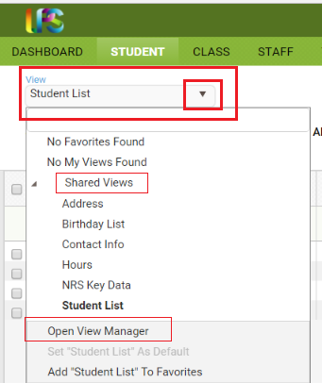

There are currently six shared views. The default view is Student List, which displays columns on the grid that provide at-a-glance information about overall status and assessments. The view may be changed by selecting a different view from the list. This view will be in effect until you change it, even if you leave the student grid temporarily by clicking on a different tab, and then return to the student grid.

To change the view, click the arrow on the drop-down list. The first item is Favorites. A favorite view is a view that you use often, whether it is a shared system view, or a view that you created. Views that have been added to Favorites will display at the top of the list. ‘No Favorites Found’ will display if no views have been added to Favorites. Views that you create and save will display under ‘My Views.’ ‘No My Views Found’ will display if you have not created any views. The third item on the list is ‘Shared Views’ with an arrow in front that allows you to expand or collapse the Shared Views list. Shared views are standard system views that are available in all agencies. A shared view can be applied, set as a favorite, or set as the default. Shared system views cannot be modified, but you may copy a shared system view, make modifications to the fields, and then save with a new view name.

A view is not a search. It does not automatically filter any information, although once a view is applied, the in-column filtering can be used to filter based on added columns. The view simply displays the data contained in the added columns, if that field was filled in for the viewed record.

To create a Custom View, go to the View: “Student List” window under the Menu bar in the upper left corner. Creating Custom Views in other populations will follow the same steps, but with different default view names.
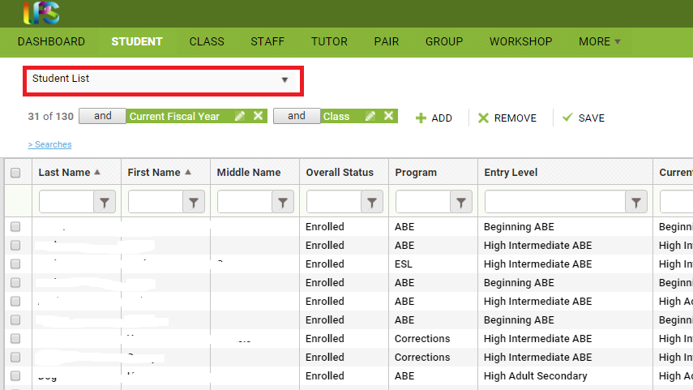
Click the drop-down menu icon and Select “Open View Manager.” From here, you can create a new view or modify an existing view. “New” (not recommended) will remove all fields and let you start completely from scratch, while “Copy” (recommended) allows you to start with the fields from the copied view and add or delete fields to create a new view but not have to enter in already present fields such as First and Last Name.
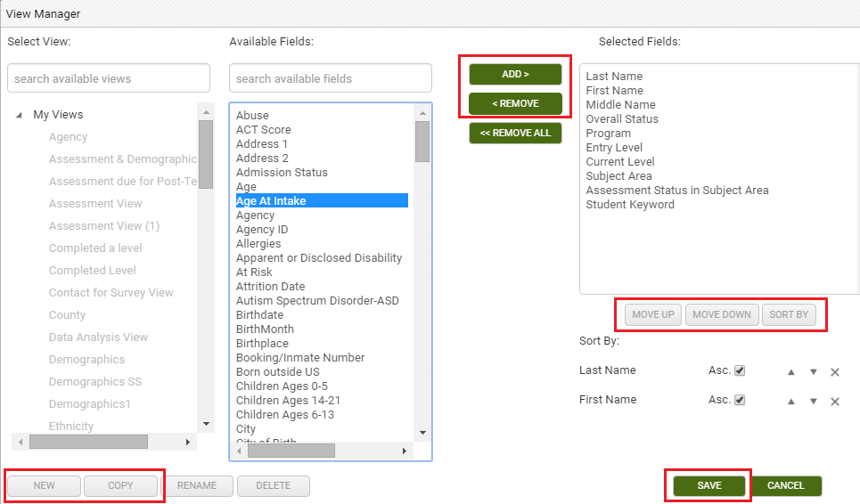
The left-hand column will display your views and shared views. The middle column displays all of the available fields that can be added to your view. In the right-hand column are the fields currently being displayed.
You must create a New or Copied view to make modifications; if you try selecting from the Available Fields without clicking New or Copt and saving the View name first, you will not be able to click, as the field names will be inactive (indicated by the grey window). Once you have saved the view name for your New or Copied view, can add fields by clicking once on the field in the middle column to select it, then clicking the “Add” button.” If you are adding multiple fields, you can hold down the CTRL button on the keyboard while making your selections to highlight more than one, and then click Add to add all of them at once. You can remove fields by clicking once on the field in the right-hand column and clicking the “Remove” button. You can also hold down the CTRL button to make multiple selections and click Remove to remove multiple fields at once. Clicking Remove All will remove all of the fields, including Last Name and First Name. You can also change the order in which fields display by clicking the “Move Up” and “Move Down” buttons. Click Save once you have added or removed the fields you want.
When creating or modifying a custom view, you can select the “Sort By” button to pre-determine the order in which columns sort. The default order is alphabetically by last name, but using the “Sort” function allows you to pre-order multiple columns at a time based on the criteria you choose. Bear in mind that you can also always sort columns into ascending or descending numeric or alphabetical order by clicking the column heading for ascending order, then clicking once more for descending order.
Sort Fields
Once you have created a view, you may specify how you want the fields to sort. You may also modify the field sort on a view that you created.
- Click the ‘Sort Fields’ link.
- The window to choose field order will display.
- Click the + at the top to add a new record.
- A row will populate with the first field name from the ‘Show these fields in this order’ column. To change the field, click on the field name to get a drop-down list of the fields in the view.
- Choose order defaults to ‘Asc’ (ascending) to sort A-Z. To change the order, click on the sort name to get a drop-down list, and click Desc (descending) to sort Z-A.
- Click Apply to save the changes, or click Cancel.

Sort records may be deleted by clicking the Delete button.
Custom Views get saved and can then be applied. You can return to the default view by going to the view window again and selecting Student List. A saved view can be re-applied at any time by going to the view window>My Views and locating the view by name. If you export or print data with a Custom View applied, the data in your custom view is what will export. You can make a custom view that you have created into the Default View by clicking in the View manager window and clicking the option at the bottom called Set {created view} as Default.
You can choose to set a view as a Favorite:

- Click the arrow on the drop-down list to display the views.
- Select the view you wish to add as a Favorite, then click the arrow on the drop-down list again.
- At the bottom is the option Add ‘view name’ To Favorites.
- Click Add ‘view name’ To Favorites.
- The view has now been added to the top of the list under ‘Favorites.’
- To remove the view from Favorites, click Remove ‘view name’ From Favorites.

You can also set a view as the Default view:

The default view displays in bold to allow you to quickly see which view is the default. The default view will always be applied to the student grid when you sign in. To change the default view:

- Click the arrow on the drop-down list to display the views.
- Select the view you wish to set as the default, then click the arrow on the drop-down list again.
- At the bottom is the option Set ‘view name’ as Default.
- Click Set “view name” as Default.
- The view name will display in bold.

The default view will be in effect at the next sign in. To change to a different default view, select the view, then select Set “view name” as Default.

You can Delete views that you created (shared views cannot be deleted):

- Click the down arrow on the View drop down list, or click the View: Change link.
- Click Open View Manager at the bottom of the drop-down list.
- Select the view name you wish to delete.
- Click Delete View.
- Click Apply.

Field Search
You do not have to scroll through the list of views or fields in the View Manager. You may enter the view or field name in the box under ‘View’ or ‘Available Fields for View.’ As you enter more information, the view or fields that contain that information will display. To clear the search field, click the X in the box.

Columns in Views
Columns in views that you created and applied can be reordered by dragging and dropping the column. This will change the field order in the view, and the new order will display when you open the View Manager and select that particular view.

SEARCHES

LACES has three basic types of searches: Pre-Generated Searches, In-Column Filtering, and the Criteria Builder. All of the searches produce the results using a visual cue called Search Tiles.

Search tiles are a graphic representation of what filters have been applied to the data set to produce the current selection of records.
The default search tiles will typically be Current Fiscal Year populations for person records and Active populations for instructional settings.
Most search tiles can be edited by clicking the Edit icon (the pencil) or closed/removed by clicking the white X at the far-right side of the tile. When clicking the Edit (pencil) icon, please remember that some tiles, such as Current Fiscal Year, do not have search parameters that can be changed. If you click on the Edit icon, you will get a message stating that the search contains no parameters.
If you have multiple search tiles applied, you can close an individual search tile, leaving the remaining tiles in place, by clicking the X on the search tile you no longer need. For example, if you have the Current Fiscal Year search tile applied and then do a search for Last Name using the column header filter, you will now have a tile for Current Fiscal Year and another for Last Name. If you don’t want the results limited to only the Current FY, you can click the X on the Current Fiscal Year search tile leaving just the Last Name tile.
To remove all of the search tiles applied so your list displays all records, click ‘Remove Search.’
Additional search tiles are added each time an additional search filter is added. Search tiles will be generated by the following:
Predefined and Templated Searches
The blue “Searches” link above the grid will open or close the left pane to display the available predefined and templated searches for that area. The searches display by category and are collapsed by default. To expand a category to show the searches by name, click the arrow in front of the category, then click the search you wish to use.

Predefined searches:
- Runs on the selection as soon as you select the search name.
- Require complex queries that are typically difficult for the user to create. For example, the student search ‘Posttest Level Lower than Current Level’ involves a query that must first find students who have been pre- and post-tested in a particular subject area, but did not advance an EFL, and the posttest EFL is lower than the pretest EFL. This is not a search that can be constructed from the front end of the system.
- Do not have parameters or search criteria that can be changed, even though there is an edit icon on the tile. If you click the edit icon, you will get the message, “This search contains no parameters.”
- Some of the pre-defined searches (such as the NRS Table Searches) are Drilldown Searches

Drilldown Searches

Drilldown searches can be run on a selection of records, then ‘drilled’ down to a subset of those records. For example, the NRS table searches at the student area are drilldown searches. After running an NRS table search, select the reporting system from the dropdown list on the search. After the search loads, click the value on a row to display only those students.
To return to the search results of a drilldown without having to run the search again, simply click on the Edit icon (pencil) in the search tile to bring back the original search results, allowing you to click another cell for additional results. Searches are not reports! These NRS Table Searches are there to allow you to search the cells for additional data analysis; to run the actual NRS Tables, you must use the Reports link.

Templated searches:
- Allow you to enter specific field search values on a template.
- Allow you to enter as little or as much search criteria as you wish. For example, the ‘Quick Select’ searches are templated searches.

Add and Replace buttons:
- The Add button will add the selected search to the end of any filters or searches already in place.
- The Replace button will remove all existing filters and searches with only the selected search criteria. When searching on prior FY data, it is usually recommended to use Replace, as the default for most grids include a filter for Current Fiscal Year data.
Criteria Builder: The Criteria Builder allows you to generate selections within the population you are in, based on the criteria you choose to add or remove from the general selection.
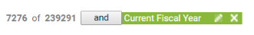
In the example above, the Criteria Builder is showing the default option for the Student Grid, which displays the Current Fiscal Year students. In this example, this results in 7276 student records being displayed of the 239,291 student records available. The Current Fiscal Year tile is displayed to indicate what criteria are currently being used. The Current Fiscal Year tile could be closed by clicking the X at the far right of the tile, removing that criteria selection and resulting in the database displaying all 239,291 students.
To add or modify criteria within the Criteria Builder, click on the + Add option to the right of the criteria tiles.
This will expand the Criteria Builder window, allowing the user to select criteria set information or fields, and apply that criteria or close the Criteria Builder window.
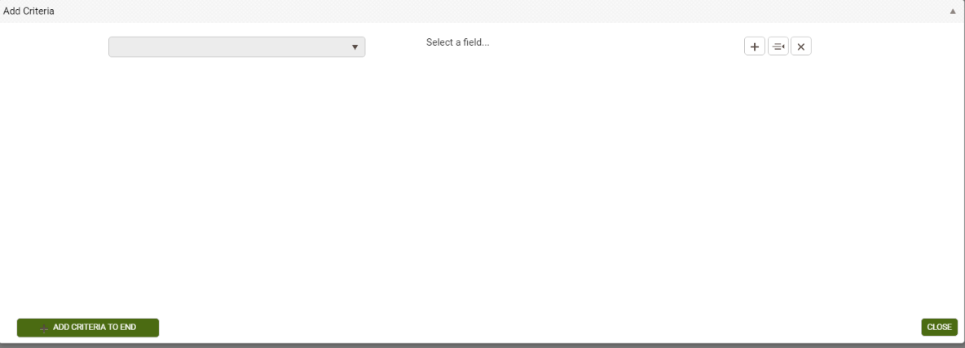
Click the down arrow to the left of the Select a field…option to choose fields on which you wish to search. Once selected, you can then choose the search terms and search parameters containing the search option you enter into the blank field. You can then choose to add additional search options and apply those criteria using the Apply button.
The following Symbols, Icons, and Filter Terms will be used in the Criteria Builder Search and Filtering
Symbol, Icon, or Search Term | Definition/Purpose
Pencil icon on search tile | Edit
X icon on search tile | Close
= | Equals
!= | Does not equal
< | Greater than
<= | Greater than or equal to
> | Less than
>= | Less than or equal to
In the list | Searches for one or more terms contained in the list. *Do not put spaces after the commas when using multiple terms!
In-Column Filtering: Every column in a grid provides the opportunity to filter/search within that column. To filter, enter your search criteria in the blank space below the column heading, then click the filter icon. Select the option (Starts with, ends with, contains, Equal to, Not equal to, etc.) and click.
Tips for in-column filtering:
- If you want to filter by something not contained in the current grid, create a custom view that adds that column to your grid in order to be able to filter. Not every field can be added to custom views.
- Spelling matters. Misspelled words and typos typically will result in no records being found.
- Remember that searching using in-column filtering adds an additional search tile to whatever search tiles are already in place. You can remove unwanted search tiles prior to or after adding an in-column search by clicking the white X in the unwanted search tile to close it. This is especially important to remember if you are searching for prior fiscal year data, as the default filter for most populations will only include current FY data.
- Filters are not case-sensitive, so capitalization is not necessary and will not affect the results.
- The filter options will be based on the type of data contained in the data field. Some fields will only contain options such as Yes/No, while others will contain longer lists with several options. Read through all available options to determine which is the best choice for your search.
A simple example of in-column filtering:
Filtering by last name: Because Last Name is part of the default view in the student list, simply type the last name, or the first few letters of the last name, into the blank field below Last Name in the column. Click the filter icon to the far right and choose your search option (in this case- Starts With), then click Enter. Notice that the search tiles are displayed to let us know the reason our current selection is 4 students is because we are filtering by two tiles: current fiscal year students AND students whose last name starts with Brown. If we were searching for prior fiscal year students whose last name begins with Brown, we would want to remove the search tile for Current Fiscal Year, and could do so by closing that search tile, by clicking the white X at the far right of the tile.
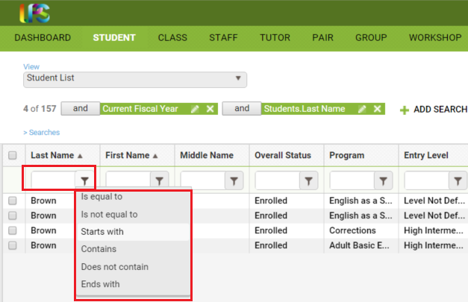
Subsetting: Manually selecting and creating a selection of data of your choosing.
Dashboard: Clicking on the results of a dashboard widget.
Search Tiles use Operators, that allow you to filter the data differently after application of a search tile based on the operator used.
Operators are simple conjunctions used to combine or exclude terms in a search, resulting in a more focused and productive result. They should save time and effort by eliminating inappropriate results and allowing you to target the exact needed selection within a population.
Search tiles have operators between then indicating And, Or, And Not, and Or Not. The default operator is AND.
AND: means that your selection is X out of Y records AND contains those records that meet the criteria contained in the search filter. Multiple search tiles with AND mean that the selection is all of those criteria. Example: 153 of 1470 and Current Fiscal Year AND Gender=Male means that your selection is 153 students because you are filtering by students who are considered current fiscal year students AND whose Gender is Male (and that your total student population is 1470 including prior fiscal year students Note that with ANDs, your selection is usually smaller, because a student must meet both tile’s criteria to be included in the search results.
This can be represented graphically like this:
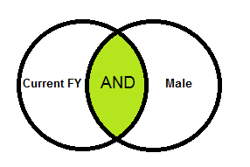
OR: means that your selection is X out of Y records and contains those records that meet the criteria contained in one search tile OR the criteria contained in a different search tile. Example: 911 of 1470 and Current Fiscal Year OR Gender=Male means that your selection is 911 students because you are filtering by students who are considered current fiscal year students OR whose Gender is Male. Notice that this selection is usually larger, because if a student meets either of the criteria, they will populate the search results.
This can be represented graphically like this:
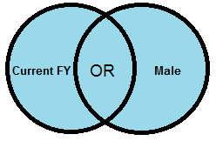
AND NOT: means that your selection is X out of Y records and contains those records that do NOT meet the criteria contained in the search filter. Example: 167 of 1470 and Current Fiscal Year AND NOT Gender=Male means that your selection is 167 students because you are filtering by current FY AND NOT including those whose Gender is Male in the current fiscal year. If you had done a search for Current FY AND Gender=Male and then changed the operator to AND NOT, you would expect to see the results be equal to the number of current FY students minus the Male students.
This can be represented graphically like this:
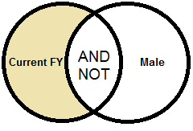
OR NOT: means that your selection is X out of Y records and contain those records that meet the initial search tile criteria OR do not meet the next search criteria. Example: 879 of 1470 and Current FY OR NOT Gender=Male means that your selection is 879 students because you are filtering by current fiscal year OR students whose Gender is not equal to Male.
This can be represented graphically like this:
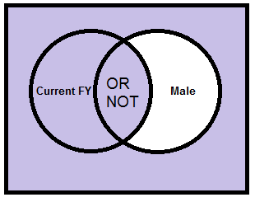
Auto Filters in Searches
Some searches come with filters already applied, which can make it seem like you are not able to search everything. Removing the filter will allow you to search all records to obtain the results you need.
An example of this is the Enrollments search in the student grid for Class/Group-All Students. When you select this search, the data selector will only initially display Active classes/groups. However, you can click the filter icon in the Status column and change the Status. The filter icon highlights in white instead of grey at the data selector window to provide a hint that it has been pre-filtered. Watch for this in other searches and data selectors to avoid frustration!

STUDENTS
The toolbar at the student grid allows you to:
- Add new student
- Select records (Subset, omit, clear and Select All)
- Export a selection of records to PDF or Excel via a CSV format
- Run Reports
- Select more functions
Adding a New Student Record
To add a new student record, click the +Add New Student icon to display the student intake form. The * indicates a required field and must be entered before the record may be saved.
Required fields in the Missouri database are:
Intake Date: This should be considered the initial date of intake and should NOT be updated at a later point in time if the student re-enrolls or begins a new period of participation. Additional re-enrollments or re-entries will be tracked in the Enrollment History panel of the History tab in the Student record.
Last Name
First Name
Program: AEL will be changed to ABE/ASE and should be used for students who start as ABE/ASE. ELL should be used for students who start as English Language Learners. You can select assessments regardless of program type.
Secondary Program: Not required, however, please be aware that these fields contain the various “environment” options such as IELCE, Community Corrections, Correctional Facility, Other Institutional Setting and Workplace Adult Education/Literacy. IET is added through the class enrollment and is not listed here. If you forget to add a Program or Secondary Program and need to update it once the record is saved, you can make updates in the Education tab>Education panel.
Birthdate:
- Birthdate will auto-populate the Age field and auto-update every year on the student’s birthday.
Gender
Ethnicity (Hispanic/Latino, yes/no)
Race (can select one or more). Per OCTAE Implementation Guidelines, a Race must be selected even if the Ethnicity indicates that the student is Hispanic. For additional information on this, please review the NRS Implementation Guidelines here: http://www.nrsweb.org/docs/tips/RaceandEthnicity.pdf
Highest Education Level Completed at Entry
Highest Education Level Completed at Entry Location
Employment Status
Barrier to Employment (yes/no; if yes, one or more barriers must be checked)

Non-required fields also include address and contact information as well as other demographic information and should be completed as thoroughly as is warranted.

Q: Should I enter the non-required fields? When entering a record, it is good practice to enter all the information you have at the time of entry, whether the field is required or not, if you plan to track this data. This saves having to go back later and edit the record.

Potential Duplicate Message

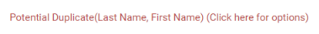

If a person being added already exists in your agency, you will get the ‘Potential Duplicate’ message when the last and first name OR social security number (if entered) match an existing record. Click the message to verify if the person being added is a completely different person with the same name, or an existing person in your agency.

You will have three options: to Continue, which should be used when you are adding the person in a new role or they are a returning/re-entering student, New, which indicates that this is NOT a duplicate but just someone with the same first and last name (this option will be inactivated as indicated by being greyed out if the person is shown as a duplicate based on a matching SSN), and Cancel, which will cancel and not add the record.

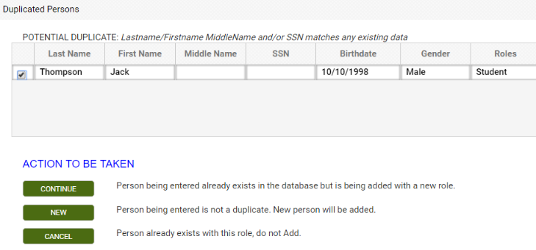

The potential duplicate warning is currently only within your program; it will not recognize if the student has attended another agency within Missouri. This functionality will be expanded in the 2018/19 FY to include cross-agency training. DESE has the ability to de-duplicate at the district level if they choose to do so. Additionally, the potential duplicate warning will not generate for similar names or misspellings unless the SSN also matched.

After completing the intake form, you may: ·
- Click Save to save the record and return to the student grid. ·
- Click Save and New to save the record and get a blank intake form so you can add another student record.
- Select a specific tab in the student record from the dropdown list, and then click Save and Go to save the record and go to that tab within the new record. ·
- Cancel without saving.

STUDENT DETAIL RECORD

Navigating is done via Panels and Tabs within records. To open a record from a list, double-click the record or click the Edit icon to the right of the record (represented by an eye).

The student header displays key information about the student in the record that is currently open, and shows at the top of each student detail tab. The header itself cannot be edited, but the fields that display in the header may be edited elsewhere in the student detail record, or populate automatically. The student header will update to display any changes.

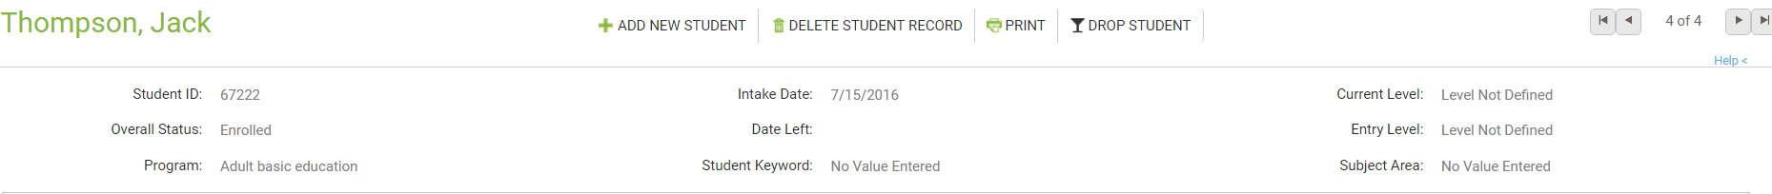

Fields that display in the student header and where the editable fields may be edited:

Student Name | Student Data tab/ Key Info panel; required at intake
Student ID | System number automatically generated when the student record is created
Overall Status | Student Data tab/ Key Info panel; prospective after intake, updates automatically based on evidence
Program | Student Education tab/ Education panel; required at intake
Intake Date | Student Data tab/ Key Info panel and Student Education tab/ Education panel; required at intake
Date Left | Automatically populates from last hours date How left date is calculated:  - Student's last instruction hours date, including unlinked hours.  - Student's last class or group start date, or pair match date if the student was enrolled or matched in a pair, but no instruction hours were entered.  - Student's intake if there are no enrollments or hours.  A left date will also calculate and display based on the criteria above after 90 days with no activity after intake, enrollment date, or last hours date, regardless of the student's enrollment status in a class, group, or pair, or the student's overall status. No activity means no enrollments or scheduled services, or enrollments with no instructional hours within 90 days of the enrollment date or last hours date. Hours records with 0 hours entered are not considered in the left date calculation.  The population of a left date does not change the student's enrollment status in a class, group, or pair but is used for calculating periods of participation for Tables 4 and 5.
Student Keyword | Student Data tab/ Key Info panel; may be entered at intake, not required
Current Level | Student Assessment tab based on level defining assessment; may be entered at time of intake but does not affect reports or populate any relevant fields
Entry Level | Student Assessment tab; based on level defining assessment
Subject Area | Student Assessment tab; based on level defining assessment

The student detail toolbar allows you to:
- Add a new student- presents a new blank intake form to enter a new student
- Delete the student record currently open- records can only be deleted if you have a role allowing deletion, and records cannot be deleted if there is a fiscal year summary for the record.
- Print- Prints the header and Key Info for the student
- Drop Student- batch drops the student from all instructional settings with a status of Left and exits them from the program

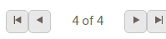

The Record Indicator at the top right of the student header shows what record you in out of a selection of records, and allows you to move forward or back either by record (single headed arrow), or to the beginning or end of the students in the list (single headed arrow with line). When you use the arrows to move forward or back, the record will be at the same panel and/or tab you were previously in.

A variety of information may be entered in the student detail record at the individual tabs and panels. Not all of the data you can track will be useful to every agency. The best approach is to look at any required reports, since many reports require specific data that is contained within a small number of fields. You should also decide what additional data you want or need to track for daily program management.

The Student Detail pages contains the following panels:
- Student Data: Key Info, Comments, Pair Comments, Custom Fields, Documents, Personal Data, and Preferences
- Assessments
- Enrollments
- Hours
- Outcomes: Cohorts, Goals & Achievements
- Demographics: Demographics, Corrections, Disability, Family Members, Health Data, Identification
- Education: Education, Diplomas/Credentials, Instructional Areas, Language, Material, Term Grades, Transcripts
- Services: Accommodations, Referrals, Social Services
- History: Address History, Enrollment Program History, Fiscal Year, Level History, Overall Status History, Work History {contains Employment Status}, Audit History

The information from the intake form primarily populates the Key Info section and Demographics.

We will cover each tab and panel in the student record in the order they are displayed in the database.

Student Data: Key Info, Comments, Pair Comments, Custom Fields, Documents, Personal Data, Preferences

Key Info: The Key Info panel contains key data regarding the student record, and is primarily populated based on information entered on the Intake Form. Fields with a red asterisk * are required fields, and edits to the Key Info panel will not be saved if any required fields are left blank through editing or deletion.

Editing within the panel can be done by opening the panel and typing directly into the field(s) you wish to edit. While making changes, the header and other tabs will become inactive until the changes have been saved or cancelled within the panel you are currently accessing.

The Key Info panel contains the following fields (some databases may have customizations that result in slight variance):

Overall Status | Auto-populated based on enrollment status. Some manual updates can be made from a drop-down, non-editable menu.  Students will always enter the program as Prospective. You can manually change a student from Prospective to Waiting, if desired. Otherwise, enrolling them into a class, group, or pair will automatically update them to Enrolled unless you have reached maximum enrollment within a class or group, in which case they will go to Waiting. From Enrolled, you must exit the student from their class or group or dissolve their pair, and they will go to Left if that was the only instructional setting they were in. If they were enrolled in multiple instructional settings, exiting them from only one class, group, or pair will not update their Overall Status. A student who comes in as Prospective but never actually attends instruction should be updated to either Left or Never Attended.  The Overall Status menu cannot be modified in the Choice List, but can be modified by LiteracyPro Systems, Inc. if requested at the state level.
Manual Status Change Date | A field in which agencies can manually enter dates for status changes. Status change dates are also automatically tracked in the student’s History tab
*Intake Date | Initial Intake Date for the student. A required field that should indicate the student’s initial entry date into the program. Type in field or calendar selection. Should not be updated based on re-enrollment or re-entry.
*Last Name | Last Name, required. Type in field.
*First Name | First Name, required. Type in field.
Middle Name | Middle Name, not required. Type in field.
Suffix | Student Suffix, if needed. Type in field.
*Program | Required field generated from a non-user-modifiable drop-down menu.
Secondary Program | Non-Required field generated from a non-user-modifiable drop-down menu. Selection of IELCE will populate the student in the Integrated English Literacy and Civics Education section of NRS Table 3 regardless of Primary Program selection or EFL. Correctional or Institutional selections will populate the student to Table 10 instead of Table 5, as well as populating coordinating sections of Table 6.
Student Unique ID | Unique number that can be used as an alternative identifier in the event SSN is not used, or for other purposes such as inmate ID’s or K12 numbers. Type in field.
Student Keyword | Keywords are additional fields for users to add student information if an existing field is not available. The keyword field is a drop-down list and can be edited by the user by adding/editing items on the Keyword choice list.
Address 1 | Primary residence street address information, not required. Type in field.
Address 2 | Additional residence street address information if needed, not required. Type in field.
Zip | 5-digit format zip code, not required. Type in field. City, County, and State will auto-populate based on a valid zip code.
City | City of residence, not required. Auto-populates when valid zip code is entered, but can be over-ridden as a type in field
State | State of residence, not required. Auto-populates when valid zip code is entered, but can be over-ridden as a type in field
County | County of residence, not required. Auto-populates when valid zip code is entered, but can be over-ridden as a type in field.
District | District of residence (if needed), not required.
Mail Preference | Drop-down, editable menu for indicator of preference for mail contact from the agency, if any; not required
Email | Email address, not required. Type in field
Phone at Address | 10-digit format telephone number, not required, typically used to indicate the primary contact phone number. Type in field
Home Phone | 10-digit format home telephone number, not required. Type in field.
Work Phone | 10-digit format work telephone number with 5-digit extension, not required. Type in field.
Mobile Phone | 10-digit format mobile/cellular telephone number, not required. Type in field.
Other Phone | 10-digit format telephone number with 5-digit extension, used to indicate other phone contact options, not required. Type in field.
Other Phone Type | Drop-down, editable menu option allowing indication of what type of other phone is being indicated in the Other Phone field.
Emergency Contact Phone | 10-digit format emergency contact telephone number, not required. Type in field.
Emergency Contact Name | Emergency contact name, not required. Type in field.
Emergency Contact Relation | Emergency contact relation, selected from a drop-down menu. This field can be edited by the user by adding/editing items in the Emergency Contact Relation choice list.
Contact Preference | Drop-down, editable menu option allowing indication of contact preferences.

Comments/Pair Comments

There are two comment areas: student comments, located in the Student Data tab; and Pair Comments, which can be entered in the Pair record and will auto-populate both the student and tutor records in the person’s Pair Comments panel. The Comment Type choice list can be modified to allow for certain types of comments, such as Assessment Notes, or Attendance Notes, which will be useful when running the Comments report, as the report parameters allow you to select by Comment Type as well as date range, if desired. They can be useful for tracking attendance issues, assessment exceptions, or anything you may want to make a note of for other staff or instructors. The Comments Report can be accessed in the Student reports list.

To enter a comment in the student Comments panel, click the panel heading to expand the panel and click the Add New Record link. Enter the comment Date (required), comment type, and comment itself, then save.

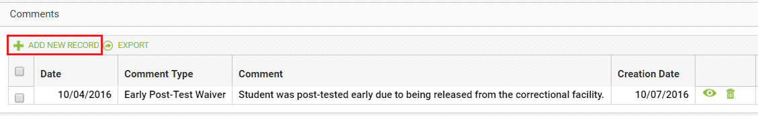

Comments cannot be added to the Pair Comments panel from the student or tutor record, but will display in this panel if comments have been added to an existing pair.

Custom Fields

The Custom Fields panel allows custom fields to be entered, edited, viewed or deleted. Custom Fields are typically used when there are additional fields of data that you wish to track for your students that are not already represented elsewhere in the database.

Editing within the panel can be done by opening the panel and typing directly into the field(s) you wish to edit. While making changes, the header and other tabs will become inactive until the changes have been saved or cancelled within the panel you are currently accessing.

The key component in using Custom Fields is to insure the consistency of data entered. It is a good idea to keep a chart or spreadsheet available for all data entry personnel within your agency so that everyone is using the same data in the same fields. Custom Fields are available in the Search and View options under their specific field names.

The following fields are available as Custom Fields:

Custom String 1
Custom String 2
Custom String 3
Keyword 2
Custom Date 1
Custom Date 2
Custom Number 1
Custom Number 2

Documents

Storage of student documents. To enter a Document, click the panel heading to expand the panel and click the Add New Record link. Enter the Document type (required) and select the file to upload, then click Upload to upload or Upload and New to upload and continue with another document, or cancel if needed. Documents can be in .doc, .xls, .pdf, .jpg, .gif, and other file types.

Personal Data

The Personal Data panel allows personal data records to be entered, edited, viewed or deleted. Columns and rows of personal data may be grouped and sorted by clicking the column headings to sort in alphabetical or numeric ascending or descending order. A single click will sort in ascending order, or a double click in descending order.

To enter personal data, click the panel heading to expand the panel and click the Add New Record link. Enter the property, value, and type of Personal Data, then save. Other areas of the database will be inactivated until the changes are completed.

Personal Data display the following column and row data:

Checkbox: | Selection tool
Type: | The type of Personal Data being entered; type-in field; not required
Property: | The property of Personal Data being entered; type-in field; not required
Value: | The value of Personal Data being entered; type-in field; not required
Creation Date: | Date the Personal Data record was created
Edit Icon: | Icon allowing editing of the Personal Data
Delete Icon: | Icon allowing deletion of the Personal Data

Preferences

The Preferences panel allows student preferences to be entered, edited, viewed or deleted. The Tutor tab also contains a Preferences panel for tutor preferences, if needed.

Preferences will display in chronological order with the most recent on top. Columns and rows of personal data may be grouped and sorted by clicking the column headings to sort in alphabetical or numeric ascending or descending order. A single click will sort in ascending order, or a double click in descending order.

The key component in using Preferences is to insure the consistency of data entered. It is a good idea to keep a chart or spreadsheet available for all data entry personnel within your agency so that everyone is using the same data in the same fields.

Preferences display the following column and row data:

Checkbox: | Allows for selection of one or more preferences.
Effective Date: | The Date recorded for the Preference record, editable, not required. Type in field or calendar selection.
Item: | The Preference Item being recorded (Days, Times, Location, etc.). Drop-down menu that can be modified using the Choice List item “PersonalDataItem”, not required.
Preference: | The preference the student has indicated for the Preference Item. Type in field, not required.
Importance: | A numeric indicator for the importance of the preference. Numeric selection field, not required.
Comment: | Additional information regarding the preference, if desired. Type in field, not required.
Creation Date: | System-generated date indicating the date the preference was entered in the database, non-editable.
Edit: | Click to open the preference record for editing.
Delete: | Click to delete the preference, after verification.

To add a new preference record, click the Add New Record link in the upper-left corner. A new preference record window will open, allowing you to enter the Effective Date, Item, Preference, Important, and Comment, or any combination of these available fields. Other areas of the database will be inactivated until the preference record is saved or cancelled.

After entering the preference information, click Save to save the preference record and return to the Preferences panel, or Save and New to save the preference record and add additional preference records, until clicking Save on the final preference record. Click Cancel to return to the Preferences panel without saving the preference information.

To edit a preference record, click the Edit button to the right of the preference record and make edits, then Save.

To delete a preference record, click the Delete button to the right of the preference record and verify that you wish to delete the preference record.
You can search for student or tutor preferences in the appropriate population criteria builder, or run the Student or Tutor Preferences reports.

Assessments

To add an assessment to the student record, go to the Assessments panel:
- Click the down arrow on the Add Assessment dropdown list.
- Only Missouri and federally approved assessments will appear in the NRS Approved list. If assessments are sunset, they may continue to display for a brief period of time after sunset, but will produce an error message indicating they can only be entered through their final approved date if selected.
- Click the arrows to expand the list. Assessments are organized in a ‘tree’ display. You must click the arrow for the instrument selection and form selection to expand and view the available options. Once at the difficulty level selection, you may then click the select the assessment. Even assessments that do not have or only have one difficulty level must have the level selected. Do NOT double click to expand the instrument, form, and level selections; click on the arrows. Double clicking often results in the assessment drop-down list freezing on your screen, making it difficult or impossible to see the assessment card to enter scores.
- Once you have expanded the list to display the assessment instrument/form/level you wish to enter, click the final display of the “tree” format to view the assessment card.
- The assessment card allows you to enter the date(s), staff (if applicable), and scores.
- Assessments cannot be entered with future dates!

LACES will only populate Educational Functioning Levels based on scaled score or GLE, it does not have a column for number correct. Currently, LACES does not have functionality in place to check for out-of-range scores but we will be implementing this for Missouri.

Fields on the assessment card:

Assessment Card | Indicator of the assessment instrument, form, and level selected on the previous page.
Date Completed for All | Checkbox to indicate the date all assessment subjects areas were completed, if multiple subject areas were administrated on the same day.
Staff | Optional field for the name of the staff member administering the assessment, or the instructor for the student.
Subtest Name or Measure | Subtest/subject area indicator. For assessments with multiple subject areas, be aware that not every subject area will result in an EFL, if not NRS approved.
Raw Score | The raw score may be entered for some assessments, but a raw score by itself will not populate an EFL.
Scaled Score | You can enter either the Scaled Score for the subtests, or the Student Performance Level/Grade Level Equivalent, or both. Follow the state assessment policy. If you enter both and there is a conflict in the EFL that would be produced for the two data points, the database will default to using the EFL generated from the Scaled Score. The Level field will automatically populate based on either the Scaled Score or the SPL/GLE.
SPL/GLE
Level | Auto-generated educational functioning level based on the assessment scores and NRS Benchmarks. Non-editable. LACES programs based on the NRS Test Benchmarks, not the test manufacturer scores. See this link: http://www.nrsweb.org/docs/NRSTestBenchmarks.doc for additional information.
Select Subject | Check to manually override the subject area, if appropriate. Not used for Period of Participation subject override!
Date Completed | Dates for individually completed subtests, if appropriate.

Subject Area

Only NRS approved assessments will display an Educational Functioning Level and Subject. Non-NRS assessments will display GLE and Scaled Score information. Although LACES defaults to display the subject area and EFL with the lowest EFL, gains will be tracked for any subject area in which there is a valid pre- and post-test.

The database will automatically track in the subject area producing the lowest EFL. If two or more subtests produce the same lowest EFL, the database will track in the one with the lowest scaled score or SPL/GLE. You can manually override the database to track in a specific subject area by clicking the Move Forward icon (circle with an arrow between the Edit and Delete icons) and selecting the option to use this subject area for the period of participation. This option will not be available until the student has established a PoP be earning 12+ hours without a 90-day gap between them.

When you are entering assessment data, you cannot navigate to a different tab or panel in the student detail record until the assessment data is either saved or cancelled.

After entering the data in the assessment card, click the Save button in the bottom right hand corner to save the assessment information, or the Cancel button to return to the Assessments grid without saving.

You should receive a confirmation pop-up in the upper left corner of your screen, indicating you have successfully saved the assessment. If, for any reason, the assessment is not successfully saved, you should receive an error message indicating the reason the database could not complete the request.

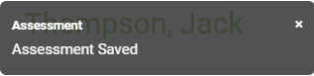

The process for adding a pre- or post-test is the same. LACES will not show a loss if a student post-tests and goes down a level; only gains are tracked for reporting purposes.

General Assessment Notes and Information

Since LACES updates levels based upon Assessment records you should regularly insure that all students have a valid assessment. Some areas to review if your student shows as Never Assessed this FY or if you do not understand something in the assessment panel:

Is the assessment date in this fiscal year? If the assessment is in a prior FY, you may move the assessment forward to count for the new FY, based on your state’s assessment policy, which allows moving forward if the assessment was given within the 90-day period prior to the new fiscal year (April 1 to June 30). To move an assessment forward, simply click on it once to highlight it, then click the “Move Forward” icon (circle with an arrow in it), and say “Yes” when the pop-up window appears asking if you are sure you want to move it forward. You will get an error message if you attempt to move forward an assessment that is not within the allowed state timeframe for pushing forward.

Moving an assessment forward duplicates the moved-forward assessment, so you do not lose the data from last year, but gain a duplicated record in the new year.

Additionally, if you enter a score that is outside of the test manufacturer’s approved range, it could result in an invalid EFL which will show the student as having no level.

Adding a post-test to a student is exactly the same process in terms of the data entry. LACES will know it is a post-test due to the date occurring after the pre-test. Please be sure to follow the state assessment policies when adding post-tests. Areas to be particularly careful with are:

  - Alternating forms. NRS policy is that you should use alternating forms for pre- and post-assessments.
  - Assess according to test manufacturer guidelines. Most test publishers recommend a minimum of 40-60 hours of instruction between assessments. Although there can be exceptions to these guidelines, they should be just that- exceptions. Exceptions should be documented based on your state exception policy. Even if there is an exception, the NRS guidelines typically recommend that a minimum of 30 hours should be earned between assessments.

It is important that you regularly search for students who are eligible for post-assessment due to having the minimum number of hours of instruction. The Dashboard is an excellent tool for this.

Editing and Deleting Assessments

Click the Edit button to open an assessment record for viewing or editing. This will open the assessment card and allow you to make and save changes to the Staff, Scaled, SPL/GLE, Select Subject, or Date Completed fields. When you are editing assessment data, you cannot navigate to a different tab or panel in the student detail record until the edits to the assessment data are either saved or cancelled.

The Delete button will delete the assessment record in that row, after verifying that you wish the delete that record.

Deleting an assessment will affect the Subject Area, Entry and Current Level, and Assessment Status in Subject Area fields. Please review the following scenarios:

Student Assessment Status of “Assessed Once this FY”
- If the assessment deleted is the only level-defining assessment in the current FY or period of participation, the Subject Area will revert to “No Value Entered,” the Entry and Current Levels will revert to “Level Not Defined,” and the Assessment Status in Subject Area will revert to “Never Assessed this FY.”
- If there are additional level defining assessments available (in other subject areas), the database will automatically select the assessment with the subject area in the lowest educational functioning level from the remaining assessments and convert the Subject Area, Entry and Current Levels, and Assessment Status in Subject Area to this subject area’s information.

Student Assessment Status of “Assessed 2+ this FY”
- If the assessment deleted is the pre-test, the data from the earliest post-test in the FY year will be used to populate the Entry and Current Levels
- If there was only one post-test, the Assessment Status in Subject Area will convert to “Assessed Once this FY.”
- If the assessment deleted is a post-test, any level gains made from that post-test will be lost.
- If there were multiple post-tests, deletion of one post-test will result in the database using the next newest post-test for tracking, and the Subject Area, Entry and Current Levels, and Assessment Status in Subject Area fields will be adjusted according to the data from that post-test.

Enrollments

There are four instructional settings for students – class, group, workshop, or pair. Classes, groups, and workshops must be created at their respective tabs prior to enrolling the student. Typically, students are not assigned to Workshops and we do not recommend doing so, but it is available as an option. Pairs may be created from the student enrollments tab by matching the student with a tutor.

The Enrollments tab comprised of two sections - the enrollments header and the enrollments grid.

Enrollments Header Views
There are four available views on the View dropdown list in the enrollment header:
- Enrollments (default)
- Enrollment Fees
- Enrollment Grades
- Meeting Info

Click on the down arrow in the dropdown menu to display and select one of the available views. The selected view will remain in place when using the record indicator at the top right to move forward or back to records within the Enrollments tab.

Fiscal Year Filter

The Fiscal Year Filter allows you to filter the student’s enrollments by All Fiscal Years, Current FY, or by a specific fiscal year.

The fiscal year is determined by the start date of the enrollment.

Select action: Enroll or Match

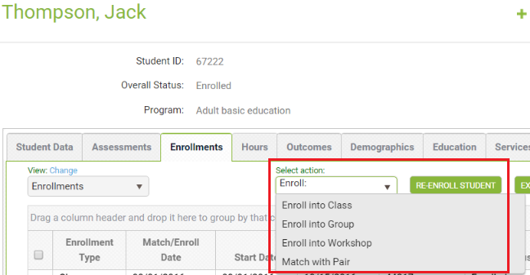

To enroll a student into a class, group, or workshop:
- Click the arrow on the dropdown list, and select the instructional setting.
- On the data chooser, select one or more enrollments by checking the box on the row. Only active classes, groups, or workshops that the student is not currently enrolled in will display on the data chooser.
- Enter an Enroll Date at the bottom left of the window, or click Show Selected to display the selected instructional settings. Show Selected allows you to enter a separate enrollment date in the field on the grid if multiple instructional settings have been selected.
- Click Enroll.

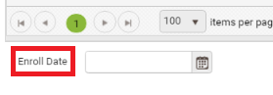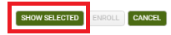

To match a student in a pair with a tutor:
- Click the arrow on the dropdown list, and select Match with Pair.
- On the data chooser, select one or more tutors by checking the box on the row.
- Enter the match date and Program at the bottom left of the window, or click Show Selected to display the selected tutors. Match date and Program are required fields. Pair Keyword, Weekly Time, and Location are optional fields. Show Selected allows you to enter a separate Match Date, Program, Pair Keyword, Weekly Time, and Location in the fields on the grid if multiple tutors have been selected.
- Click Match to create the pair(s).

Students may not be enrolled in a class, group, or workshop, or matched in a pair on a date that is prior to the student intake date.

The most common data entry error when enrolling is neglecting to enter the Enroll Date. If not filled out the Enroll Date will populate an information message indicating that some required fields (the Enroll Date) are empty or have invalid data. Other data entry errors including neglecting to check the box of the selected instructional setting, and attempting to enroll a student into an instructional setting prior to their program Intake Date.

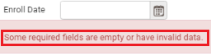

Students can be enrolled into instructional settings from either the student Enrollments panel or from the instructional setting itself. Often, it is preferable to enroll from the instructional setting itself, as this allows for batch enrollment of many students at one time into the instructional setting. Please see the Class Enrollment instructions in the Class section for additional details. IETP (Integrated Education & Training Program) enrollment cannot be added at the time of enrollment if you are enrolling a student from the student record, but can be done if enrolling from the Class or Group record. IETP can be added to the student record by editing the enrollment.

Enrollments Grid

The enrollments grid displays enrollment data. The default selection is All Fiscal Years, which will display all enrollments in the student’s enrollment history in chronological order beginning with most current, but can be changed using the Fiscal Year filter. The enrollment grid contains Rows and Columns, which work the same as all grids in LACES NexGen. Column headings on the enrollments grid can be dragged to the top row heading to group by column.

Editing and Deleting Enrollments

Click the Edit button to open an enrollment record for viewing or editing. This will open the enrollment record and allow you to make and save changes. The fields that you are allowed to edit vary with the type of enrollment. When you are editing enrollment data, you cannot navigate to a different tab or panel in the student detail record until the edits to the record are either saved or cancelled. The Delete button allows you to delete existing enrollments. Before an enrollment record can be deleted, all associated hours must be deleted first. Pairs must also be dissolved before deleting.

Exiting a Student from an Enrollment

Exiting a student from an enrollment is done by editing the enrollment record. Typically, students are exited from an enrollment when they have met all the requirements, or left without completing all requirements either through known departure or 90 days without service. A Left Date cannot be determined for NRS report population until 90 days after the last hours date, with no scheduled services in the future within the FY.

There are various enrollment statuses that may be selected when exiting a student. These are available solely for the tracking purposes of your agency and have no effect on the student in terms of reporting, other than to indicate that the student is no longer enrolled or matched in a pair.

Exit Status | Typically used to indicate: | Populates the Overall Status (IF this is the only class in which they are enrolled) as:
Completed Class | Completed all requirements and exited | Left
Incomplete | Did not complete all requirements but has exited or ceased attending | Left
Stopout | Left but plans to return within the fiscal year | Left
Left | Did not complete all requirements but has exited or ceased attending | Left
Never Attended | Enrolled but never attended | Left
Dropout | Dropped out with no plans to return | Left
Transferred | Transferred from one class to another | Left (although typically, they would remain Enrolled because presumably you have enrolled them in the class to which they transferred)
Dismissed | Dismissed from attending | Left
On Hold | A temporary, less than 90-day hiatus | Enrolled- Overall Status remains enrolled until student is exited or goes 90+ days without service

To exit or complete a student from a class, group, or workshop:

- Click the Edit icon.
- Select the status from the Enroll Status dropdown list on the left side.
- Update the End Date to reflect when the student exited or completed the enrollment.
- Click Save.

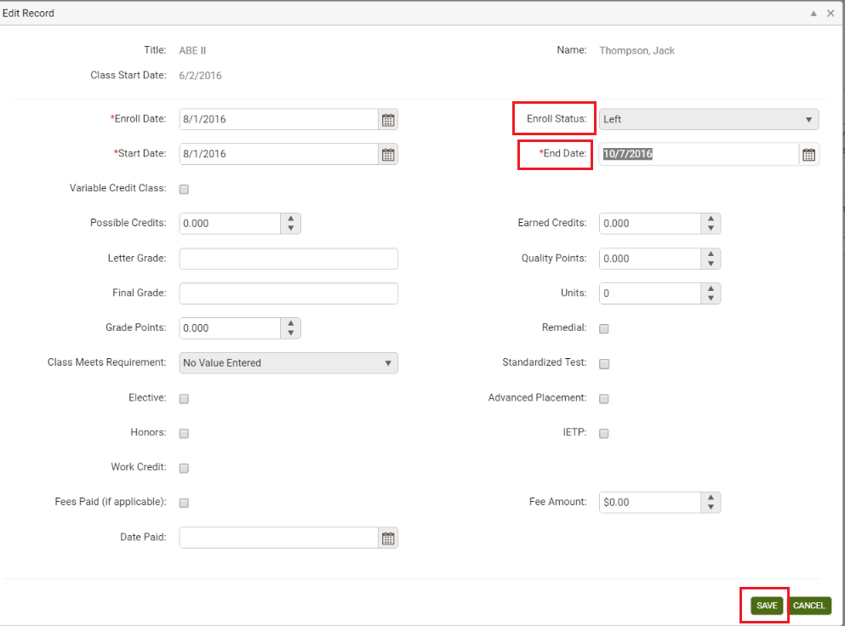

You can update additional information, if needed, such as IETP enrollment or grade information prior to saving.

If the exact date of exit is unknown and the student is being exited due to non-attendance, the student’s last hours date should be used, since this is the student’s last known date of attendance. For classes, groups, and workshops, the End Date must be within the Start and End Date of the class, group, or workshop, and must be after the Enrollment and Start Dates. For pairs, the End Date must be after the Match and Start Dates.

- To exit or complete a student from a pair:
- Click the Edit button.
- Enter the End Date. If this field is left blank, the date will default to today’s date.
- Select the status ‘Dissolved.’
- Click Save.

The student’s overall status will automatically update to Left (ABE) when the student is no longer enrolled in any instructional setting.

Most common data entry errors when exiting a student are:

- Using an exit/left date that is not within the Start and End Date of the instructional setting enrollment.
- Neglecting to update the End Date to the correct date. It will default to the End Date of the instructional setting, but End Dates cannot be on a future date.

Student Hours Tab

The Hours tab is comprised of two sections - the Hours header and the Hours grid.

Hours Header: Views There is one available view on the View dropdown list in the hours header: The Hours/Attendance View.

The hours view contains the following fields:

Checkbox | Selection tool to select a specific row
Enrollment Type | Displays the type of instructional setting: class, group, pair, workshop
Date | Date of the hours record
Title | The title of the class, group, or workshop, or the tutor name for Pair, or Unlinked Hours if not associated with an instructional setting
Instructor Name | Name of primary instructor assigned to the instructional setting
Hours Type | Type of hours. Note that hours will only count for NRS table purposes if the hours type contains the work “Instruction”
Hours Present | Number of hours present for the date entered. This may also represent an aggregate count if hours are entered weekly or bi-weekly.
Hours Absent | Number of hours absent for the date entered. This may also represent an aggregate count if hours are entered weekly or bi-weekly.
Late | Indicates if a student was late, if checked when entering the hours data
Creation Date | System-generated date indicating the date on which the hours record was entered into the database
Edit and Delete Icons | Click the Edit (eye) icon to edit or Delete (trash can) icon to delete

Grouping and expanding or collapsing

- Grouping, expanding and collapsing may be used after a column heading has been dragged to the top row header to group. Once a column is grouped, the information can be collapsed to display only the information for that column. To see how this works:
- Drag the column Hours Present to the top row header. This will group together the records with the same number of hours present.
- Now click Collapse All icon (the side arrow to the far right. This will reduce the number of records that display so only one record displays for each grouping.
- Each row has an arrow at the beginning of the row. Click one of the arrows to expand that particular group.
Date Range

Hours in the student record may be searched by a specific fiscal year, or fiscal year and quarter by clicking the down arrow on the Date Range dropdown list. Once a selection has been made, the dates will display in the date fields. For example, selecting the fiscal year 2014-2015 will automatically display the date range 7/1/2014 to 6/30/2015 (start and end dates of the 2014-2015 fiscal year). Click Apply to search the hours records.

Even after a selection has been made from the list, a custom date range may be entered and applied. The date range will overwrite the previous selection. The last selection will remain in effect until Cancel is selected on the dropdown list.

The Hours header contains the following fields:

Current FY Instructional Hours | Automatically calculated from the student’s total instructional hours entered in the current FY
Days Since Last Hours Date | Automatically calculated from the number of days since hours were last added to the student record
Instructional Hours | Automatically calculated from the number of student instructional hours earned in the current fiscal year, based on the fiscal year setting in the agency or state database
Lifetime Hours | Automatically calculated from the number of all hours earned over the entire history of the student, including instructional and other hours types

Add Hours

To add hours to the student record:

- Click the drop-down arrow next to Add Hours in the action window.

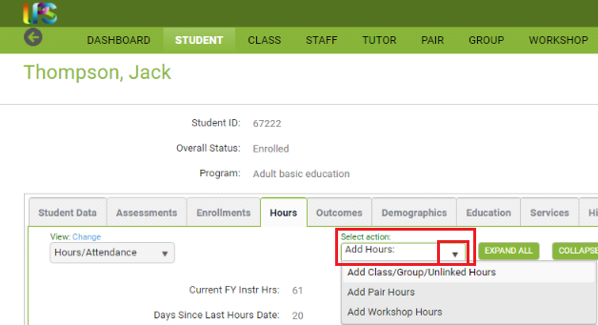

- The Add Hours options will display, allowing you to add hours for Class/Group/Unlinked, Pair Hours, or Workshop Hours. Click the option currently being used.
- The Calendar hours selector and hours type options will display.

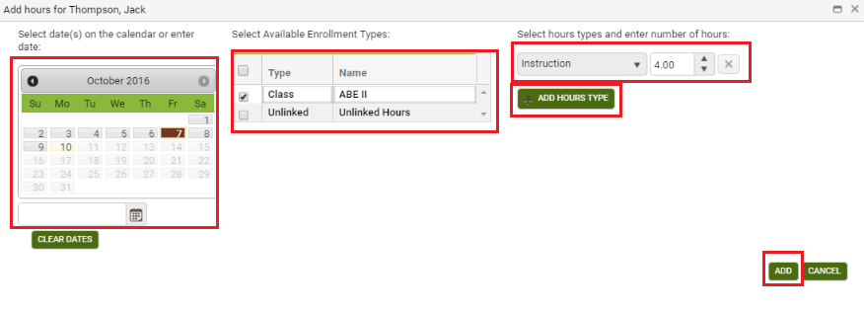

- You may make multiple date selections by clicking the dates on the calendar for which you would like to add hours, or type in a date in the field below the calendar to add hours for only one date if adding an aggregated total.
- Missouri’s policy is that hours can be entered once a month but you should use daily or weekly totals. Monthly totals can be added to catch the hours up from data migrated from the legacy system.
- When the start and end date of an enrollment is within the selected dates, the enrollment type will display.
- Check the enrollment you wish to add hours for.
- Select the hours type and enter the number of hours (you CAN use 0 or any other numeric indicator, you will be able to edit if needed!) Please note that if you track specific hours types such as Distance Learning hours, you should select those specific hours types.
- You can add additional hours types and hours, if needed.
- Click the Add button when ready to proceed. Note that the hours have NOT been added yet, they will need to be saved on the next screen. If the Add button is inactive, you either need to click Enter to move the cursor out of the Hours window, or double-check your dates to ensure that the hours date you are using is within the student’s Start and End date and also not a future date.
- After clicking Add, the hours records will display and can be edited if needed, by clicking in any column or row. Once any changes have been made, click Save to complete, or Save and New if you wish to save and add additional hours to this record.

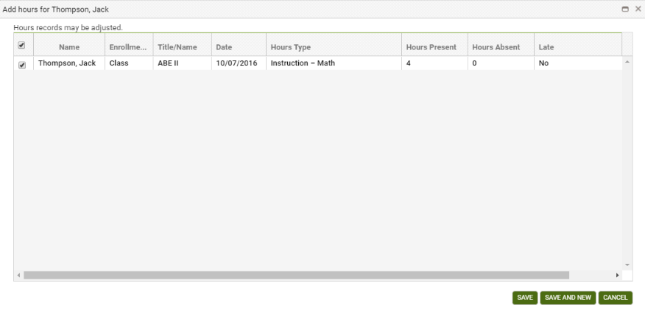

Unlinked Hours

Unlinked Hours are not associated with an instructional setting, and should be entered only when there is a valid reason to do so, such as tracking the amount of time a student spends taking an assessment or in orientation, if your agency allows such tracking (although we recommend just rolling those hours into the first hours entry for the class, pair, or group). Typically, all instructional hours are associated with a class, group, workshop, or pair.

Hours Grid
The hours grid displays hours data. The default selection is all hours records, which display in chronological order beginning with most current. The hours grid contains Rows and Columns, which work the same as all grids in LACES NexGen. Column headings on the enrollments grid can be dragged to the top row heading to group by column. Editing and Deleting Hours Records Click the Edit icon to open an hours record for viewing or editing. This will open the hours record and allow you to make and save changes. Date, Hours Present, Hours Absent, and Late may be edited. When you are editing an hours record, you cannot navigate to a different tab or panel in the student detail record until the edits to the record are either saved or cancelled.

The Delete icon allows you to delete hours records in the event an error was made. Deleting hours records will update the hours fields in the header.

Students hours can be entered from either the student Hours panel or from the instructional setting itself. Often, it is preferable to add hours from the instructional setting itself, as this allows for batch hours entry for many students at one time rather than having to enter individually from each student record. Please see the Class Hours instructions in the Class section for additional details.

The most common errors when adding hours are:

- Selecting dates that are not within the instructional setting and student’s Start and End dates. Hours cannot be added prior to the student’s Start date or after their exit date, or prior to the instructional setting’s Start date or after the instructional setting’s End Date.
- Not clicking the enrollment for which you wish to add hours.
- Not entering the number of hours into the Instruction number of hours box.
- Neglecting to hit Add and Save to review and save the hours.

Accurate hours entry is of vital importance, as hours tracking is used to determine enrollment, period of participation entry and exit, program exit, eligibility for post-test, and NRS participation eligibility. Be sure to follow state and federal guidelines for attendance tracking and entry.

Student Outcomes Tab

The Outcomes tab contains three panels:
- Cohorts
- Goals and Achievements

Cohorts were in effect from 2012-2016 for Table 5 reporting, but are no longer used-you should ignore this panel.

Goals and Achievement panel

The Goals and Achievements panel allows you to track goals made by your students during or after their time at your agency.

To add a new goal, click the Add New Record button to open a new goal window. Other areas of the database will be inactivated until the record is saved or cancelled. After entering the goal information, click Save to save the goal record and return to the Goals and Achievements panel, or Save and New to save the goal record and add additional goals, until clicking Save on the final record. Click Cancel to return to the Goals and Achievements panel without saving the record.

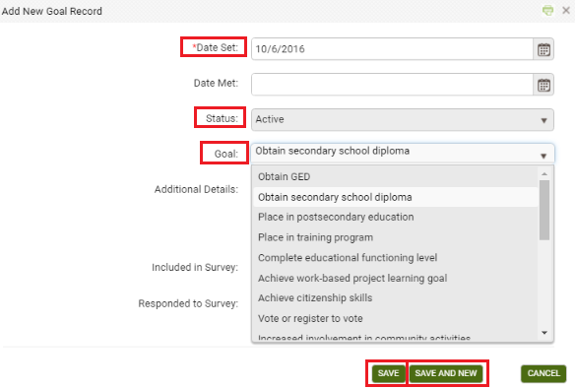

To edit goals, click the Edit button to the right of the record and make edits, then Save.

To delete goals, click the Delete button to the right of the record and verify that you wish to delete the record.

To add or update multiple goals at one time, click the + All Goals button. Add a Date Set to all rows for which you want to set a goal, or a Date met to all rows for which you want to indicate the goal has been met. Click Save when finished.

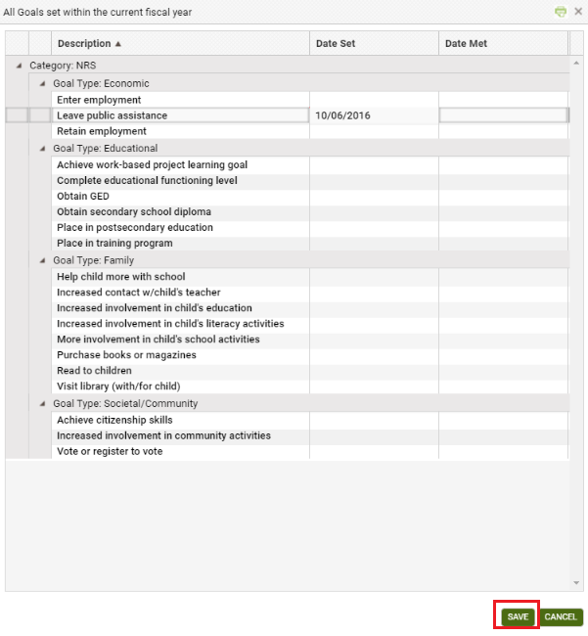

Goals populate Tables 8 (family literacy), and 9 (Secondary Outcome Measures). Tables 5 and 10 are populated based on evidence in the student record.

Pop Summary/Measurable Outcomes tab

This is a read-only panel that displays a summary of the activity recorded for the student related to PoPs, Measurable Skills Gains and Measurable Outcomes. It can be useful to use the green More menu and view the All PoPs Summary to see aggregated PoP data.

Demographics Tab: Demographics, Corrections, Disability, Family Members, Health Data, Identification

Demographics

The Demographics panel contains the student’s demographic data, and is partially populated based on information entered on the Intake Form. Fields with a red asterisk * are required fields, and edits to the Demographics panel will not be saved if any required fields are left blank through editing or deletion.

Editing within the panel can be done by opening the panel and typing directly into the field(s) you wish to edit. While making changes, the header and other tabs will become inactive until the changes have been saved or cancelled within the panel you are currently accessing.

The Demographics panel contains the following:

*Gender | Male or Female, required. Drop-down menu. Populated from the Intake Form.
*Is this student Hispanic/Latino (Ethnicity) | Indication of student’s ethnic origin as Hispanic/Latino. Indicated by a yes or no radio button. Required.
American Indian or Alaska Native (Race) | Indication of student’s race as American Indian or Alaska Native. Indicated by a checkbox where a check means Yes/True and a blank means No/False. At least one race selection must be made; multiple selections may be made for multi-racial students.
Asian (Race) | Indication of student’s race as Asian. Indicated by a checkbox where a check means Yes/True and a blank means No/False. At least one race selection must be made; multiple selections may be made for multi-racial students.
Black or African American (Race) | Indication of student’s race as Black or African American. Indicated by a checkbox where a check means Yes/True and a blank means No/False. At least one race selection must be made; multiple selections may be made for multi-racial students.
Native Hawaiian or Pacific Islander (Race) | Indication of student’s race as Native Hawaiian or Pacific Islander. Indicated by a checkbox where a check means Yes/True and a blank means No/False At least one race selection must be made; multiple selections may be made for multi-racial students.
White (Race) | Indication of student’s race as White. Indicated by a checkbox where a check means Yes/True and a blank means No/False At least one race selection must be made; multiple selections may be made for multi-racial students.
*Birthdate | Student birthdate. Can be typed in or entered with the calendar selection tool. Required. Populated from the Intake Form.
Age | Auto-generated and updated annually based on the student’s birthdate. Required and un-editable. Populates NRS Tables 2, 3, and 12. Populated from the Intake Form.
Birthdate Verification | Type-in field to indicate that the birthday has been verified, not required
Birthplace Used to indicate if the student is a US Citizen. Indicated by a checkbox where a check means Yes/True and a blank means False. | Type-in field indicating the birthplace of the student, not required.
City of Birth | Type-in field indicating the birth city of the student, not required.
Born outside US | Used to indicate if the student was born outside of the US. Indicated by a checkbox where a check means Yes/True and a blank means No/False. Not required.
Country of Birth | Student’s Country of Birth, as populated from a user-modifiable choice list drop-down menu. The drop-down menu is modifiable in the Choice List under “BirthCountry.” Not required.
Registered Voter | Used to indicate if the student is a registered voter. Indicated by a checkbox where a check means Yes/True and a blank means No/False. Not required.
Immigrant | Used to indicate if the student is an immigrant. Indicated by a checkbox where a check means Yes/True and a blank means No/False. Not required.
US Citizen | Used to indicate if the student is a US Citizen. Indicated by a checkbox where a check means Yes/True and a blank means No/False. Not required.
Plan to Stay in USA | Used to indicate if the student intends to continue residing in the United States. Indicated by a checkbox where a check means Yes/True and a blank means No/False. Not required.
Country of Citizenship | Student’s Country of Citizenship, as populated from a user-modifiable choice list drop-down menu. The drop-down menu is modifiable in the Choice List under “CountryofCitizenship.” Not required.
Residence Area | Indicator of Rural or Urban residence status, not required
Employment Status | Required field indicating employment status as selected from a non-modifiable drop-down menu. Populated from the Intake Form.
Cultural Barriers | Part of the Joint Reporting of Employment Barriers; a check means Yes, the student has this barrier, a blank checkbox means no, they do not have this barrier. These fields are Read Only in the Demographics tab but should be updated every time a student begins a new period of participation using the History tab>Barriers to Employment History panel and adding a new record with any changes.
Disabled | Part of the Joint Reporting of Employment Barriers; a check means Yes, the student has this barrier, a blank checkbox means no, they do not have this barrier. These fields are Read Only in the Demographics tab but should be updated every time a student begins a new period of participation using the History tab>Barriers to Employment History panel and adding a new record with any changes.
Displaced Homemaker | Part of the Joint Reporting of Employment Barriers; a check means Yes, the student has this barrier, a blank checkbox means no, they do not have this barrier. These fields are Read Only in the Demographics tab but should be updated every time a student begins a new period of participation using the History tab>Barriers to Employment History panel and adding a new record with any changes.
Economic Disadvantage | Part of the Joint Reporting of Employment Barriers; a check means Yes, the student has this barrier, a blank checkbox means no, they do not have this barrier. These fields are Read Only in the Demographics tab but should be updated every time a student begins a new period of participation using the History tab>Barriers to Employment History panel and adding a new record with any changes.
English Language Learner | Part of the Joint Reporting of Employment Barriers; a check means Yes, the student has this barrier, a blank checkbox means no, they do not have this barrier. These fields are Read Only in the Demographics tab but should be updated every time a student begins a new period of participation using the History tab>Barriers to Employment History panel and adding a new record with any changes.
Ex Offender | Part of the Joint Reporting of Employment Barriers; a check means Yes, the student has this barrier, a blank checkbox means no, they do not have this barrier. These fields are Read Only in the Demographics tab but should be updated every time a student begins a new period of participation using the History tab>Barriers to Employment History panel and adding a new record with any changes.
Exiting TANF within Two Years | Part of the Joint Reporting of Employment Barriers; a check means Yes, the student has this barrier, a blank checkbox means no, they do not have this barrier. These fields are Read Only in the Demographics tab but should be updated every time a student begins a new period of participation using the History tab>Barriers to Employment History panel and adding a new record with any changes.
Foster Care Youth | Part of the Joint Reporting of Employment Barriers; a check means Yes, the student has this barrier, a blank checkbox means no, they do not have this barrier. These fields are Read Only in the Demographics tab but should be updated every time a student begins a new period of participation using the History tab>Barriers to Employment History panel and adding a new record with any changes.
Homeless | Part of the Joint Reporting of Employment Barriers; a check means Yes, the student has this barrier, a blank checkbox means no, they do not have this barrier. These fields are Read Only in the Demographics tab but should be updated every time a student begins a new period of participation using the History tab>Barriers to Employment History panel and adding a new record with any changes.
Long Term Unemployed | Part of the Joint Reporting of Employment Barriers; a check means Yes, the student has this barrier, a blank checkbox means no, they do not have this barrier. These fields are Read Only in the Demographics tab but should be updated every time a student begins a new period of participation using the History tab>Barriers to Employment History panel and adding a new record with any changes.
Low Literacy Levels | Part of the Joint Reporting of Employment Barriers; a check means Yes, the student has this barrier, a blank checkbox means no, they do not have this barrier. These fields are Read Only in the Demographics tab but should be updated every time a student begins a new period of participation using the History tab>Barriers to Employment History panel and adding a new record with any changes.
Seasonal Farmworker | Part of the Joint Reporting of Employment Barriers; a check means Yes, the student has this barrier, a blank checkbox means no, they do not have this barrier. These fields are Read Only in the Demographics tab but should be updated every time a student begins a new period of participation using the History tab>Barriers to Employment History panel and adding a new record with any changes.
Single Parent or Guardian | Part of the Joint Reporting of Employment Barriers; a check means Yes, the student has this barrier, a blank checkbox means no, they do not have this barrier. These fields are Read Only in the Demographics tab but should be updated every time a student begins a new period of participation using the History tab>Barriers to Employment History panel and adding a new record with any changes.
Public Assistance | Part of the Joint Reporting of Employment Barriers; a check means Yes, the student has this barrier, a blank checkbox means no, they do not have this barrier. These fields are Read Only in the Demographics tab but should be updated every time a student begins a new period of participation using the History tab>Barriers to Employment History panel and adding a new record with any changes.
Dislocated Worker | Part of the Joint Reporting of Employment Barriers; a check means Yes, the student has this barrier, a blank checkbox means no, they do not have this barrier. These fields are Read Only in the Demographics tab but should be updated every time a student begins a new period of participation using the History tab>Barriers to Employment History panel and adding a new record with any changes.
Migrant Worker | Part of the Joint Reporting of Employment Barriers; a check means Yes, the student has this barrier, a blank checkbox means no, they do not have this barrier. These fields are Read Only in the Demographics tab but should be updated every time a student begins a new period of participation using the History tab>Barriers to Employment History panel and adding a new record with any changes.
Marital Status | Student’s Marital Status, as populated from a user-modifiable choice list drop-down menu. The drop-down menu is modifiable in the Choice List under “MaritalStatus.” Not required.
Parents’ Highest Education Completed | Education Completed  The Highest Level of Education Completed by the student’s parent, as populated from a user-modifiable choice list drop-down menu. The drop  down menu is modifiable in the Choice List under “HighestLevelofEducationCompleted.” Not required.
Military Service Experience | Student’s Military Service, as populated from a user-modifiable choice list drop-down menu. The drop-down menu is modifiable in the Choice List under “MilitaryService.” Not required.
Family Income Range | Student’s Family Income Range, as populated from a user-modifiable choice list drop-down menu. The drop-down menu is modifiable in the Choice List under “FamilyIncomeRange.” Not required
Number of Dependents | Type in field to indicate the number of dependents.
Minor with Adult Status | Used to indicate if the student is a Minor with Adult Status. Indicated by a checkbox where a check means Yes/True and a blank means No/False. Not required
At Risk | Used to indicate if the student is an At Risk student. Populated from a user-modifiable choice list drop-down menu. The drop-down menu is modifiable in the Choice List under “AtRisk.” Not required
Abuse | Used to indicate if the student is an Abused student. Populated from a user-modifiable choice list drop-down menu. The drop-down menu is modifiable in the Choice List under “Abused.” Not required.
Correctional | Used to indicate if the student is enrolled in Correctional Education. Populated from a user-modifiable choice list drop-down menu. The drop-down menu is modifiable in the Choice List under “Correctional.” Not required.
Institutional | Used to indicate if the student is a resident of an Institutional Setting. Populated from a user-modifiable choice list drop-down menu. The dropdown menu is modifiable in the Choice List under “Institutional.” Not required.

Corrections
The Corrections panel contains the student’s correctional education information.

Editing within the panel can be done by opening the panel and typing directly into the field(s) you wish to edit. While making changes, the header and other tabs will become inactive until the changes have been saved or cancelled within the panel you are currently accessing.

Disability
The Disability panel contains the student’s disability information.

Editing within the panel can be done by opening the panel and typing directly into the field(s) you wish to edit. While making changes, the header and other tabs will become inactive until the changes have been saved or cancelled within the panel you are currently accessing.

Family Members
A display-only panel that will display any linked family members attached in the Family tab.

Health Data
The Health Data panel contains the student’s health information.

Editing within the panel can be done by opening the panel and typing directly into the field(s) you wish to edit. While making changes, the header and other tabs will become inactive until the changes have been saved or cancelled within the panel you are currently accessing.

Identification
The Identification panel allows identification records related to the student record to be entered, edited, viewed or deleted.

Identification records will display in chronological order with the most recent on top. Columns and rows may be grouped and sorted by clicking the column headings to sort in alphabetical or numeric ascending or descending order. A single click will sort in ascending order, or a double click in descending order.

To add a new identification record, click the Add New Record link in the upper-left corner. A new the identification record window will open, allowing you to enter the Start Date, Identification System Code (Type), and Document or ID Number. Other areas of the database will be inactivated until the identification record is saved or cancelled.

After entering the identification record, click Save to save the identification record and return to the Identification panel, or Save and New to save the identification record and add additional identification records, until clicking Save on the final identification record. Click Cancel to return to the Identification panel without saving the identification record.

To edit identification records, click the Edit button to the right of the identification records and make edits, then Save.

To delete identification records, click the Delete button to the right of the identification record and verify that you wish to delete the identification record.

Education Tab: Education, Diplomas/Credentials, Instructional Areas, Language, Material, Term Grades, Transcripts

Education

The Education panel contains education information for the student. Some data will be populated based on information entered on the Intake Form. Other data may be added, if desired. Fields can be edited, viewed, modified, and deleted from the Education panel. Fields with a red asterisk * are required fields, and edits to Education panel will not be saved if any required fields are left blank through editing or deletion.

Editing within the panel can be done by opening the panel and typing directly into the field(s) you wish to edit. While making changes, the header and other tabs will become inactive until the changes have been saved or cancelled within the panel you are currently accessing.

The Education panel contains the following fields (some databases may have customizations that result in slight variance):

*Intake Date | Student’s initial Intake Date into the program, populated from the Intake Form at entry. Should not be edited with new enrollments; should always remain the initial date of enrollment into the program. Required, editable.
Last Enroll Date | Date of last enrollment into an instructional setting, automatically populated based on class, pair, group, or workshop enrollment. Editable, not required
Last Hours Date | Date on which hours were last entered for the student record. Non-editable.
Last Assessment Date | Date on which an assessment was last entered for the student record. Non-editable.
*Program | Student’s main Program type, populated from the Intake Form at entry. Required, editable. Populates from a non-editable drop-down menu.
Secondary Program | Student’s secondary Program type, populated from the Intake Form at entry. Not required, editable. Populates from a non-editable drop-down menu. Primarily used to indicate enrollment in an Integrated English Literacy and Civics Education program.
ESL Student | A checkbox or Yes/No drop-down menu indicating if the student is considered an ESL student where a check indicates Yes and a blank box indicates No. ESL indication is related to assessment levels for some assessments. Not required, editable.
Enrolled in Other Reading Program | A checkbox indicating if the student is enrolled in another reading program where a check indicates Yes and a blank box indicates No. Not required, editable.
Enrolled in Other GED Program | A checkbox indicating if the student is enrolled in another GED program where a check indicates Yes and a blank box indicates No. Not required, editable.
Exempt from Assessment | A checkbox indicating if the student is exempt from assessment where a check indicates Yes and a blank box indicates No. Not required, editable
Fee Waiver | A type in text field for indicating fee waiver information for the student record. Not required, editable.
*Highest Education Level Completed on Entry | A drop-down menu for indicating the highest education level completed by the student at their time of initial entry into the program. Required, editable. Populates from the intake form at entry.
*Highest Education Level Completed on Entry Location | A drop-down menu for indicating the location at which the highest education level completed by the student at their time of initial entry into the program occurred. Required, editable.
Highest Education Completed | A drop-down menu for indicating the highest education level completed by the student at any point in their enrollment within the program. Not required, editable.
Admission Status | A drop-down menu for indicating admission status within the program. Not required, editable.
Mandated Student Type | A drop-down menu for indicating mandated student type within the program. Not required, editable.
Staff Assigned | A type-in field for indicating the staff member assigned to the student as a case manager or lead. Not required, editable.
File Location | A type in text field for indicating file location information for the student record. Not required, editable.
File Security | A drop-down menu for indicating file security information for the student record. Not required, editable. Drop-down menu options may be modified in the Choice List under the file name “File Security.”
Current School Attending | A type in text field for indicating information for the current school being attended. Not required, editable.
Current School Contact Info | A type in text field for indicating contact information for the current school being attended. Not required, editable.
Last School Attended | A type in text field for indicating information for the last school attended. Not required, editable.
Last School Attended Location | A type in text field for indicating contact information for the last school attended. Not required, editable.
Source Type | A drop-down menu for indicating the source type (referral) information for the student record. Populates from the Intake Form. Not required, editable. Drop-down menu options may be modified in the Choice List under the file name “Source Type.”
Source Name | A drop-down menu for indicating additional source name (referral) information for the student record. Not required, editable. Drop-down menu options may be modified in the Choice List under the file name “Source Name.”
Why Enroll | A drop-down menu for indicating the reason for the student enrollment. Not required, editable. Drop-down menu options may be modified in the Choice List under the file name “Why Enroll.”
Other Why Enroll | A type in text field for indicating additional enrollment reason details. Not required, editable.
Post School Recognition-Graduation Exercises | A drop-down menu for indicating a post-school recognition or graduation exercises in which the student participates. Not required, editable. Dropdown menu options may be modified in the Choice List under the file name “PostSchoolRecognition.”
Reason Left | A drop down menu for indicating the reason the student exited the program. Not required, editable. Drop-down menu options may be modified in the Choice List under the file name “ReasonLeft.”
Reason Left Detail | A type in field for indicating additional reason left details when the student has exited the program. Not required, editable.
TABE Identifier | A type in field for indicating TABE Identifier information, if needed. Not required, editable.

Diploma/Credentials

The Diploma/Credentials panel allows diploma information related to the student record to be entered, edited, viewed or deleted. We do not recommend using this to enter GED, HiSet, or TASC information unless state instruction is to do so, as that should be entered in the assessments panel or obtained through data match, but the credentials panel can be used for other certifications earned.

Diploma records will display in chronological order with the most recent on top. Columns and rows may be grouped and sorted by clicking the column headings to sort in alphabetical or numeric ascending or descending order. A single click will sort in ascending order, or a double click in descending order.

To add a new diploma record, click the Add New Record link in the upper-left corner. A new diploma Info Record window will open, allowing you to enter the Type, Expected Award Date, Date Exam Last Taken But Not Passed, Date Earned, Actual Award Date, Name of Diploma/Credential, Description/Number, Person’s Name Displayed on Diploma/Credential, Completed Requirements, and By Exam Only fields. Other areas of the database will be inactivated until the diploma info record is saved or cancelled.

After entering the diploma record, click Save to save the diploma record and return to the Diploma Info panel, or Save and New to save the diploma record and add additional diploma records, until clicking Save on the final diploma record. Click Cancel to return to the Diploma Info panel without saving the diploma information.

To edit diploma info records, click the Edit button to the right of the diploma record and make edits, then Save.

To delete diploma info records, click the Delete button to the right of diploma record and verify that you wish to delete the diploma record.

Some Diploma Types can only be entered into the student diploma folder if indicators elsewhere in the student record indicate that it is an appropriate diploma type based on business rules:
- High School Diploma: Student must be enrolled in Adult High School (must be indicated through the Agency Settings) and have an Entry Level of High Adult Secondary for this type of diploma/credential.
- Secondary Diploma/Credential: Student must be enrolled in Adult High School (must be indicated through the Agency Settings) and have an Entry Level of High Adult Secondary for this type of diploma/credential.
- NEDP High School Diploma: Student must be indicated as being in the assessment phase of the EDP through the Education folder for this type of diploma/credential.

Instructional Areas

The Instructional Areas panel allows instructional areas records related to the student record to be entered, edited, viewed or deleted. Most agencies do not use this folder.

Records will display in chronological order with the most recent on top. Columns and rows may be grouped and sorted by clicking the column headings to sort in alphabetical or numeric ascending or descending order. A single click will sort in ascending order, or a double click in descending order.

Language

The Language panel allows languages records to be entered, edited, viewed or deleted.

Language records will display in chronological order with the most recent on top. Columns and rows may be grouped and sorted by clicking the column headings to sort in alphabetical or numeric ascending or descending order. A single click will sort in ascending order, or a double click in descending order.

To add a new language, click the Add New Record link in the upper-left corner. A new language window will open, allowing you to enter the Date, Language, Language Type, and check the Native, Read, Write, and/or Speak checkbox indicators. Other areas of the database will be inactivated until the language record is saved or cancelled.

After entering the language information, click Save to save the language record and return to the Language panel, or Save and New to save the language record and add additional languages, until clicking Save on the final language record. Click Cancel to return to the Language panel without saving the language information.

To edit languages, click the Edit button to the right of the language record and make edits, then Save.

To delete languages, click the Delete button to the right of the language record and verify that you wish to delete the language record.

You can search for students who speak a particular language by using the criteria builder. There is not currently a language report but it is in the development queue for a language report to be created.

Material

The Material panel is a display-only panel that allows material records to be viewed. Material information populates automatically from the Materials tab and cannot be edited or deleted from the student record. New materials cannot be added from the student record or checked out/given away from the student record; these actions must occur in the Materials record itself.

Materials records will display in chronological order with the most recent on top. Columns and rows may be grouped and sorted by clicking the column headings to sort in alphabetical or numeric ascending or descending order. A single click will sort in ascending order, or a double click in descending order.

Any additions or edits to materials data must be made from the Materials tab record.

Term Grades

The Term Grades panel allows grades related to the student enrollment records to be entered, edited, viewed or deleted. Most agencies do not track term grades and do not commonly use this folder.

Term Grades will display in chronological order with the most recent on top. Columns and rows may be grouped and sorted by clicking the column headings to sort in alphabetical or numeric ascending or descending order. A single click will sort in ascending order, or a double click in descending order.

To add a new term grade record, click the Add New Record link in the upper-left corner. A new term grade record window will open, allowing you to enter the Term, Credits Attained, Credits Received, Grade Points Received, Term Grade Point Average, Year to Date Grade Point Average, and Cumulative Grade Point Average fields. Other areas of the database will be inactivated until the term grade record is saved or cancelled.

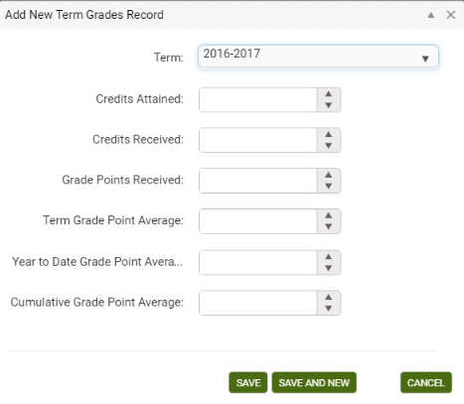

After entering the term grade information, click Save to save the term grade record and return to the Term Grades panel, or Save and New to save the term grade record and add additional term grades, until clicking Save on the final term grade record. Click Cancel to return to the Term Grade panel without saving the term grade information.

To edit term grades, click the Edit button to the right of the term grade record and make edits, then Save.

To delete term grades, click the Delete button to the right of the term grade record and verify that you wish to delete the term grade.

Transcripts

The Transcript panel allows transcript information related to the student records to be entered, edited, viewed or deleted. Most agencies do not create transcripts and do not commonly use this folder.

Transcript records will display in chronological order with the most recent on top. Columns and rows may be grouped and sorted by clicking the column headings to sort in alphabetical or numeric ascending or descending order. A single click will sort in ascending order, or a double click in descending order.

To add a new transcript record, click the Add New Record link in the upper-left corner. A new transcript record window will open, allowing you to enter the fields described above. Other areas of the database will be inactivated until the transcript record is saved or cancelled.

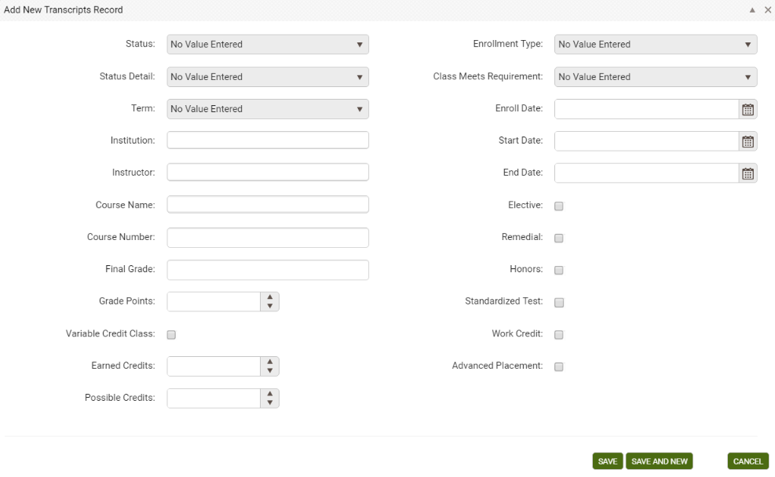

After entering the transcript information, click Save to save the transcript record and return to the Transcript panel, or Save and New to save the transcript record and add additional transcript records, until clicking Save on the final transcript record. Click Cancel to return to the Transcript panel without saving the transcript information.

To edit transcript records, click the Edit button to the right of the transcript record and make edits, then Save.

To delete transcript records, click the Delete button to the right of the transcript record and verify that you wish to delete the transcript record.

Services Tab: Accommodations, Referrals, Social Services

Accommodations

The Accommodations panel allows accommodations made for the student to be entered, edited, viewed or deleted. Accommodations are typically any services offered to the student such as disability related services (interpreter, software, etc.) or financial assistance (bus passes, etc.)

Accommodations will display in chronological order with the most recent on top. Columns and rows may be grouped and sorted by clicking the column headings to sort in alphabetical or numeric ascending or descending order. A single click will sort in ascending order, or a double click in descending order.

To add a new accommodation, click the Add New Record link in the upper-left corner. A new accommodation window will open, allowing you to enter any or all of the above fields. Other areas of the database will be inactivated until the accommodation record is saved or cancelled.

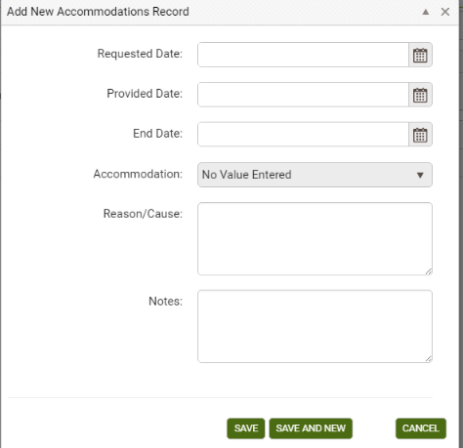

After entering the accommodation information, click Save to save the accommodation record and return to the Accommodations panel, or Save and New to save the accommodation record and add additional accommodations, until clicking Save on the final accommodation. Click Cancel to return to the Accommodations panel without saving the accommodation information.

To edit accommodations, click the Edit button to the right of the accommodation and make edits, then Save. To delete accommodations, click the Delete button to the right of the accommodation and verify that you wish to delete the accommodation.

Referrals

The Referrals panel allows referral information for the student to be entered, edited, viewed or deleted. This panel is typically used for tracking referrals your agency makes to another agency for the benefit of the student, such as a referral to DVR to confirm a disability.

Referrals will display in chronological order with the most recent on top. Columns and rows may be grouped and sorted by clicking the column headings to sort in alphabetical or numeric ascending or descending order. A single click will sort in ascending order, or a double click in descending order.

To add a new referral, click the Add New Record link in the upper-left corner. A new referral window will open, allowing you to enter any or all of the above fields. Other areas of the database will be inactivated until the referral record is saved or cancelled.

After entering the referral information, click Save to save the referral record and return to the Referrals panel, or Save and New to save the referral record and add additional referrals, until clicking Save on the final referral. Click Cancel to return to the Referrals panel without saving the referral information.

To edit referrals, click the Edit button to the right of the referral and make edits, then Save.

To delete referrals, click the Delete button to the right of the referral and verify that you wish to delete the referral.

Social Services

The Social Services panel allows social service information for the student to be entered, edited, viewed or deleted.

Social Services records will display in chronological order with the most recent on top. Columns and rows may be grouped and sorted by clicking the column headings to sort in alphabetical or numeric ascending or descending order. A single click will sort in ascending order, or a double click in descending order.

To add a new social service record, click the Add New Record link in the upper-left corner. A new social service record window will open, allowing you to enter any or all of the above fields. Other areas of the database will be inactivated until the social service record is saved or cancelled.

After entering the social service record information, click Save to save the social service record and return to the Social Services panel, or Save and New to save the social service record and add additional social service records, until clicking Save on the final social service record. Click Cancel to return to the Social Services panel without saving the social service record information.

To edit social service records, click the Edit button to the right of the social service record and make edits, then Save.

To delete social service records, click the Delete button to the right of the social service record and verify that you wish to delete the social service record.

History: Address History, Enrollment Program History, Fiscal Year, Level History, Overall Status History, Work History, Audit History

The History tab contains seven panels where student history information may be entered. Student employment used for Table 5 reporting purposes is populated from the Work History panel, and other student history records populate automatically and cannot be edited or deleted.

Address History Panel

The Address History panel allows the student’s primary address history to be entered, edited, viewed or deleted.

When you enter a new student, the field ‘Phone at Address’ does not display on the intake page. This field will be blank when you open the student record and go to Key Info. However, when you enter a phone number in the field and save, it is included as part of the student’s primary address history record.

A primary address record will be created in the Address History panel whether an address was entered at intake or not, and the record will be designated as the primary address. A primary address history record may be edited, but cannot be deleted. Address information added at the Student Key Info panel will automatically populate or update the primary address record. Conversely, address information entered or edited in the primary Address History record will automatically populate or update the address information in the Key Info panel.

If the student moves, but you want to keep a history of the student's addresses, you may enter a new record at the Address History panel (instead of updating the address fields), and include Phone at Address. Check Primary Address. This will update the Student Key Info; primary address always populates the address fields at student key info, and the Phone at Address field is tied to the primary address.

There must always be at least one address history record designated as the primary address. The primary address record cannot be deleted.

Q: Why is there a separate ‘Phone at Address’ field for the primary address when I’ve already entered the student’s home phone number?

The primary address may or may not be the address where the student currently resides. For example, a student may indicate a parent’s address as their primary address where they wish to receive mail, and indicate the phone number for that particular address. The student’s home phone number may be the number where the student actually resides. The agency should decide how they plan to enter and use student contact information.

Enrollment Program History Panel

The Enrollment Program History panel allows program history related to the student enrollments to be entered, edited, viewed or deleted. Initial enrollment program history records automatically populate from the class, group, workshop, or pair program when the student is enrolled or matched in a pair. The enrollment program history record will reflect the student’s start date or match date. If the student is enrolled in multiple instructional settings that have the same program, only one enrollment program history record will populate, with the first enrollment start date.

Fiscal Year Panel

The student Fiscal Year panel allows you to track summary fiscal year information regarding the student for current and past fiscal years.
FY summaries are created for two reasons: to keep the data concise and reduce the probability of errors being made by the database, and to allow us to “freeze” FY data so that all historical data can be maintained in one database, rather than having to use a new database every new fiscal year.

- Students and staff will not populate the NRS tables or searches without a FY Summary
- The Fiscal Year Summary records are created from the Student or Staff tab and are run on the selection. Since this functionality requires a great deal of processing, we have limited the range of records that can be run. Also, if the selection is generated from the records themselves, you will get an error message letting you know to subset the selection first. You do not need to subset records if you are scheduling them, but to run them yourself, they must be subset first. To subset a selection, click the checkbox in front of the student name(s) for which you wish to create a new FY summary, or click the checkbox in the upper left corner of a page to select everyone on that page, and then go to the toolbar in the upper right-hand corner and click Selection>Subset.
- Once you have subset your selection, to create new FY Summary records, click the More option on the right-hand Toolbar (NOT the More option on the left hand, green toolbar!), and then click Create FY Summaries.
- The selection is limited to 500 records
- If your selection is 500 students or fewer, click Create Now.
- The window will reflect that the summaries are being processed. You will not be able to work in LACES on the same computer from which you are creating summaries while they are being processed.
- Student and staff NRS tables both use FY summary data. You can run new summaries just on records that have been recently changed, or you can wait for the bi-monthly automatic creation of FY summaries.
- Only the FY Data NRS table reports and the FY Data searches run based on summaries. Every other report and search runs on current or “raw” data and does not need a FY summary, but will display information added immediately upon addition and saving.

Level History Panel

The Level History panel allows level history related to the student record to be entered, edited, viewed or deleted. Level history records populate automatically when a level defining assessment is entered at the Assessment tab.

Overall Status History Panel

An overall status history record is populated when:
•The student record is entered.
•The first assessment is entered.
•The student’s overall status changes.
•The student’s program changes.

When a student whose overall status is ‘left’ and the student is then re-enrolled into a class or group, a record will populate with the note ‘Re-enroll.’

Work History Panel

The Work History panel allows the student Work History to be entered, edited, viewed or deleted.

The initial work history record is populated at the time of the student intake, and the start date of the work history record will be the same as the student intake date.

Do not delete Work History unless an error was made. A new record should be added to update new work history.

Audit History

Non-editable panel displays the date, area, action, and username of updates and creations to the student record.

Classes
The instructional options in LACES are Class, Pair, Group, and Workshop. Classes are typically enrollment settings for a designated number of students and are taught by staff members. Groups are small, tutor-led instructional settings. Pairs are one-on-one student/tutor instruction. Workshops are typically used for tracking tutor and staff training and are generally not used for student data but can be, if desired and appropriate.
Please note that classes, groups, and workshops work in essentially the same manner so only class data is discussed in great detail within this documentation, but the Group and Workshop information should be conducted in a similar manner.
When you first sign in to LACES, the default view at the Class tab is the Class List view. The default filter is Active and class with the status of Active will display in the list. To display all class records entered in your agency regardless of status, click the X on the Active tile to remove the filter. To re-apply the Active filter, click Searches>General>Active. Class Views are available and can be created, just as in the student views. Shared views are predefined and are available on a dropdown list that displays at the top left of the class grid. There are three shared views. The default view is Class List, which displays columns on the grid that provide at-a-glance information about the class dates and details. The view may be changed by selecting a different view from the list. This view will be in effect until you change it, even if you leave the class grid temporarily by clicking on a different tab, and then return to the class grid. For more information about views, go to View Manager.
The toolbars in the class population are similar to the student toolbars. To add a new class record, click the Add New Class icon to display the class intake form. The * indicates a required field and must be entered before the record may be saved. After entering the record, you may:
- Click Save to save the record and return to the class grid.
- Click Save and New to save the record and get a blank intake form so you can add another class record.
- Select a specific tab in the class record from the dropdown list, and then click Save and Go to save the record and go to that tab within the new record.
- Cancel without saving. Opening a class detail record Class records may be opened by double-clicking on the record, or by clicking the edit icon on the row.

Class Detail Record
The Class header displays key information about the class record that is currently open, and shows at the top of each class detail tab. The header itself cannot be edited, but the fields that display in the header may be edited elsewhere in the class detail record, or populate automatically. The class header will update to display any changes.
Fields that display in the class header and where the editable fields may be edited:
Class Name, in green, left corner | Class Data tab; required at intake
Class ID | System number automatically generated when the class record is created
Term | Class data tab
Course Number | Class data tab
Title | Class data tab; required at intake
Status | Class data tab; required at intake
Start Date | Class data tab; required at intake
End Date | Class data tab; required at intake
Program | Class data tab
Class Keyword | Class detail tab
Days | Class data tab
Times | Class data tab
Bldg/Room | Class data tab
Max Enroll | Class data tab
Enrolled | Auto-generated from class enrollment
Waiting | Auto-generated from class enrollment
Completed | Auto-generated from class enrollment

The class detail toolbar allows you to:
- Add a new class
- Delete the class record currently open
- Print

The Record Indicator at the top right of the class header shows what record you in out of a selection of records, and allows you to move forward or back either by record (single headed arrow), or to the beginning or end of the classes in the list (single headed arrow with line). When you use the arrows to move forward or back, the record will be at the same panel and/or tab you were previously in.

The Class Detail page contains the following tabs:
- Class Data
- Enrollment
- Attendance
- Instructor
- Instructor Hours
- Comments

Class Data

The Class Data tab contains key information regarding the class record, and is primarily populated based on information when creating the class record. Fields with a red asterisk * are required fields, and edits to the Class Data will not be saved if any required fields are left blank through editing or deletion.

Editing can be done by opening the tab and typing directly into the field(s) you wish to edit. While making changes, the header and other tabs will become inactive until the changes have been saved or cancelled within the tab you are currently accessing.

The Class Data tab contains the following fields (some databases may have customizations that result in slight variance):

Term | The term in which the class is occurring.
Course Number | The course number of class
*Title | The title of the class, required
*Status | The status of the Class. (Students may only be enrolled into an Active class.)
*Start Date | The date on which the class started or is scheduled to start
*End Date | The date on which the class ended or is scheduled to end
Program | The type of Program for which this class is associated. The class Program does not have to correspond to the enrolled students’ Programs. Editable, required.
Class Keyword | Optional class keyword, can be modified in the ClassKeyword choice list
Level | The level for the class
Department | The department for the class
Days | Indicates the days the class meets
Times | Indicates the times the class meets
Bldg/Room | Indicates the building and room where the class meets
*Max Enroll | Indicates the maximum enrollment allowed in the class. Students enrolled beyond this number will enter with an enrolled status of Waiting. If this number is edited to increase after the number has been surpassed, Waiting students will not automatically go to an Enrolled status but must be manually updated from Waiting to Enrolled.
Min Enroll | Indicates the minimum enrollment allowed in the class.
Weeks of Class | Numeric field indicating the number of Weeks of Class
Hours Per Week | Numeric field indicating the number of Hours Per Week
Hours Per Term | Numeric field indicating the number of Hours Per Term
Organization | Drop down menu indicating the organization associated with the class
Location | Drop-down menu to indicate the location where the class meet
Location Detail | Type in field for additional detail regarding where the class meets
Variable Credit | Checkbox to indicate if the class is a variable credit class
Credits | Numeric field indicating the number of credits
Maximum Credits | Numeric field indicating the number of max credits
Instructional Area | Drop-down menu to indicate instructional area
Class Meets Requirement | Drop-down menu to indicate what requirement the class meets
Language of Instruction | Drop-down menu to indicate the Language of Instruction
Cost | Numeric field indicating the cost of the class
Total Paid | Numeric field indicating the Total Paid
Last Date Hours Added | Auto-generated field indicating the last date on which hours were added

Enrollment
The following views are available at the class Enrollment tab grid:
- Enrollment Info (default)
- Student Contact Info

Click on the down arrow in the dropdown menu to display and select one of the available views. The selected view will remain in place when using the record indicator at the top right to move forward or back to records within the Enrollment tab.

Enroll Button

The class status must be active for students to be enrolled in the class. To enroll a student:
- Click the Enroll button.
- On the data chooser, select one or more students by checking the box on the row. All students will display. You may select students on different pages.
- Enter an Enroll Date at the bottom left of the window, or click Show Selected to display the selected students. Show Selected allows you to enter a separate enroll date in the field on the grid if multiple students have been selected.
- Click Enroll Students.

IETP (Integrated Education & Training Program) Enrollment for Table 3:

To enroll students in an IETP at the time of enrollment:

Open the class record and click the Enrollment tab. Click the green Enroll button. In the enrollment selection window, select the students to enroll by clicking the checkbox to the left of their names. Once selected, note the IETP checkbox in the bottom left, near the Enroll Date window. Check this box if any or all of the selected students should be indicated as enrolled in an IETP. Enter the Enroll Date.

If not all of the selected students are in an IETP or have the same enrollment date, you can click the green Show Selected button in the right-hand corner to display the selected students and allow you to edit the IETP and/or Enroll Dates to modify them on an individual student basis while still allowing you to enroll the students as a batch.

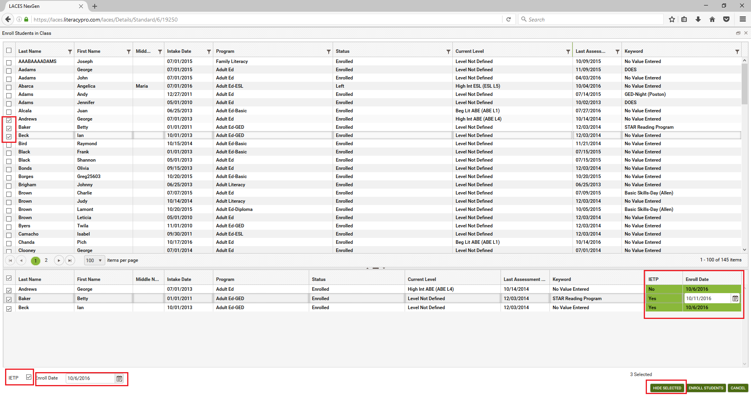

Make changes, if needed, and click the Enroll Students button to enroll the selected students when finished.

To enroll students in an IETP after they were already enrolled in the class without the IETP indicator:

If you need to update the IETP checkbox at any point to indicate IETP enrollment for a student, open the class record in which the student is enrolled. Double click the student’s enrollment record in the class, or click the Edit (eye) icon. In the Edit Enrollment window, locate the IETP checkbox in the right-hand column. Check or uncheck, as appropriate, and save. You cannot currently update IETP as a batch.

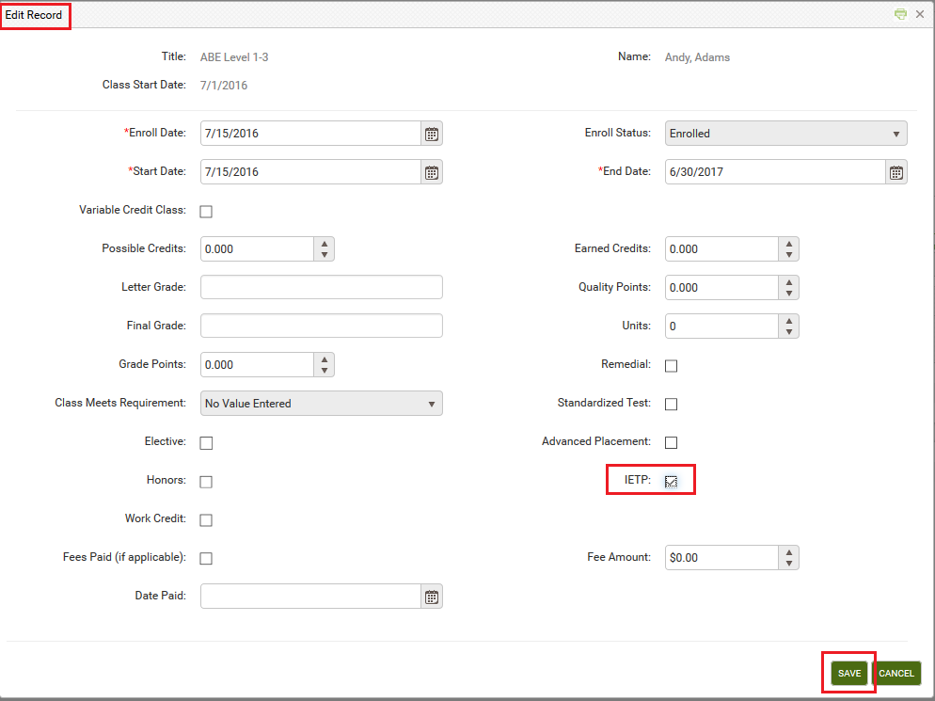

To view the IETP indicator for all students in a class:

In the Class Enrollment tab, change the View from the default Enrollment Info to Grades. This view displays a column for IETP, allowing you to view the IETP indicator for all students in the class at once.

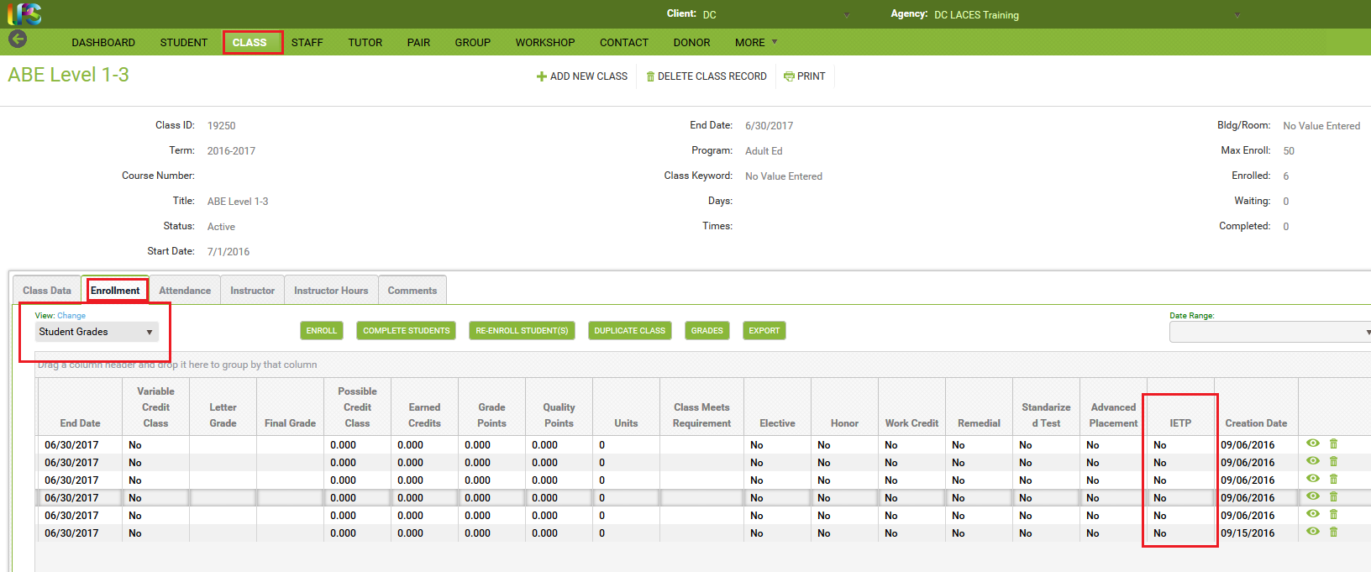

Data Chooser Filters
Each column at the enroll data chooser has a filter that allows you to search for the students you want to enroll by Last Name, First Name, Middle Name, Intake Date, Program, Status, Current Level, Last Assessment Date, or Keyword. Click the filter icon on the column name and enter the search criteria, then click Filter. Multiple columns may be filtered.

Editing and Deleting Enrollments
Click the Edit button to open an enrollment record for viewing or editing. This will open the enrollment record and allow you to make and save changes. When you are editing enrollment data, you cannot navigate to a different tab or panel in the class detail record until the edits to the record are either saved or canceled.
The Delete button allows you to delete existing student enrollments. Before an enrollment record can be deleted, all associated hours must be deleted first. Hours may be deleted at the student record or the class attendance tab.
Exiting or Completing Students from a Class
Exiting or completing one student from the class is done by editing the enrollment record. Typically, students are exited from an enrollment when they have met all the requirements, or left prior completing all requirements whether through known departure or no attendance in 90 or more days.

There are various enrollment statuses that may be selected when exiting a student.

These are available solely for the tracking purposes of your agency and have no effect on the student in terms of reporting, other than to indicate that the student is no longer enrolled or matched in a pair.

Exit Status | Typically used to indicate: | Populates the Overall Status (IF this is the only class in which they are enrolled) as:
Completed Class | Completed all requirements and exited | Left
Incomplete | Did not complete all requirements but has exited or ceased attending | Left
Stopout | Left but plans to return within the fiscal year | Left
Left | Did not complete all requirements but has exited or ceased attending | Left
Never Attended | Enrolled but never attended | Left
Dropout | Dropped out with no plans to return | Left
Transferred | Transferred from one class to another | Left (although typically, they would remain Enrolled because presumably you have enrolled them in the class to which they transferred)
Dismissed | Dismissed from attending | Left
On Hold | A temporary, less than 90 day hiatus | Enrolled- Overall Status remains enrolled until student is exited or goes 90+ days without service

To exit or complete one student from the class:
- Click the Edit button on the row.
- Select the exit status from the Enroll Status dropdown list.
- Update the End Date to reflect when the student exited or completed the enrollment.
- Click Save.

If the exact date of exit is unknown and the student is being exited due to non-attendance, the student’s last hours date should be used, since this is the student’s last known date of attendance. The End Date must be within the Start and End Date of the class and must be after the Enrollment and Start Dates.

Complete Students Button

The Complete Students button may be used to exit or complete some or all of the students from the class.

- Click the Complete Students button.
- The students whose class enrollment status is still enrolled will display on the data chooser.
- On the data chooser, select all students whom you with to exit by checking their individual selection checkboxes. If you wish to exit all of the students in a class, you may do so by checking the box on the top header row. If there are multiple pages, you must select the top row checkbox on all pages.
- Enter a Completed/End Date at the bottom left of the window, or click Show Selected to display the selected students. Show Selected allows you to edit fields on the grid for each student and add grade and fee information. (Editable fields are highlighted.)
- The Status field at the bottom of the window may also be changed to reflect a different enrollment status for the selected students, if applicable.
- To close the class by changing the class status to Completed, check the box “Change Class Status to Completed” at the bottom of the window.
- Click Complete.

An error message will display if there are waiting or on hold students left in the class if you checked the box to change the class status.

Re-enroll Students Button

The Re-Enroll button allows you to re-enroll students whose class enrollment status was changed from Enrolled but who have returned to the class. Tom re-enroll a student:
- Click the Re-Enroll Students button.
- Only students who may be re-enrolled will display on the data chooser.
- On the data chooser, select the students to re-enroll.
- Enter a Re-Enroll Date at the bottom left of the window, or click Show Selected to display the students. Show Selected allows you to edit the re-enroll date if multiple students have been selected.
- Click Re-Enroll Students.
- The student status will update to Enrolled. The enroll date will update in the student enrollment record and the end date will update to the end date of the class.

Duplicate Class Button

It is recommended that at the end of the fiscal year, class are closed and recreated in the new fiscal year. Classes that are being offered again in the same fiscal year, or will be offered in the new fiscal year may be duplicated when:

- A class that is ending will be offered again with the same title and requirements, including the max enroll (although these fields can be edited after duplication)
- Students still enrolled in a class that is ending are planning to continue enrollment in the new class.

To duplicate a class:
- Open the class record to be duplicated.
- Complete or mark left all students who are NOT continuing in the duplicated class.
- Click the Duplicate Class button.
- At the top right of the window, select the term for the duplicated class.
- Enter the new start and end date.
- Select the staff options for including assigned staff members in the duplicated class.
- All students who are currently enrolled will display on the data chooser and will be checked by default. You can uncheck the Display Currently Enrolled checkbox if you want formerly enrolled students to display, as well.
- Uncheck any students you do not want to have enrolled in the duplicated class. These students will need to be exited or completed individually.
- Click Save.

The duplicated class will have the status of active and will display on the class list, although if you subset the class you intended to duplicate, you will need to remove the subset filter.

After duplicating the class, you can open the original class record and complete students and mark the class status to Completed at the Class Data tab, if needed.

Class Attendance Tab

The Class Attendance tab is for entering hours earned by the students while enrolled in the class, and is comprised of two sections - the class attendance header and the class attendance grid.

Attendance Header
There is one available view on the view dropdown list in the class attendance header:
- Attendance

The Attendance view contains the following fields:

*Date | Date of attendance record
Last Name | Last name of student
First Name | First name of student
Middle Name | Middle name of student
Hours Type | The type of hours earned by the student
Hours Present | Number of hours present for the date entered
Hours Absent | Number of hours absent for the date entered
Late | Number of hours late for the date entered
Creation Date | System-generated date indicating the date the hours record was entered in the database
Edit | Click to open the hours record for editing
Delete | Click to delete the hours record. All student hours associated with the enrollment must be deleted before the enrollment record can be deleted.

Add Hours

Hours may be added for both assigned instructors and enrolled students.

To add class attendance records:
- Click the Add button.

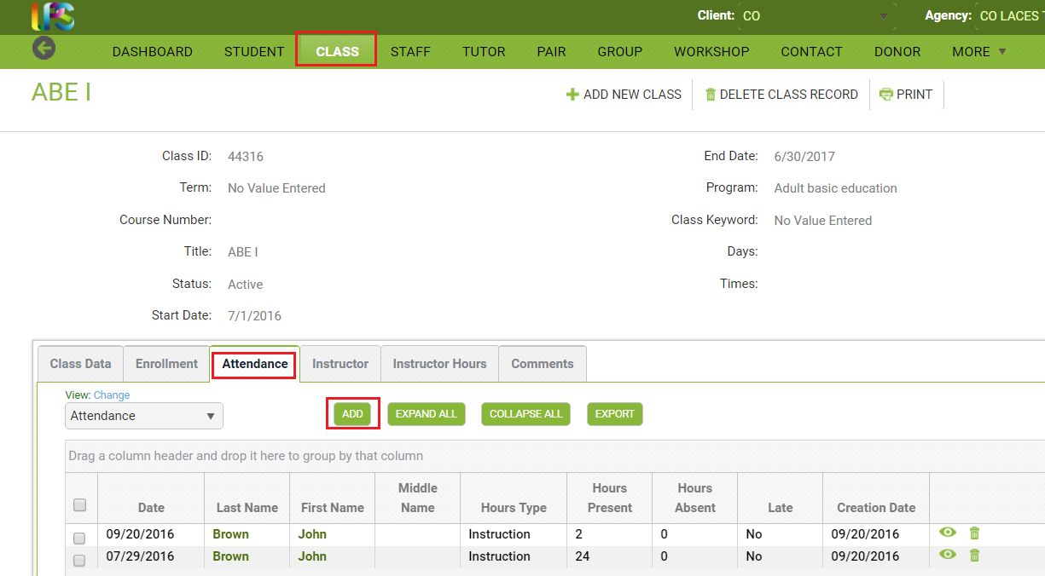
- The Add Hours data chooser will display.

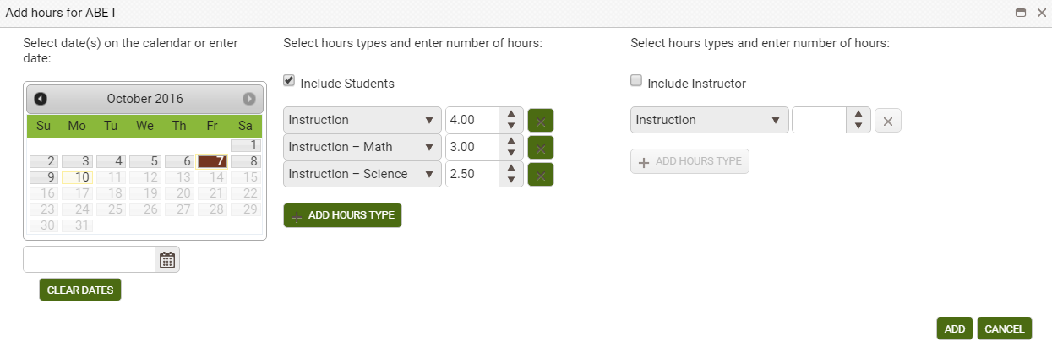

- You may make multiple date selections by clicking the dates on the calendar for which you would like to add hours, or enter a single date to add an aggregate hours total on a representative date. The selected date(s) must be within the start and end date of the class.

- Missouri’s policy is that hours can be entered once a month but you should use daily or weekly totals. Monthly totals can be added to catch the hours up from data migrated from the legacy system.

- Select the hours type for the students and enter the number of hours. Click the Add Hours Type button to add additional hours types and hours. You can enter multiple hours types.

- Check the ‘Include Instructor’ checkbox if you want to add hours for the instructor, then select the hours type and enter the number of hours.

- Hit Enter or Tab on your keyboard to activate the Add button, then click Add.

- A new window will open and display the information entered for the instructor (if selected) and the students:

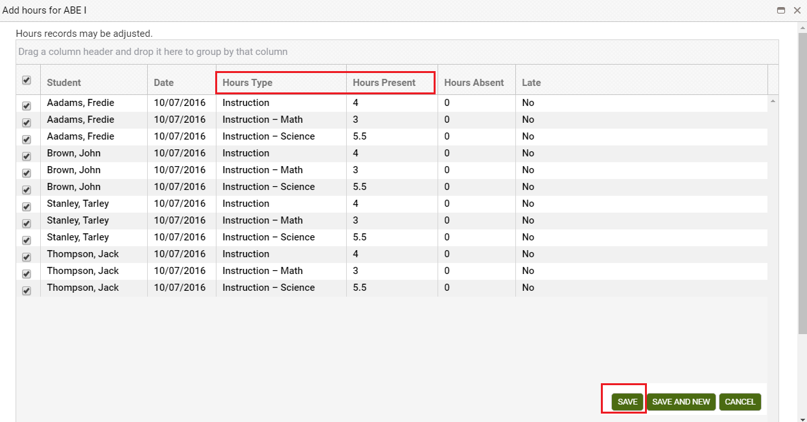
- The Hours Type, Hours Present, Hours Absent, and Late may be edited on each individual row. (If you don’t want to add a particular hours record, uncheck the record on the data chooser grid.)

- Click Save, or Save and New in the bottom right corner (be aware that, based on your screen resolution, you may need to scroll to see the Save options.)

Editing and Deleting Hours Records

Click the Edit icon to open an hours record for viewing or editing. This will open the hours record and allow you to make and save changes. Date, Hours Present, Hours Absent, and Late may be edited. When you are editing an hours record, you cannot navigate to a different tab or panel in the class detail record until the edits to the record are either saved or canceled.

The Delete icon allows you to delete hours records.

Date Range

Hours records may be searched by a specific fiscal year, or fiscal year and quarter by clicking the down arrow on the Date Range dropdown list. Once a selection has been made, the dates will display in the date fields. For example, selecting the fiscal year 2013-2014 will automatically display the date range 7/1/2013 to 6/30/2014 (start and end dates of the 2013-2014 fiscal year). Click Apply to search the hours records.

Even after a selection has been made from the list, a custom date range may be entered and applied. The date range will overwrite the previous selection. The last selection will remain in effect until Cancel is selected on the dropdown list.
Instructor Tab

The Instructor tab in the class tab is comprised of two sections; the instructor header and the instructor grid.

There are two views available on the view dropdown list in the instructor header:
- Instructor Info (default)
- Instructor Contact

Click on the down arrow in the dropdown menu to display and select one of the available views. The selected view will remain in place when using the record indicator at the top right to move forward or back to records within the Instructor tab.

Assign an Instructor to the Class

Only staff members may be assigned to teach a class. Staff may also be assigned to classes from the staff record.

- Click the Assign button.
- On the data chooser, select one or instructor records by checking the box on the row.
- Enter an Assign Date at the bottom left of the window, or click Show Selected to display the selected instructors. Show Selected allows you to enter a separate assignment date in the field on the grid if multiple instructors have been selected.
- Click Assign Instructor.

Class Instructor Hours Tab

The Hours tab is for entering hours that the instructor provided in the class. Instructor hours may also be entered at the Attendance tab. The Instructor Hours tab is comprised of two sections; the hours header and the hours grid. Hours Header

There is one available view on the View dropdown in the instructor hours header:
- Instructor/Hours

Add Hours

- Click the Add button.
- The Add Hours data chooser will display.
- You may make multiple date selections by clicking the dates on the calendar for which you would like to add hours. The start and end date of the class must be within the selected dates.
- Select the hours type and enter the number of hours then click Add.
- A row will display on the date chooser for the instructors assigned to the class.
- The Hours Type, Hours Present, Hours Absent, and Late may be edited on each individual row. (If you don’t want to add a particular hours record, uncheck the record on the data chooser grid.)
- To add additional hours types, click Add Hours Type and select from the dropdown list.
- Click Save, or Save and New.

Instructor Hours Grid

The hours grid displays instructor hours data. The default selection is all hours records, which display in chronological order beginning with most current. The hours grid contains Rows and Columns, which
work the same as all grids in LACES NexGen. Column headings on the enrollments grid can be dragged to the top row heading to class by column.

Editing and Deleting Hours Records

Click the Edit icon to open an hours record for viewing or editing. This will open the hours record and allow you to make and save changes. Date, Hours Present, Hours Absent, and Late may be edited. When you are editing hours data, you cannot navigate to a different tab or panel in the staff detail record until the edits to the hours data are either saved or canceled. The Delete icon allows you to delete hours records.

Class Comments Tab

The Comments panel allows comments related to the class record to be entered, edited, viewed or deleted.

To add a new comment, click the Add New Record button to open a new comments window. Other areas of the database will be inactivated until the record is saved or cancelled. After entering the comment information, click Save to save the record and return to the Comments panel, or Save and New to save the current record and get a new window to add an additional record, until clicking Save on the final record. Click Cancel to return to the Comments panel without saving the record.

To edit the record, click the Edit button to the right of the comment record and make edits, then Save. To delete, click the Delete button to the right of the comment record and verify that you wish to delete the record.

Staff

Staff members are typically paid instructors who provide instruction to adult students in classes or workshops, and teach workshops designed for professional development.

When you first sign in to LACES, the default view at the Staff tab is the Staff List view. Views can be modified, just as in the student view. The default filter is Current FY.

The Current FY filter displays staff members:
- With the overall status of active.
- Who have any status except active but had at least one hour in the fiscal year.

To display all staff records entered in your agency, click the X on the Current FY tile to remove the filter.

Shared views are predefined and are available on a dropdown list that displays at the top left of the staff grid. There are three shared views. The default view is Staff List, which displays columns on the grid that provide at-a-glance information about overall status, program and department. The view may be changed by selecting a different view from the list. This view will be in effect until you change it, even if you leave the staff grid temporarily by clicking on a different tab, and then return to the staff grid. For more information about views, go to View Manager. The staff toolbars are basically identical to the student toolbars, but with staff specific fields.

To add a new staff record, click the Add New Staff icon to display the staff intake form. The * indicates a required field and must be entered before the record may be saved. After entering the record, you may:
- Click Save to save the record and return to the staff grid.
- Click Save and New to save the record and get a blank intake form so you can add another staff record.
- Select a specific tab in the staff record from the dropdown list, and then click Save and Go to save the record and go to that tab within the new record.
- Cancel without saving.

Staff Required Fields

In addition to basic required fields, such as last name and first name, certain staff fields are required at intake because they must be entered for the staff to count correctly on NRS Table 7, or because the field values affect data in other fields.

Overall Status | The overall status field must be set at intake, typically set to Active. This field must be manually updated when there are changes in the staff overall status.
Employment Classification | Indicates the classification or function of the staff member. For agencies who report to the NRS, staff members must have a classification represented in Column B of NRS Table 7 in order to populate Table 7. The following Classifications will populate NRS Table 7:  - Local Aide/Paraprofessional  - Local Counselor  - Local Teacher  - Local Administrator  - Local Ancillary Services  - Local Tutor  - Local Supervisor
Employment Status | Indicates the staff employment status; Staff Title II Funded (staff who receive all of some portion of their funding from Title II), Staff Not Title II funded (other staff who may be paid from funds through a community college or local school board), Volunteer and Volunteer Tutor.
Full Time | Indicates that the staff member is a full-time (Yes) or part-time (No) employee of your agency
Start Date | The date the staff member began employment at the agency. Class or workshop assignment dates must be on or after this date.
Years of Teaching Experience in Adult Education | Required number of years of teaching experience in adult education. Required for all staff members, including those not designated as a local teacher. 0 is an acceptable option; the field cannot be left blank. This field should include only years of teaching experience in adult education; it should not include teaching experience in other types of education or administrative experience in adult education. This field should be manually updated every fiscal year if the teacher has increased their years of experience in adult education.

Staff Detail Record

The staff header displays key information about the staff in the record that is currently open, and shows at the top of each staff detail tab. The header itself cannot be edited, but the fields that display in the header may be edited elsewhere in the staff detail record, or populate automatically. The staff header will update to display any changes.

The staff detail toolbar allows you to:
- Add a new staff record
- Delete the staff record currently open

The Record Indicator at the top right of the staff header shows what record you in out of a selection of records, and allows you to move forward or back either by record, or to the beginning or end of the staff in the list. When you use the arrows to move forward or back, the record will be at the same panel and/or tab you were previously in. A variety of information may be entered in the staff detail record at the individual tabs and panels. Not all of the data you can track will be useful to every agency. The best approach is to look at any required reports, since many reports require specific data that is contained within a small number of fields. You should also decide what additional data you want or need to track for daily program management.

The Staff record contains the following tabs:
- Staff Data
- Assignments
- Hours
- Workshop Enrollments
- Workshop Attendance
- Professional Development
- Demographics
- History

Staff Data Tab

The Staff Data tab contains four individual panels that allow you to track staff assignments, workshop enrollments and attendance, and other information that may be tracked in your agency for daily program management. The Staff Data panels are:
- Key Info
- Credentials
- Materials
- Comments

Key Info Panel

The Key Info panel contains key data regarding the staff record, and is primarily populated based on information entered on the Intake Form. Fields with a red asterisk * are required fields, and edits to the Key Info panel will not be saved if any required fields are left blank through editing or deletion.

Editing within the panel can be done by opening the panel and typing directly into the field(s) you wish to edit. While making changes, the header and other tabs will become inactive until the changes have been saved or cancelled within the panel you are currently accessing.

Credentials

The Credentials panel allows credential or certification information related to the staff record to be entered, edited, viewed or deleted. Information entered into the Credentials panel will affect NRS Table 7. A staff member may have more than one credential type, and a record for each type should be entered. Both the Type and Date Earned are required for the information to correctly populate Table 7, which is a mandatory table if you do NRS reporting. If the staff member has additional certifications or credentials outside of the four tracked on Table 7, you should enter those based on your state or agency policy.

To add a new credential, click the Add New Record button to open a new credential window. Other areas of the database will be inactivated until the record is saved or cancelled. After entering the credential information, click Save to save the record and return to the Credential panel, or Save and New to save the current record and get a new window to add an additional record, until clicking Save on the final record. Click Cancel to return to the credential panel without saving the record. To edit, click the Edit icon to the right of the credential record and make edits, then Save. To delete, click the Delete icon to the right of the credential record and verify that you wish to delete the record.

Materials Panel

The Material panel allows material records checked out to the staff to be viewed. Material information populates automatically from the Materials tab and cannot be edited or deleted from the staff record. New materials cannot be added from the staff record or checked out/given away from the staff record; these actions must occur in the Materials record itself. Any additions or edits to materials data must be made from the Materials tab record.

Comments Panel

The Comments panel allows comments related to the staff record to be entered, edited, viewed or deleted.

To add a new comment, click the Add New Record button to open a new comments window. Other areas of the database will be inactivated until the record is saved or cancelled. After entering the comment information, click Save to save the record and return to the Comments panel, or Save and New to save the current record and get a new window to add an additional record, until clicking Save on the final record. Click Cancel to return to the Comments panel without saving the record. To edit the record, click the Edit button to the right of the comment record and make edits, then Save. To delete, click the Delete button to the right of the comment record and verify that you wish to delete the record.

Staff Assignments Tab

There are two assignment settings for staff – class and workshop. Classes and workshops must be created at their respective tabs prior to assigning the staff. The Assignments tab is comprised of two sections - the assignments header and the assignments grid.

Assignments Header

Views: There are two available views on the View dropdown list in the assignment header: •
- Assignments (default)
- Meeting Info
Click on the down arrow in the dropdown menu to display and select one of the available views. The selected view will remain in place when using the record indicator at the top right to move forward or back to records within the Enrollments tab.

Assign a Staff to a Class or Workshop

Assigning a staff is pretty much exactly like enrolling a student in a class. To assign a staff to a class or workshop:
- Click the arrow on the dropdown list, and select either Assign to Class or Assign to Workshop.
- On the data chooser, select one or more class or workshop records by checking the box on the row. Only active classes or workshops that the staff is not currently assigned to will display on the data chooser.
- Enter an Assign Date at the bottom left of the window, or click Show Selected to display the selected classes or workshops. Show Selected allows you to enter a separate assignment date in the field on the grid if multiple classes or workshops have been selected.
- Click Assign.

Assignments Grid

The assignments grid displays the staff assignment data. The assignment grid contains Rows and Columns, which work the same as all grids in LACES NexGen. Column headings on the assignments grid can be dragged to the top row heading to group by column.

Editing and Deleting Assignments

Click the Edit icon to open an assignment record for viewing or editing. This will open the assignment record and allow you to make and save changes. The fields that you are allowed to edit vary with the type of assignment. When you are editing assignment data, you cannot navigate to a different tab or panel in the staff detail record until the edits to the assignment data are either saved or canceled. To show that the staff member is inactive in a class, edit the assignment record and select Inactive from the Status dropdown list. Inactive indicates that the staff completed the assignment, or left the assignment. The assign status in a class or workshop does not automatically affect the overall status of the staff. This must be changed manually. The Delete icon allows you to delete existing assignments. Before an assignment record can be deleted, all associated hours must be deleted first. Be sure to review and update the overall status of your staff members at the end of each fiscal year, especially if the staff member is leaving your program. The overall status of staff members who are not continuing should be changed to Left.

Staff Hours Tab

The Hours tab is for entering hours that the staff member provided in a class or workshop assignment, typically instructional hours. The Hours tab is comprised of two sections; the hours header and the hours grid. Hours Header There is one available view on the View dropdown in the hours header: Staff Hours

Add Hours

To add hours to the staff record:
- Click the Add button.
- The Add Hours data chooser will display.
- You may make multiple date selections by clicking the dates on the calendar for which you would like to add hours.
- When the start and end date of an assignment is within the selected dates, the assignment type will display.
- Check the assignment you wish to add hours for.
- Select the hours type and enter the number of hours then click Add.
- A row will display for each date selected for the assignment type.
- The Hours Type, Hours Present, Hours Absent, and Late may be edited on each individual row. (If you don’t want to add a particular hours record, uncheck the record on the data chooser grid.)
- To add additional hours types, click Add Hours Type and select from the dropdown list.
- Click Save, or Save and New.

Unlinked Hours

Unlinked Hours are not associated with an instructional setting, and should be entered only when there is a valid reason to do so in the staff record.

Hours Grid

The hours grid displays hours data. The default selection is all hours records, which display in chronological order beginning with most current. The hours grid contains Rows and Columns, which work the same as all grids in LACES NexGen. Column headings on the enrollments grid can be dragged to the top row heading to group by column.

Editing and Deleting Hours Records

Click the Edit icon to open an hours record for viewing or editing. This will open the hours record and allow you to make and save changes. Date, Hours Present, Hours Absent, and Late may be edited. When you are editing hours data, you cannot navigate to a different tab or panel in the staff detail record until the edits to the hours data are either saved or canceled. The Delete icon allows you to delete hours records.

Staff Workshop Enrollments Tab

The Workshop Enrollments tab in the staff record allows you to track a staff member’s enrollments in workshops. Workshops are created at the Workshop tab, and may be created for professional development or workshops that relate to staff continuing education.

Workshops Enrollments Header

There are two available views on the View dropdown list in the workshop enrollment header:
- Enrollments (default)
- Meeting Info

Click on the down arrow in the dropdown menu to display and select one of the available views. The selected view will remain in place when using the record indicator at the top right to move forward or back to records within the Enrollments tab.

Enroll a Staff in a Workshop

To enroll a staff in a workshop (basically just like enrolling a student in a class):
- Click the Enroll button.
- On the data chooser, select one or more workshops by checking the box on the row. Only active workshops that the staff is not currently enrolled in will display on the data chooser.
- Enter an Enroll Date at the bottom left of the window, or click Show Selected to display the selected workshops. Show Selected allows you to enter a separate enrollment date in the field on the grid if multiple workshops have been selected.
- Click Enroll.

Staff may not be enrolled in a New Tutor Training Workshop.

Workshop Enrollments Grid

The workshop enrollments grid displays the staff workshop enrollment data. The workshop enrollments grid contains Rows and Columns, which work the same as all grids in LACES NexGen. Column headings on the assignments grid can be dragged to the top row heading to group by column.

Editing and Deleting Workshop Enrollments

Click the Edit icon to open a workshop enrollment record for viewing or editing. This will open the workshop enrollment record and allow you to make and save changes. When you are editing workshop enrollment data, you cannot navigate to a different tab or panel in the staff detail record until the edits to the record are either saved or canceled. The Delete icon allows you to delete existing workshop enrollments. Before a workshop enrollment record can be deleted, all associated hours must be deleted first.

Staff Professional Development Tab

The Professional Development tab is for tracking staff attendance at seminars, conferences, or other training or professional development not associated with a pre-created workshop in LACES NexGen.

Click Add New Record and enter any professional development earned by the staff member by name, date, and number of hours, and Save.

Dashboard

The Dashboard allows you to visually display data in the forms of ‘widgets’ that are used to help you evaluate the success of your agency in reaching current fiscal year state targets and NRS negotiated targets for enrollment and post testing. The dashboard widgets also allow you to ‘drill down’ to the list of students who need post tested or are not receiving instructional hours. Information for the widgets is pulled from raw data – not FY summaries – using a base set of queries.
The dashboard widgets do not run on selection, but run on current fiscal year students with one or more hour of instruction.
To display the Dashboard and select the widgets you wish to display, click the Dashboard menu area link.
When you click the Dashboard menu area link but no widgets have been selected, you will see the Widget Library list on the left side of the window, and a ‘welcome’ screen that gives you instructions for setting a widget. Once a widget has been selected the ‘welcome’ screen will no longer display.
Adding, editing, and removing a dashboard widget:
- Click the Widget Library link.
- Select a title from the widget library.
- Widgets that require a parameter will display with the setting side first.
- Once you have entered the parameter, click Save to display the widget. You may add the widget multiple times with different parameters.
- To edit the parameter, click the gear icon on the widget.
- To remove a widget, click the X in the upper right corner of the widget.

Currently, only the first series may be clicked on to drill down into the list of students who meet the dashboard criteria, but we will be implementing multi-series drill downs in a future release.

A series on a graph may be temporarily removed by clicking the legend on the dashboard widget graph. Clicking the legend again will add the series back to the graph. For example, the dashboard widget ‘Post Test Percentage Rate by EFL Current FY’ displays a series for ‘% Students Post Tested - State Average.’ Click the label in the heading to temporarily remove that series. Click the label again to display the series.
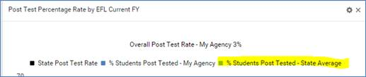
Once a dashboard widget displays, you may click a bar on the graph to drilldown to the list of students. A tile will display indicating the widget used to display the list. This tile cannot be edited.

The Dashboard options contain the following:

Enrollment Dashboard Widgets

Enrolled Students with No Instructional Hours in [X] Days – by Current EFL

Displays students, by current EFL, with the overall status of enrolled but with no instructional hours in the past [x] days, starting from yesterday’s date. Hours records with 0 hours are counted as no instructional hours.

Students who meet the widget criteria will display by their current EFL – not the entry EFL.

Students Enrolled – Actual vs. Target

Target
•Displays the state enrollment target. If no target has been set, this will be 0.

Enrolled to Date
•Students who have at least one instructional hour in the current FY, regardless of overall status.
•Includes instructional hours from classes, groups, pairs, and unlinked hours.

NRS fundable to date
•Students who are 16+ years of age at intake, and
•Have 12+ instructional hours from class, group, pair, or unlinked hours, regardless of overall status, and
•Assessed at least once in the current FY.

Non-NRS fundable students
•At least one instructional hour in the current FY.
•No assessment OR less than 12 hours in the current FY, regardless of overall status.

The total number of students on the second and third bars will equal the number of students on the first bar.

Assessment Dashboard Widgets

Level Completion by EFL

% - Negotiated Target
•The level completion target negotiated between the state and the NRS. (Please refer to your state assessment policy.)

% Level Gain – My Agency
•The percentage of current FY NRS fundable students who made a level gain by EFL based on the state negotiated target for each level.
•Drill down to the list of students.

For example:
The state’s negotiated level gain target for entry EFL Low Adult Secondary is 37%. The number of students whose entry level was Low Adult Secondary is 112. Forty-three of those students made a level gain. The percentage of students making a level gain is 39% (rounded to the nearest percent). The negotiated target for entry level Low Adult Secondary has been exceeded.

The target will be 0 when a negotiated target has not been set.

% Level Gain - State Average
•The average percentage gain for a particular level for the entire state. This allows you to see how your agency compares with the state average.
•No drill down.

Post Test Eligible by EFL

Eligible for post test
•Students who have been pre-tested, and have earned enough instructional hours by assessment instrument to be post tested, and
•Students who have been post tested with no level gain, and have earned enough instructional hours by assessment instrument to be post tested again.
•Drill down to the list of students.

Eligible for post test/no level gain in current FY
•Students who have been post tested with no level gain, and have earned enough instructional hours by assessment instrument to be post tested again.
•This bar is a subset of the first bar; students who are included on this bar are also included on the first bar.
•Drill down on this bar will be available in a future beta.

# students required to be post tested to meet state target
•The number of students with a particular entry level who need to be post tested to meet the state target.
a. For example, 13 students have the entry level of ABE Beginning. If your state posttest target is 60%, then a total of 8 students out of the 13 will need to be post tested to meet the target. Since 4 students have already been post tested, your agency currently needs an additional 4 students to be post tested.
•No drill down.

Note that the number may change throughout the current FY as new students enter your program and are pre-tested.
The state posttest target is set by the state, and is typically an overall posttest target – not a posttest target for each individual EFL.

Post Test Eligible by EFL Within [X] Instructional Hours

Eligible for posttest within X hours
•Students who have been pre-tested, and are within a specific number of hours by assessment instrument to be post tested.
a. For example, 40 hours are typically required between TABE assessments. Students who have 30 – 39 instructional hours will display when the parameter is set for ‘within 10 instructional hours.’ (Note that at 40 hours the student will display on the widget ‘Post Test Eligible by EFL.’)
•Drill down to the list of students.

Eligible for posttest within X hours/no level gain in current FY

•Students who have been post tested with no level gain, and are within a specific number of hours by assessment instrument to be post tested again.
•This bar is a subset of the first bar; students who are included on this bar are also included on the first bar.
•Drill down on this bar will be available in a future beta.

Note that the number may change throughout the current FY as new students enter your program and are pre-tested.

Post Test Percentage Rate by EFL Current FY

Overall Post Test Rate – My Agency [X] %
•The average percentage of students who have been post tested across all EFLs. The percentage is based on the number of students with 12+ instructional hours who have been pre-tested, divided by the number of students with at least 12 instructional hours who have been post tested at least once in the current FY.
•Entry levels High Adult Secondary and Completed Advanced ESL are not included in the calculation.

State Post Test Rate
•The posttest target set by your state.

% Students Post Tested – My Agency
•The percentage of students post tested by EFL. Only students with at least 12 instructional hours in the current FY are included.
•Drill down to the list of students.

% Students Post Tested – State Average
•Displays the average posttest percentage for a particular level for the entire state. This allows you to see how your agency compares with the state average.
•No drill down.

Post Test Percentage Rate Over the Past Two Fiscal Years

State Post Test Rate
•The posttest target set by your state.

Overall percentage of post tested students this FY – My Agency
•First bar: percentage of students post tested in the current FY in your agency. Note that this percentage will be the same as the ‘Overall Post Test Rate – My Agency’ in the widget ‘Post Test Percentage Rate by EFL Current FY.’ Drill down to the list of students.
•Second Bar: percentage of students post tested in the previous FY. This percentage is based on the number of instructional hours and the entry level in the student’s previous FY summary. Drill down on this bar will be available in a future beta.

Overall percentage of post tested students this FY: State
•Third bar: average posttest percentage of students post tested in the current FY for the entire state. No drill down.
•Fourth bar: average posttest percentage of students post tested for the previous FY for the entire state. No drill down.
Post Test Percentage Rate by EFL Past Two Fiscal Years

Average Post Test Rate – Current FY: [X]%
•Average percentage of students who have been post tested across all EFLs. The percentage is based on the number of students with 12+ instructional hours who have been pre-tested, divided by the number of students with at least 12 instructional hours who have been post tested at least once in the current FY.
•Entry levels High Adult Secondary and Completed Advanced ESL are not included in the calculation.
•This percentage will match the ‘Overall Post Test Rate – My Agency’ percentage on the widget ‘Post Test Percentage Rate by EFL Current FY.’

Average Post Test Rate – Previous FY: [X]%
•Percentage of students post tested in the previous FY. This percentage is based on the number of instructional hours and the entry level in the student’s previous FY summary.
•This percentage will match the ‘Overall percentage of post tested students last FY’ on the widget ‘Post Test Percentage Rate Over the Past Two Fiscal Years.’

% Students Post Tested Current FY
•Percentage of students post tested by EFL in the current FY in your agency.
•These percentages by EFL will be the same as ‘% Students Post Tested – My Agency’ in the widget ‘Post Test Percentage Rate by EFL Current FY.’

% Students Post Tested Previous FY
•Percentage of students post tested by EFL in the previous FY. This percentage is based on the number of instructional hours and the entry level in the student’s previous FY summary.
•The percentages by EFL will be the same as the ‘% Students Post Tested – My Agency’ in the widget ‘Post Test Percentage Rate by EFL Current FY.’

Scheduled Enrollment
- Using the same student from the example above, the last activity in his first PoP was 9/28/2016. There is no date in the Scheduled Service Start Date field.
- The student was, however, enrolled in a class that is scheduled to begin on 5/1/2017.
- If the student's enrollment date in the class is within 90 days of 9/28/2017, he will not be considered left. In this example, his enrollment date was 10/15/2016, which is within 90 days of his left date of 9/28/2016.
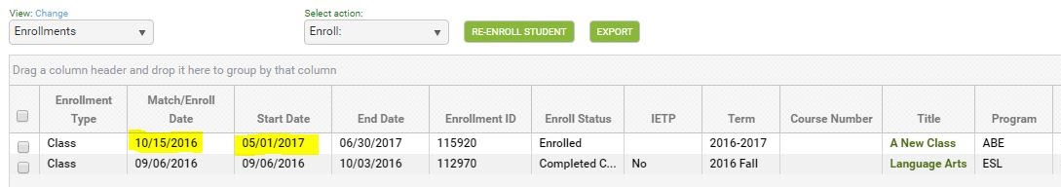

Q: When will Jim be considered left in the PoP?
A: If Jim does not earn instructional hours within 90 days of the class start date, his original left date of 9/28/2016 will re-populate in the PoP summary record. This may affect follow up for his outcome measures.
You may delete Jim's enrollment record in the class if he does not return. When the enrollment is deleted, the left date will repopulate in the PoP summary record.
It is important to utilize Scheduled Services only as directed by your state policy. When a student has a scheduled service, they are not left unless the scheduled services requirements have not been met. This is important for employment, obtain secondary credential, and entered postsecondary follow up. Make sure you are following your state policy regarding scheduled services.

Printing/Saving the NRS Tables
.
1. Click the <Searches link at the student area.
2. Expand the NRS category.
3. Select one of the new tables - NRS tables 1, 2, 3, or 6.
4. Select NRS FY current on the drop-down list at the 'Select Reporting System' field.
5. The new report will display. From here, you may print the report by clicking the Print icon at the top right.
6. Click any of the cells to drill down to the list of students populating the cell.
The correct table format will display once you select the Reporting System. For example, if you select NRS FY 15-16, the table format appropriate for that reporting year will display. If you select NRS FY 16-17, the new table for that reporting year will display.

Q: How do I save the new table?
A: Most browsers have a built-in PDF printer that allows you to 'print' and save any file to PDF.

To print an NRS table to PDF:
  - First, follow the steps above to display an NRS table using the <Searches link.
  - Click the printer icon on the window.
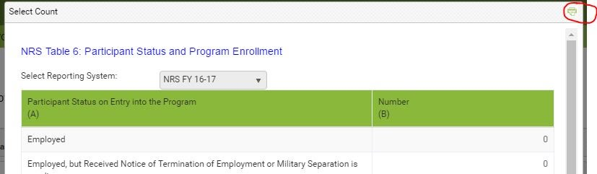
  - The 'PrintFriendly' window will display
  - Click the Print button at the bottom of the window.
  - The printer dialog window will display. Depending on your browser and/or printer, you will see:
- Chrome: Destination/Change
- Firefox: Name field with a drop-down list
- IE: 'Select Printer' area

6. Depending on your browser/printer, you will then:
- Chrome: Click the Change button and select 'Save as PDF'
- Firefox: Select 'Microsoft Print to PDF.'
- IE: Select 'Microsoft Print to PDF.

7. Depending on your browser and/or printer, you will then:
- Chrome: Click the Save button
- Firefox: Click the OK button
- IE: Click the Print button

8. Select a location on your computer drive, enter a name for the file, and click Save.
9. The table is now saved as a file on your computer. You can locate the file, open, then print.

IMPORTANT NOTE: Be sure to look at the print dialog box the next time you print a file. You may have to change the destination or printer, back to your default printer name.

