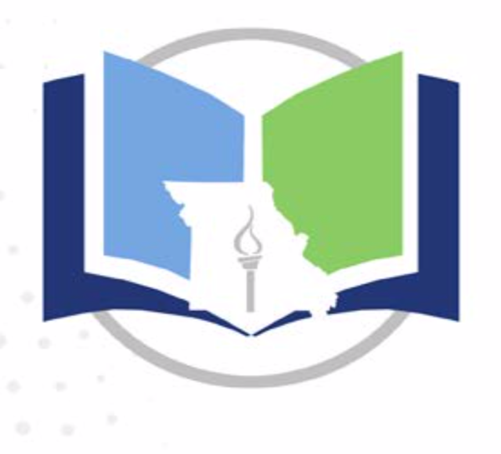
The Missouri State Literacy Plan
“Literacy is a bridge from misery to hope. It is a tool for daily life in modern society. It is a bulwark against poverty, and a building block of development ... for everyone, everywhere, literacy is, along with education in general, a basic human right ... Literacy is, finally, the road to human progress and the means through which every man, woman and child can realize his or her full potential.”
Kofi Annan,
Winner – the Nobel Peace Prize – 2001

“Literacy is the ability to identify, understand, interpret, create, compute and communicate using visual, audible and digital materials across disciplines and in any context. The ability to read, write and communicate connects people to one another and empowers them to achieve things they never thought possible. Communication and connection are the basis of who we are and how we live together and interact with the world” (International Literacy Association, 2018).

Literacy is essential to success; literacy is the key to opportunity and a necessary skill for all Missouri students. The Missouri State Literacy Plan embodies the ever-increasing breadth and depth of what it means to be literate and reflects the reality of twenty-first-century change in guiding Missouri students’ learning. It is because of these changes in the complexity and wide range of literacies that DESE’s Comprehensive Literacy Plan has been revised, providing stakeholders with updated research and pedagogy.

Purpose
In Missouri, local school boards make curriculum decisions tailored to the needs of their students and communities. The state literacy plan is not a mandated document for districts but rather a collection of resources, ideas and themes that might be considered in building a local, comprehensive literacy plan.
The K-12 Missouri State Literacy Plan is an evidence-based resource for administrators and teachers with useful information for parents and caregivers all along the K-12 continuum. It provides information on integrating literacy instruction with the state standards and current knowledge about literacy development. It offers ideas and links to resources to promote literacy, provides clear guidance on the components of a comprehensive literacy system, incorporates evidence-based practices necessary to achieve long-term success for our students and guides districts in developing a comprehensive literacy plan. The state literacy plan encompasses all aspects of reading, writing, listening and speaking using effective methods, strategies and supports for the development of the following broad range of skills and knowledge necessary to be truly literate:
• The integration of listening, speaking, reading, writing and critical thinking across all media types
• The knowledge to recognize and use language appropriate to a situation
• The ability to think, create, question, analyze, solve problems and reflect

Components of the State Literacy Plan
The most current research on literacy has been used to develop the state literacy plan which includes the following components. Each component, necessary for the literacy development of all children educated in the Missouri school system, is interwoven to create a full picture of literacy education in Missouri. This plan explains the key components and encourages a systemic and synchronized approach that includes state, district and community involvement.

Leadership and Sustainability
Leadership is a key component in any literacy initiative. Several stakeholders may be involved within this component, including state leaders (DESE), district and building administration, and instructional staff working collaboratively to ensure a common set of values and beliefs guide literacy instruction for all students.

Standards-based Curriculum
The foundation of any literacy plan, whether at the state, district, building or classroom level, is a standards-based curriculum. A standards-based curriculum provides the content and expectations for all students to be successful in college, other post-secondary training and careers.
A strong, standards-based curriculum ensures students, teachers, administrators and parents of a rigorous and intentional curriculum aligned to the Missouri Learning Standards to promote student learning and success in reading, writing, speaking and listening across all content areas.
Intentional Instruction, Intervention and Enrichment
Effective instruction focuses on all learner groups, including age- and grade-level groups, high school, and special populations such as special education, gifted, dyslexic and English learners. It is important to recognize that certain instructional strategies, structures and methodologies are more applicable and appropriate to specific learners. All literacy learners need to be engaged in speaking, listening, reading and writing for authentic purposes many times throughout the school day. The four key resources at the heart of high-quality instruction are
- strong instruction that lets students do most of the thinking in the lesson,
- consistent opportunities to work on grade-level appropriate assignments,
- a sense by students of deep engagement in what they’re learning and
- teachers who hold high expectations for students and truly believe they can meet grade-level standards.
Assessment
Assessing literacy is a complex task. Assessments should reflect the multiple dimensions of reading and writing and the various purposes for assessment, as well as the diversity of the students being assessed. All literacy assessments are best used in combination with research-based effective practices, as well as teacher observation to monitor individual student progress.

Because of the variety of assessment options available to districts and teachers—formal/informal, formative/ summative, teacher created/commercial—it is essential to evaluate whether the particular assessments being used are aligned to the intended purpose and provide results that inform teaching and learning (Yale Center for Teaching and Learning, 2018). The best way to evaluate the assessment system is to complete assessment audits at the district, building and classroom levels. An assessment audit provides teachers and districts with an opportunity to look at assessments with a critical lens in order to ensure they are useful and timely and provide the intended information.

Partnerships
No single education stakeholder group can do the job ahead . . . it will take all of us—teachers, education support professionals, principals, superintendents, school board members, parents, families, government leaders, business leaders, faith-based leaders” (National Education Association, 2011).
Partnerships among schools and businesses, community organizations, and other educational entities are essential components in fostering a culture of literacy. Each community offers unique opportunities for relationships and collaboration. The strength of any literacy program is reflected in the school district’s ability to seek and build the affiliations available.
Using the K-12 Missouri State Literacy Plan as a guide, it is the hope that individual school districts will design their own literacy plan to meet the needs of their students.
The Department of Elementary and Secondary Education does not discriminate on the basis of race, color, religion, gender, gender identity, sexual orientation, national origin, age, veteran status, mental or physical disability, or any other basis prohibited by statute in its programs and activities. Inquiries related to department programs and to the location of services, activities, and facilities that are accessible by persons with disabilities may be directed to the Jefferson State Office Building, Director of Civil Rights Compliance and MOA Coordinator (Title VI/Title VII/Title IX/504/ADA/ADAAA/Age Act/GINA/USDA Title VI), 5th Floor, 205 Jefferson Street, P.O. Box 480, Jefferson City, MO 65102-0480; telephone number 573-526-4757 or TTY 800-735-2966; email civilrights@dese.mo.gov

