Breaking Traditions Employer Nomination 2021

The Missouri Department of Elementary and Secondary Education recognizes employers who have supported Missouri’s nontraditional employees and/or students through Breaking Traditions. The employer winner will be honored publicly this spring along with the students who win the state-level Breaking Traditions Award.
Retain a paper or digital copy at your school. More information about the program and ceremony can be found at: https://dese.mo.gov/college-career-readiness/career-education/breaking-traditions-awards

The Employer Award will:
● Foster partnerships between your school or college and local non-traditional employers.
● Reinforce the good practices of companies that hire and retain non-traditional employees.
● Create community awareness about issues affecting non-traditional employees and students.
● Encourage other employers to broaden their views about the role of men and women in the workforce.
Criteria for Selection of Employer Nominees:
There are many ways companies and employers support non-traditional employees or students. A supportive employer might:
● Offer mentoring, internship or job-shadowing opportunities for non-traditional employees or students.
● Allow non-traditional employees to serve as speakers or advisory council members.
● Actively recruit non-traditional employees.
● Provide services to help retain non-traditional employees.
● Have written, effective and enforceable sexual harassment policies.
● Provide equitable advancement opportunities.
● Pay equitable wages to non-traditional employees.
● Provide adequate facilities and equipment for non-traditional employees.
● Offer education and training opportunities for non-traditional employees, including on-the-job training and tuition reimbursement.

1. Employer/Company Information:
______________________________________ Name of Company
______________________________________ Company Address
______________________________________ Company Phone Number
______________________________________ City & State Zip Code
______________________________________ Email

2. Representative attending Award Ceremony if employer/company wins.

______________________________________ Company Representative Name

3. Nominator Information (You)
______________________________________ Name
______________________________________ School or College
______________________________________ Address
______________________________________ Phone Number
______________________________________ City & State Zip Code
______________________________________ Email

4. Designated Contact Person Information
______________________________________ Name
______________________________________ School or College
______________________________________ Address
______________________________________ Phone Number
______________________________________ City & State Zip Code
______________________________________ Email

5. Briefly describe the school's/college's relationship with the employer.

6. How has the employer shown commitment to providing internships for students?

7. How has the employer shown commitment to recruiting and retaining nontraditional employees?

8. You will be notified to upload a picture of the Employer to be used in the Breaking Traditions Promotion if they are selected as the winner.

9. Choose your RPDC region based on the map

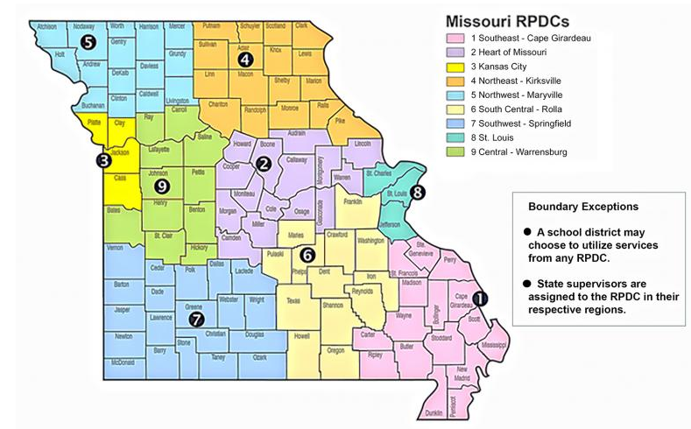

Choose your RPDC region based on the map
- 1
- 2
- 3
- 4
- 5
- 6
- 7
- 8
- 9

