- The correct answer is:

C. 2 pounds

- The correct answer is:

D. Red and green

- Sample Correct Response: Answer: 156,000 or 156000 tickets Solution (not required in response):

Correct - Answer of 156,000

Incorrect - Incorrect response

- The correct answer is:

C. 568

- The correct answer is:

D. Each OUTPUT number is two times the INPUT number.

- The correct answer is:

B. Each shape is a quadrilateral.

- Sample Correct Response:

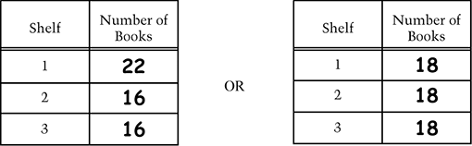

The following is a complete list of acceptable responses. The three numbers in each response may appear in any order.

16, 16, 22
16, 17, 21
16, 18, 20
16, 19, 19
17, 17, 20
17, 18, 19
18, 18, 18

Correct - Correctly completed table

Incorrect - Incorrect response

- Sample Correct Response: First part Shortest: Paul Second part Tallest: Ned

Correct - Both answers correct

Partial 1 - First answer correct only

Partial 2 - Second answer correct only

Incorrect - Incorrect response

- The correct answer is:

A. Midnight

- The correct answer is:

D. Trapezoid

- Sample Correct Response:

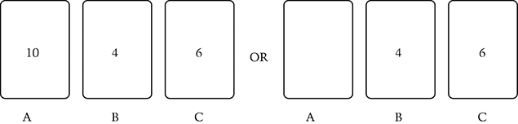

Correct 1 - A = 10, B = 4, and C = 6

Correct 2 - A blank, B = 4, and C = 6

Partial 1 - A = 10, B = 6, C = 4

Partial 2 - A = 6, B = 10, C = 4

Partial 3 - A = 6, B = 4, C = 10

Partial 4 - A = 4, B = 10, C = 6

Incorrect - Incorrect response

- The correct answer is:

A. 10 to 12

- Sample Correct Response: Correct oval: No

Explanation:
If Nick eats of the pizza, thats the same as . If he gives to Sam, there is only left for Joe.
OR
If he gives away , hell have only for himself, and .
OR
Student indicates who got which pieces of pizza and shows that there is not enough.

Correct - Correct oval filled in with acceptable explanation

Partial 1 - Neither oval filled in with acceptable explanation

Partial 2 - Correct oval filled in with incomplete explanation such as indicating that is the same as or 4 pieces of the pizza or indicating that

Partial 3 - Incorrect oval filled in with an explanation that indicates student misinterpreted question as either of the remaining pizza or of the remaining pizza

Incorrect 1 - Correct oval filled in with no explanation or an incorrect explanation

Incorrect 2 - Other incorrect responses

- The correct answer is:

D. Dunbar

- Sample Correct Response: Answer: 12 pencils

Explanation:

(or )
(or )
OR
If 3 blue boxes equal 1 red box, then 6 blue boxes equal 2 red boxes.

Satisfactory 1 - Answer of 12 with correct explanation

Satisfactory 2 - Answer of 12 with adequate explanation that may include imprecise use of language or notation (e.g., run on = as in )

Partial 1 - Answer of 12 with no explanation, incomplete explanation, or explanation of I used the calculator

Partial 2 - Correct process is shown (may contain one or more computational errors)

Minimal 1 - Answer of 18, 24, or 36 with supporting explanation

Minimal 2 - Answer of 12 with incorrect explanation

Incorrect 1 - Answer of 18, 24, or 36 with no explanation, incomplete or incorrect explanation, or explanation of I used the calculator

Incorrect 2 - Other incorrect responses

