- Item Detail for Question 1
No student responses are available for this question.

- Item Detail for Question 2
No student responses are available for this question.

- Item Detail for Question 3

Correct - Student Response
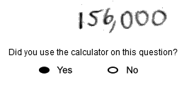

-------------------------------------------------------------------------------------------------------------------------------------------------------------------------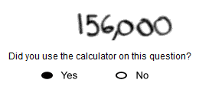

-------------------------------------------------------------------------------------------------------------------------------------------------------------------------These correct responses both show the correct total number of tickets.

Incorrect - Student Response
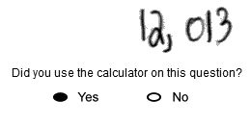

-------------------------------------------------------------------------------------------------------------------------------------------------------------------------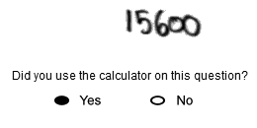

-------------------------------------------------------------------------------------------------------------------------------------------------------------------------These incorrect responses show an incorrect total number of tickets.

- Item Detail for Question 4
No student responses are available for this question.

- Item Detail for Question 5
No student responses are available for this question.

- Item Detail for Question 6
No student responses are available for this question.

- Item Detail for Question 7
Correct - Student Response
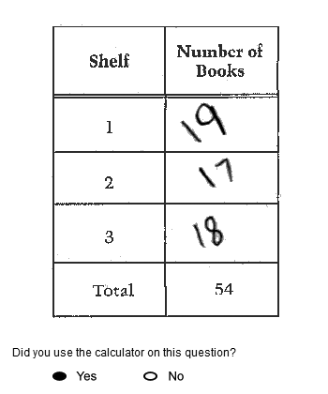

-------------------------------------------------------------------------------------------------------------------------------------------------------------------------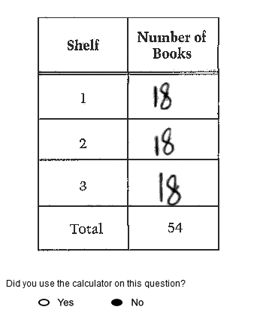

-------------------------------------------------------------------------------------------------------------------------------------------------------------------------These correct responses contain a correct number of books that could be on each shelf, which satisfies all the constraints given in the prompt.

Incorrect - Student Response
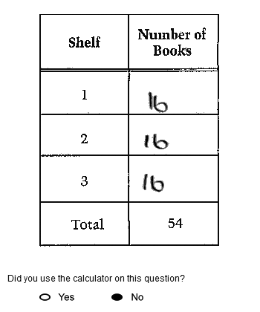

-------------------------------------------------------------------------------------------------------------------------------------------------------------------------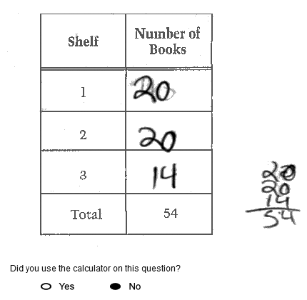

-------------------------------------------------------------------------------------------------------------------------------------------------------------------------The incorrect response on the top shows the number 16 for each shelf, which does not satisfy all the constraints given in the prompt since this total would be 48. The incorrect response on the bottom does not satisfy all the constraints given in the prompt since one of the rows contains fewer than 16 books.

- Item Detail for Question 8

Correct - Student Response

-------------------------------------------------------------------------------------------------------------------------------------------------------------------------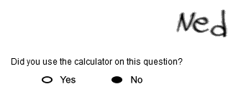

-------------------------------------------------------------------------------------------------------------------------------------------------------------------------

-------------------------------------------------------------------------------------------------------------------------------------------------------------------------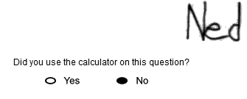

-------------------------------------------------------------------------------------------------------------------------------------------------------------------------These correct responses correctly identify both the shortest boy and the tallest boy.

Partial 1 - Student Response

-------------------------------------------------------------------------------------------------------------------------------------------------------------------------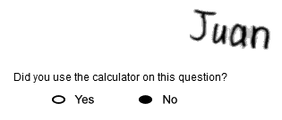

-------------------------------------------------------------------------------------------------------------------------------------------------------------------------

-------------------------------------------------------------------------------------------------------------------------------------------------------------------------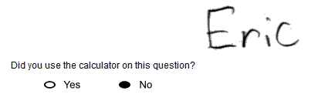

-------------------------------------------------------------------------------------------------------------------------------------------------------------------------These partially correct responses correctly identify the shortest boy only.

Partial 2 - Student Response

-------------------------------------------------------------------------------------------------------------------------------------------------------------------------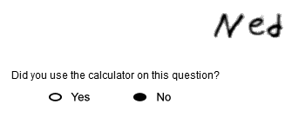

-------------------------------------------------------------------------------------------------------------------------------------------------------------------------

-------------------------------------------------------------------------------------------------------------------------------------------------------------------------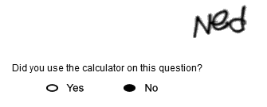

-------------------------------------------------------------------------------------------------------------------------------------------------------------------------These partially correct responses correctly identify the tallest boy only.

Incorrect - Student Response
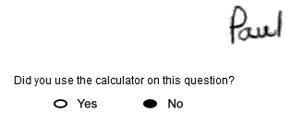

-------------------------------------------------------------------------------------------------------------------------------------------------------------------------

-------------------------------------------------------------------------------------------------------------------------------------------------------------------------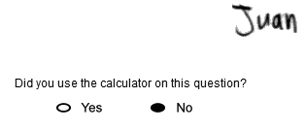

-------------------------------------------------------------------------------------------------------------------------------------------------------------------------The incorrect response on the top contains the two correct names, but the names are written in the incorrect response spaces. The incorrect response on the bottom incorrectly identifies both the shortest boy and the tallest boy.

- Item Detail for Question 9
No student responses are available for this question.

- Item Detail for Question 10
No student responses are available for this question.

- Item Detail for Question 11

Correct 1 - Student Response
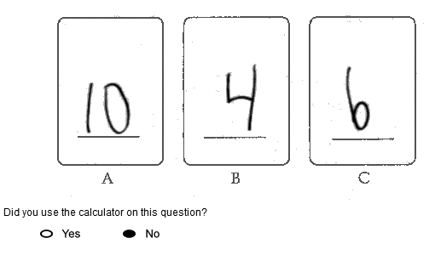

-------------------------------------------------------------------------------------------------------------------------------------------------------------------------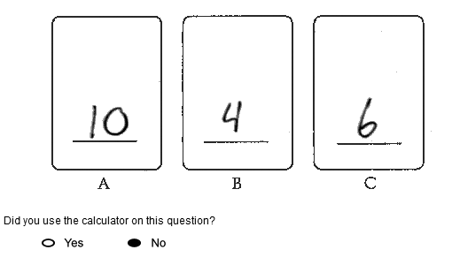

-------------------------------------------------------------------------------------------------------------------------------------------------------------------------These correct responses contain the correct number written on each card.

Correct 2 - Student Response
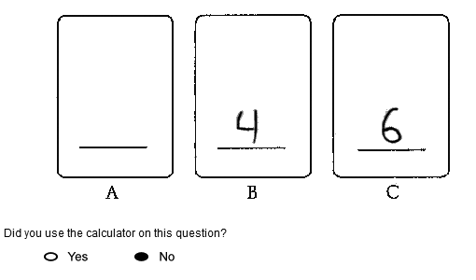

-------------------------------------------------------------------------------------------------------------------------------------------------------------------------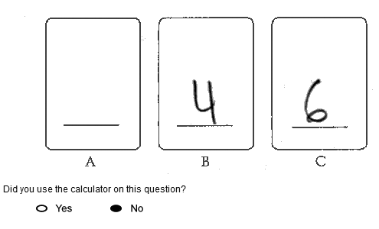

-------------------------------------------------------------------------------------------------------------------------------------------------------------------------These correct responses have no number written on card A, but 4 is correctly written on card B and 6 is correctly written on card C.

Partial 1 - Student Response
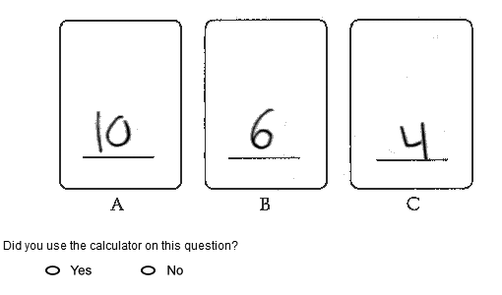

-------------------------------------------------------------------------------------------------------------------------------------------------------------------------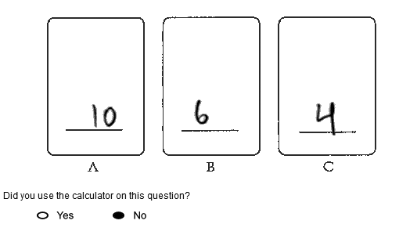

-------------------------------------------------------------------------------------------------------------------------------------------------------------------------These partially correct responses have 10 correctly written on card A, but 6 is incorrectly written on card B and 4 is incorrectly written on card C.

Partial 2 - Student Response
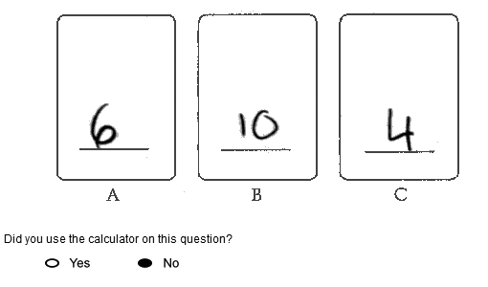

-------------------------------------------------------------------------------------------------------------------------------------------------------------------------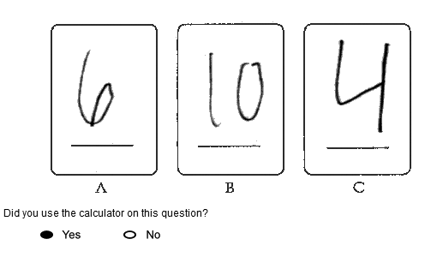

-------------------------------------------------------------------------------------------------------------------------------------------------------------------------These partially correct responses have 6 written on card A, 10 written on card B and 4 written on card C. This particular response received partial credit since 4 is also a factor of 12.

Partial 3 - Student Response
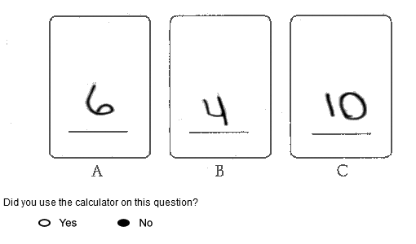

-------------------------------------------------------------------------------------------------------------------------------------------------------------------------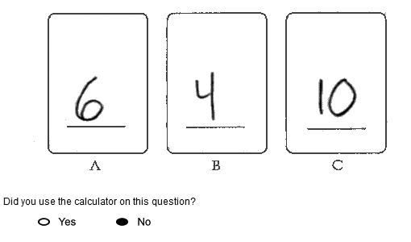

-------------------------------------------------------------------------------------------------------------------------------------------------------------------------These partially correct responses have 6 incorrectly written on card A, 4 correctly written on card B, and 10 incorrectly written on card C.

Partial 4 - Student Response
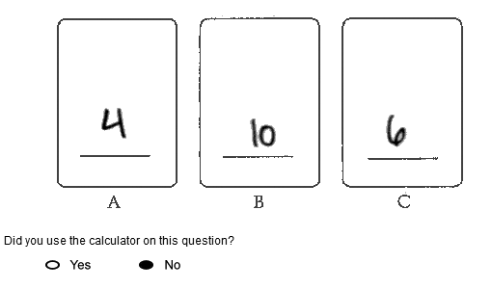

-------------------------------------------------------------------------------------------------------------------------------------------------------------------------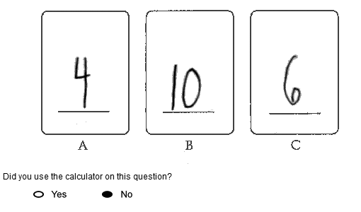

-------------------------------------------------------------------------------------------------------------------------------------------------------------------------These partially correct responses have 4 incorrectly written on card A, 10 incorrectly written on card B, and 6 correctly written on card C.

Incorrect - Student Response
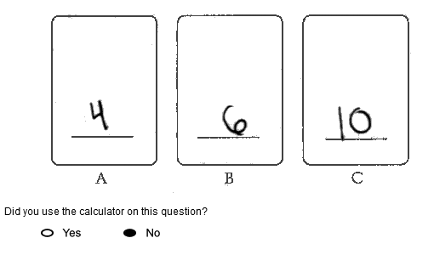

-------------------------------------------------------------------------------------------------------------------------------------------------------------------------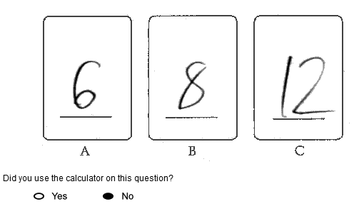

-------------------------------------------------------------------------------------------------------------------------------------------------------------------------The incorrect response on the top uses the numbers given in the prompt, but they are not written in an order that is acceptable for partial credit. The incorrect response on the bottom has an incorrect number written on each card.

- Item Detail for Question 12
No student responses are available for this question.

- Item Detail for Question 13

Correct - Student Response

-------------------------------------------------------------------------------------------------------------------------------------------------------------------------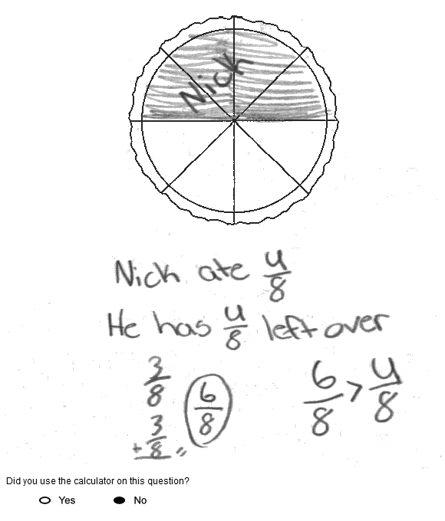

-------------------------------------------------------------------------------------------------------------------------------------------------------------------------

-------------------------------------------------------------------------------------------------------------------------------------------------------------------------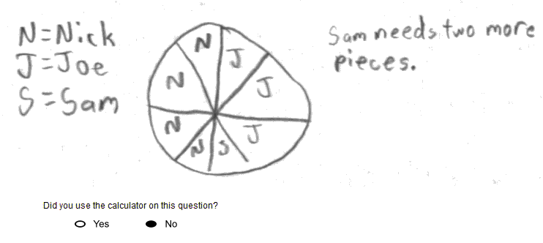

-------------------------------------------------------------------------------------------------------------------------------------------------------------------------These correct responses have the correct oval filled in and provide acceptable explanations to support that choice.

Partial 1 - Student Response

-------------------------------------------------------------------------------------------------------------------------------------------------------------------------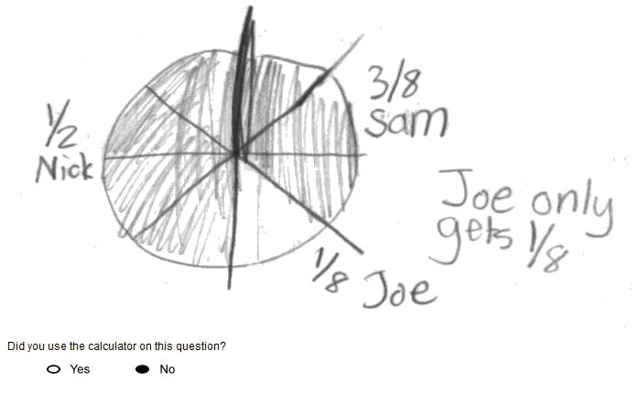

-------------------------------------------------------------------------------------------------------------------------------------------------------------------------

-------------------------------------------------------------------------------------------------------------------------------------------------------------------------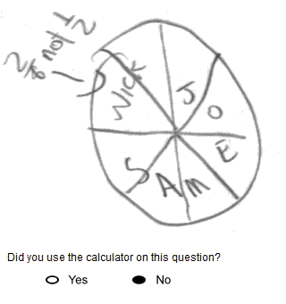

-------------------------------------------------------------------------------------------------------------------------------------------------------------------------These partially correct responses do not have an oval filled in, but the explanations are acceptable.

Partial 2 - Student Response

-------------------------------------------------------------------------------------------------------------------------------------------------------------------------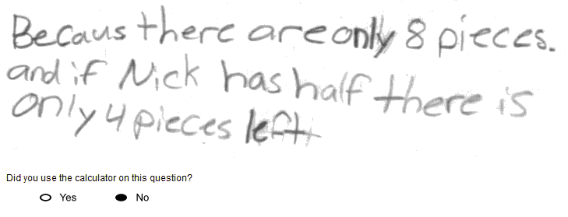

-------------------------------------------------------------------------------------------------------------------------------------------------------------------------

-------------------------------------------------------------------------------------------------------------------------------------------------------------------------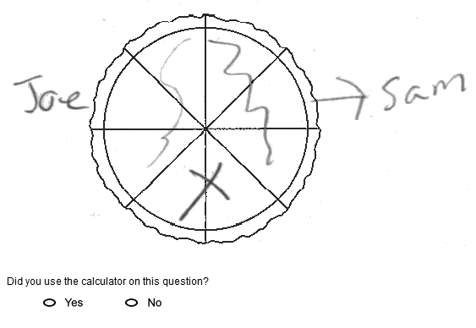

-------------------------------------------------------------------------------------------------------------------------------------------------------------------------The partially correct response on the top has the correct oval filled in, but the explanation is incomplete by only indicating that half of the pizza is equal to 4 slices. The partially correct response on the bottom has the correct oval filled in, but the explanation is incomplete by only indicating that Sam and Joe's portions would be equal to 6/8 of the pizza.

Partial 3 - Student Response
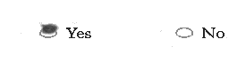

-------------------------------------------------------------------------------------------------------------------------------------------------------------------------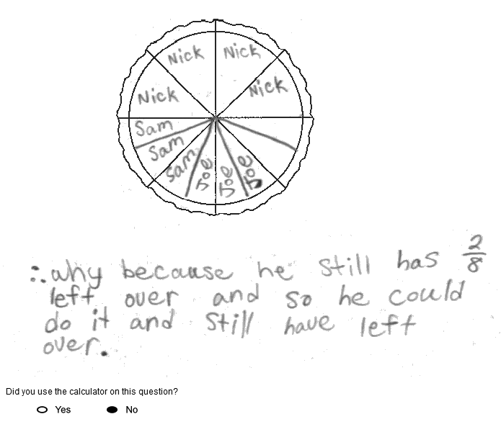

-------------------------------------------------------------------------------------------------------------------------------------------------------------------------

-------------------------------------------------------------------------------------------------------------------------------------------------------------------------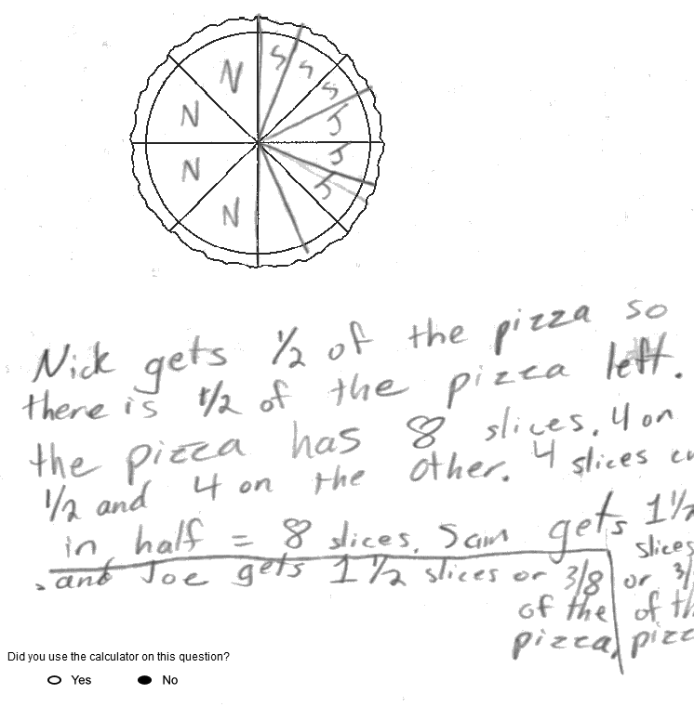

-------------------------------------------------------------------------------------------------------------------------------------------------------------------------These partially correct responses have the incorrect oval filled in. The explanations are based on dividing the half that Nick does not eat into eighths, and then sharing the remaining slices of pizza with his friends. This is an unacceptable explanation because the size of the slices that Nick shares with his friends is equal to 1/16 of the original pizza, instead of 1/8.

Incorrect 1 - Student Response

-------------------------------------------------------------------------------------------------------------------------------------------------------------------------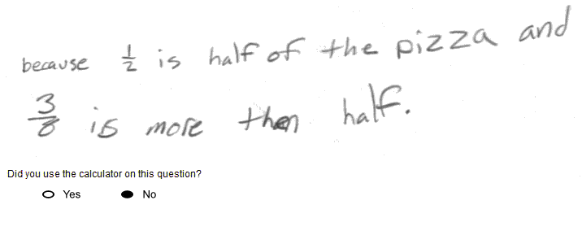

-------------------------------------------------------------------------------------------------------------------------------------------------------------------------

-------------------------------------------------------------------------------------------------------------------------------------------------------------------------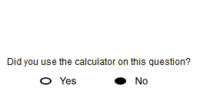

-------------------------------------------------------------------------------------------------------------------------------------------------------------------------The incorrect response on the top has the correct oval filled in, but the explanation is incorrect. The incorrect response on the bottom has the correct oval filled in, but no explanation is given.

Incorrect 2 - Student Response
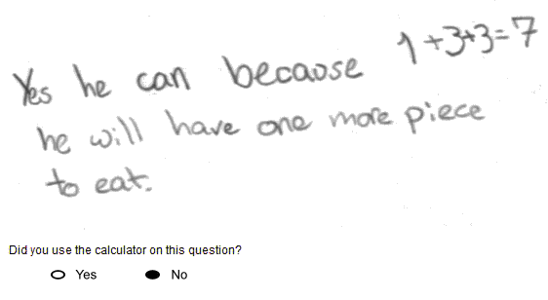

-------------------------------------------------------------------------------------------------------------------------------------------------------------------------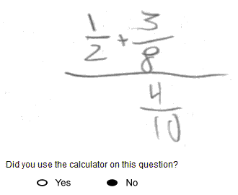

-------------------------------------------------------------------------------------------------------------------------------------------------------------------------These incorrect responses have the incorrect oval filled in and the explanations are incorrect.

- Item Detail for Question 14
No student responses are available for this question.

- Item Detail for Question 15

Satisfactory 1 - Student Response
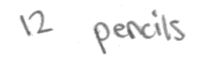

-------------------------------------------------------------------------------------------------------------------------------------------------------------------------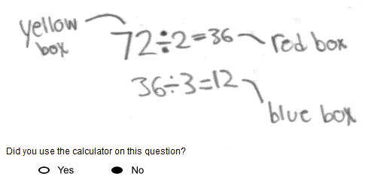

-------------------------------------------------------------------------------------------------------------------------------------------------------------------------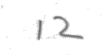

-------------------------------------------------------------------------------------------------------------------------------------------------------------------------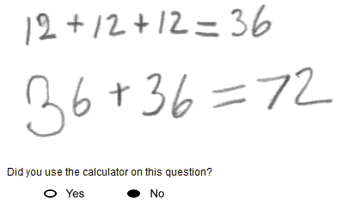

-------------------------------------------------------------------------------------------------------------------------------------------------------------------------These satisfactory responses indicate that each blue box can hold 12 pencils and provide correct explanations to support that answer.

Satisfactory 2 - Student Response
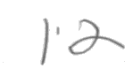

-------------------------------------------------------------------------------------------------------------------------------------------------------------------------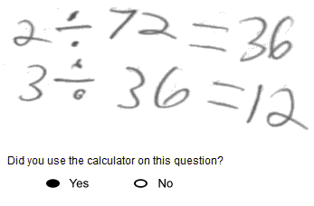

-------------------------------------------------------------------------------------------------------------------------------------------------------------------------

-------------------------------------------------------------------------------------------------------------------------------------------------------------------------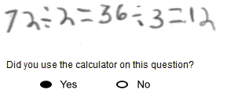

-------------------------------------------------------------------------------------------------------------------------------------------------------------------------The satisfactory response on the top indicates that each blue box can hold 12 pencils and provides an explanation to support that answer, but the equations 2 ÷ 72 = 36 and 3 ÷ 36 = 12 are imprecise mathematical sentences. The satisfactory response on the bottom indicates that each blue box can hold 12 pencils and provides an explanation to support that answer, but the equation 72 ÷ 2 = 36 ÷ 3 = 12 is an imprecise mathematical sentence.

Partial 1 - Student Response
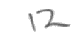

-------------------------------------------------------------------------------------------------------------------------------------------------------------------------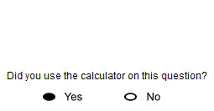

-------------------------------------------------------------------------------------------------------------------------------------------------------------------------

-------------------------------------------------------------------------------------------------------------------------------------------------------------------------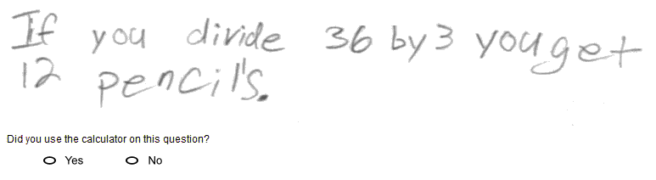

-------------------------------------------------------------------------------------------------------------------------------------------------------------------------The partially correct response on the top indicates that each blue box can hold 12 pencils, but does not provide any explanation to support that answer. The partially correct response on the bottom indicates that each blue box can hold 12 pencils, but the explanation is incomplete.

Partial 2 - Student Response
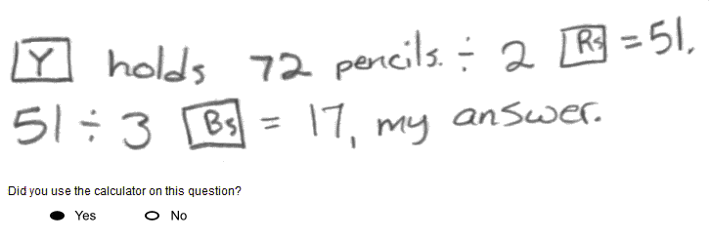

-------------------------------------------------------------------------------------------------------------------------------------------------------------------------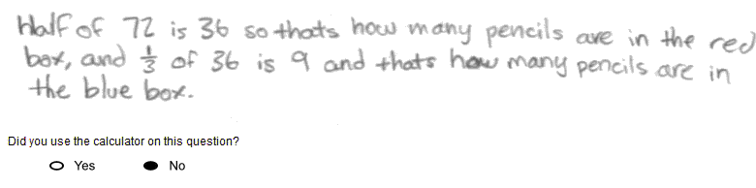

-------------------------------------------------------------------------------------------------------------------------------------------------------------------------These partially correct responses indicate an incorrect number of pencils that each blue box can hold. Both responses contain explanations that demonstrate a correct process, but with a computational error.

Minimal 1 - Student Response
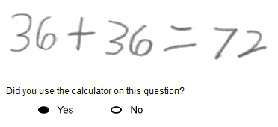

-------------------------------------------------------------------------------------------------------------------------------------------------------------------------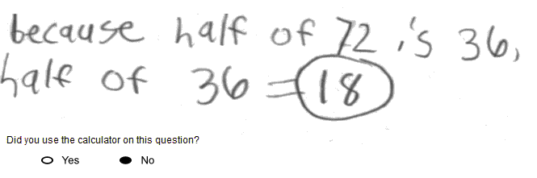

-------------------------------------------------------------------------------------------------------------------------------------------------------------------------The minimally acceptable response on the top indicates that each blue box can hold 36 pencils with an explanation that is based on one of the necessary computations. The minimally acceptable response on the bottom indicates that each blue box can hold 18 pencils with an explanation that is based on one of the necessary computations.

Minimal 2 - Student Response
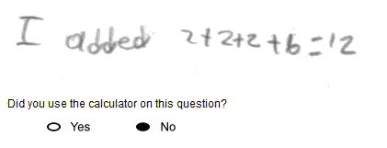

-------------------------------------------------------------------------------------------------------------------------------------------------------------------------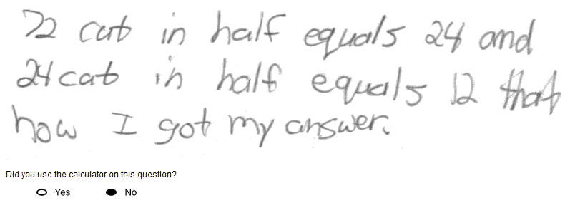

-------------------------------------------------------------------------------------------------------------------------------------------------------------------------These minimally acceptable responses indicate that each blue box can hold 12 pencils, but the explanations are incorrect.

Incorrect 1 - Student Response
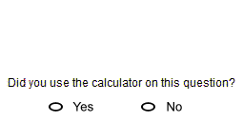

-------------------------------------------------------------------------------------------------------------------------------------------------------------------------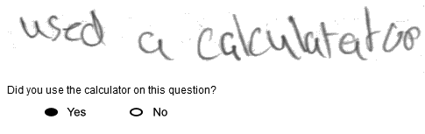

-------------------------------------------------------------------------------------------------------------------------------------------------------------------------The incorrect response on the top indicates that each blue box can hold 24 pencils, but does not provide any explanation to support that answer. The incorrect response on the bottom indicates that each blue box can hold 36 pencils with an explanation based on using the calculator.

Incorrect 2 - Student Response
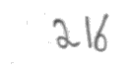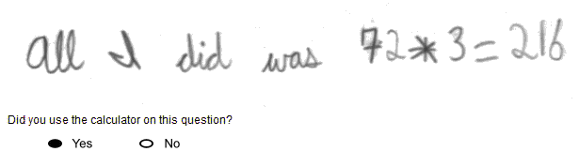

-------------------------------------------------------------------------------------------------------------------------------------------------------------------------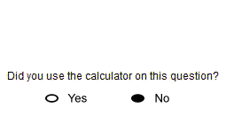

-------------------------------------------------------------------------------------------------------------------------------------------------------------------------The incorrect response on the bottom indicates that each blue box can hold 216 pencils and provides an incorrect explanation. The incorrect response on the bottom indicates that each blue box can hold 52 pencils and provides no explanation.

