- The correct answer is:

C. 85 F

- The correct answer is:

  - Pentagon

- The correct answer is:

B. There are between 12 and 13 pounds of potatoes in the bag.

- The correct answer is:

  - 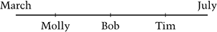

- The correct answer is:

B. 4,073,082

- The correct answer is:

D. How long Louisa was at the store

- The correct answer is:

  - For every 1 , there are 2 s

- The correct answer is:

C. 28 feet

- The correct answer is:

D. Nina

- Sample Correct Response:

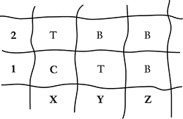

Correct - Correct response

Incorrect - Incorrect response

- Sample Correct Response:

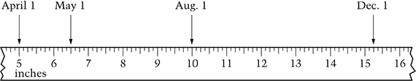

All 3 points correctly marked and labeled (the label can be the month or the number of inches)

May: inches
August: 10 inches
December: inches

NOTE:
Any point within 1 tick mark of the correct location will be correct. This includes any point that is exactly 1 tick mark off.

Correct - Correct response

Partial
Three correctly marked points but no labels
OR
Two correctly marked points with labels

Incorrect - Incorrect response

- The correct answer is:

D.

- The correct answer is:

B.

- Sample Correct Response:

6 ways (accept )
Al and Bev
Al and Carmen
Al and Derek
Bev and Carmen
Bev and Derek
Carmen and Derek

The supporting work or explanation should show or explain how the pairings of people were obtained; this may include drawings only, words only, or a combination of both.

Note: If student lists only 1 pair involving Derek, and has no other explanation, and numerical answer is not 6, then response is incorrect.

Correct - Correct response

6 different ways with a justification that demonstrates how the four people would be paired. It is possible to justify the answer of 6 without explicitly stating the 6 pairs by name, but the justification needs to be clear.

Partial 1 - Partially correct response

Response contains the 6 different ways, but the justification is either missing or is partially correct/partially complete. The partial justification may demonstrate that Derek can be paired with more than just one of the remaining people, but the justification falls short of complete, or the justification may include only a relevant computation. A response of 6 with no correct work, as long as the work shown does not demonstrate that 6 was obtained via invalid reasoning, should also be placed here.

Partial 2 - Partially correct response

Response does NOT obtain 6 ways, but does demonstrate in some way that Derek can be paired with more than just one of the remaining people.

Note: Justifications that show that Derek can be paired with more than one of the remaining people but [with] repeat pairings of the four people would be given a score of Partial 2.

Incorrect - Incorrect response

- The correct answer is:

D. 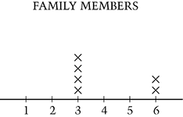

- The correct answer is:

C.

