- Item Detail for Question 1
No student responses are available for this question.

- Item Detail for Question 2
No student responses are available for this question.

- Item Detail for Question 3
No student responses are available for this question.

- Item Detail for Question 4
No student responses are available for this question.

- Item Detail for Question 5
No student responses are available for this question.

- Item Detail for Question 6
No student responses are available for this question.

- Item Detail for Question 7
No student responses are available for this question.

- Item Detail for Question 8
No student responses are available for this question.

- Item Detail for Question 9
No student responses are available for this question.

- Item Detail for Question 10
Correct - Student Response
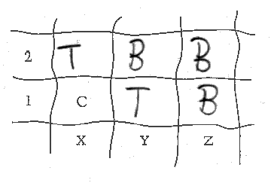

-------------------------------------------------------------------------------------------------------------------------------------------------------------------------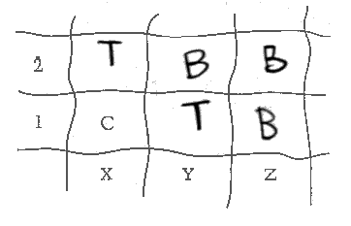

-------------------------------------------------------------------------------------------------------------------------------------------------------------------------These correct responses show the grid completed correctly with the appropriate symbols in the correct sections.

Incorrect - Student Response
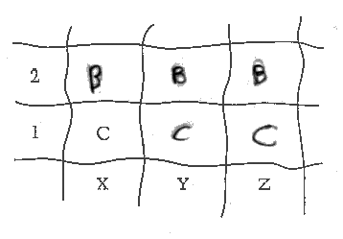

-------------------------------------------------------------------------------------------------------------------------------------------------------------------------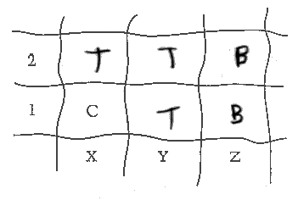

-------------------------------------------------------------------------------------------------------------------------------------------------------------------------These incorrect responses do not have the grid completed correctly. The wrong symbol is used in one or more sections.

- Item Detail for Question 11

Correct - Student Response
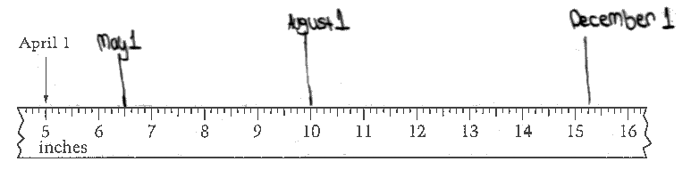
-------------------------------------------------------------------------------------------------------------------------------------------------------------------------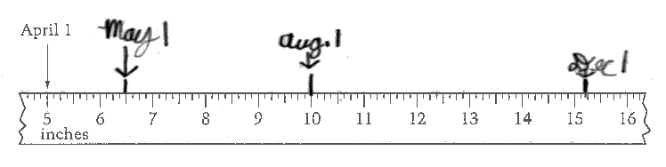
-------------------------------------------------------------------------------------------------------------------------------------------------------------------------These correct responses show all three measurements correctly marked and labeled on the picture of the ruler.

Partial - Student Response
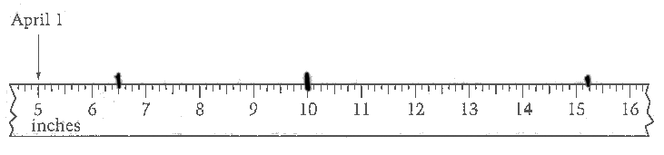

-------------------------------------------------------------------------------------------------------------------------------------------------------------------------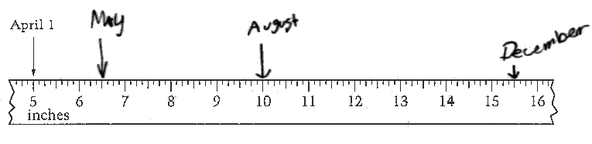

-------------------------------------------------------------------------------------------------------------------------------------------------------------------------The partially correct response on the top has all three measurements correctly marked, but not labeled. The partially correct response on the bottom has two measurements (May and August) correctly marked and labeled, but the mark for the December measurement is incorrect.

Incorrect - Student Response
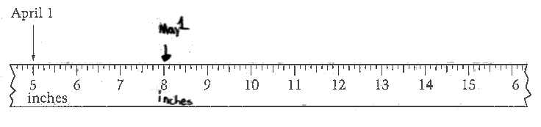

-------------------------------------------------------------------------------------------------------------------------------------------------------------------------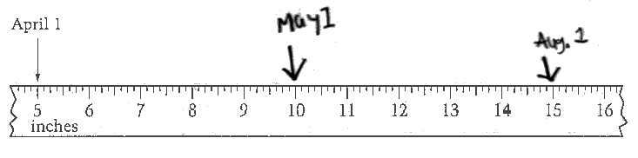

-------------------------------------------------------------------------------------------------------------------------------------------------------------------------These incorrect responses do not have any measurements correctly marked.

- Item Detail for Question 12
No student responses are available for this question.

- Item Detail for Question 13
No student responses are available for this question.

- Item Detail for Question 14

Correct - Student Response

-------------------------------------------------------------------------------------------------------------------------------------------------------------------------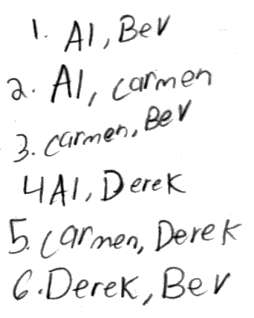

-------------------------------------------------------------------------------------------------------------------------------------------------------------------------

-------------------------------------------------------------------------------------------------------------------------------------------------------------------------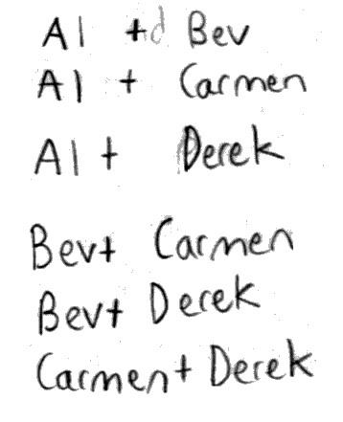

-------------------------------------------------------------------------------------------------------------------------------------------------------------------------These correct responses specify that there are a total of six ways that the four students can be paired up and contain acceptable explanations that show all six pairings.
Partial 1 - Student Response

-------------------------------------------------------------------------------------------------------------------------------------------------------------------------

-------------------------------------------------------------------------------------------------------------------------------------------------------------------------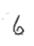

-------------------------------------------------------------------------------------------------------------------------------------------------------------------------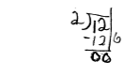

-------------------------------------------------------------------------------------------------------------------------------------------------------------------------The partially correct response on the top specifies that there are six ways that the four students can be paired up, but does not contain any explanation. The partially correct response on the bottom specifies that there are six ways that the four students can be paired up, but the work is incomplete. The work shown may represent the number of permutations of two people from a group of four, but since order is not important in the pairings and each combination would be listed twice, that value is divided in half to obtain the answer of 6; however, it is not clear if that is the process being used without additional work.

Partial 2 - Student Response

-------------------------------------------------------------------------------------------------------------------------------------------------------------------------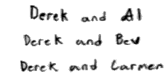

-------------------------------------------------------------------------------------------------------------------------------------------------------------------------

-------------------------------------------------------------------------------------------------------------------------------------------------------------------------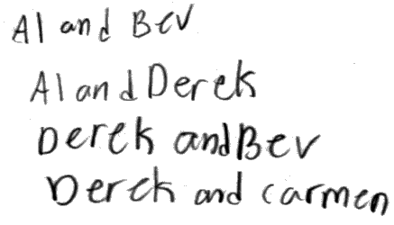

-------------------------------------------------------------------------------------------------------------------------------------------------------------------------These partially correct responses do not specify that there are six ways, but the explanations show that Derek can be paired up with each of the other three people.

Incorrect - Student Response
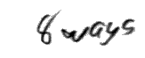

-------------------------------------------------------------------------------------------------------------------------------------------------------------------------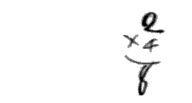

-------------------------------------------------------------------------------------------------------------------------------------------------------------------------

-------------------------------------------------------------------------------------------------------------------------------------------------------------------------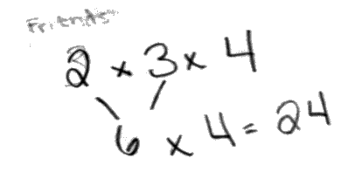

-------------------------------------------------------------------------------------------------------------------------------------------------------------------------These incorrect responses do not specify the correct number of pairings and the work shown is incorrect.

- Item Detail for Question 15
No student responses are available for this question.

- Item Detail for Question 16
No student responses are available for this question.

