- Item Detail for Question 1
Correct - Student Response
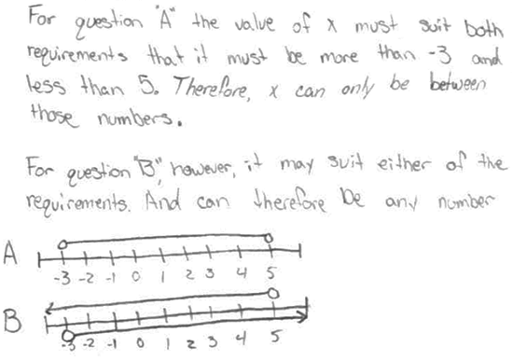
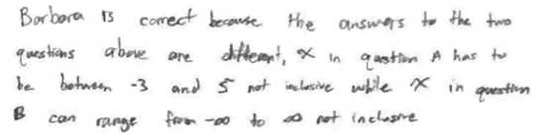

These correct responses each include a selection of the correct oval and an acceptable explanation.

Partial 1 - Student Response
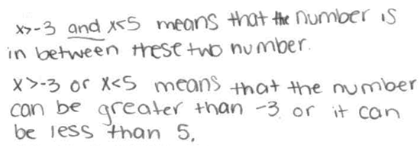

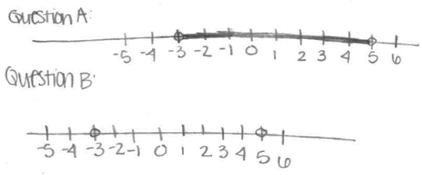

These partially correct responses each include the correct oval filled in with a partially correct explanation.

Partial 2 - Student Response

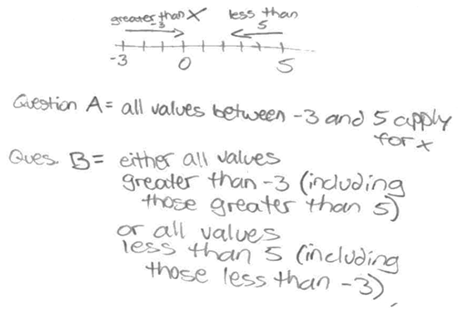
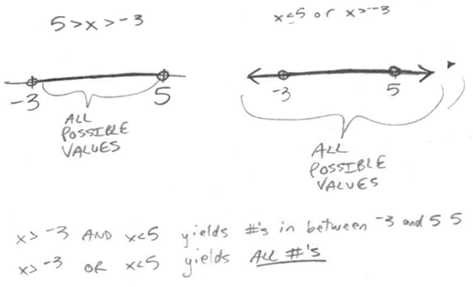

These partially correct responses each include an acceptable explanation that supports the correct oval, however, the first response includes a selection of an incorrect oval and the second response does not include a selection of an oval.

Partial 3 - Student Response
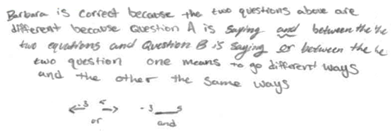
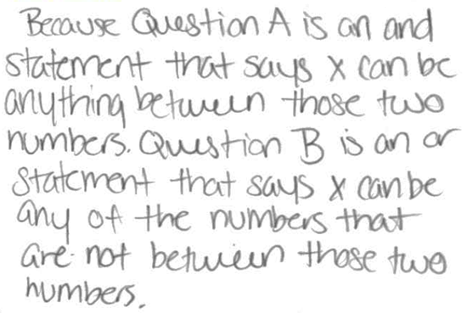

These partially correct responses each include a selection of the correct oval with an explanation that treats the "or" in question B as an exclusive or.

Incorrect 1 - Student Response
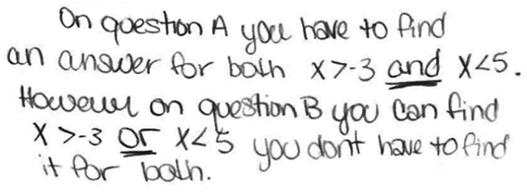

These incorrect responses each include a selection of the correct oval. The first response includes an incorrect explanation and the second response does not include an explanation.

Incorrect 2 - Student Response

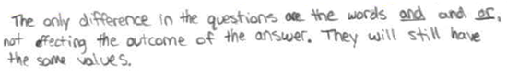

These incorrect responses each include a selection of the incorrect oval. The first response includes an incorrect explanation and the second response does not include an explanation.
- Item Detail for Question 2 - No student responses are available for this question.

- Item Detail for Question 3 - No student responses are available for this question.

- Item Detail for Question 4

Extended - Student Response
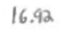
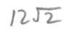
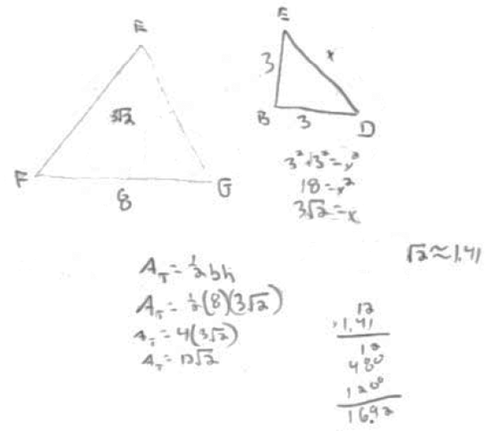
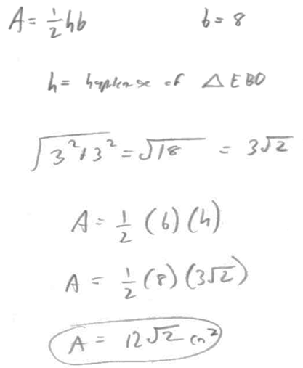

These extended responses each show a correct area of triangle EFG with an acceptable solution. The first response contains an exact correct area, while the second response contains an acceptable decimal approximation.

Satisfactory - Student Response
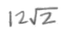
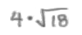

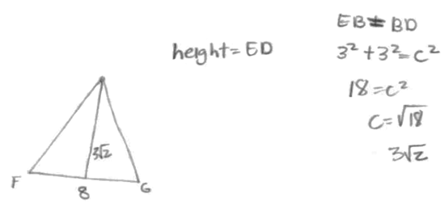

The first satisfactory response contains an exact correct area but does not contain an acceptable solution because it does not show how the area of triangle EFG was calculated. The second satisfactory response contains an area equivalent to the correct area, but does not include a solution.

Partial - Student Response
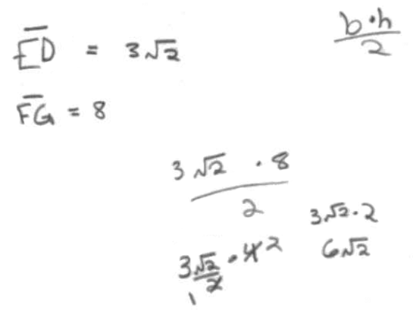
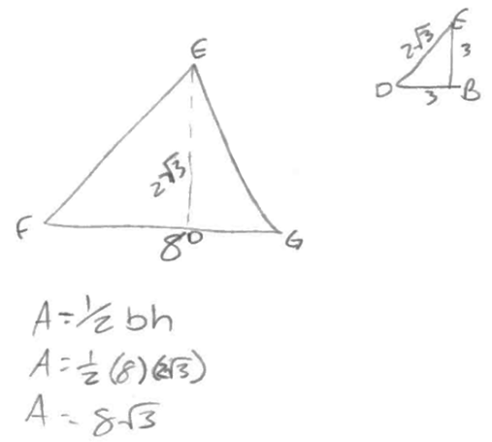
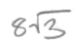
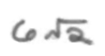

These partially correct responses each contain a correct process for finding the area of triangle EFG, but do not contain the correct area.

Minimal - Student Response

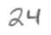

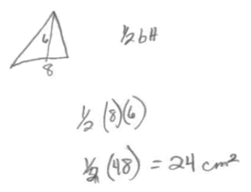
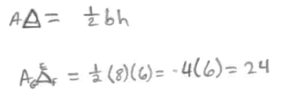
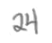

These minimal responses each contain an incorrect area of 24 cm2 with work showing.

Incorrect - Student Response

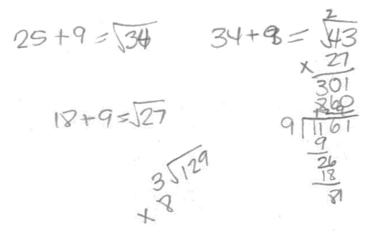
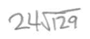
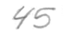

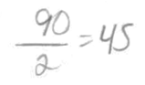

These incorrect responses do not contain a correct area of triangle EFG, nor do they contain a correct process for finding the area of triangle EFG.

- Item Detail for Question 5 - No student responses are available for this question.

- Item Detail for Question 6

Correct - Student Response

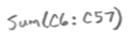

These correct responses each show a correct formula for determining the total amount of tax paid.

Incorrect - Student Response
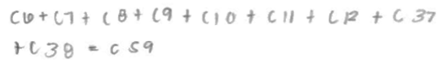
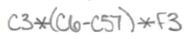

These incorrect responses each show an incorrect formula for determining the total amount of tax paid.

- Item Detail for Question 7 - No student responses are available for this question.

- Item Detail for Question 8 - No student responses are available for this question.

- Item Detail for Question 9 - No student responses are available for this question.

- Item Detail for Question 10

Satisfactory - Student Response
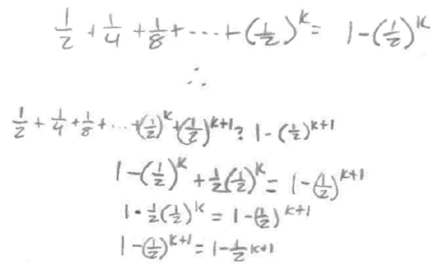
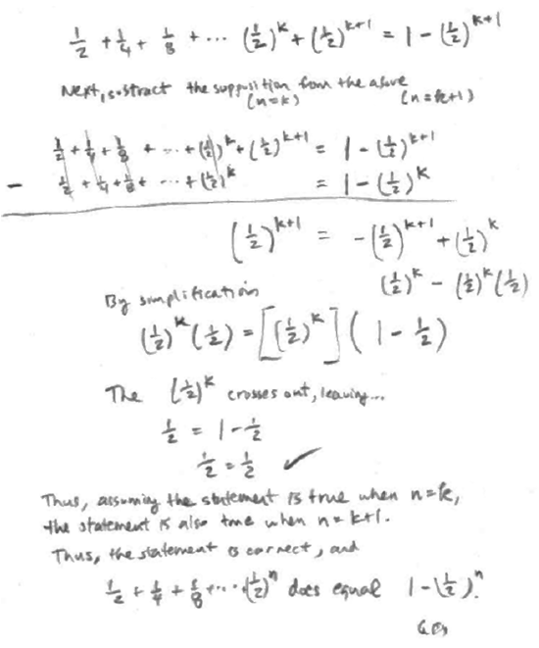

These satisfactory responses each include a correct completion of the proof.

Partial - Student Response
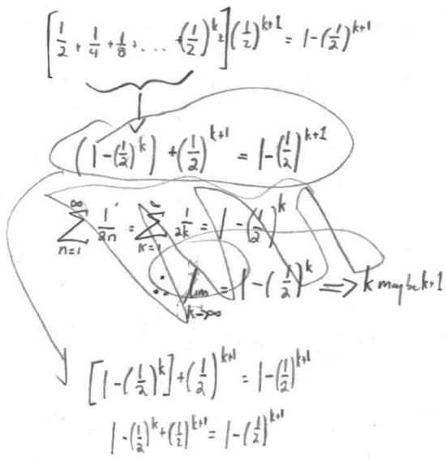
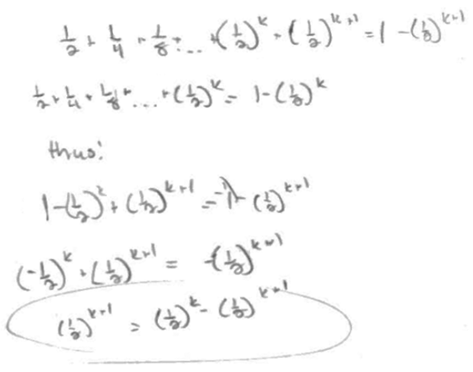

These partially correct responses each include a correct induction step, but do not include a correct completion of the proof.

Minimal - Student Response
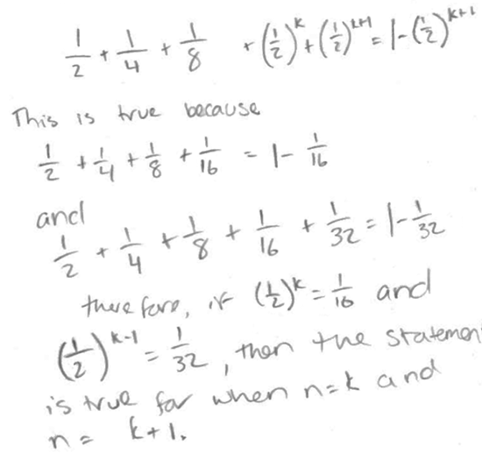
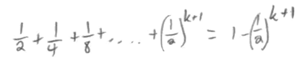

These minimally correct responses each indicate what needs to be proved but do not include the induction step or a correct completion of the proof.

Incorrect - Student Response
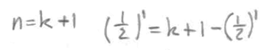
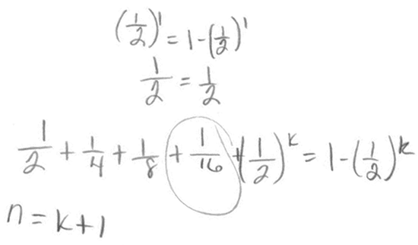

These incorrect responses do not indicate what needs to be proved, and do not include the induction step or a correct completion of the proof.

