- Item Detail for Question 1
No student responses are available for this question.

- Item Detail for Question 2
No student responses are available for this question.

- Item Detail for Question 3
No student responses are available for this question.

- Item Detail for Question 4
No student responses are available for this question.

- Item Detail for Question 5
No student responses are available for this question.

- Item Detail for Question 6
No student responses are available for this question.

- Item Detail for Question 7
No student responses are available for this question.

- Item Detail for Question 8

Correct - Student Response
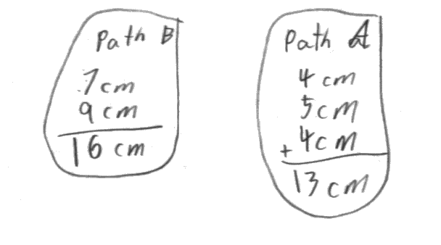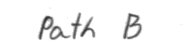
-------------------------------------------------------------------------------------------------------------------------------------------------------------------------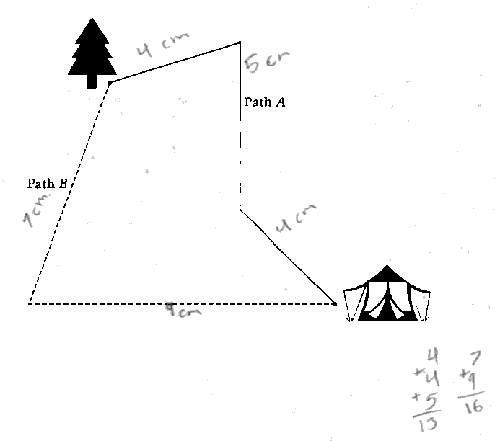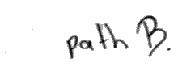
-------------------------------------------------------------------------------------------------------------------------------------------------------------------These correct responses indicate that Path B is the longer path and give the correct difference between the lengths of the two paths in the second question.

Partial 1 - Student Response

-------------------------------------------------------------------------------------------------------------------------------------------------------------------------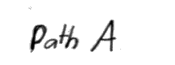

-------------------------------------------------------------------------------------------------------------------------------------------------------------------------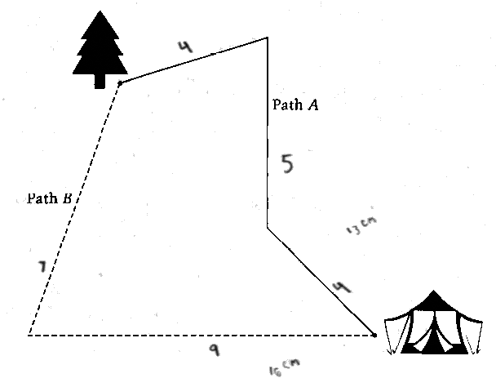

-------------------------------------------------------------------------------------------------------------------------------------------------------------------------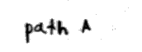

-------------------------------------------------------------------------------------------------------------------------------------------------------------------------These partially correct responses indicate that Path A is the longer path and give a value of 3 for the difference between the lengths of the two paths.

Partial 2 - Student Response
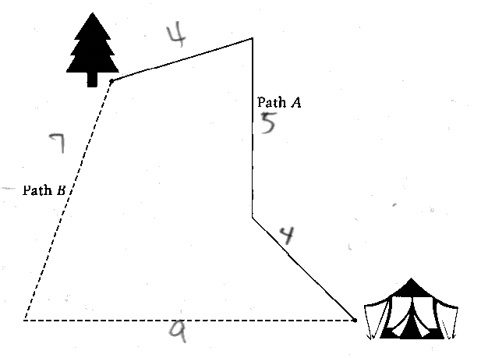

-------------------------------------------------------------------------------------------------------------------------------------------------------------------------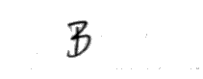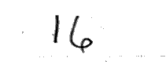

-------------------------------------------------------------------------------------------------------------------------------------------------------------------------

-------------------------------------------------------------------------------------------------------------------------------------------------------------------------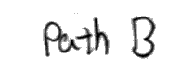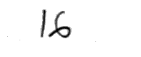

-------------------------------------------------------------------------------------------------------------------------------------------------------------------------These partially correct responses indicate that Path B is the longer path, but give the length of Path B, instead of the difference in lengths between the two paths, for the second question.

Partial 3 - Student Response
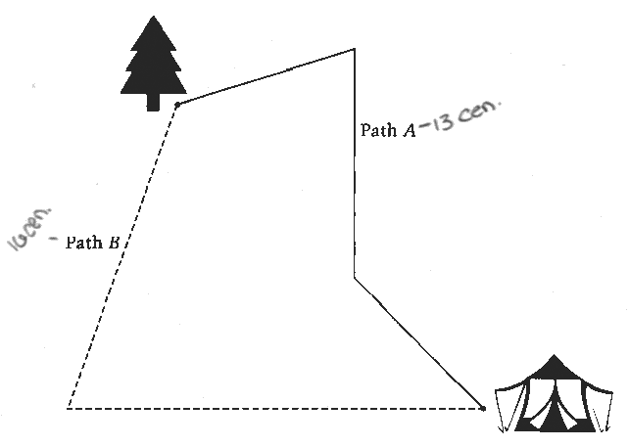

-------------------------------------------------------------------------------------------------------------------------------------------------------------------------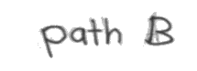

-------------------------------------------------------------------------------------------------------------------------------------------------------------------------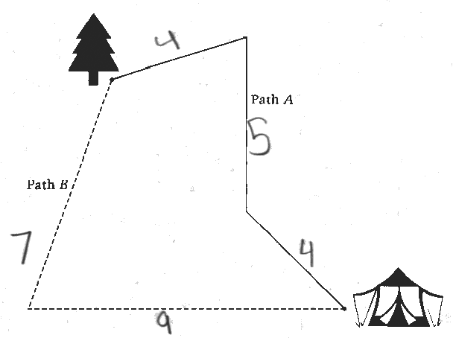

-------------------------------------------------------------------------------------------------------------------------------------------------------------------------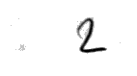

-------------------------------------------------------------------------------------------------------------------------------------------------------------------------The partially correct response on the top indicates that Path B is the longer path and shows the correct total length for each path, but the difference between the lengths of the two paths is incorrect. The partially correct response on the bottom shows the correct length for each segment of the paths, but the longer path is not identified and the difference between the lengths of the two paths is incorrect.

Partial 4 - Student Response
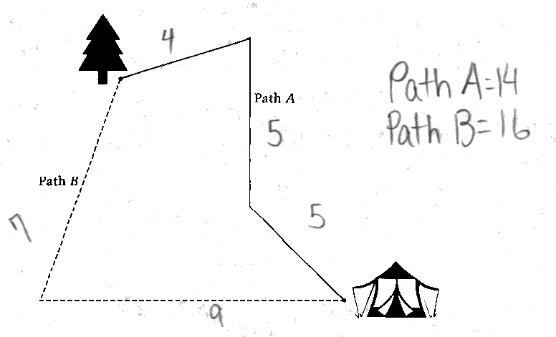

-------------------------------------------------------------------------------------------------------------------------------------------------------------------------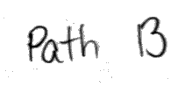

-------------------------------------------------------------------------------------------------------------------------------------------------------------------------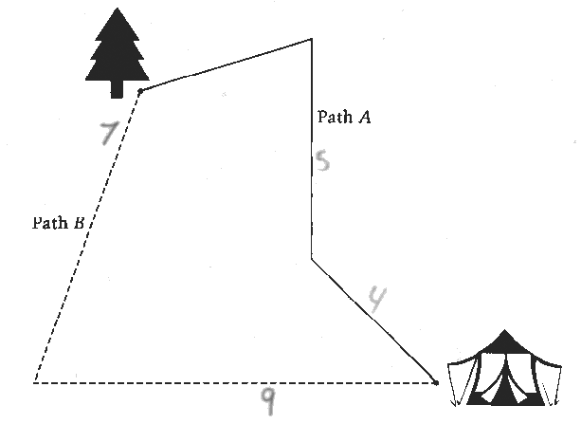

-------------------------------------------------------------------------------------------------------------------------------------------------------------------------

-------------------------------------------------------------------------------------------------------------------------------------------------------------------------These partially correct responses indicate that Path B is the longer path and show correct measurements for four of the five segments. The difference between the lengths of the two paths is computed correctly based on those measurements.

Incorrect 1 - Student Response
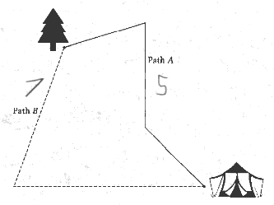

-------------------------------------------------------------------------------------------------------------------------------------------------------------------------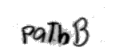
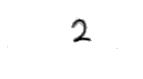
-------------------------------------------------------------------------------------------------------------------------------------------------------------------------The incorrect response on the top indicates that Path B is the longer path and gives a value of 2 for the difference between the lengths of the two paths that is based on measuring one segment of each path. The incorrect response on the bottom indicates that Path B is the longer path and gives a value of 2 for the difference between the lengths of the two paths, but no measurements are shown to support that answer.

Incorrect 2 - Student Response
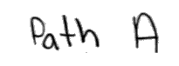

-------------------------------------------------------------------------------------------------------------------------------------------------------------------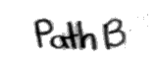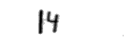

-------------------------------------------------------------------------------------------------------------------------------------------------------------------------The incorrect response on the top indicates that Path A is the longer path and gives an incorrect difference between the lengths of the two paths. The incorrect response on the bottom indicates that Path B is the longer path and gives an incorrect difference between the lengths of the two paths.

- Item Detail for Question 9
  - No student responses are available for this question.

- Item Detail for Question 10

Correct 1 - Student Response

-------------------------------------------------------------------------------------------------------------------------------------------------------------------------
-------------------------------------------------------------------------------------------------------------------------------------------------------------------------These correct responses contain line segments that start at point A and measure within tolerance.

Correct 2 - Student Response
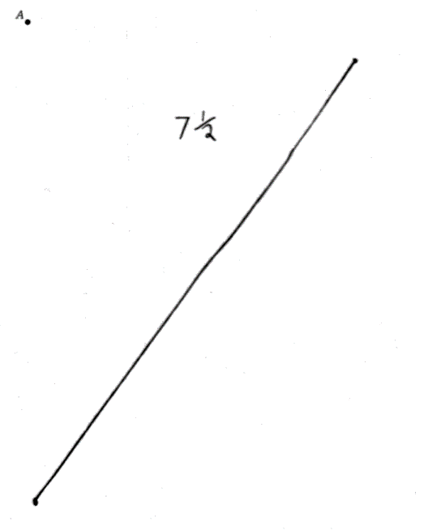

-------------------------------------------------------------------------------------------------------------------------------------------------------------------------

-------------------------------------------------------------------------------------------------------------------------------------------------------------------------These correct responses contain line segments that measure within tolerance, but they do not start at point <i>A</i>.

Incorrect 1 - Student Response
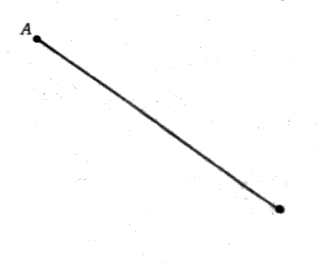

-------------------------------------------------------------------------------------------------------------------------------------------------------------------------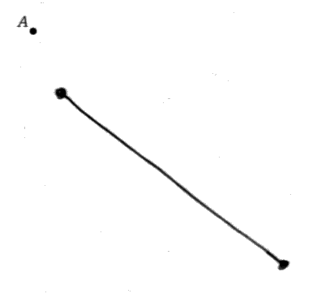

-------------------------------------------------------------------------------------------------------------------------------------------------------------------------These incorrect responses contain line segments drawn using centimeters instead of inches.

Incorrect 2 - Student Response
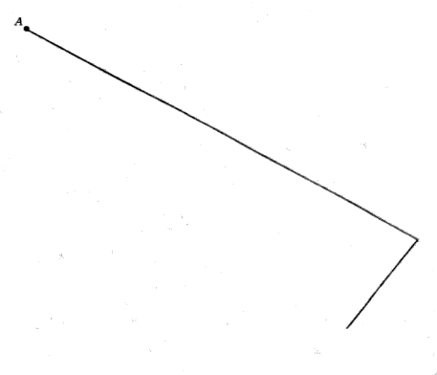

-------------------------------------------------------------------------------------------------------------------------------------------------------------------------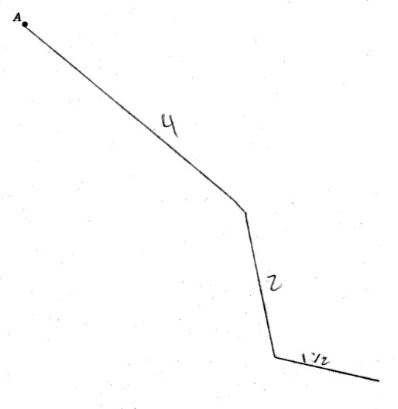

-------------------------------------------------------------------------------------------------------------------------------------------------------------------------These incorrect responses contain two or more line segments that have a total length within tolerance.

Incorrect 3 - Student Response
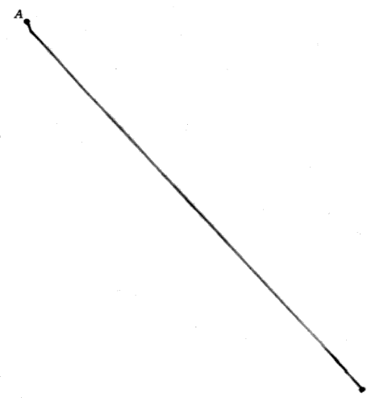

-------------------------------------------------------------------------------------------------------------------------------------------------------------------------

-------------------------------------------------------------------------------------------------------------------------------------------------------------------------These incorrect responses do not measure within tolerance for either inches or centimeters.

- Item Detail for Question 11
No student responses are available for this question.

- Item Detail for Question 12

Correct - Student Response
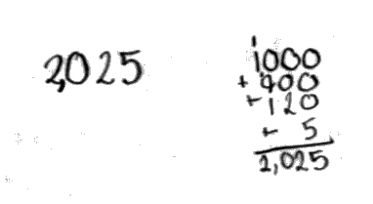

-------------------------------------------------------------------------------------------------------------------------------------------------------------------------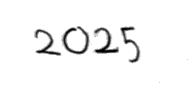

-------------------------------------------------------------------------------------------------------------------------------------------------------------------------These correct responses indicate the correct number of buttons.

Partial 1 - Student Response
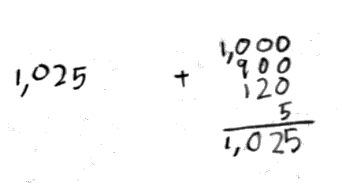

-------------------------------------------------------------------------------------------------------------------------------------------------------------------------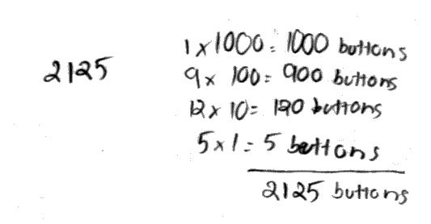

-------------------------------------------------------------------------------------------------------------------------------------------------------------------------These partially correct responses have an incorrect total number of buttons. The work shows the correct composition for each type of button, but an arithmetic mistake is made when computing the total.

Partial 2 - Student Response
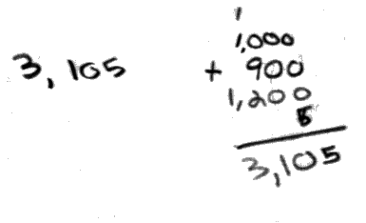

-------------------------------------------------------------------------------------------------------------------------------------------------------------------------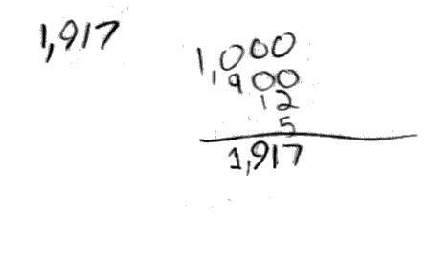

-------------------------------------------------------------------------------------------------------------------------------------------------------------------------These partially correct responses have an incorrect total number of buttons. The work shows an incorrect composition for one of the types of buttons in each response, but the total is consistent with the incorrect composition.

Incorrect - Student Response
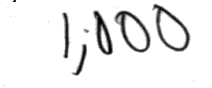

-------------------------------------------------------------------------------------------------------------------------------------------------------------------------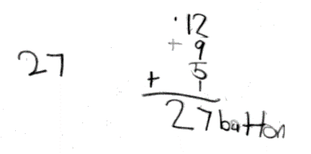

-------------------------------------------------------------------------------------------------------------------------------------------------------------------------The incorrect response on the top has an incorrect number of buttons. The incorrect response on the bottom has an incorrect number of buttons and the work shows an incorrect composition for three of the types of buttons.

- Item Detail for Question 13

Correct - Student Response

-------------------------------------------------------------------------------------------------------------------------------------------------------------------------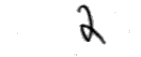

-------------------------------------------------------------------------------------------------------------------------------------------------------------------------

-------------------------------------------------------------------------------------------------------------------------------------------------------------------------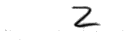

-------------------------------------------------------------------------------------------------------------------------------------------------------------------------These correct responses show point B correctly marked and give the correct length of line segment AB.

Partial - Student Response
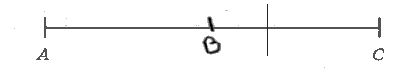

-------------------------------------------------------------------------------------------------------------------------------------------------------------------------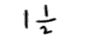

-------------------------------------------------------------------------------------------------------------------------------------------------------------------------

-------------------------------------------------------------------------------------------------------------------------------------------------------------------------

-------------------------------------------------------------------------------------------------------------------------------------------------------------------------The partially correct response on the top shows point B incorrectly marked, but gives a correct length for line segment AB based on the location of point B. The partially correct response on the bottom does not contain any mark for point B, but gives the correct length of line segment AB.

Incorrect - Student Response
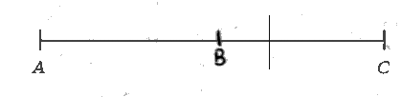

-------------------------------------------------------------------------------------------------------------------------------------------------------------------------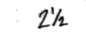

-------------------------------------------------------------------------------------------------------------------------------------------------------------------------

-------------------------------------------------------------------------------------------------------------------------------------------------------------------------

-------------------------------------------------------------------------------------------------------------------------------------------------------------------------The incorrect response on the top shows point B incorrectly marked and gives an incorrect length for line segment AB based on the location of point B. The incorrect response on the bottom does not contain any mark for point B and gives an incorrect length for line segment AB.

- Item Detail for Question 14
No student responses are available for this question.

- Item Detail for Question 15

Extended - Student Response

-------------------------------------------------------------------------------------------------------------------------------------------------------------------------

-------------------------------------------------------------------------------------------------------------------------------------------------------------------------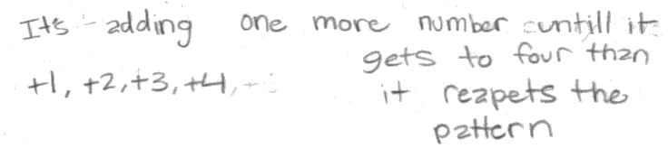

-------------------------------------------------------------------------------------------------------------------------------------------------------------------------
-------------------------------------------------------------------------------------------------------------------------------------------------------------------------The extended response on the top contains an acceptable explanation of the rule that does not mention repeating the pattern of numbers being added, and then correctly uses that rule to generate the new pattern. The extended response on the bottom contains a correct rule that mentions repeating the pattern of numbers being added, and then correctly uses that rule to generate the new pattern.

Satisfactory - Student Response
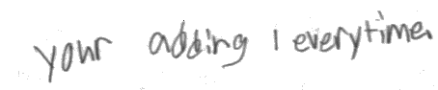

-------------------------------------------------------------------------------------------------------------------------------------------------------------------------

-------------------------------------------------------------------------------------------------------------------------------------------------------------------------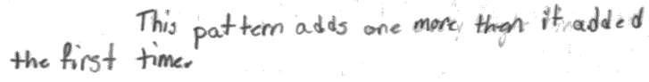

-------------------------------------------------------------------------------------------------------------------------------------------------------------------------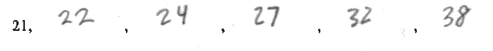

-------------------------------------------------------------------------------------------------------------------------------------------------------------------------The satisfactory response on the top contains an unclear explanation of the rule, but the new pattern is generated following the same rule as the first pattern. The satisfactory response on the bottom contains an acceptable explanation of the rule, but makes an error applying that rule to generate the new pattern.

Partial - Student Response

-------------------------------------------------------------------------------------------------------------------------------------------------------------------------

-------------------------------------------------------------------------------------------------------------------------------------------------------------------------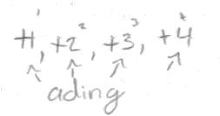

-------------------------------------------------------------------------------------------------------------------------------------------------------------------------

-------------------------------------------------------------------------------------------------------------------------------------------------------------------------The partially correct response on the top does not contain any explanation for the rule, but the new pattern has been generated following the same rule as the first pattern. The partially correct response on the bottom contains an acceptable explanation of the rule, but that rule is not used to generate the new pattern.

Minimal - Student Response

-------------------------------------------------------------------------------------------------------------------------------------------------------------------------

-------------------------------------------------------------------------------------------------------------------------------------------------------------------------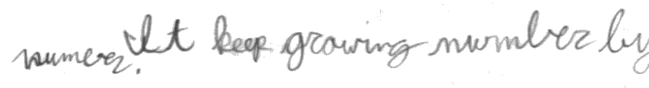

-------------------------------------------------------------------------------------------------------------------------------------------------------------------------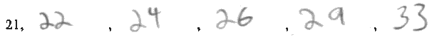

-------------------------------------------------------------------------------------------------------------------------------------------------------------------------The minimally acceptable response on the top does not contain any explanation for the rule, but a new pattern has been generated based on differences between successive terms that keep increasing by one. The minimally acceptable response on the bottom contains an unclear rule and there is more than one error made applying a rule to generate the new pattern.

Incorrect - Student Response
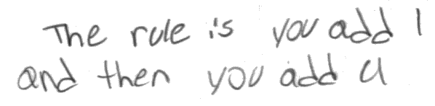

-------------------------------------------------------------------------------------------------------------------------------------------------------------------------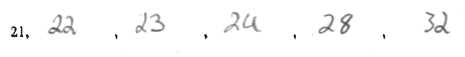

-------------------------------------------------------------------------------------------------------------------------------------------------------------------------

-------------------------------------------------------------------------------------------------------------------------------------------------------------------------

-------------------------------------------------------------------------------------------------------------------------------------------------------------------------The incorrect response on the top gives an unacceptable rule that is incorrectly applied to generate the new pattern. The incorrect response on the bottom does not contain any explanation for the rule and the new pattern that is generated does not follow any rule that is based on the rule for the first pattern.

