Name _________________________________________________

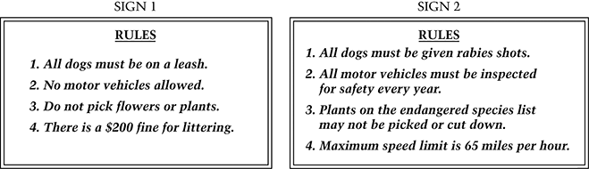
Questions 1, 2 & 3 refer to the two lists of rules shown. Each list shows some of the rules for a particular place.

1. Sign 1 most likely lists the rules for a

A. school

B. city

C. skating rink

D. park

2. Pick one of the rules from the list on Sign 1 and explain why it is important.

Rule # ____ is important because _________________________________________________

____________________________________________________________________________

____________________________________________________________________________

____________________________________________________________________________

3. Sign 2 most likely lists rules for a

A. family

B. club

C. state

D. business
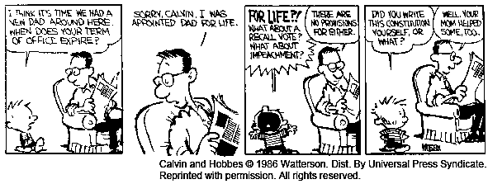
4. The child in the cartoon strip above is a six-year-old boy named Calvin. What is the main point of the cartoon?

A. Constitutions have rules about how long someone can stay in office.

B. Families and governments are not run the same way.

C. The term of office for elected and appointed officials is different.

D. Calvin does not know how a constitutional government works.

5. In 1963 Martin Luther King, Jr., said:

"I have a dream that my four children will one day live in a nation where they will not be judged by the color of their skin but by the content of their character."

From I Have a Dream, copyright 1963 by Dr. Martin Luther King Jr.; copyright renewed 1991 by Coretta Scott King. Used by permission of The Heirs to the Estate of Martin Luther King Jr., c/o Writers House as agent for the proprietor NY, NY.

Explain what Martin Luther King, Jr.'s dream was.

________________________________________________________________________________

________________________________________________________________________________

________________________________________________________________________________

________________________________________________________________________________

6. Which of the following does the United States Constitution do?

A. It outlines the boundaries of our states.

B. It tells us when our national holidays are.

C. It establishes public elementary schools.

D. It gives a plan for how our government is set up.

Questions 7 & 8 refer to the paragraph below, which is a summary of the introduction to the Declaration of Independence.

We hold these truths to be self-evident, that all people are created equal; that they are given certain rights that cannot be taken away; that among these are life, liberty, and the pursuit of happiness. That to protect these rights, governments are created that get their powers from the consent of the governed . . .

7. Which of the following ideas is in the summary of the Declaration of Independence?

A. People in the United States should have some control over the government.

B. Kings can rule in the United States, as long as they are fair to people.

C. The smartest people should control the government of the United States.

D. Everyone in the United States should try to be elected to the government.

8. Read the paragraph again. Why did the writers of the Declaration say that we need a government?

A. To protect our rights

B. To provide relief for the poor

C. To make sure that we all get an education

D. To make sure that no one breaks the law

9. The United States is a big country with many people. The people of the United States come from many backgrounds. Some of us were born here. Some of us were born in other countries. But, as Americans, we share many important things.

Give two reasons why the United States benefits from having people from many different countries and backgrounds.

1) __________________________________________________________________________

____________________________________________________________________________

____________________________________________________________________________

2) __________________________________________________________________________

____________________________________________________________________________

____________________________________________________________________________

10. Which of the following kinds of organizations would most likely be involved in protecting peoples' right to have a safe workplace?

A. A political party

B. A parent-teacher association

C. A labor union

D. A charity

11. When he became President, John F. Kennedy said: "Ask not what your country can do for you; ask what you can do for your country."

Give an example of one important thing that individuals can do for their country and explain why it is important.

________________________________________________________________________________

________________________________________________________________________________

________________________________________________________________________________

________________________________________________________________________________

________________________________________________________________________________

12. Usually United States citizens elect a President by

A. voting for delegates to national conventions

B. secret ballot on election day

C. a recall vote in each state

D. extending a Vice President's term of office

13. In general, which of these people have a "term of office"?

A. Elected officials

B. Police officers

C. Secretaries

D. Schoolteachers

14. Which of these is an example of a person using power without having the right to?

A. A teacher giving homework

B. A principal calling a teachers' meeting

C. A parent limiting the amount of television that a child can watch

D. A larger child pushing a smaller child

15. All of the following are part of the job of the President of the United States EXCEPT

A. vetoing bills passed by Congress

B. commanding the armed forces

C. sentencing criminals to jail

D. appointing Supreme Court judges

