- Item Detail for Question 1
No student responses are available for this question.

- Item Detail for Question 2

Complete - Student Response
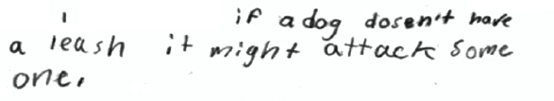

-------------------------------------------------------------------------------------------------------------------------------------------------------------------------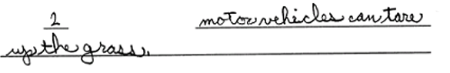

These responses refer to a rule from Sign 1 and provide a reasonable explanation why the rule is important.

Partial - Student Response
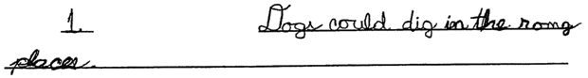

-------------------------------------------------------------------------------------------------------------------------------------------------------------------------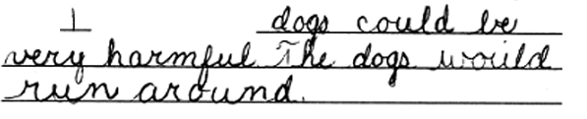

These responses referred to a rule from Sign 1 but provided only vague explanations why the rule was important. The first response is too vague to receive full credit. The second response does not give a specific reason how dogs could be harmful in the park or why dogs running around would have a harmful effect.

Unacceptable - Student Response
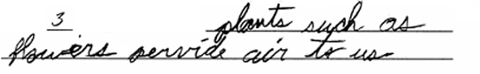

-------------------------------------------------------------------------------------------------------------------------------------------------------------------------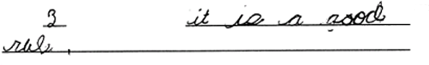

These responses did not provide a valid explanation of why a rule is important. The reason provided in the first response is not reasonable. (Picking plants and flowers in a park would not have any effect on the quality of the air people would breathe in the park.) The second response only gives an opinion about a rule.

- Item Detail for Question 3
No student responses are available for this question.

- Item Detail for Question 4
No student responses are available for this question.
- Item Detail for Question 5

Complete - Student Response
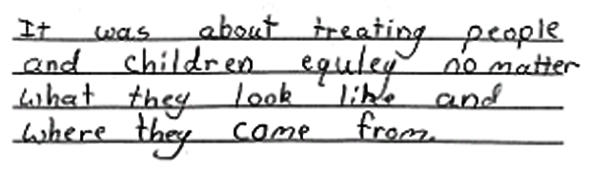

-------------------------------------------------------------------------------------------------------------------------------------------------------------------------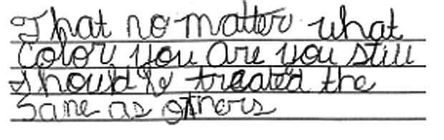

These responses each demonstrated an understanding of the idea that all people should not be judged by their race.

Partial - Student Response
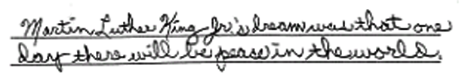

-------------------------------------------------------------------------------------------------------------------------------------------------------------------------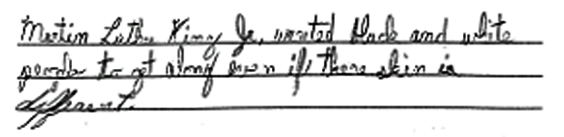

Each of these responses provided a general statement related to the quotation. However, in each case, the response failed to address the specific concept of racial equality.

Unacceptable - Student Response
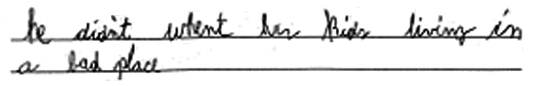

-------------------------------------------------------------------------------------------------------------------------------------------------------------------------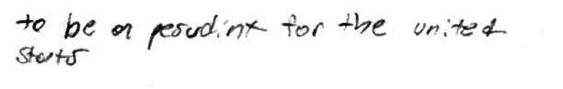

These responses failed to demonstrate any understanding of the quotation.
- Item Detail for Question 6
No student responses are available for this question.

- Item Detail for Question 7
No student responses are available for this question.

- Item Detail for Question 8
No student responses are available for this question.

- Item Detail for Question 9

Complete - Student Response
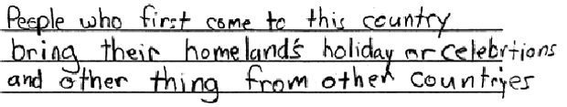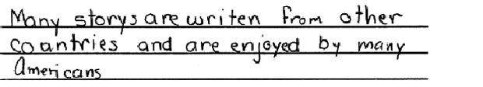

-------------------------------------------------------------------------------------------------------------------------------------------------------------------------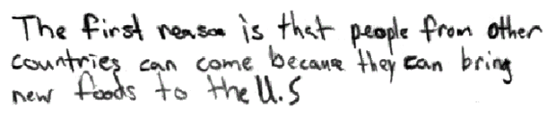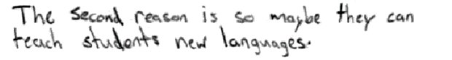

These responses provided two ways in which the United States benefits from having people from different countries and backgrounds.

Partial - Student Response
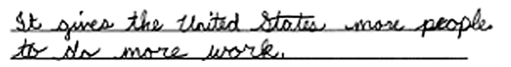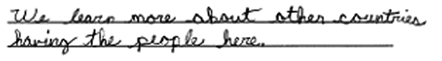

-------------------------------------------------------------------------------------------------------------------------------------------------------------------------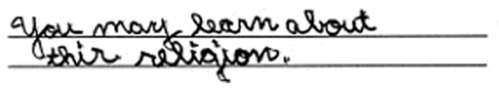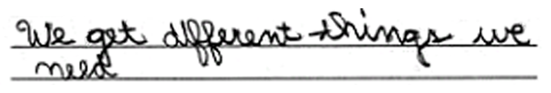

These responses provided one way in which the United States benefits from having people from different countries and backgrounds. The first response did not receive credit for the first statement because the benefit provided ("more people to do more work") is not a result of having people from many different countries or backgrounds. The second statement provided ("We learn more about the countries having the people here") was credited as an appropriate answer. The second response received credit for the first statement (referring to learning about people's religions). The second statement did not receive credit because it was considered too vague.

Unacceptable - Student Response

-------------------------------------------------------------------------------------------------------------------------------------------------------------------------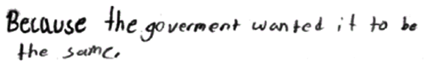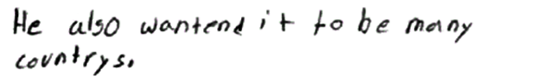

These responses did not provide any ways in which the United States benefits from having people from different countries and backgrounds. The first response provides reasons why immigrants have come to the United States but does not address the issue of how the United States benefits from diversity among immigrants as provided in the prompt. The information in the second response is unclear and does not describe any benefits to the United States.

- Item Detail for Question 10
No student responses are available for this question.

- Item Detail for Question 11

Complete - Student Response
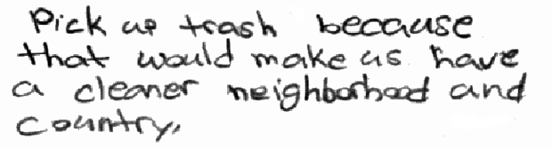

-------------------------------------------------------------------------------------------------------------------------------------------------------------------------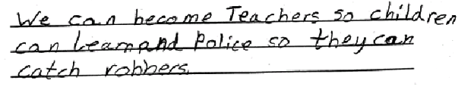

Each of these responses provided one action that demonstrates an understanding of what will support the country, with at least one reason that explains why the example given is important.

Partial - Student Response
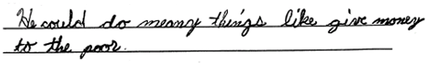

-------------------------------------------------------------------------------------------------------------------------------------------------------------------------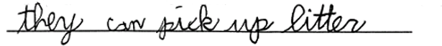

Each of these responses provided one action that individuals can do for their country, but failed to provide a reason why the action is important. In the first response, the imprecise use of the word "He" rather than "Individuals" was judged to be permissible.

Unacceptable - Student Response
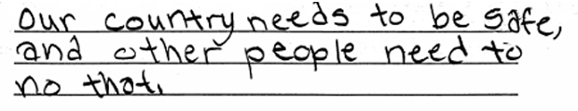

-------------------------------------------------------------------------------------------------------------------------------------------------------------------------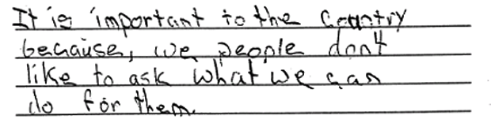

These responses did not provide any specific action that individuals can do to help their country.

- Item Detail for Question 12
No student responses are available for this question.

- Item Detail for Question 13
No student responses are available for this question.

- Item Detail for Question 14
No student responses are available for this question.

- Item Detail for Question 15
No student responses are available for this question.

