- Item Detail - Question Key

The correct answer is:

B. Metal

- Item Detail - Question Key

The correct answer is:

B. The erosion of the walls of a canyon

- Item Detail - Question Key

The correct answer is:

C. Wide, long leaves

- Item Detail - Question Scoring Guide

Complete

Student response indicates one type of grocery bag and correctly explains why using this type of bag helps protect the environment. Response indicates reusing, recycling, or biodegradation of the bags, as appropriate.
OR
Student response indicates one type of grocery bag and correctly explains why not using bags made of one of the other materials helps protect the environment.

Unsatisfactory/Incorrect

Student response is inadequate or incorrect.

- Item Detail - Question Key

The correct answer is:

D. Water absorbs light energy.

- Item Detail - Question Key

The correct answer is:

C. Matt

- Item Detail - Question Key

The correct answer is:

D. The car is moving west to east.

- Item Detail - Question Scoring Guide

Complete
Student response describes a complete investigation whose objective is to count the number of birds that go to each type of food in a particular time period. Investigation consists of five components: 1) using two containers that are the same type, 2) testing both types of food, keeping them separate from each other, 3) placing the containers in the same location, 4) counting the number of birds seen eating the seeds, and 5) observing for the same amount of time.

Satisfactory

Student response describes four components of an investigation whose objective is to count the number of birds that go to each type of food in a particular time period.
OR
Student response describes a valid investigation or five components of an investigation whose objective is to compare the amount of each type of bird food that remains after a certain time period. This investigation does not get full credit because some birds may eat more than other birds. Investigation consists of six components: 1) using two containers that are the same type, 2) testing both types of food, keeping them separate from each other, 3) placing containers in the same location, 4) using the same amount of each type of seed, 5) measuring the amount of each type of food remaining, and 6) observing for the same amount of time.

Essential

Student response describes two or three components of an investigation whose objective is to count the number of birds that go to each type of food in a particular time period.
OR
Student response describes three or four components of an investigation whose objective is to compare the amount of each type of bird food that remains after a certain time period.

Partial

Student response describes one component of an investigation whose objective is to count the number of birds that go to each type of food in a particular time period.
OR
Student response describes one or two components of an investigation whose objective is to compare the amount of each type of bird food that remains after a certain time period.

Unsatisfactory/Incorrect

Student response is inadequate or incorrect.

- Item Detail - Question Scoring Guide

Complete

Student response correctly indicates that people or animals that are related can look different and provides a comparison of a specific characteristic of individuals.

Partial

Student response correctly indicates that people or animals that are related can look different, but does not provide a comparison of a specific characteristic of individuals.

Unsatisfactory/Incorrect

Student response is inadequate or incorrect.

- Item Detail - Question Key

The correct answer is:

A. 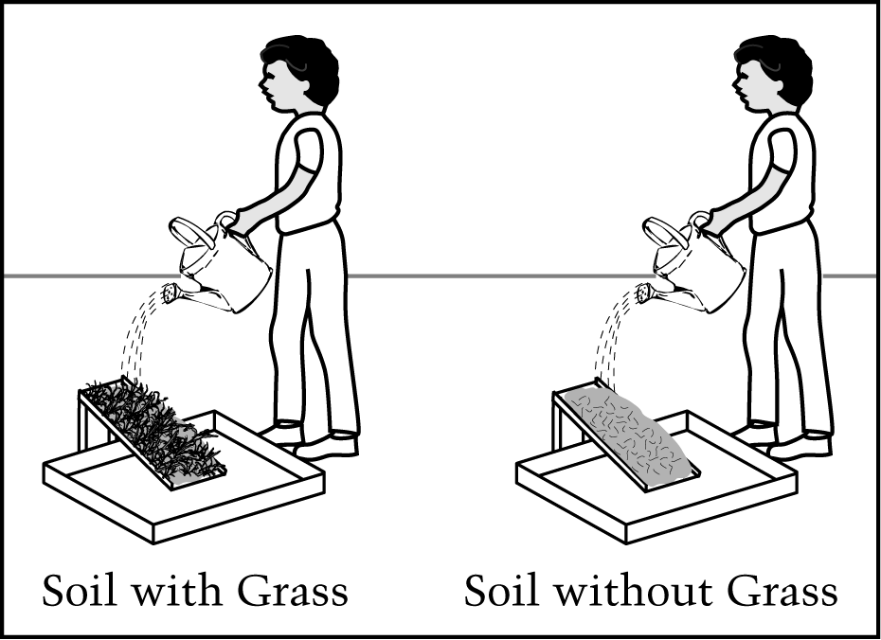

- Item Detail - Question Scoring Guide

Complete

Student response selects (A) Yes and indicates a correct characteristic of grass that helps keep water from carrying away soil, and explains how this characteristic keeps water from carrying away soil.

Partial

Student response selects (A) Yes and indicates a correct characteristic of grass that helps keep water from carrying away soil or explains how this characteristic keeps water from carrying away soil.
OR
Student response selects (B) No and addresses both parts of a correct explanation.

Unsatisfactory/Incorrect

Student response is inadequate or incorrect.

- Item Detail - Question Key

The correct answer is:

A. The grass helped to hold the soil in place.

- Item Detail - Question Key

The correct answer is:

D. Connect the steel nails with a short piece of wire.

- Item Detail - Question Scoring Guide

Complete

Student response indicates Rafael and compares the number of rows of tiles over which each boy's ball rolled. Student response may or may not include quantitative information in the comparison.

Partial

Student response indicates Rafael and indicates that Rafael's ball traveled farther, but does not compare the number of rows of tiles over which each boy's ball rolled.

Unsatisfactory/Incorrect

Student response is inadequate or incorrect.

- Item Detail - Question Key

The correct answer is:

D.

- Item Detail - Question Key

The correct answer is:

D. Butter changing into liquid in a warm pan

