- Item Detail for Question 1

No student responses are available for this question.

- Item Detail for Question 2

No student responses are available for this question.

- Item Detail for Question 3

No student responses are available for this question.

- Item Detail for Question 4

Complete - Student Response
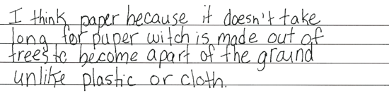

-------------------------------------------------------------------------------------------------------------------------------------------------------------------------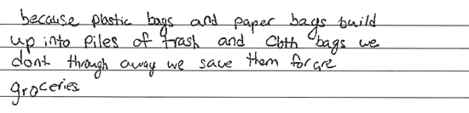

-------------------------------------------------------------------------------------------------------------------------------------------------------------------------The first response selects (B) and indicates that paper biodegrades quickly. The second response selects (C) and indicates how to reuse cloth. Response also offers why not using the other type bags reduces trash buildup.

Unsatisfactory/Incorrect - Student Response
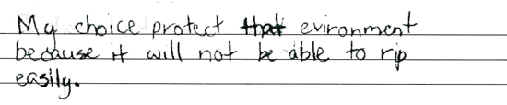

-------------------------------------------------------------------------------------------------------------------------------------------------------------------------

-------------------------------------------------------------------------------------------------------------------------------------------------------------------------Neither response indicates why the selected material helps protect the environment.

- Item Detail for Question 5

No student responses are available for this question.

- Item Detail for Question 6

No student responses are available for this question.

- Item Detail for Question 7

No student responses are available for this question.

- Item Detail for Question 8

Complete - Student Response
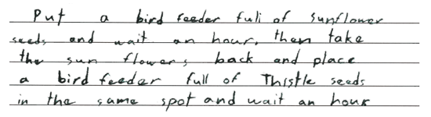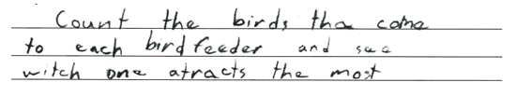

-------------------------------------------------------------------------------------------------------------------------------------------------------------------------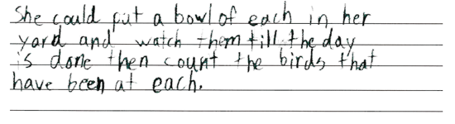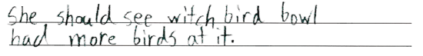

-------------------------------------------------------------------------------------------------------------------------------------------------------------------------Both responses describe complete investigations the bird-watcher could conduct to help her decide which food will attract more birds: placing the two types of seeds in separate containers that are the same type, placing the containers at or near the same location, and counting the number of birds that visit each container in the same amount of time.

Satisfactory - Student Response
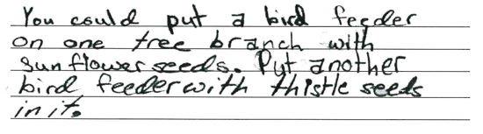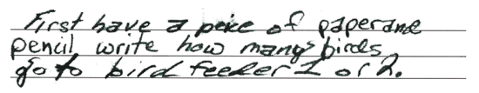

-------------------------------------------------------------------------------------------------------------------------------------------------------------------------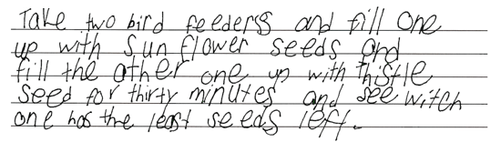

-------------------------------------------------------------------------------------------------------------------------------------------------------------------------The first response describes four components of an investigation whose objective is to count the number of birds that go to each type of food in a particular time period, but does not indicate that the birds have to be observed for the same amount of time. The second response describes a valid investigation whose objective is to compare the amount of each type of bird food that remains after a certain time period.

Essential - Student Response
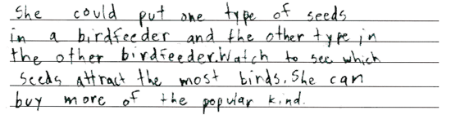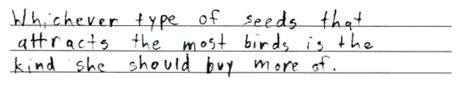

-------------------------------------------------------------------------------------------------------------------------------------------------------------------------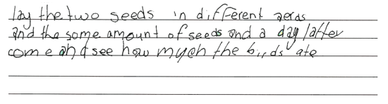

-------------------------------------------------------------------------------------------------------------------------------------------------------------------------The first response describes three components of an investigation whose objective is to count the number of birds that go to each type of food in a particular time period, but does not indicate that the birds have to be counted and observed for the same amount of time and that the containers should be placed at or near the same location. The second response describes four components of an investigation whose objective is to compare the amount of each type of bird food that remains after a certain time period, but does not indicate using the same type of container and that the seeds have to be placed at or near the same location.

Partial - Student Response
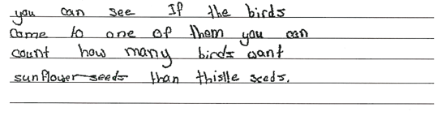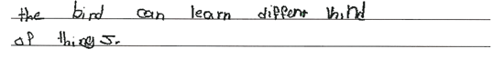

-------------------------------------------------------------------------------------------------------------------------------------------------------------------------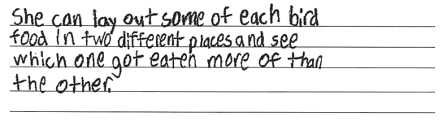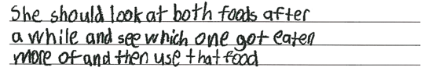

-------------------------------------------------------------------------------------------------------------------------------------------------------------------------The first response provides one component of an investigation whose objective is to count the number of birds that go to each type of food in a particular time period: counting the number of birds. The second response provides two components of an investigation whose objective is to compare the amount of each type of bird food that remains after a certain time period: offering the two types of bird food separately and comparing the amount of each type of food that remains.

Unsatisfactory/Incorrect - Student Response
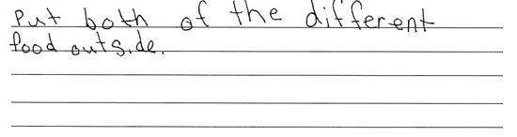

-------------------------------------------------------------------------------------------------------------------------------------------------------------------------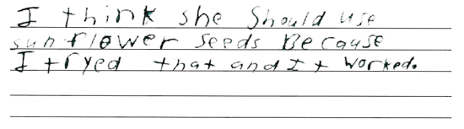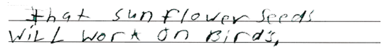

-------------------------------------------------------------------------------------------------------------------------------------------------------------------------Neither response describes any details of a valid investigation. The first response includes information from the question, and the second response cites personal experience.

- Item Detail for Question 9

Complete - Student Response
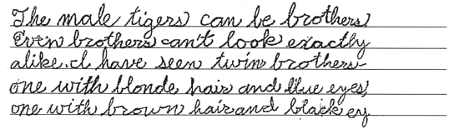

-------------------------------------------------------------------------------------------------------------------------------------------------------------------------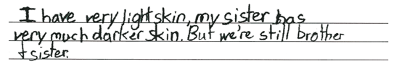

-------------------------------------------------------------------------------------------------------------------------------------------------------------------------Both responses correctly explain that people or animals that are related can look different and provide a specific characteristic of individuals. The first response indicates that twin brothers can have different hair and eye color, and the second response indicates that brothers and sisters can have different skin color.

Partial - Student Response
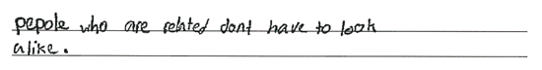

-------------------------------------------------------------------------------------------------------------------------------------------------------------------------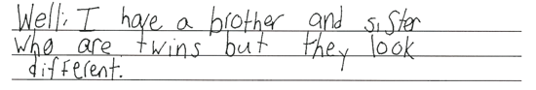

-------------------------------------------------------------------------------------------------------------------------------------------------------------------------Both responses correctly explain that people or animals that are related can look different, but do not provide a specific characteristic of individuals. The first response indicates that people who are related can look different, and the second response indicates that twins can look different.

Unsatisfactory/Incorrect - Student Response

-------------------------------------------------------------------------------------------------------------------------------------------------------------------------

-------------------------------------------------------------------------------------------------------------------------------------------------------------------------The first response is inadequate and does not explain that people or animals that are related can look different, but instead states that everybody and everything is different. The second response incorrectly explains that the differences in the color of the tigers is because one is male and one is female.

- Item Detail for Question 10

No student responses are available for this question.

- Item Detail for Question 11

Complete - Student Response
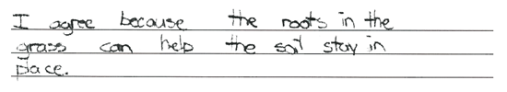

-------------------------------------------------------------------------------------------------------------------------------------------------------------------------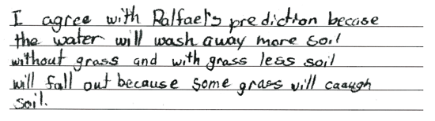

-------------------------------------------------------------------------------------------------------------------------------------------------------------------------Both responses select (A), indicate a correct characteristic of grass, and explain how this characteristic helps prevent soil erosion. The first response describes the binding ability of roots; the second response describes the blocking ability of grass.

Partial - Student Response
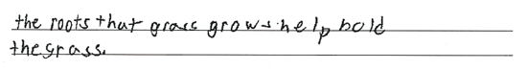

-------------------------------------------------------------------------------------------------------------------------------------------------------------------------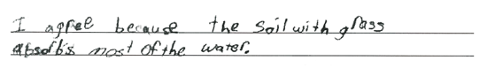

-------------------------------------------------------------------------------------------------------------------------------------------------------------------------The first response selects (A) and indicates roots help prevent soil erosion, but does not explain how this occurs. The second response selects (A) and describes water absorption, but does not identify a characteristic of grass that helps prevent soil erosion.

Unsatisfactory/Incorrect - Student Response
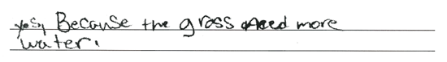

-------------------------------------------------------------------------------------------------------------------------------------------------------------------------

-------------------------------------------------------------------------------------------------------------------------------------------------------------------------The first response selects (A) and provides an incorrect explanation. The second response selects (B) and provides an incorrect explanation.

- Item Detail for Question 12

No student responses are available for this question.

- Item Detail for Question 13

No student responses are available for this question.

- Item Detail for Question 14

Complete - Student Response
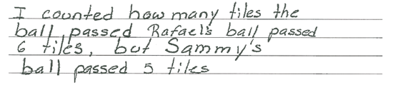

-------------------------------------------------------------------------------------------------------------------------------------------------------------------------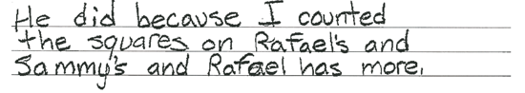

-------------------------------------------------------------------------------------------------------------------------------------------------------------------------Both responses indicate that Rafael rolled his ball faster. The first response includes a quantitative comparison of the number of rows of tiles over which each boy's ball rolled, while the second response includes a qualitative comparison.

Partial - Student Response
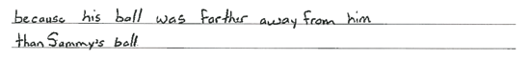

-------------------------------------------------------------------------------------------------------------------------------------------------------------------------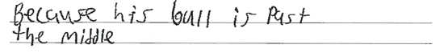

-------------------------------------------------------------------------------------------------------------------------------------------------------------------------Both responses indicate that Rafael rolled his ball faster and that his ball traveled farther. The responses do not provide a comparison of the number of rows of tiles over which each boy's ball rolled.

Unsatisfactory/Incorrect - Student Response
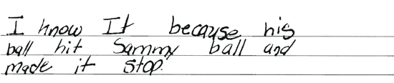

-------------------------------------------------------------------------------------------------------------------------------------------------------------------------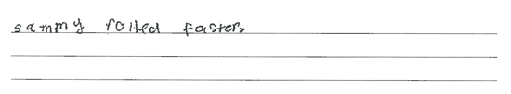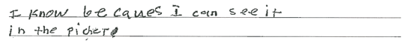

-------------------------------------------------------------------------------------------------------------------------------------------------------------------------The first response indicates that Rafael rolled his ball faster, but does not provide a valid explanation. The second response indicates that Sammy rolled his ball faster.

- Item Detail for Question 15

No student responses are available for this question.

- Item Detail for Question 16

No student responses are available for this question.

